|  |  |  |  |  |
| --- | --- | --- | --- | --- |
| |  | | --- | |  | | |  |  | | --- | --- | | |  | | --- | |  | | |
| **Welcome to our latest Newsletter: Meeting cooling demand with low carbon solutions** | |
| Our demonstration EnergiVault unit has been in situ at Quotient Sciences for 6 months, and is performing exceptionally well, beyond our expectations. We have published initial test data as part of a White Paper on meeting cooling demand with low-carbon energy. The White Paper can be accessed below. | |
| |  | | --- | | [View White Paper](https://o-hx.us10.list-manage.com/track/click?u=1f33a0e5287530a0c2f3a2e69&id=c1dd640df5&e=55d0c9f108) | | View White Paper | | |

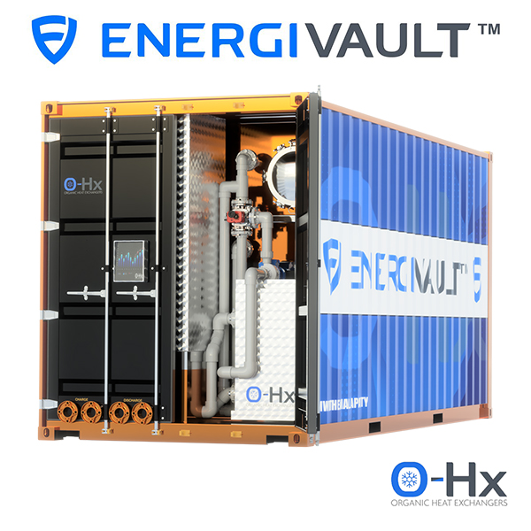

|  |
| --- |
| The EnergiVault unit is not just performing exceptionally well; it has also delighted Quotient Sciences, highlighting its impressive capabilities. A promotional video, featuring interviews with Quotient Sciences' key staff members, illustrates this success and can be viewed here. |
| |  | | --- | | [View the Video](https://o-hx.us10.list-manage.com/track/click?u=1f33a0e5287530a0c2f3a2e69&id=d35bfaecd4&e=55d0c9f108) | | View the Video | |
| The unit's contribution to sustaining full business operations during the hot weather speaks volumes about its adaptability. It stands as a robust solution that enhances operational resilience while also delivering substantial economic benefits through carbon and cost savings. |

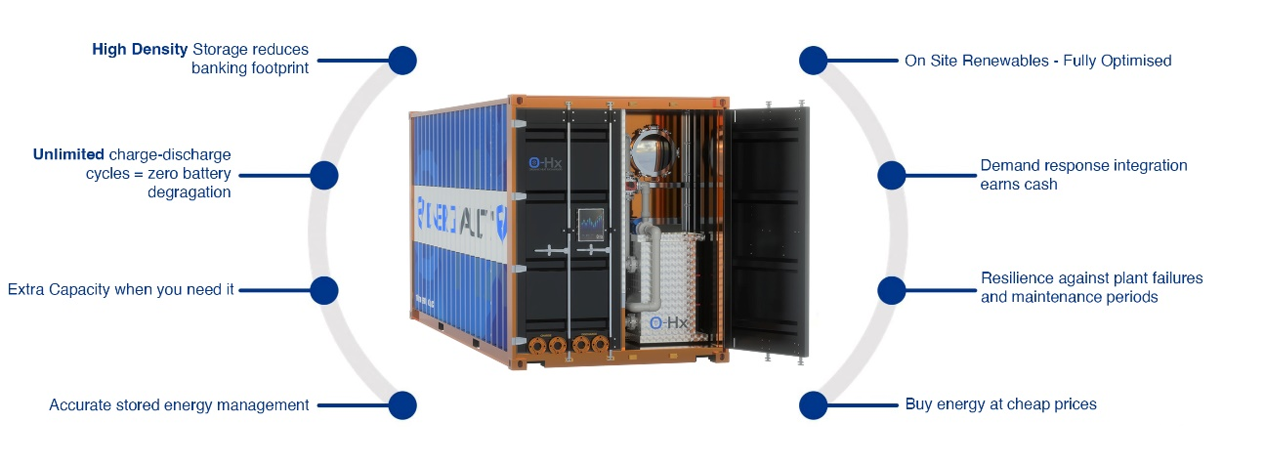

|  |
| --- |
| In parallel, recent months have seen further enhancements in the energy storage system. This system ingeniously consolidates all necessary components into a singular, standard shipping container. Notably, it achieves an energy storage capacity that now surpasses the 1MWh threshold. This development represents a pivotal stride in our continuous pursuit of a fully modular, plug-and-play installation design, demonstrating our commitment to more efficient and versatile energy solutions.  The application of O-Hx’s EnergiVault® around the world could lead to huge reductions in greenhouse gas emissions.  Visit [www.o-hx.com](https://o-hx.us10.list-manage.com/track/click?u=1f33a0e5287530a0c2f3a2e69&id=2eac9a0313&e=55d0c9f108) for further information. |