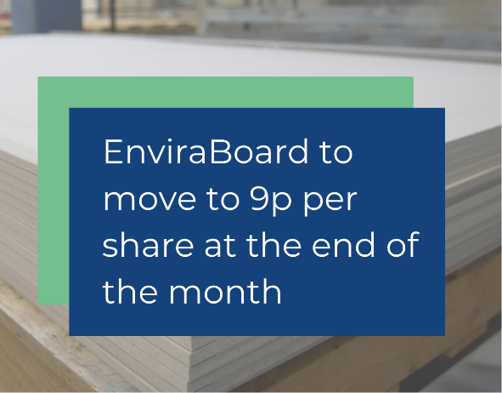
EIS tax relief available
Dear ,

As you were following the developments of EnviraBoard during the past year, it may be interesting for you know that at the investor briefing on Thursday, 17/10/2025 it was announced that at the end of this month the share-price will, after being kept at 6 p per share for a long time, now move to £0,09/ share, following the progress of the company.
With faster movements up expected to follow in the nearby future this may be an excellent investment opportunity for you in a solid product/ company that absolutely serves a high demand in the market.

Read the words of Enviraboard CEO Taus Nohrlind and Director of Investor Relations Nick Dimmock below:

Taus Nohrlind
CEO, EnviraBoard

“Of course, we have a duty to our shareholders to maximise shareholder value, yet our price increases are based on developments within the business. It just happens that over the last year, EnviraBoard Ltd, has made very significant progress adding management expertise to our team, we’re in talks with several paper mills about converting their waste into EnviraBoards, and finding new distributors and customers wishing to sell or use EnviraBoard, completing the construction of our mini plant in Denmark and preparing for our first full scale production facility.”
Nicholas Dimmock
Director of Investor Relations, EnviraBoard

“It’s not really about comparables, bitcoin or AI Bubbles. Over €30M has been invested in the development of EnviraBoard, to make a building board that’s superior to all our competitors; that has negative input costs, which means larger margins for us and our agents and distributors. Thus, a brilliant product with great margins and natural competitive advantage. The move to 9p, meaning a market cap of circa 12M, is a warranted step forward. Our target is now 24p by Christmas, rather than the 11p in the forecasts and 100p in four years’ time as forecast – the 100p is based on having one factory in development. Investors need to be aware that this is a 32-billion-dollar market, dominated by a product that was invented in 1890 and ripe for disruption.”
A quick glance:
short EnviraBoard youtube video, still 6p per share till 31/10/2025.
EnviraBoard is EIS approved, offering investors generous tax reliefs alongside high growth potential. We are currently offering shares at 6 pence till the end of October 2025, with a forecasted share price of 100 pence in 3 years, based on market growth projections and current commercial discussions.

EnviraBoard Ltd is registered in England under Company Number 15730632.
EnviraBoard ApS is registered in Denmark with company number: 36971142
Registered office address: 25 Cabot Square, London, Canary Wharf, E14 4QZ, United Kingdom.

