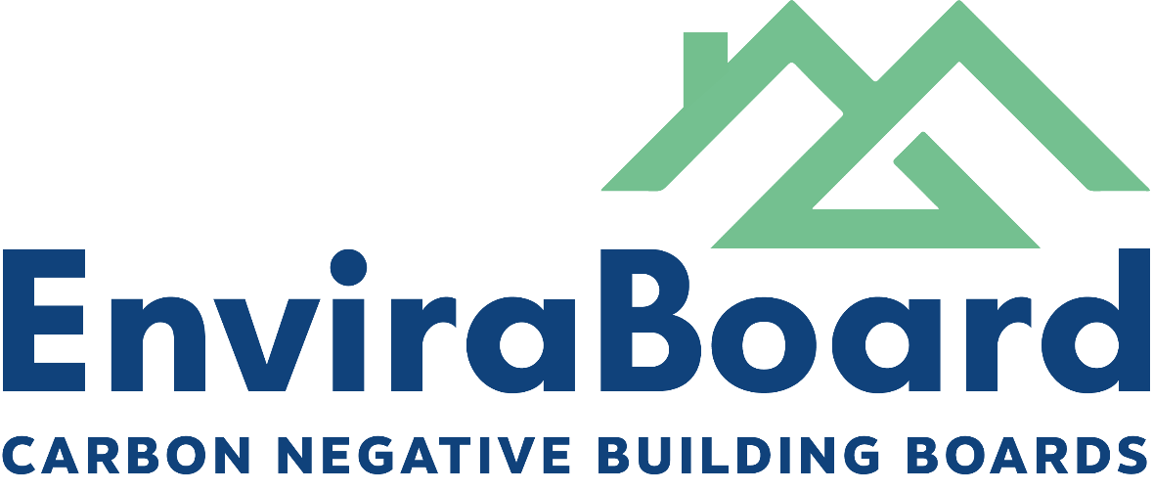

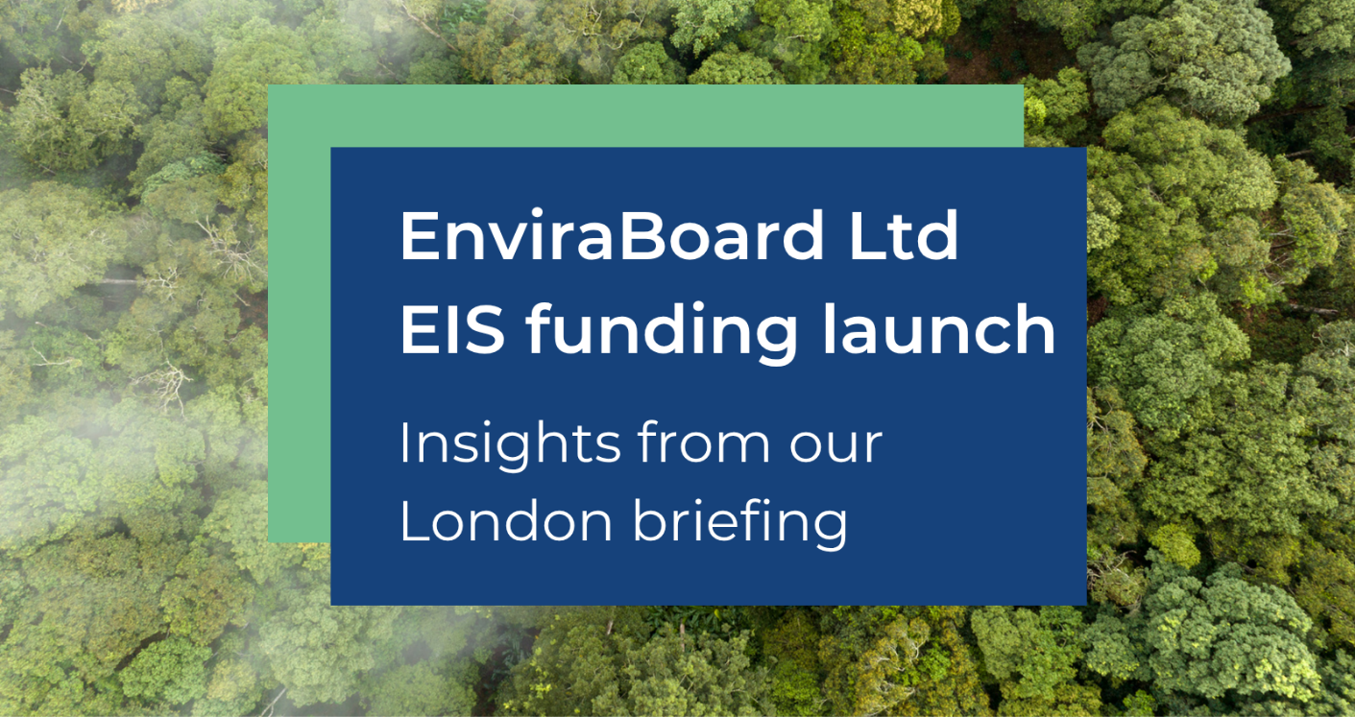

In October, EnviraBoard hosted a London briefing for investors, featuring the founders, advisory board, and partners from GreenBridge (experts shaping the future of sustainable construction). With superior patented carbon-negative building boards, strategic partnerships, and a $32bn global market opportunity, this is the kind of early-stage innovation you rarely get to see before validation and full-scale production.

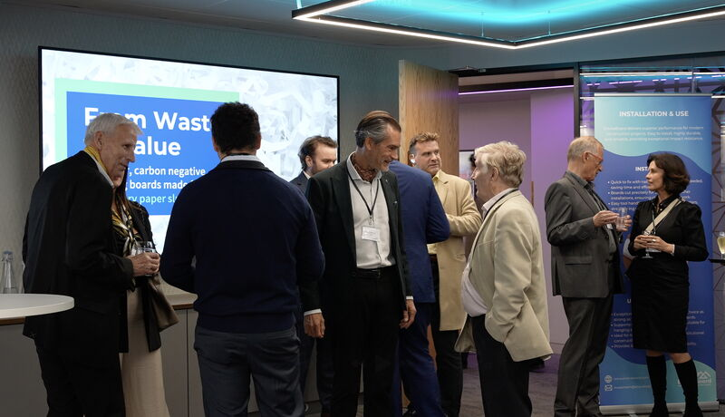

Here are the key takeaways from the event:

  Funding & Production
  - £800k raised to build the first mini-plant in Denmark. Operational in 4–6 weeks to produce sample boards for testing and technical validation.
  - £1.6m seed round now live: shares at 9p expected to rise when the mini-plant is operational
  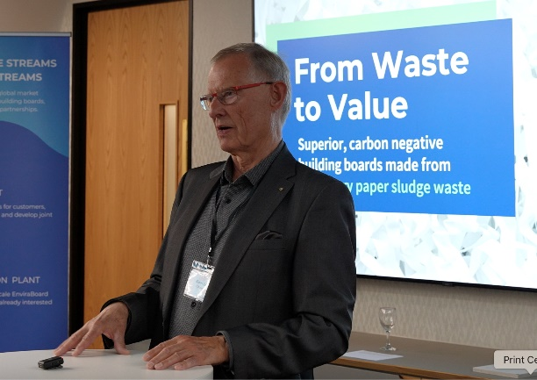
  Product & Market
  - Carbon-negative building boards that are fire-resistant, strong, cost-competitive, easy to install, and fully recyclable.
  - Positioned within a $32bn global market as demand for sustainable materials accelerates.
  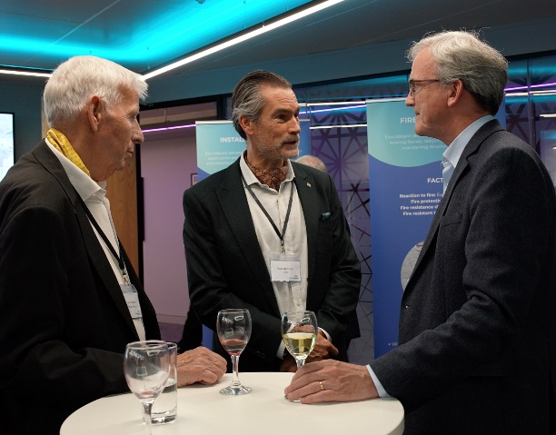
  Strategic Partnerships
  - Collaboration with GreenBridge: brings global experience to scale production through full scale production facilities around the world, establish supply chains, and support joint ventures worldwide.
  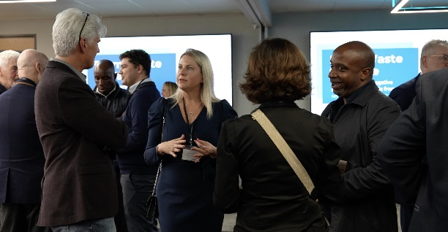
  Intellectual Property
  - Patents filed covering the production process and board formulation, with plans to extend protection to 163 countries and deepen existing patents
  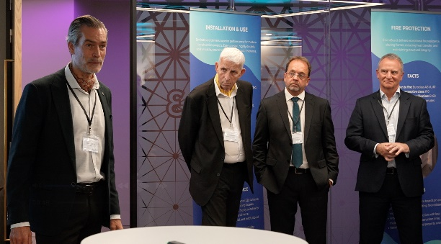
  Regulatory Tailwinds
  - EU landfill bans on sending paper waste sludge to landfill, the European Union ETS and circular economy rules are creating a clear opportunity for solutions like EnviraBoard’s. The timing couldn’t be better.

Why Investors Should Take Notice

- First-mover advantage: a rapidly expanding, sustainability-driven market.
- Significant Competitive Advantages: through negative priced input costs and a superior board, against incumbents which were invented 130 years ago
- Clear technical advantage: patented, carbon-negative, cost-competitive, and validated by industry experts.
- Strategic partnerships: GreenBridge provides the know-how to scale globally.
- Regulation-backed growth: EU regulation + circular economy rules create long-term growth.
- Commercial momentum: mini-plant under construction and first sample boards for testing available shortly.

