
ENG8 - A Breakthrough in Clean Energy with its EnergiCell® Technology.

ENG8 is a deep-tech energy company that is commercialising one of the most genuinely promising clean energy technologies in development today.

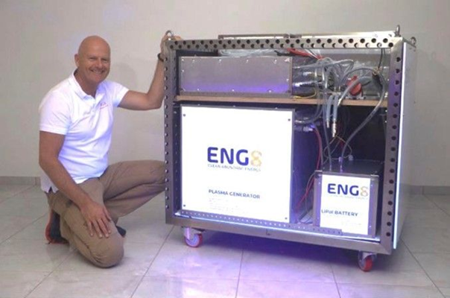
ENG8® launched its 100 kW Modular Thermal Power Generator at IWAHLM-17 in Bergamo, Italy, this week. IWAHLM-17 was a key international forum for the LENR community.

ENG8 Energy is a deep-tech energy company that is commercialising one of the most genuinely promising clean energy technologies in development today.
EnergiCells are low energy nuclear reaction (LENR) reactors that use high power electrical impulses to transmute the hydrogen and oxygen (from water) into helium 1 and carbon. This safely generates five to ten times more thermal, electrical and chemical energy than the electricity put in (COP/Q 5 to 10, means 1 KW in gives 5-10 KW out using only water as the base).
ENG8’s EnergiCells (LENR reactors) have the highest COP and power output of any other company’s LENR reactors.
The energy produced is sufficient to create a self-powering system with plenty of energy to sell. There are no nuclear or radioactive fuels used or produced.
NASA who has been conducting LENR research for twenty years estimate that eight million times more energy per gram can be produced by LENR than from a chemical reaction. In effect, only grams of fuel (matter) are consumed in the LENR process to produce megawatts of energy.
The EnergiCell® has been independently validated on multiple occasions since 2020, confirming net energy export and sustained operation, including a self-powering configuration… verified on two separate occasions, demonstrating a Q/COP that is effectively infinite: the system sustains its own operation without external energy input, producing a net energy export. Suitable for and highly needed in developed and developing countries.

350PPM was instrumental in raising €3 million for ENG8 in 2023/4 from over 100 investors. As they consistently hit milestones the valuation of the shares went from €2 per share to €20 (£17) per share this year.
ENG8 is now actively engaged in discussions with strategic investors and grant providers to raise €20 million to finish development, then testing and installation of the first megawatt of generating capacity at a client’s premises to be completed this year.
About ENG8
Over the past eight years, and with the support of more than one hundred private investors, ENG8 has invested in developing its proprietary EnergiCell® reactor: a modular system that generates clean thermal and electrical energy through a patented process.
ENG8 has an experienced engineering team of 35 people with deep knowledge of the EnergiCell (plasma LENR) and power generation technology, enabling it to complete the next stage of development.
The company is registered in Gibraltar and operates its administration, application engineering and demonstration laboratory at the PCI Science Park at the University of Aveiro, Portugal.

Intellectual Property
ENG8 holds two international patent families at national stage, with a US patent granted in April 2025. Three further patent applications were filed last week, reflecting the pace at which the company's technology and engineering capability continues to develop.

The 100 kW Modular Thermal Generator and Megawatt Generating Containers
The company is advancing from laboratory validation (TRL 4) to industrial prototyping (TRL 7), with the 100 kW Modular Thermal Power Generator as the lead commercial product. Each unit will initially supply 100 kW of steam at 10 bar directly into clients' industrial processes.
The modular power generating system is designed so that 24 units fit within a six meters shipping container, with four units held in reserve, delivering 2 MW of continuous thermal capacity per container. This containerised architecture makes the technology straightforward to deploy and scale across a wide range of industrial sites, and it is this combination of modularity, simplicity and output that makes the EnergiCell® genuinely disruptive for energy-intensive industries.
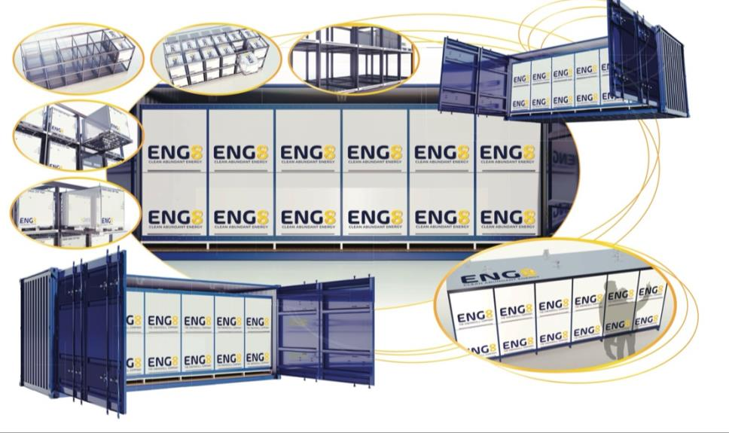

Economics
ENG8’s estimated thermal, electrical and chemical (HHO) generation cost is €15/MWh (based on early modelling) which when compared to European oil & gas prices of €60+/MWh and electrical costs of €100/MWh will give a good sales margin.
350PPM is assisting ENG8 with its considerable experience in carbon trading / ITMOs (International Transferable Mitigation Outcomes) to enable ENG8 to qualify its generators and then monetise them under Article 6. Depending on offset source, revenues of €600k to €1.1M rising to €1.2M to €1.7M per annum per MW installed are realistic.
This is in addition to ENG8 being able to forward sell its energy contracts once the first megawatt (10 x 100kW generators) has been successfully demonstrated operating for six months to a year.
Both these revenue streams should enable the company to grow exponentially, globally, with minimum capital risk after month 24.

Commercial

Various agreements with institutional investors are at the point of completion.
On the commercial side more broadly, ENG8 has already identified over one gigawatt of potential client demand from five industrial businesses located within 30 minutes of its facility in Portugal. Discussions are under way with early-adopter clients ahead of first commercial thermal energy deliveries, targeted for Q4 2026.
The company is also launching two structured partnership programs: one for energy-intensive industrial clients seeking to lock in long-term energy supply at significantly reduced cost, and another for manufacturers of power-intensive machinery seeking to integrate EnergiCell® technology into their product lines under a profit-share model.
From 2031, ENG8 plans to license the core technology to major power equipment manufacturers so they can sell energy in addition to equipment, with a revenue sharing agreement with ENG8.
This would be concurrent with ENG8 expanding its own generation capacity geographically.

Investing in ENG8
We believe ENG8 is in the final stages of closing its present funding round. Once this target is reached, the company will enter a 12-month pause from external fundraising in order to focus entirely on MVP completion and first client deployment. The window to participate at the current valuation is therefore limited.
The company's share price has grown from £2 to £17 (€20) over the past three years, reflecting a current valuation of over £100 million.
To learn more about ENG8, receive our full investor materials, or arrange a conversation with wit me, please contact me by email. WhatsApp or phone at my contact details below.

Paul Dopierala

ENG8 International Limited

Tel.: +44(0) 203 582 2970 ​
WhatsApp: +34 696 67 49 63
Email: Paul-Dopierala@eng8.org
Web: www.eng8.energy

