ERKANGERUS DE LANDESERE
Ce nom d’Erkangerus de Landesere apparait à partir de 1160 en styrie province d’Autriche dans un document.
Plusieurs autres documents contiennent ce nom jusqu’en 1300 environ. Ce sont donc au moins trois générations d’ Erkangerus qui sont des acteurs nobles « ministériels » dans cette région pendant cette période.
Une étude publiée en 1861 Vienne suggère que le premier Erkangerus pouvait être originaire de Landesere près de Bâle.
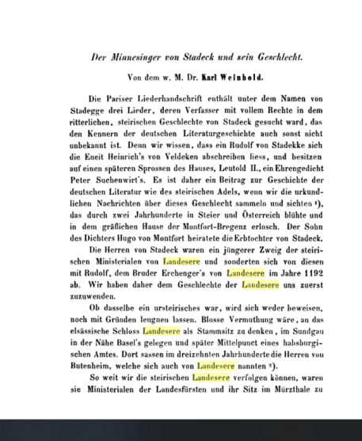

Dans l’hypothèse que ce premier Erkangerus était originaire de Landesere cela aurait plusieurs significations :
1. Pourquoi a- t -il dû quitter son lieu d’origine ? A t il été chassé ? Est-ce le Sire de Butenheim qui a pris possession du lieu ?
2. Si tel était le cas l’occupation et la création de notre village est bien antérieure à l’arrivée des Butenheim.

La période 1160 pourrait effectivement correspondre à l’arrivée des Butenheim à Landsere.
Ce qui est surprenant c’est que ce Erkangerus a refait sa vie de noble en Styrie.
N’aurait-il pas plutôt vendu son bien de Landser pour émigrer vers l’Est ?
Autant de questions qui resteront certainement sans réponses.
Une autre piste à explorer sont ses armes… et là nous trouvons notamment un lion …selon XXXXXX surmonté d’un aigle …
On dira que le lion se retrouve souvent en écusson…Mais ne serait- ce pas plutôt un indice déterminant pour affirmer qu’il est bel et bien originaire de LANDESERE.
Dans un texte datant de 1248 il est dit de Hongrie ville de Landsee…
Est-ce une erreur ? Pendant plus d’un siècle tous les documents mentionnent Erkangerus de Landesere ou Landsere mais jamais Landse…
Il est même l’objet d’un pamphlet lors d’un tournoi en 1240 écrit par le seigneur, chevalier, homme politique et poète lyrique : ULRICH VON LICHTENSTEIN

Si recht Nam was ERCHENGER
Si Hus genannt was LANDESER
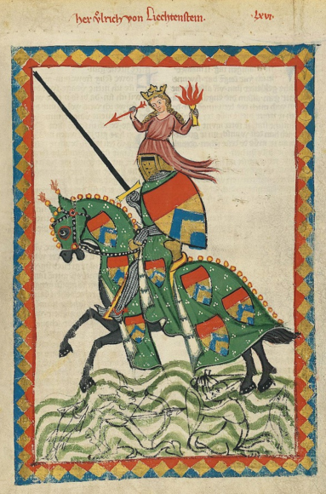

Certaines sources le présente comme le frère de Rodolphe von SCHADECK
Rodolphe était un serviteur du duc de Styrie tout comme son frère Erchenger von Landesere. Nous trouvons Rodolphe comme témoin dans les confirmations princières et les dons aux monastères spirituels.
Il écrivait des chants d’amour
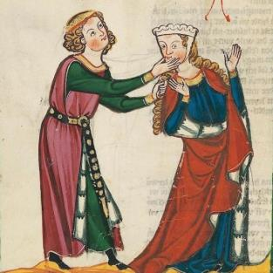
Rudolf von Stadeck: Minnelieder
Die drei Minnelieder Rudolfs II. von Stadeck erzählen von Liebeshoffnungen, Sehnsüchten, aber auch Enttäuschungen. Dem Sehnen des Sängers nach seiner Dame, die sich im kalten Winter vor ihm verberge, folgen erwartungsvolle Forderungen an sie für die kommende Sommerzeit. Als der Sommer aber naht, zeigt er sich enttäuscht: Er fragt sich gar, ob hinter der äußeren Schönheit seiner Auserwählten auch Herzlichkeit zu finden sei. Nach einigem Hin und Her gelangt er zu einer Antwort…

In den Liedern Rudolfs spiegelt sich auch ein Stück der steirischen Landesgeschichte: Für den Minnedienst an einer Dame wie auch für den Dienst an einem Herrn erwartete man sich Lohn. Nach dem Tod Herzogs Friedrichs II. des Streitbaren im Jahr 1246 wollten Teile des steirischen Adels seinen Großneffen nicht als Landesherrn anerkennen. Gleichzeitig versuchten der böhmische und der ungarische König, sich die Herrschaft über die Steiermark anzueignen: Ihre steirischen Parteigänger ehrhielten zum Teil nicht den erhofften Lohn und suchten sich schlussendlich einen neuen Herrn, Rudolf I. von Habsburg.

Bibliographische Anga

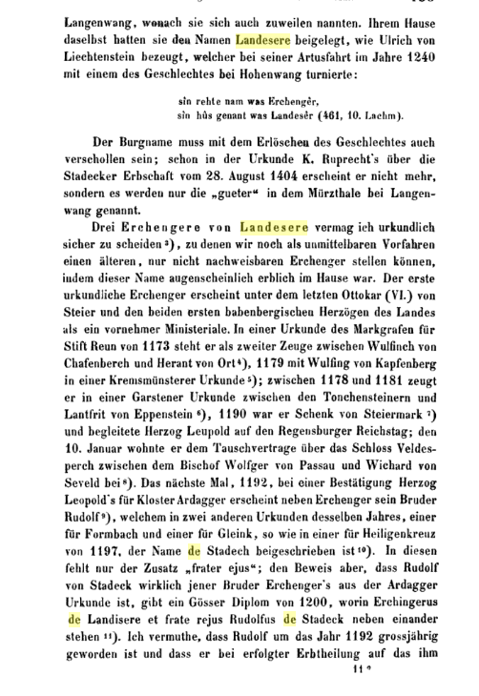
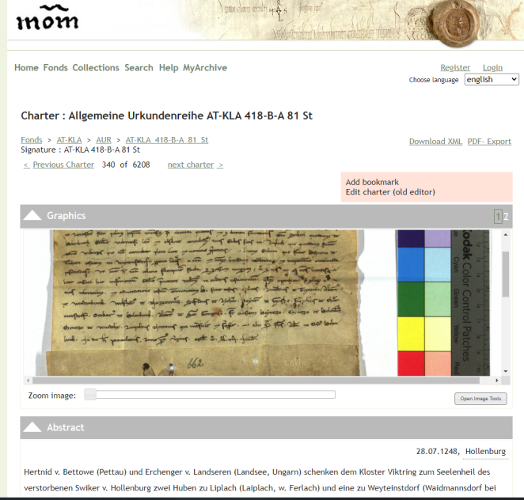

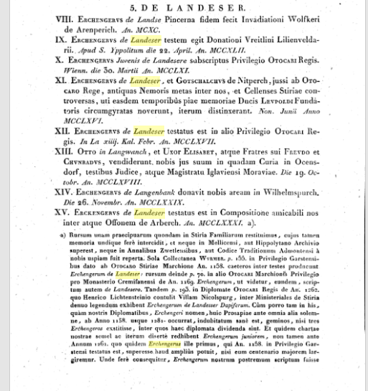

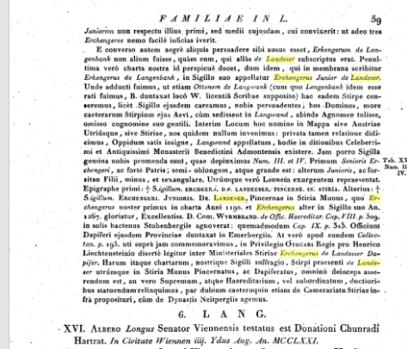

D’où provient ce nom d’ERCHANGERUS ?Nous joignons cette information
https://fmg.ac/Projects/MedLands/FRANCONIA.htm
Chapter 2. Die AHALOLFINGER

It is not certain that Erchanger, father of Empress Richilde, was related to the Ahalolfinger family, but his name suggests that this may have been the case. The name of one of his brothers Worad suggests a family connection with Worad who was recorded in 782 (see the document CAROLINGIAN NOBILITY).

1. --- . m ROTRUD, daughter of --- (-after 4 Mar 828). Emperors Louis I and Lothar confirmed that “Vualdo abba monasterii...Svarzaha” had exchanged property with "Erkingarius comes ac genitrix et fratri sui Rotdrudis, Vuoradus, Bernaldus et Bernardus" by charter dated 4 Mar 828[18]. Four children:

a) ERCHANGER (-864). Emperors Louis I and Lothar confirmed that “Vualdo abba monasterii...Svarzaha” had exchanged property with "Erkingarius comes ac genitrix et fratri sui Rotdrudis, Vuoradus, Bernaldus et Bernardus" by charter dated 4 Mar 828[19]. An agreement between Charles II "le Chauve" King of the West Franks and his brother Ludwig II "der Deutsche" King of the East Franks dated Jun 860 names "nobilis ac fidelibus laicis…Chuonradus, Evrardus, Adalardus, Arnustus, Warnarius, Liutfridus, Hruodolfus, Erkingarius, Gislebertus, Ratbodus, Arnulfus, Hugo, item Chuonradus, Liutharius, Berengarius, Matfridus, Boso, Sigeri, Hartmannus, Liuthardus, Richuinus, Wigricus, Hunfridus, Bernoldus, Hatto, Adalbertus, Burchardus, Christianus, Leutulfus, Hessi, Herimannus, item Hruodulfus, Sigehardus"[20]. The Annales Alamannicorum record "Erkingarius comes in Alamannia, pater primæ uxoris anonymæ Caroli Crassi" among those who swore allegiance in 864[21]. The Annales Weingartenses record the death in 864 of “Eberht, Liutolf, Erchanger, Liutfrid, Ruadolf, Purghart et alii quam plurimi istius regni Principes”[22]. m ---. The primary source which confirms the name of Erchanger’s wife has not been identified. Erchanger & his wife had [two] children:

i) RICHARDIS (-Abbey of Andlau, Alsace 18 Sep before [906/11]). The Annales Alamannicorum record "Erkingarius comes in Alamannia, pater primæ uxoris anonymæ Caroli Crassi"[23]. Abbess of Andlau in Alsace 887. At the time of their divorce, the couple both declared that the marriage had never been consummated. Regino names "Gozzelino eiusdem urbis [=Paris?] episcopo" in 887, recording that he left the church and married "Richardem sic enim Augusta vocabatur"[24]. m firstly (862, divorced 887) CHARLES, son of LUDWIG II "der Deutsche" King of the East Franks & his wife Emma [Welf] (839-Neudingen an der Donau 13 Jan 888, bur Kloster Reichenau). He succeeded his father in 876 as KARL III King of the East Franks. He was crowned Emperor KARL III "le Gros" in 881. m secondly GAUZLIN ex-Bishop, son of ---.

ii) [---. If “neptis” in the charter quoted below can be interpreted in the strict sense of “niece”, one of the parents of Rotrud was the sibling of Richardis. However, as illustrated by numerous examples, the term could indicate a more remote family relationship. m ---.] One child:

(a) ROTRUD . "Hludouuicus…rex" confirmed donations of Empress Richgard by charter dated [900/09] which names "Ruuddrudis neptis sepe dicte imperatricis"[25]. The precise relationship is not known.

b) WORAD . Emperors Louis I and Lothar confirmed that “Vualdo abba monasterii...Svarzaha” had exchanged property with "Erkingarius comes ac genitrix et fratri sui Rotdrudis, Vuoradus, Bernaldus et Bernardus" by charter dated 4 Mar 828[26]. Conte di Verona.

c) BERNALD . Emperors Louis I and Lothar confirmed that “Vualdo abba monasterii...Svarzaha” had exchanged property with "Erkingarius comes ac genitrix et fratri sui Rotdrudis, Vuoradus, Bernaldus et Bernardus" by charter dated 4 Mar 828[27].

d) BERNHARD . Emperors Louis I and Lothar confirmed that “Vualdo abba monasterii...Svarzaha” had exchanged property with "Erkingarius comes ac genitrix et fratri sui Rotdrudis, Vuoradus, Bernaldus et Bernardus" by charter dated 4 Mar 828[28].

Three siblings:

1. ERCHANGER (-executed 917). "Chuonradus…rex" granted property "in loco Munichinga in pago Chlethgeuue" to Kloster St Gallen by charter dated 11 Mar 912 at the request of "comitum quoque Erchangarii et Chuonradi, Odalrici, Hugonis"[29]. "Chuonradus…rex" made donations by charter dated 5 Mar 912 with the consent of "fidelium nostrorum comitum vero Sigihardi, Arnolfi, Erchangarii, Odalrici, Perchtoldi, Chuonradi, Herimanni, Luitfredi atque Iringi"[30], which shows that Erchanger was considered third in importance among the nobility in the realm at that time, assuming that the order of the names is of significance. Konrad I King of Germany granted property "in pago Ibfigeuue et in comitatu Ernusti comitis sitas…in locis Leimbah, Steinaha et Thiefbach" to the bishop of Freising at the request of "Erchangarii et Heinrici comitum" by charter dated 8 Aug 912[31]. Konrad I King of Germany granted property "in pago Lobotungouue in comitatu Liutfridi comitis" to the monk Sigulf of Heiligenberg, and after his death to Kloster Lorsch, at the request of "Erkangeri comitis ac…Erlolfi et Folnandi" by charter dated 23 Aug 912[32]. "Chuonradus…rex" granted property to Diotolf Bishop of Chur on the advice of "Erchangarii comitis palatii, Perahtoldi, Chuonradi, Henrici" by charter dated 25 Sep 912[33]. "Chuonradus…rex" confirmed privileges to Kloster Murbach by charter dated 12 Mar 913 with the consent of "fidelium nostrorum…Erchangarii, Chuonradi, Hugonis, Ottonis, Heinrici, Bopponis, Udalrici, Eberhardi"[34]. The Annales Alamannicorum record "discordiam inter regem et Erchangerum" in 913, but that he was among those who defeated the Hungarians and thereafter made peace with the king (confirmed by the latter's marriage to Erchanger's sister)[35]. He revolted against Konrad I King of Germany in 913/14, was acclaimed dux after the defeat of his rivals at Hohenaltheim in 916, but executed in 917[36]. Regino records in 917 "Erchanger et Berahtold decollantur"[37].

2. BERTHOLD (-executed 917). "Chuonradus…rex" made donations by charter dated 5 Mar 912 with the consent of "fidelium nostrorum comitum vero Sigihardi, Arnolfi, Erichangarii, Odalrici, Perchtoldi, Chuonradi, Herimanni, Luitfredi atque Iringi"[38]. The Annales Sangallenses record that "Erchanger et Perehtolt frater eius et Uadalricus comes" were among those who defeated the Hungarians in 913[39]. The Annales Alamannicorum record that "Erchanger, Perahtolt et Liutfrid" were killed in 916[40], without specifying the relationship between Erchanger and Berthold.

3. KUNIGUNDE (-after 7 Jun 914, bur Kloster Lorsch). Her two marriages are confirmed by the Annales Alamannicorum which record the marriage in 913 of "sororem [Erchangeri] Liupoldi relictam" with the king[41]. Her second husband arranged their marriage in an unsuccessful attempt to ally himself with her brother and with Arnulf Duke of Bavaria[42]. "Chuonradus…rex" granted rights to Kloster Lorsch by charter dated 7 Jun 914 which names "coniugis nostre Chunigunde regine"[43]. "Chuonradus…rex" confirmed grants of property "sue locum Ginga" to Kloster Lorsch by "coniux nostra Chunigund" by charter dated 8 Feb 915[44]. m firstly [as his second wife,] LIUTPOLD Markgraf [Luitpoldinger], son of --- (-killed in battle near Pressburg 4 Jul 907). m secondly (913) KONRAD I King of Germany, son of KONRAD Graf in der Wetterau und im Wormsgau, Markgraf in Thuringia [Konradiner] & his wife Glismut (-19 Oct 918, bur Fulda).

1. ERCHANGER (-after 7 Nov 921). A document dated 7 Nov 921 recording a meeting between Charles III "le Simple" King of France and Heinrich I King of Germany names "Matfredus, Erkengerus, Hagano, Boso, Waltherus, Isaac, Ragenberus, Theodricus, Adalardus, Adelelmus" as representatives of the former[45]. It is not known how Erchanger may have been related to the earlier counts of this name.

