Most Worshipful Prince Hall Grand Lodge, F. & A.M.
Washington and Jurisdiction
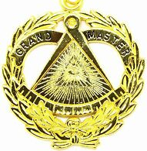



RESIDENCE
12906 60th Ave East
Puyallup, WA 98373
Phone: (253) 353-1787
Email: mwgm@mwphglwa.org
OFFICE
P.O. Box 68234
Seattle - WA 98168
Phone: (206) 323-8835
Email: mwphglwa@gmail.com

Office of the
Most Worshipful Grand Master
Antonio d graham

SUBJECT: Response to Correspondence Regarding Admission of Filipino Nationals Mabuhay Lodge No. 59

Greetings, Most Worshipful Raul E. Canon, Jr.

This office acknowledges receipt of your recent correspondence concerning the admission of Filipino nationals into the membership of Mabuhay Lodge No. 59 and the concerns raised regarding territorial jurisdiction and inter-Grand Lodge relations.
RW DDGM Flint transmitted the Mabuhay Lodge No. 59 roster on 25 February to the following email address: ogm@grandlodge.ph.

At the outset, we wish to reaffirm that this matter is not being taken lightly. The principles governing territorial jurisdiction, as well as the long-standing fraternal understandings between Grand Lodges, are of the utmost importance and are essential to maintaining harmony within the Craft.

As previously established in the directive issued in October 2011, this Grand Lodge clearly set forth its position on restricting petitioning by Local Nationals within the Republic of the Philippines, absent a formal agreement with the recognized Grand Lodge of that jurisdiction. That directive remains in force and will be complied with as official policy.

Furthermore, in alignment with the 17th Landmark of Freemasonry, which affirms the sovereignty and exclusive jurisdiction of a Grand Lodge within its territorial bounds, this office fully recognizes the necessity of respecting jurisdictional integrity and proper fraternal protocol.

Upon becoming aware of the present concerns, this office has issued a new edict to Mabuhay Lodge No. 59 to ensure full compliance. Additionally, a copy of the edict is enclosed. We respectfully assure your Grand Lodge that corrective measures are being undertaken and that this matter is being handled with the seriousness and diligence it warrants. It is our intention to ensure that harmony is preserved and that all actions moving forward reflect both the spirit and letter of our fraternal obligations.
We appreciate your communication and your commitment to upholding the principles that bind us together as Masons.

Please be assured that this office remains open to continued dialogue to ensure mutual understanding and strengthen fraternal relations. I look forward to congratulating you in person on a successful year at your Annual Communication.

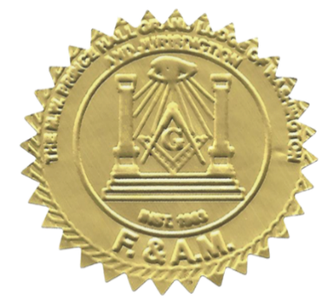
Given under my hand and the Seal of this Grand Lodge, this 26th day of March, A.D. 2026, A.L. 6026.
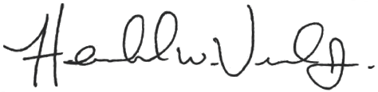
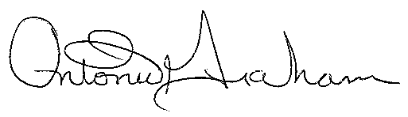
_
________________________
R.W. Hershel Veal, Jr.
Grand Secretary

_______________________
M.W. Antonio D. Graham
51st Grand Master of Masons

