Most Worshipful Prince Hall Grand Lodge, F. & A.M.
Washington and Jurisdiction
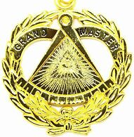



RESIDENCE
12906 60th Ave East
Puyallup, WA 98373
Phone: (253) 353-1787
Email: mwgm@mwphglwa.org
OFFICE
P.O. Box 68234
Seattle - WA 98168
Phone: (206) 323-8835
Email: mwphglwa@gmail.com

Office of the
Most Worshipful Grand Master
Antonio d graham

TO: All Mabuhay Lodge #59 Members

SUBJECT: Petition of Local Nationals – Republic of the Philippines

This correspondence serves as a reaffirmation and continuation of the directive originally issued in October 2011 regarding the petitioning of Local Nationals for membership in lodges operating within the Republic of the Philippines.
.
As previously established in the October 2011 letter, signed by MWPGM Gardner M. Torrence Sr., Mabuhay Lodge No. 59 mutually agreed with Grand Lodge of the Philippines (GLP) that membership within such lodges would be limited to the following: active-duty military personnel, their dependents, civilians employed by the military, and retired military personnel.
This policy remains in full force and effect and has not changed. Since 2011, Mabuhay Lodge has violated these principles not only in the memorandum but also in the 17th Landmark of Freemasonry, which affirms the Grand Lodge's sovereignty and exclusive jurisdiction over its territory.

Therefore, effective immediately and until further notice from this office and from this office only, you are hereby directed to refrain from petitioning or initiating Local Nationals of the Republic of the Philippines for membership. Additionally, any Local National that was initiated, passed, and raised in Mabuhay Lodge No. 59 is directed not to seek visitation or Masonic privileges within lodges under the jurisdiction of the GLP unless specifically approved by this Grand Lodge.

It is further directed that any inquiries or matters concerning the aforementioned shall be immediately forwarded to your District Deputy Grand Master.

This directive shall be communicated as official Grand Lodge correspondence, read in open lodge at your next three (3) consecutive stated meetings, and duly recorded in the minutes thereof.

Take due notice and govern yourselves accordingly.
Given under my hand and the Seal of this Grand Lodge, this 26th day of March, A.D. 2026, A.L. 6026.
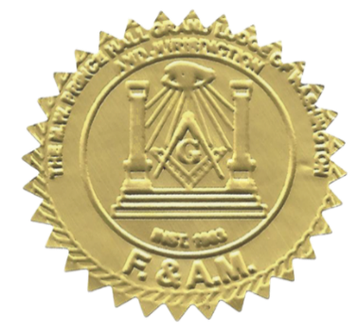
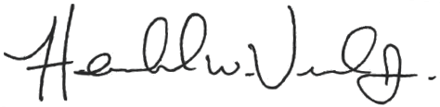
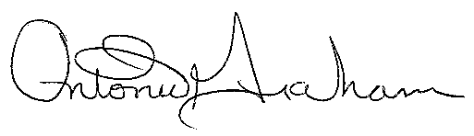
_
________________________
R.W. Hershel Veal, Jr.
Grand Secretary

_______________________
M.W. Antonio D. Graham
51st Grand Master of Masons

