|  |  |  |
| --- | --- | --- |
|  | DEPARTMENT OF THE ARMY  HEADQUARTERS, U.S. ARMY JUNIOR ROTC  NORTH PAUDLING HIGH SCHOOL  300 NORTH PAULDING DRIVE  DALLAS, GEORGIA 30132  770-443-9400 EXT. 42707  **“HONOR UNIT WITH DISTINCTION”** |  |

MEMORANDUM FOR SEE DISTRIBUTION 14 July 2023

SUBJECT: Memorandum of Instruction (MOI), North Paulding High School Raider Challenge, 16 September 2023

1. Purpose: This MOI prescribes the policies and procedures for the **North Paulding High School Raider Challenge / 1 of 3 Area 7 State Qualifiers** held at the North Paulding High School on 16 September 2023 in Dallas, GA.

2. Scope: The North Paulding Raider Challenge is designed to:

1. Provide a physically demanding competition.
2. Promote a competitive spirit among the participants.
3. Emphasize teamwork and cooperation to complete the events.
4. Develop respect and self-esteem among cadets.

3. Challenge events: There will be a total of five events with a ten-person team competing in each of the events.

1. **Team Run**: TBD due to construction, The uniform for the team run is OCP trousers, team/brown t-shirt, and running shoes or boots. (Annex A)
2. **Raider Fitness Challenge**: Consisting of a sprint, a Kettle Bell carry, a Log carry, a Water Jug carry, ammo can carry, Canoe carry, etc.…... (Annex B)
3. **One Rope Bridge**: Length of spans are 45 feet for female teams and 55 feet for male and mixed teams. Ropes must be a minimum of 120 feet. (Annex C)
4. **Cross Country Rescue**: A 0.5-mile marked course. Cadets will negotiate the course with a litter and 4 ruck sacks. (Annex D)
5. **Tire Flip**: Teams will flip a tractor tire a total of 100 yards. Course will be broken down into two 50-yard legs with 5 cadets in each leg. **Male/Mixed Tire 600 lbs, Female Tire 400 lbs** (Annex E).

# Participants:

# Participation will be limited to Area 7 schools and additional schools but not to exceed 50 teams. Schools can enter a maximum of three teams with no more than two like category teams entered in each category. Only one team per category will be eligible for awards. Forward registration form as soon as possible. (Annex F)

* 1. Each team will consist of 12 members but only 10 will be allowed to compete in any one event. Substitutions cannot be made during the event and competing cadets will only be allowed to compete in one category (Male, Mixed, or Female).
  2. **The coaches/judges meeting will begin at 0745 and the competition will begin at 0900. Schools will provide a roster for each team (Annex G) at the coaches meeting. The coaches will maintain a release from reliability form (Annex H) for each cadet for this event.**
  3. **Entrance fees are $100.00 for the first team, and $25.00 for each additional team.** Mail in advance is preferred method but payment on the day of the competition will be accepted.
  4. Please arrive prior to 0800 to in process and pay the registration fee. **Make checks payable to: North Paulding High School JROTC.**
  5. The uniform for all events is OCPs with boots (patrol cap and blouse can be removed) except for the team run in which running shoes can be worn.
  6. The team run will be the first event and all other events will be completed in group rotations.

# Grading Events:

# Guidon streamers will be awarded for First, Second, and Third Place in each event for each category. Guidon streamers will also be awarded to the overall winner in the male, mixed and female categories.

# Graders will be recruiting personnel from the Army, National Guard, Marine Corps, Air Force, Navy, and JROTC Instructors as well as senior ROTC cadets.

# No cursing is allowed. A one-minute penalty will be added to the team’s score for each occurrence during that event.

* + 1. Teams will be assigned groups and must stay with their respective group. Failure to do so could result in a DQ for the team at that event.
    2. Score sheets for the different events will be provided to teams at the coaches meeting.
    3. The awards ceremony will be conducted on the practice field or main gym at the completion of all events.

# Facilities: A map of the North Paulding campus shows the location of the events and facilities. (Annex I)

# Latrines are in the school. Water is available. Meals will be the team’s responsibility. There are no restaurants close to the school. Currently no concession stand will be available but subject to change.

1. **Bus parking will be in the bus loop. POVs will park in the parking lot in front of the school NOT along the road facing the competition field.**
2. The coaches meeting will be in the JROTC room located in the rear of the school; signs will be posted.
   1. POC for this MOI is MSG Monte D. Briggs Sr., 770-443-9400 ext. 42707 or email at mbriggs@paulding.k12.ga.us.

*//Original Signed//*

Monte D. Briggs Sr.

MSG, US Army (Ret)

DISTRIBUTION: 6th BDE JROTC Units

ANNEXES:

A. Team Run

B. Raider Fitness Challenge

C. One Rope Bridge

D. Cross Country Rescue

E. Tire Flip

F. Registration

G. Team Roster

H. Covenant Not to Sue

I. NPHS Campus Map

ANNEX A (TEAM RUN) To North Paulding High School Raider Challenge (MOI)

1. TASK:Each Team must complete a 1.5-mile run over a designated course along a paved road.

2. CONDITIONS: During daylight hours and under existing weather conditions, each 10-member Raider Team will negotiate a 1.5-mile course consisting of a paved road and various terrain in their prescribed Raider uniform (OCP trousers, team/brown t-shirt, boots or running shoes). Team members must stay together and be within 10 meters of each other during the final 10 meters of the course. Coaches, parents, chaperones, or other team members will not be allowed to run with the team. Coaches, parents, chaperones, or other team members are encouraged to cheer on the team from the sidelines if they do not impair or help the team or graders.

3. STANDARDS: Team scores will be based on total time it takes for the team to finish the course. All Raider Team members must cross the finish line within 10 meters (THAT WILL BE CLEARLY MARKED) of each other and the time will stop when the last member of the team crosses the finish line. If any Raider violates the 10-meter rule there will be a 30 second penalty for each Raider in violation. Raider team members cannot push, pull, hold, or carry their teammates at any time during the team run. No coach, cadet, team member, parent, chaperone, or cadre may run along or “pace” a Raider team. Any Raider team caught violating this rule will be **DISQUALIFIED**. If for any reason a Raider team member drops out of the Team Run the team will be assessed a 5-minute penalty per occurrence.

4. CONCEPT: Each Raider team will report to the Team Run ready area and will be briefed on the task, conditions, and standards for the course. The team will be given 3 minutes to get ready and to conduct any last-minute preparations. When told to report to the starting line, the Team will move forward, and a judge will give the command “Get Ready” and “Go”. Time will stop when ALL Raiders have crossed the finish line.

**NORTH PAULDING HIGH SCHOOL RAIDER CHALLENGE**

**TEAM RUN**

**SCORE SHEET**

**SCHOOL NAME: _____________________________**

**TEAM CAPTAIN: _____________________________**

**MALE TEAM FEMALE TEAM MIXED TEAM**

**10 Meter Rule # of Violations _____ x 30 seconds = _________**

**Drop Out # of Violations _____ x 5 minutes = _________**

**Profanity # of Violations _____ x 1 minute = _________**

**ROUTE TIME: _____________________**

**+**

**PENALTIES (TIME): ________________**

**=**

**TOTAL TIME: ___________________**

**INSTRUCTOR SIGNATURE: ____________________________**

ANNEX B (Raider Fitness Challenge) To 6th BDE JROTC Raider Challenge SOP, Raider Fitness Challenge

RAIDER FITNESS CHALLENGE

1. Task: Complete the Raider Fitness Challenge course which is designed to test strength, stamina, strategy, and endurance of the team of cadets over a course less than ½ mile in length using various obstacles.
2. Conditions: During daylight hours and under existing weather conditions, each member of the 10-member Raider Team will complete the Raider Fitness Challenge in the Raider Team uniform: Boots, OCP trousers, and school t-shirt with sleeves or OCP t-shirts. OCP tops may be worn depending on weather conditions.
3. Standards: The Team will be scored on the amount of time that it takes all 10 members to complete the course.
4. Concept:
5. A course will be set up IAW the diagram in this annex. The team will complete the course and time will be recorded. The grader will command “Get set…Go” which will start the clock. The course will consist of the following items:
6. Tire Dance
7. Barrel Maze
8. Equipment Carry 30 yards
9. Pick up Sandbags place in Canoe
10. Weighted Canoe carry 180lbs
11. Under wooden frame
12. Over the table
13. Sprint to the line and the other 5 raiders will repeat the course in reverse.
14. **Cadets will be given 1 minute to reset the equipment prior to starting**. There will be only five cadets on the course at a time. The other 5 cadets will complete the course in reverse so that all items will be returned to where you picked them up from the original start point. Once the 5 cadets complete the course in reverse, time will stop.

**NORTH PAULDING HIGH SCHOOL RAIDER CHALLENGE**

**Raider Fitness Challenge**

**SCORE SHEET**

**SCHOOL NAME: _____________________________**

**TEAM CAPTAIN: _____________________________**

**MALE TEAM FEMALE TEAM MIXED TEAM**

**Equipment touching the line # of Violations ___ x 10 Seconds =_______**

**Equipment not upright # of Violations____x 10 Seconds =_______**

**Skip a Tire # of Violations ___ x 10 Seconds =_____**

**Thrown or left equipment # of Violations ____x 30 Seconds =_______**

**Picked up Canoe w/4 or less # Violations___ x 30 Seconds =________**

**Hand/Foot didn’t touch table # Violations___ x 30 Seconds =______**

**Profanity # of Violations ___ x 1 Minute =_________**

**COURSE TIME: _____________________**

**+**

**PENALTIES (TIME): ________________**

**=**

**TOTAL TIME: ___________________**

**JUDGE’S SIGNATURE: ____________________________**

**TEAM CAPTAIN’S SIGNATURE: _______________________**

ANNEX C (ONE ROPE BRIDGE) To North Paulding High School Raider Challenge (MOI)

1. TASK: Construct a one-rope bridge spanning approximately fifty-five feet.

2. CONDITIONS:

a. Under existing weather conditions and in a field environment each Raider Team will cross an 50-foot obstacle (stream crossing) on a one-rope bridge spanning approximately 50 to 55 feet.

b. Teams will make only one timed crossing and will compete against the clock. Time will not stop during the conduct of the event unless Teams go over the 10-minute time limit. Penalties will be assessed for rule infractions and safety lapses. Total event time will be calculated from the crossing time plus any accessed penalty time.

c. Ten cadets will compete as a Team in this event. All Raiders must cross the obstacle on the rope with the exception of the first and last Raider.

d. A complete OCP uniform will be worn by all Team members. Caps may be carried in the cargo pocket prior to commencing construction of their one rope bridge. Uniform may be adjusted at the beginning of the meet depending on heat category.

e. Each Raider Team is responsible for providing their own equipment; 1-bridge rope 120feet long X 7/16inch diameter (static rope,), 8-10-Swiss seat ropes 14 feet or longer X 7/16inch diameter, 12-14-snap links, or 1-stick (implement) that replaces two snap links.

3. STANDARDS: **IAW the new TC 3-97.61 dated July 2012**

a. The Swiss seat must be secured with a **square knot** and with an **overhand knot** at each side of the square knot to prevent the knot from becoming untied with at least a four (4) inch pig tail on each knot. First and last Raider may wear sling ropes tied around their waist using an **Australian Seat**. Aussie seat rope is double wrapped around the waist and tied off with a square knot with overhand safeties with a minimum 4-inch pig tail on each side. An end of the line bowline w/overhand knot or figure 8 hooked into the far side Raider’s snap link is used to secure the far side Raider while crossing the stream.

The Swiss seat (rappel seat) will be tied IAW TC 3-97.61, Military Mountaineering, page 4-29.

**Note: On Step 5, the two ends may travel from bottom to top or top to bottom as long as a half hitch is created on both hips creating a bite.**

b. The only knots allowed for the far side anchor point will be two round turns around the anchor point secured by two half hitches on a bite, or a tensionless anchor knot (**see Pg.5-6)** with a minimum of 4 round turns around the anchor point secured by a snap link which must be secured to the rope bridge rope by an end of the line bowline w/overhand knot or figure 8 knot. The only knots allowed for the near side anchor point/tightening system will be: the wireman’s knot and /or the figure 8 on a bite knot **(Transport Tightening System Pg. 7-15 Fig 7-10)** as the tightening system knot; two round turns around the near side anchor point secured by two half hitches on a bight. The half hitches on a bight are not required to go over all ropes if it provides a safe knot extending toward the tightening system knot.

c. The two anchor knots, the wireman’s knot or figure 8 on a bite (either may be used to construct the one rope bridge) and the two half hitches on a bight will be visually inspected for safety prior to Raiders mounting the bridge rope. If improperly tied team is STOP and DQed.

d. After each Raider Team has been given five minutes to tie their Swiss Seats and to prepare their rope by either back laying the rope or coiling the rope. **THE SWISS SEATS AND AUSSIE KNOTS WILL BE CHECKED BY THE COACHES PRIOR TO BEGINNING THE ROPE BRIDGE.** **THE ROPE MUST BE FLAT ON THE GROUND WITH NO LOOPS OR TWISTS, or MARKINGS THAT MAY ASSIST WITH TYING THE KNOTS.**

e. When crossing, **only three Raiders** will be clipped onto the bridge rope with the Swiss seat at any one time. While crossing each **Raider is not required to have one leg/foot** in contact with and over the bridge rope. The bridge will not be disassembled until the last Raider has crossed and safely unclipped on the far-side.

4. CONCEPT: Upon arrival at the bridge site, the Team will enter the holding area with their bridging equipment and wait for further instructions from a guide or judge. Teams will receive a safety briefing and be given the Task, Conditions and Standards for the event. When a lane is clear, the Team will then move to the preparation area, be given a site orientation and begin the 5-minute cross preparations, for tying Swiss seats and to prepare your rope. “Time Start” begins the exercise/event. “Time Stop” ends the crossing/event, the Team then gathers their equipment, is given a short debrief and proceeds to the next event.

5. BRIDGING PREPARATION, CONSTRUCTION, CROSS, & DISASSEMBLY:

a. Preparation:

(1) The first and last Raiders can tie either an **Aussie Seat** (around-the-waist harness or a Swiss Seat. The Aussie seat rope is double wrapped around the waist and tied off with a square knot with overhand safeties with a minimum 4-inch pig tail on each side. The snap-link is then clipped around all coils of the harness. The remaining Raiders will tie Swiss seats with snap-links to aid in transporting themselves across the rope bridge. The snap-link is centered on the body and closed over all the rope parts with the gate facing up and away from the body. The seat must be snug.

(2) The 120-foot bridge rope is uncoiled and either stacked in a coil or is back laid on the ground.

b. Construction: The following steps can be conducted simultaneously but all steps must be completed.

(1). Step One: The Far-Side Raider ties an end of the line bowline w/overhand knot or figure 8 and snaps in before crossing into the stream (dead zone) and is belayed across the stream (no figure 8 across the body). Belaying involves a stationary Raider managing and controlling the bridge rope as the Raider crosses the obstacle. Too much “slack” is to be avoided in order to sense the movement of the crossing Raider and to ensure an immediate safety response.

(2) Step Two: When the Far-Side Raider reaches the far-side, he/she moves to the anchor point, detaches the snap-link from the harness, wraps the bridge rope around the anchor 180 degrees and “temporarily” secures it by closing the snap-link on the bridge rope.

(3) Step Three: On the near-side, approximately 3 Meters from the near-side anchor, a wireman’s knot or figure 8 slip knot on a bite is tied into the bridge rope, using a wooden, metal, plastic stick/implement or 2 snap links **(Mandatory),** to aid in the disassembly of the knots can be used (**Transport Tightening System Pg. 7-15 Fig. 7-10)** for securing the nearside. Inserting the stick/implement is accomplished by placing it into the upper wing above the butterfly of the knot (upper bight of the wireman’s knot). The stick/implement may not be used as a speed tightener. The fixed loop formed in the knot must naturally lie toward the near-side anchor. The fixed loop is placed into the two (2) snap-links with gates opposed Pg. 5-5. The remainder of the bridge rope is routed around the anchor point and through the snap-links.

(4) Step Four: When the bridge rope has been passed through and been secured by the one (1) locked or two (2) snap-links in the wireman’s knot or figure 8 on a bite, the far-side Raider now detaches the “temporary” snap-link and pulls the wireman’s knot or figure 8 on a bite out from the near-side anchor point approximately 5 to 6 feet and then secures the bridge rope to the anchor with two round turns and two (2) half hitches on a bight w/4” pig tail, or tensionless anchor knot ensuring the knot is at least waist high or higher.

(5) Step Five: The Raiders on the near side tighten the bridge rope with their pull team. The rope is tightened until the two (2) snap-links clear the dead zone area. The bridge rope should be tight enough to prevent crossing Raiders from contacting the stream. The transport tightening system is then secured to the anchor using a round turn and two (2) half hitches on a bight w/4” pig tail. The half hitches do not have to pass around all ropes between the anchor point and the wireman’s knot or figure 8 on a bite.

c. Crossing: The Raider will face the bridge rope with his/her left or right shoulder toward the far-side anchor and clip onto the bridge rope. The Raider will then rotate his/her body under the bridge rope and pull with their hands until across the obstacle. No more than three (3) Raiders will be on or clipped into the bridge rope at any one time. No part of the body or equipment may touch the obstacle (dead zone) when hooking up or getting off the rope bridge. **(Do not touch the boundary marker or any part of the obstacle).** Raiders are not required to have one leg or foot in contact with bridge rope if the cadet is clipped into the rope.

d. Disassembly:

(1) When the last Raider has crossed and unclipped from the bridge rope the far-side anchor may be untied while the Near Side Raider disassembles the transport system on the near-side. He/she can tie a bowline w/overhand in the end of the bridge rope or uses the existing Wireman’s or Figure 8 loop and secures the snap-link on his/her waist harness. The bowline may be tied during construction or crossing. The Near Side Raider is then belayed across the obstacle by Raiders on the far-side.

(2) Once the Near Side Raider is across, all knots (the wireman’s knot or figure 8 on a bite and bowline knot) will be removed from the bridge rope. When the Team leader is certain that all knots are out of the rope, equipment, Raiders are accounted for and the obstacle has been cleared he/she will call “TIME”. No individual equipment needs to be removed nor do any Swiss seats/around-the-waist harnesses untied and removed.

6. SCORING: The score earned by the Team will be the total time based on the time for the crossing plus any penalty time. The fastest time is first etc. (See Score Sheet B-7)

7. PENALTIES: 30 second penalties will be assessed for the following rule violations, except as otherwise noted.

a. Equipment/Preparation/Inspection Penalties:

(1) The Raider Team not having as a minimum 1 - 120-foot-long X 7/16-inch diameter static bridge rope, 10- Swiss seat ropes 12 to 15 feet long X 7/16-inch diameter, 14 – snap-links if not using a stick, or 1 – stick/implement and 12 snap links (1 stick takes the place of two snap links to aid in the disassembly of the knots).

(2) Failure to properly coil or back lay the bridge rope.

(3) Far Side and Near Side Raider fails to tie an around-the-waist harness (Aussie Seat) secured with a square knot w/overhand and snap-links with the gate up and away from the body and attached to all coils if not using a Swiss Seat.

b. Construction Penalties:

(1) Far Side Raider fails to secure the bridge rope to his/her waist harness with a figure 8 or bowline knot w/overhand and snap-link. The use of an improper belay.

(2) The Far Side improperly belayed across the stream. There should be little “slack” in the bridge rope.

(3) Far Side Raider fails to “temporarily” secure the bridge rope with a 180 degree

turn around on the far-side anchor and reattach the snap-link from his/her waist harness to the bridge rope before calling secure.

(4) Failure to tie the wireman’s knot or figure 8 on a bite the Team must retie for safety– safety stop, time continues to run. The wireman’s knot must naturally lie toward the near-side anchor and both ends should exit opposite each other without any bends, the loop formed in the wireman’s and figure eight on a bite knot must not be less then twelve (12) inches in length, and the gates on the snap-links must be opposed and form a X when checked.

(5) Failure to secure the bridge system on the far-side or near-side with two round turns with two (2) half hitches on a bight– DQ.

c. Crossing Penalties:

(1) Not mounting (clipping into) the bridge rope with the shoulder facing the far-

side anchor, and then rotating under the bridge rope to cross or mounting before all bridge knots are secure.

(2) More than three (3) Raiders on the bridge rope or clipped into the bridge rope at any one time. Disqualification.

(3) Each Raider who enters and touches the obstacle with his/her body this includes members on the far and near-side attempting to assist Raiders who are crossing. Any equipment that the Raider loses in the obstacle while crossing or mounting and dismounting of the bridge will result in 30 second penalty per occurrence.

(4) Parts of the uniform/equipment dropped into the obstacle on the cross.

(5) Less than eight (8) Raiders crossing on the rope bridge disqualification.

d. Disassembly Penalties:

(1) Near Side Raider fails to secure the bridge rope to his/her waist harness with a figure 8 or bowline knot w/overhand, or transport knot and snap-link. The use of an improper belay.

(2) All knots do not remove from the rope 1-minute penalty.

e. Other:

(1) Safety issues – clock runs while corrected.

(2) Sportsmanship – profanity, abusive or unethical conduct – 630 second penalty and possibly disqualification.

**ROPE BRIDGE NORTH PAULDING HIGH SCHOOL RAIDER CHALLENGE**

**SCHOOL: ________________________________________ MALE / FEMALE / MIXED**

(CIRCLE ONE)

**TEAM CAPTAIN:** ___________________________________________

|  |  |  |  |  |  |  |
| --- | --- | --- | --- | --- | --- | --- |
| **ROPE BRIDGE SCORE SHEET** | | | | **Time Per Penalty** | **# of**  **Penalties** | **Total** |
| **DISQUALIFICATION PENALTIES** | | | | | | |
| Less than 10 cadets or less than 4 females on mixed team | | | | **DQ** |  |  |
| Walking/running across obstacle vs crossing on rope | | | | **DQ** |  |  |
| Rope bridge failure | | | | **DQ** |  |  |
| Use of speed tightener (twisting dowel, etc.) | | | | **DQ** |  |  |
| Use of markings on rope to assist with tying knots | | | | **DQ** |  |  |
| **SET-UP PENALTIES** | | | | | | |
| Rope improperly laid out. (coiled, back coiled or laid in a “S” shape is OK) | | | | **30 SEC** |  |  |
| Only 9 competitors | | | | **30 SEC** |  |  |
| Rope min. 120’ x 7/16”, 10 Swiss seats 14’ x 7/16”, enough snap links | | | | **30 SEC** |  |  |
| **CONSTRUCTION PENALTIES** | | | |  | | |  |  |
| Far Side - Improper Bowline w/safety or Figure 8 knot used | | | | **30 SEC** |  |  |
| Far Side - Raider not clipped in with snap link prior to entering dead zone | | | | **30 SEC** |  |  |
| Far Side - Raider not belayed properly across the dead zone | | | | **30 SEC** |  |  |
| Far Side - Raider failed to temporarily snap in until near side “secure” **(not required if far side ties knot immediately)** | | | | **30 SEC** |  |  |
| **Far Side - Incorrect anchor knot (round turn w/2 half hitches or tensionless anchor w/4 wraps)** | | | | **STOP and FIX** |  |  |
| **Near Side - Improper Transport Knot: wireman’s knot or figure 8 knot with a bite** | | | | **STOP and FIX** |  |  |
| Near Side - Single steel locking snap link not locked with gate closed | | | | **30 SEC** |  |  |
| Near Side - Two snap links are not opposed with gates forming an “X” when depressed | | | | **30 SEC** |  |  |
| Near Side – Single steel locking snap link is positioned incorrectly (hinged portion of gate away from the near side anchor point when secured to transport knot loop) | | | | **30 SEC** |  |  |
| Near Side - not secured w/round turn, 2 half hitches with or without quick release | | | | **30 SEC** |  |  |
| **CROSSING PENALTIES** | | | | | | |
| Near Side - Mounting (clipping into) the rope bridge or mounting before all knots are secure | | | | **30 SEC** |  |  |
| Less than 8 Raiders crossing on the rope bridge | | | | **5 MIN** |  |  |
| Dead zone violation (touching obstacle during loading/unloading, equipment loss) ( 1 2 3 4 5 6 7 8 9 10 ) | | | | **30 SEC** |  |  |
| More than three (3) Raiders clipped into the bridge rope at any one time | | | | **30 SEC** |  |  |
| **DECONSTRUCTION PENALTIES** | | | | | | |
| Breaking Down rope bridge before last cadet is off rope | | | | **30 SEC** |  |  |
| Near Side Raider not clipped in with snap link prior to entering dead zone | | | | **30 SEC** |  |  |
| Near Side Raider not belayed properly across the obstacle | | | | **30 SEC** |  |  |
| Rope or any item left in the dead zone after time is called | | | | **30 SEC** |  |  |
| Knots/snap links left in the Rope after “TIME” is called | | | | **30 SEC** |  |  |
| **SPORTSMANSHIP PENALTIES (profanity, disrespecting judge, etc.)** | | | | **1 MIN** |  |  |
| **Judge’s Signature**: _____________________________________________  **Team Captain’s Signature: ______________________________________**  COMMENT(S) on Reverse side | | | |  |  |  |
|  |  |  |  | **RAW TIME** | |  |
|  |  |  |  | **PENALTIES** | |  |
|  |  |  |  | **TOTAL TIME** | |  |

ANNEX D (CROSS COUNTRY RESCUE) To North Paulding High School Raider Challenge (MOI)

1. TASK: Each 10-member team is given instructions to rescue a casualty. An approximately .5-mile steep, cross-country route will be used. The objective is to complete the course in the shortest time with all personnel and equipment.

2. CONDITIONS: The uniform for the Cross-Country Rescue is OCP trousers, team/brown t-shirt, and boots.

Each Raider Team will be given a weighted litter and 4 rucksacks. All team members, along with the weighted litter and ruck sacks must negotiate the obstacles and finish the course together.

3. STANDARDS: Upon the command “GO”, each team will transport the simulated casualty and the rucksacks to their destination in the shortest possible time. Upon reaching an obstacle, all team members and equipment must navigate the obstacle. Failure to complete any obstacle will result in a 1-minute penalty. The penalty will be added to the total time. All equipment and team members must complete the course before time stops. Equipment will not be dragged or thrown. The rucksacks will not be carried on or attached to the litter in any manner. Once a team member or any equipment has crossed the finish line they cannot go back to aid their team. Raiders may however place their equipment by the finish line without penalty before crossing it and return to help their team. If all Raiders cross the finish line without all of their equipment they will be DISQUALIFIED.

**NORTH PAULDING HIGH SCHOOL RAIDER CHALLENGE**

**CROSS-COUNTRY RESCUE**

**SCORE SHEET**

**SCHOOL NAME: _____________________________**

**TEAM CAPTAIN: _____________________________**

**MALE TEAM FEMALE TEAM MIXED TEAM**

**Equipment Dropped # of Violations _____ x 30 seconds = _________**

**Drop Out # of Violations _____ x 5 minutes = _________**

**Profanity # of Violations _____ x 1 minute = _________**

**Failed to complete course with all equipment = DQ**

**COURSE TIME: _____________________**

**+**

**PENALTIES (TIME): ________________**

**=**

**TOTAL TIME: ___________________**

**JUDGE’S SIGNATURE: ____________________________**

**TEAM CAPTAIN’S SIGNATURE: ____________________**

ANNEX E (TIRE FLIP) To North Paulding High School Raider Challenge (MOI)

1. TASK: Each 10-member team will flip a large tire **(Male/Mixed teams 600 lbs, Female teams 400 lbs)** a distance of 50 yards, cross a mid-point line, and flip the same tire back to the start/finish line. The team will be broken down into 2 groups of 5 each. Time begins at the command of “GO” and stops when the whole tire is completely across the start/finish line and is flat on the ground.is given instructions to rescue a casualty. An approximately .5-mile steep, cross-country route will be used. The objective is to complete the course in the shortest time with all personnel and equipment.

2. CONDITIONS: The uniform for this event is OCP trousers, team/brown t-shirt, and boots. Gloves are recommended but not required. This event will take place on a practice football field in marked lanes 50 yards long by 20 yards wide. (See diagram)

3. STANDARDS: The first group of 5 moves forward from a near side ready line then flips the tire 50 yards out past the mid-point line. The second 5 will move forward from the far side ready line and flips the tire back past the finish line. Members of either group are not allowed to lead or follow the group doing the flipping. The tire cannot twist or roll while being flipped. The tire must always remain within the lane. If any portion comes into contact with the boundary line the team has committed a lane violation.

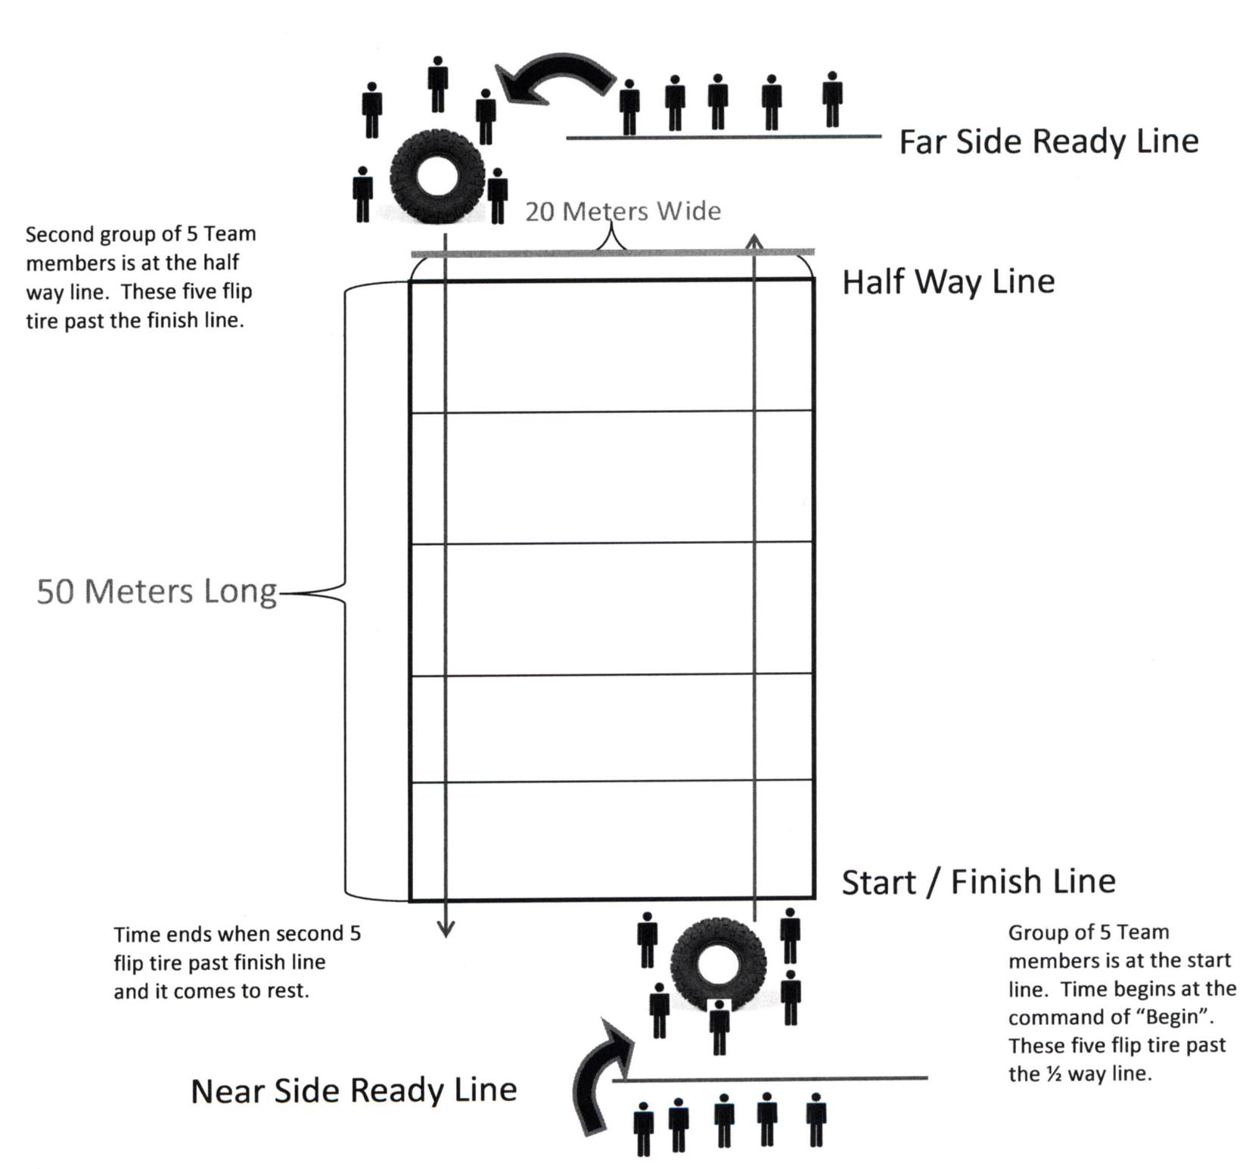

Yards

Yardss

**NORTH PAULDING HIGH SCHOOL RAIDER CHALLENGE**

**TIRE FLIP**

**SCORE SHEET**

**SCHOOL NAME: _____________________________**

**TEAM CAPTAIN: _____________________________**

**MALE TEAM FEMALE TEAM MIXED TEAM**

**Tire rolls to cover ground # of Violations _____x 30 seconds = _____**

**Move before tire rests # of Violations _____x 30 seconds = _____**

**Lane boundary # of Violations _____x 30 seconds = ____**

**Profanity # of Violations _____x 1 minute = _____**

**Cadets in front of tire # of Violations _____x 1 minute =______**

**COURSE TIME: _____________________**

**+**

**PENALTIES (TIME): ________________**

**=**

**TOTAL TIME: ___________________**

**JUDGE’S SIGNATURE: ____________________________**

**TEAM CAPTAIN’S SIGNATURE: _____________________**

ANNEX F (REGISTRATION FORM) To North Paulding High School Raider Challenge (MOI)

**REGISTRATION FORM**

From (School) _______________________________ Receipts provided the day of the event

School POC (Please Print) _______________________________________

Contact Number: ______________________________________________

SCHOOL ADDRESS: _________________________________________

_________________________________________

_________________________________________

Total Number of Teams: _____________ (Three team limit – No more than two team per category)

Name of Teams: Team 1: Male ____ Female ____ Mixed ____ ($75.00)

Team 2: Male ____ Female ____ Mixed ____ ($100.00)

Team 3: Male ____ Female ____ Mixed ____ ($125.00)

Amount Enclosed: ________ (Make checks payable to: North Paulding High School JROTC)

Signature of POC: _____________________________________

**\*\*\*\* NO REFUNDS AFTER 15 SEPTEMBER 2023. \*\*\*\***

Mail to: North Paulding High School

Attn: MSG Briggs, JROTC Department

300 North Paulding Drive

Dallas, GA 30132

ANNEX G (TEAM ROSTER) To North Paulding High School Raider Challenge (MOI)

**TEAM(S) ROSTER**

Name of school:_______________________________________

|  |  |  |
| --- | --- | --- |
| **MALE MIXED FEMALE** | **MALE MIXED FEMALE** | **MALE MIXED FEMALE** |
| **1.** | **1.** | **1.** |
| **2.** | **2.** | **2.** |
| **3.** | **3.** | **3.** |
| **4.** | **4.** | **4.** |
| **5.** | **5.** | **5.** |
| **6.** | **6.** | **6.** |
| **7.** | **7.** | **7.** |
| **8.** | **8.** | **8.** |
| **9.** | **9.** | **9.** |
| **10.** | **10.** | **10.** |
| **11.** | **11.** | **11.** |
| **12.** | **12.** | **12.** |

SIGNED:__________________________________

(Raider Team Coach)

ANNEX H (COVENANT NOT TO SUE) To North Paulding High School Raider Challenge (MOI)

SUBJECT: North Paulding High School Raider Challenge – **COVENANT NOT TO SUE.** **These forms will be** **collected and held by the cadre from each school.** OFF-CAMPUS TRAINING AND PRACTICAL FIELD/HIGH –RISK TRAINING AUTHORITY: Title 10, M.S. Code 2301. 2. PRINCIPLE PURPOSE(S): To release The U.S. Government, the host institution, The Unified Government of Paulding County Georgia and the state in which said institution is located from liability for injury, death, or damages while participating in voluntary off-campus training programs, practical field trips/exercises, drill meets, raider competition, and high risk training. 3. ROUTINE USES: Normal personnel actions. Disclosures of information may be provided to proper authorities in actions regarding law enforcement, legal actions as a result in injury or death, and investigations of accidents resulting from such voluntary off-campus training, practical field trips/exercises, drill meets, raider competition, and high-risk training. 4. MANDATORY OR VOLUNTARY DISCLOSURE AND EFFECT OF NOT PROVIDING INFORMATION: Voluntary. FAILURE TO COMPLETE FORM WILL DISQUALIFY STUDENT FROM PARTICIPATING IN SPECIFIC VOLUNTARY TRAINING EXERCISES.

I, _______________________________, residing at _________________________ (TYPE OR PRINT NAME OF STUDENT) (ADDRESS) _________________________________________ AGE OF STUDENT: ________ PERIOD COVERED: ________16 September 2023_________________ Do hereby agree that in consideration for being allowed to participate in the North Paulding High School (NPHS) Raider Challenge Competition to be conducted at NPHS, a supervised activity, and whereas I am doing so entirely on my own initiative, risk and responsibility: and being fully aware of the risk adhering to this type of training, hereby RELEASE AND DISCHARGE FOREVER, the United States Army, NPHS, Paulding County School district, Georgia, and all its officers, agents, and employees, acting agents and otherwise, from any other claims, demands, actions, or causes of actions, on account of myself or on account of any injury to me which may occur from any cause during activity or continuances thereof, and I do further covenant and agree to hold the said Government of the United States, Paulding County Government, Georgia, NPHS and the State of Georgia blameless for any and all damages which I may cause either intentionally or through my negligence.

_________________________________ ___________________________________

**Type/Print Name of Parent/Guardian, Signature** of Parent/Guardian,

(If student is under 18) (If student is under 18)

__________________________ ___________________________________

**Relationship to Student** **Date**

_____________________________ ___________________________

**(Witness) Form 145 14-R, May 93** **Signature of Student**

ANNEX I (NPHS MAP) To North Paulding High School Raider Challenge (MOI)



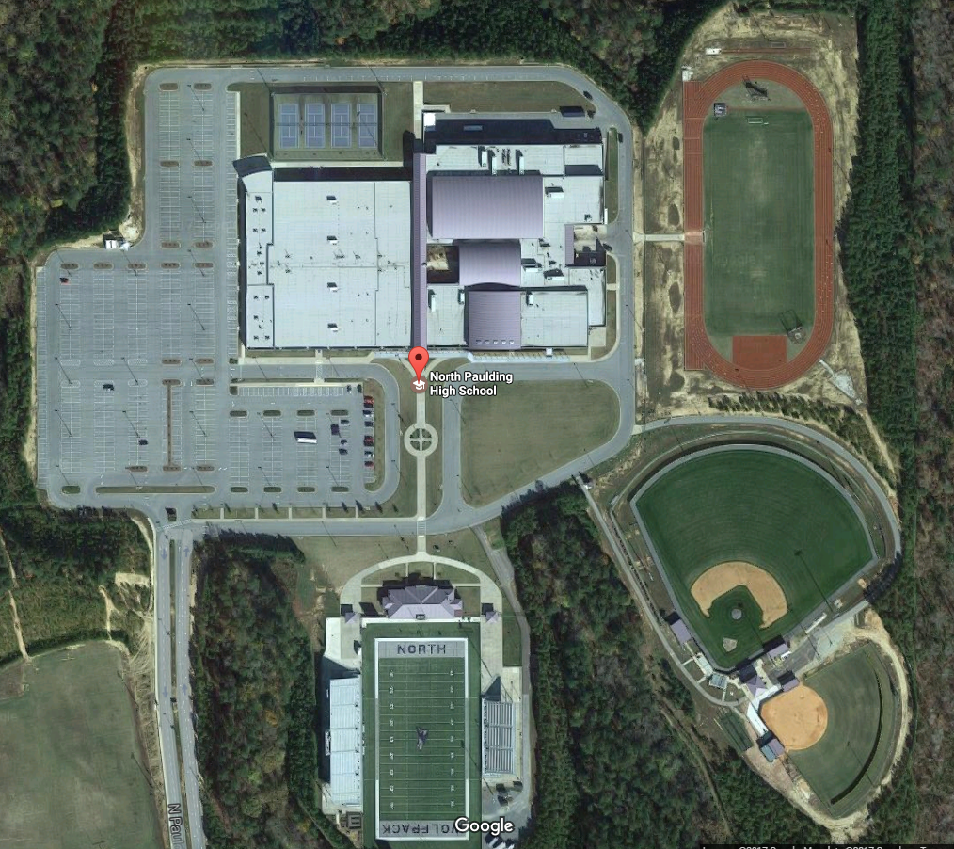

**2**

**5**

**Latrine**

**Latrine**



**4**

1. Team Run-TBD

2. Raider Fitness Challenge

3. Rope Bridge

4. CCR

5. Tire Flip

6. Bus Parking

7. Parent/Cadet Parking

**6**

**7**

**Latrine**

**JROTC**

**1**

**3**

