2026 Perry Raider Rampage Competition

MOI

SUBJECT: Rules and Regulations for the event.

GENERAL INFORMATION:
- This Competition will be hosted the Saturday 29 August 2026 at Perry High School, Georgia. This event will be limited to 25 teams.

- Entry Fees: $125.00 per school plus $25.00 per additional team. Mail in advance is the preferred method but payment on the day of the event will be accepted by checks or cash. Checks need to be made out to: Perry High School AFJROTC. Registration form is attached in this M.O.I. Mail Checks to Perry High School AFJROTC: Attn: SMSgt Jason Hemphill. 1307 North Avenue, Perry Ga 31069

- The coach’s meeting will take place @ 0830 under the covered pavilion located on the raider field. 1 Cadet from each team will be allowed in this meeting. The competition will begin at 0900. The awards ceremony will be held on the football field shortly after the conclusion of the competition.

- Trophies will be awarded to the top 3 teams in each category.

- Latrines are located at the raider field behind the softball field concessions stands and behind the male baseball field. Also @ the football field in the new Gym. As well as in the old gym lobby. A Detailed map will be given to as many people as possible to help find the locations.

- Locations for teams to set up their Tailgating “Base Camp” are identified on the enclosed maps. The team Set up areas will be in the open space AROUND the Baseball Field, and softball field. Please note your trailers will need to drop off equipment and park elsewhere, with construction on campus, we have lost some parking spaces.

- In the event of rain, all events will continue as planned. In the event of severe weather (Lightning in the area), the holding area is the new school gym of the lightning has departed. A weather call will be made by noon the day prior to the event. If the event needs to be postponed/cancelled due to weather, there will be no plans this semester to reschedule.

- Please Park all cars in the parking area outlined on the map and around the new gym, old gym and any other open lots on campus. Buses and cars will be provided a MAP prior to arrival and upon arrival if needed. They will need to park on the opposite side of campus, and we will have golf carts assisting to shuttle people around campus. This is outlined on the attached map. Equipment vehicles can park in the designated area also outlined on map. Please look for cadet guides/signs when you arrive.

- Instructors please bring a stopwatch/cellphone for backup timing of events.

- Participating Cadets will wear wrist bands provided in the team packets

SPECIFIC INSTRUCTIONS:

- All coaches will receive a packet at the coaches meeting with the sequence of events, wrist bands for each team member.

- All Teams are required to bring their own gloves if they deem gloves necessary.

- Male teams will consist of a maximum of 12 raiders with ten raiders competing on each event. Female teams will consist of 12 raiders with 10 (TEN) raiders competing on each event (depending on feedback we may reduce the female teams to 8 competitors), and can include only females. Mixed teams will consist of a maximum of 12 raiders and must have at least four females competing on each event. Male teams may include males or females. Coaches may substitute cadets using only cadets that have not competed on another team. Once out/substituted, that individual cadet is no longer eligible to compete for the duration of the event, even if they begin feeling better. If any team drops below the required number of cadets, the team may continue, but without eligibility for awards on those events. Likewise, if a school must “cross-level”, they lose eligibility for awards. If a team skips any stations/events, they must remain in assigned sequence order. Teams will be assigned to a starting location and a rotation sequence and complete each event within the time limit or risk disqualification. Teams delayed will be skipped and not allowed to participate in a missed event unless time allows and coordinated by PHS SASI/ASI. The PHS SASI/ASI will make final decisions.

- Competing cadets will be allowed to compete on one team only; meaning a cadet on the male team cannot be a substitute for a cadet on the mixed team.

- Teams are not authorized to “float” from event to event. Groups will rotate to the next event once all events have reported they have completed that iteration. Teams who report to an event prior to their group’s designated start time will be instructed to wait for their designated rotation with their assigned group. Simply put, don’t let your team get ahead and don’t let your team be late when we rotate. Schools with multiple teams need to run their fastest teams first.

- Only the Raider team members will be allowed to be on the courses. Coaches, parents, or spectators must observe the events from the spectator’s area or a safe distance without interfering with competitors. Coaches and parents are not allowed to coach teams once the event has started. Any coaching during the event will result in that team being disqualified from that event.

- Judges will briefly brief groups/rotations before each event. Penalties will be clearly defined. After each event, the team commander will go to the judge for the time and notification of any penalties assessed. Do not argue with the Judge. Address all concerns with the PHS ASI/SASI.

- If a team member is injured during the course of an event and cannot finish, the team will be disqualified from only that event. The team must leave one member with the injured Cadet and continue along the course and inform the judge of the injured Cadet. The event judge will notify the Event Organizer for medical assistance.
- If a team or school decides not to compete in any event, please inform the Judge on the event so there can be a score sheet completed. All teams must complete a score sheet even if they do not compete on an event. Simply write Did Not Compete on the score sheet. This will prevent searching for missing scores after the event is over.

- Unsportsmanlike conduct, such as profanity, will be subject to a 1-minute penalty each time a member of a team does not conduct themselves as a JROTC Cadet. Profanity in this case is defined as any obscene language that would be inappropriate for a classroom setting. Judges may disqualify a team for unsportsmanlike conduct, to include actions of Team coaches and parents. Coaches, please ensure your parents know that sportsmanship and professionalism reside with them also. If incidents occur, they will be instructed to depart the school property or be escorted out by law enforcement.

- Coaches, please instruct your Cadets about taking care of the equipment. Do not drop any equipment before, during, or after each event. Dropping equipment before, during, or after an event can result in a penalty. This is to help preserve the equipment. Dropping of equipment is defined as uncontrolled contact with the ground from above the top of the Cadet’s boots.

- Team Commanders will sign all score cards. Once the score card is signed, no protest may be submitted. Judges will inform Team Commanders if there is a penalty and adjudicate it on site. If it cannot be decided within a 2-minutes, find PHS ASI/SASI to resolve the issue. Do not delay other teams.

COMPETITION EVENTS:

The Raider Competition will consist of Five events that are designed with minimal chance for penalty. Raider Team will rotate to each event together.

Team Run-On Track: Team members will run as a group. All 10 Cadets will begin at the same time and run 5 laps on the track. Other teams in the rotation will line up in a single file line in the outside lanes. Once the team running completes their 4th lap the next team will move into the inside lap and begin their race. Time will complete when the final cadet crosses the finish line. If a School has multiple teams their fastest teams must run first and 2nd fastest run second. And so on down the line. Male and Mixed teams will carry a 30 pound medicine ball. Female teams will carry three 8.0lb medicine balls. The ball can be switched to different teammates during the run. The ball must start and finish with the team.

-Uniform will be Team-shirt or appropriate Uniform T-shirt, ACU/OCP boots or Tennis shoes and ACU/OCP trousers. All team members must be in the same shirt.

- Raider Fitness Challenge-On Football Field: This is a timed event consisting of multiple challenges on the course. 5 Team members will negotiate 5 challenges through the course and the 2nd set of 5 cadets will repeat the course backwards, resetting equipment.
Beginning with 6 Jerry Cans & wooden box (about 35 lbs.) they are to be moved approximately 50 yards and set into a clearly marked area. All equipment must be set down gently and in an upright position. There are no penalties for equipment that falls over, as long as it is set in an upright position prior to leaving the lay down area.. Then carrying several telephone poles segments a distance of approx.. 50 yards and setting into another clearly marked area. Team members will then proceed around a cone to the Tire Stacking challenge. There will be two stacks of 5 tires in a clearly marked area. Each tire will need to be moved as quickly as possible to another clearly marked box and stacked as they were in the first box, in 2 stacks of 5. The tire boxes will be approximately 25 yards apart. Next will be two sleds each with a rope. One team member will sit in each sled and be pulled approximately 50 yards. Teammates can change out sled pullers if needed but may not allow the sled to be pulled forward without a cadet being seated in it. Cadets are not allowed to fall out of the sled, so please be sure they are seated prior to pulling. Finally, there will be two tires weighing approximately between 125 and 175LBS for all teams to be flipped 25 yards. Once complete, the first 5 members will finish by tagging the next 5 cadets to complete the course in reverse order resetting all equipment to its original placement.
Each team will be given instructions on how to negotiate the course. The time will stop when the last cadet crosses the finish line.

-Uniform will be Team-shirt or appropriate Uniform T-shirt, ACU/OCP boots and ACU/OCP trousers. All team members must be in the same shirt.

- One-Rope Bridge-- At the rope bridge site each team is responsible for providing a rope and associated equipment for their use. Each team will report to the site area ready for team to sign in. Teams will put on their Swiss Seats in the ready area. When the team is called forward to the start line they will be told that they have 13 minutes total to prepare and conduct a one-rope bridge. The 13 minutes includes prep time and execution time (13 min. max.). Ropes may be bagged or coiled. Not laid out in a large zig\zag pattern Back laying the rope is not allowed. Rope bridge time will start when the cadets say “GO” or touches the rope. No extra time allowed. Knots tied and bridge construction must be safe and IAW brigade standards. After all raiders are across, all knots are cleared of the rope and the team has gathered all equipment, the time will stop. Any team that has not completed the event inside the 13 minutes will be disqualified. Loss of equipment or using feet to propel any member on the rope will incur scoring penalties. Dangerous or unsafe acts will cause a DQ. The distance is 60 Feet for all teams.

Uniform will be Team-shirt or appropriate Uniform T-shirt, ACU/OCP Boots, and ACU/OCP trousers. All team members must be in the same shirt.

- Obstacle Course: https://www.youtube.com/watch?v=oAs9uCirqfU

Obstacles are: (Photos attached to MOI)

NOTE: A 4’ wall will be the first and last obstacle to traverse. At the starting line and before the finish line.

      - High Stepper: Each cadet will negotiate their way over each cross bar from start to finish. Cadet’s feet must touch the ground between each bar.

      - 5 foot ball to balance beam: Each cadet will traverse the 5 foot wall directly onto the balance beam. Then cross the beam onto a 2nd beam which is the start of the monkey bars.

      - Monkey Bars: Each cadet will use the balance beam to engage and negotiate the Monkey Bars ensuring both hands touch the first and last bar. Cadets can be assisted across the bars by a teammate. The teammate MUST first complete the event then return to assist. The person assisted must meet the same rules of two hands on first and last bar.

      - Balance Beam: Each Cadet will negotiate the balance beam from beginning to end. If a cadet falls off, they must get back on from any point before the fall and continue. There are trees which can be touched. No penalty for falling.

      - Low Crawl: Each Cadet will negotiate the low crawl from one end to another. The low Crawl has a 4-foot wall to travers prior to entering the low crawl and another 4-foot wall half way through. Both walls must be negotiated by going over.

      - 8-foot Wall: Each cadet will negotiate their way over the wall.

      - Suspended Inclined Tunnel Crawl: Each Cadet will negotiate through the tube from one end to the other.

      - Tire Dive: There are two tires, each cadet must go through either tire without grabbing the cables. (Safety)

      - Rope Swing: Each cadet must utilize a rope to swing over the small water filled pond. No penalty for falling in. If a cadet FALLS IN, they are free to exit the pond the same place cadets who swing over the pond exit. No crossing over the sand bags to exit the swing.

      - Low Crawl through 24” Tunnel: Each cadet will negotiate a low craw from one end to the other of the crawl.

      - “A FRAME” Cargo Net Climb: All ten members of the team must traverse over the cargo net. Only 2 cadets can be on either side of the net at one time.

      - Mario Pipes: Each Cadet will climb to the top of the Drainage tubes where there are two holes to drop into. One is approximately 5 feet deep and the other is approximately 4 feet deep. Once down you simply crawl out one of the two ends. Which end chosen to crawl out is optional.

      - 11 Foot Wall: Each cadet will climb over the wall. All female teams are allowed to use a rope on the right side of the wall. Male and Mixed Teams are not allowed to use the rope. Once over the wall there is a landing deck approximately 3 feet below the top of the wall. Exit the landing deck VIA the angled ladder/steps. There is a one minute penalty for each cadet that cannot climb over the wall.

      - Rolling Log: Each cadet will maneuver over a rolling Log which is about 50 inches above the ground.

      - Obstacle Course is growing, we are working on it regularly, if any more obstacles are constructed notifications will be sent.

-Uniform will be Team-shirt or appropriate Uniform T-shirt, ACU/OCP Boots, and ACU/OCP trousers. All team members must be in the same shirt

- Sandbag Relay- This 10-Raider activity has the Raider team breaking up into two groups of five. Raiders 1 through 5 will move ten, 25-pound sandbags (six for female cadets) from Circles A through F. Raiders 6 through 10 reset the course. Time stops when all sandbags are returned to Circle A. To start, Raider 1 will grab up to two sandbags from Circle A, carry them around a cone 25-yards away, and then run the bags to Circle B where they will be set (not dropped or thrown!) down. Raider 1 will then return to Circle A in the most direct manner possible to repeat this process until all ten sandbags have been moved to Circle B. Raider 2 will carry any available bags from Circle B to Circle C by carrying them around a cone 25-yards away. As soon as Raider 3 has any bags to carry in Circle C, Raider 4 will carry those bags around a cone 25-yards away and place them in Circle D. This process will continue until all ten sandbags have been moved by Raider 5 from Circle E to Circle F. At this point, Raiders 6 through 10 repeat the process in reverse Circle order until all sandbags have been returned to Circle A. For mixed teams, females will be Raiders 4 through 7. Raider 4 will only take six of the ten sandbags brought to Circle D, leaving the other four, and move them to Circle E where female Raider 5 will take the bags around the cone to Circle F. Female Raider 6 will take the six sandbags from Circle F around the cone to Circle E where female Raider 7 will take the six sandbags from Circle E around the cone to Circle D. At that point, Raider 8 needs to move all ten sandbags around the cone to Circle C and so on. Three notes worth mentioning here. First, every Raider will only carry the appropriate number of sandbags (ten or six). In other words, no Raider can do the course twice so a weaker Raider does not get a turn. Second, if a mixed team uses more than four females for this event, only female Raiders 4 through 7 carry six bags. In other words, any addition female will be required to carry all ten. Last, also for mixed teams, because female Raiders 4 through 7 are carrying six bags, this means that there are four bags waiting in Circle D as mentioned above. Raider 8 cannot begin moving those bags early in an effort to get a head start on getting those bags moved from Circle D to Circle C. Raider 8 can only begin carrying bags when female Raider 7 sets the first two bags from Circle E to Circle D.

-Uniform will be Team-shirt or appropriate Uniform T-shirt, ACU/OCP Boots, and ACU/OCP trousers. All team members must be in the same shirt.

NOTE: In the event of a TIE, the tiebreaker will be PULL UPS Each team will provide two members off the team and their combined pull ups will decide. Same for mixed teams.

ANNEX A – COVENANT NOT TO SUE

These forms will be collected and held by the instructors/cadre from each school.
OFF-CAMPUS TRAINING AND PRACTICAL FIELD/HIGH –RISK TRAINING

- AUTHORITY: Title 10, M.S. Code 2301. 2. PRINCIPLE PURPOSE(S): To release The U.S. Government, the host institution, The Unified Government of Houston County Georgia and the state in which said institution is located from liability for injury, death, or damages while participating in voluntary off-campus training programs, practical field trips/exercises, drill meets, raider competition, and high risk training. 3. ROUTINE USES: Normal personnel actions. Disclosures of information may be provided to proper authorities in actions regarding law enforcement, legal actions as a result in injury or death, and investigations of accidents resulting from such voluntary off-campus training, practical field trips/exercises, drill meets, raider competition, and high risk training. 4. MANDATORY OR VOLUNTARY DISCLOSURE AND EFFECT OF NOT PROVIDING INFORMATION: Voluntary.

FAILURE TO COMPLETE FORM WILL DISQUALIFY STUDENT FROM PARTICIPATING IN SPECIFIC VOLUNTARY TRAINING EXERCISES.

I, ________________________________________________________________________, RESIDING AT: (TYPE OR PRINT NAME OF STUDENT)
(ADDRESS) _____________________________________________________________________________
AGE OF STUDENT: ________ PERIOD COVERED: 29 August 2026
Do hereby agree that in consideration for being allowed to participate in the Perry High School (PHS) Raider Challenge Competition to be conducted at PHS, a supervised activity, and whereas I am doing so entirely on my own initiative, risk and responsibility: and being fully aware of the risk adhering to this type of training, hereby RELEASE AND DISCHARGE FOREVER, the United States Air Force, PHS, Houston County Board of Education, Georgia, and all its officers, agents, and employees, acting agents and otherwise, from any other claims, demands, actions, or causes of actions, on account of myself or on account of any injury to me which may occur from any cause during activity or continuances thereof, and I do further covenant and agree to hold the said Government of the United States, Paulding County Government, Georgia, SPHS and the State of Georgia blameless for any and all damages which I may cause either intentionally or through my negligence.

____________________________________ __________________________________
Type/Print Name of Parent/Guardian, Signature of Parent/Guardian,
If Student is a Minor (below 18 years of age). If Student is a Minor (below 18 years of age).
________________________________ __________________________________Relationship to Student) (Date)

___________________________________ __________________________________
(Witness) Signature of Student

PHS RAIDER MEET
Obstacle Score Sheet

School: _________________________________ Male Mix Female

Team Commander: _____________________________________________________

Penalties Assessed:
Penalty | Incidents | Incident Total Time
Going back after finished, once obstacle is complete, must move to next (15 sec per incident). Exception for monkey bars
Profanity (1-minute per incident)
Not Touching White Stripes on Balance Beam with 1 foot. (15 sec per incident)
Cadet failed to negotiate obstacle. 2 attempts max (15 seconds per incident)
Monkey Bars: Not touching both hands on first and last bar (15 seconds per incident)
Drop Out, Non-Completion (5 minutes per incident)
 | Cumulative Penalty Time

Event Time: ________________ Event Distance (If pull not completed)_______
+
Penalty Time: __________________

Total Time/Distance: _____________________

Head Judges Signature: ______________________________________

Commanders Signature: _______________________________________

PHS RAIDER MEET
Cross Country Rescue Score Sheet

School: _________________________________ Male Mix Female
Team Commander: _____________________________________________________
Penalties Assessed:
Penalty | Incidents | Incident Total
Pushing Humvee from side (15 seconds per incident)
Failure of any team member to go around the turn around cone (2 minute penalty per incident)
Failure to picked up required equipment at each pick up point (DQ)
Any equipment not placed into the appropriate box (15 seconds per incident)
Dragging Ruck Sacks on the ground (1 minute per incident)
Profanity (1-Minute per Incident)
Failure to push the Humvee to the finish point (2 minute Penalty)
Dropping equipment at any point on the course (15 seconds per incident)
 | Cumulative Penalty Time

Event Time: ___________________
+
Penalty Time: __________________

Total Time: _____________________

Head Judges Signature: ______________________________________

Commanders Signature: _______________________________________

PHS RAIDER MEET
Team Run Score Sheet

School: _________________________________ Male Mix Female

Team Commander: _____________________________________________________

Penalties Assessed:
Penalty | Incidents | Incident Total
Interferes with another team (30 seconds per incident)
Profanity (1-Minute first incident)
Any Cadet not completing the event (DQ)
Dropping medicine ball (15 seconds per incident)
 | Cumulative Penalty Time

Event Time: ___________________
+
Penalty Time: __________________

Total Time: _____________________

Head Judges Signature: ______________________________________

Commanders Signature: _______________________________________

PHS RAIDER MEET
Sandbag Relay Score Sheet

School: _________________________________ Male Mix Female

Team Commander: _____________________________________________________

Penalties Assessed:
Penalty | Incidents | Incident Total Time
Sandbag dropped anywhere on the course (30 seconds per incident) From Higher than ankle.
Any cadet starting prior to the previous teammate moving all their bags (30 seconds per incident)
boundary Violation: Any Sandbag not in the marked spot before the next cadet begins. (30 Seconds per incident)
Profanity (1-minute per incident)
 | Cumulative Penalty Time

Event Time: ___________________
+
Penalty Time: __________________

Total Time: _____________________

Head Judges Signature: ______________________________________

Commanders Signature: _______________________________________

PHS RAIDER MEET
Rope Bridge Score Sheet

COMMANDER: ________________________________ ____ Male Mix Female

SCHOOL: |  |  |  | MIX
ROPE BRIDGE SCORE SHEET |  |  |  | Time Per Penalty | # of  Penalties | Total
EQUIPMENT/PREPARATION/INSPECTION: 7 MINUTES.
 |  |  |  | 30 SEC
Rope improperly laid out. |  |  |  | 30 SEC
CONSTRUCTION OF ROPE BRIDGE
Far Side Raider –Improper Bowline or Figure 8 when crossing |  |  |  | 30 SEC
Far Side Raider not clipped in with snap link prior to entering dead zone |  |  |  | 30 SEC
Far Side Raider not belayed properly across the dead zone |  |  |  | 30 SEC
Far Side Raider improperly secures to far side via 180° and snap link (note 1) |  |  |  | 30 SEC
Far Side anchor knot not two round turns w/2 half hitches or tensionless anchor |  |  |  | DQ
Improper Transport Knot: wireman’s knot or figure 8 knot with a bite |  |  |  | DQ
One steel locking snap link not locked |  |  |  | DQ
Two snap links in transport knot do not have opposite gate openings |  |  |  | DQ
Near-side not secured w/round turn, 2 half hitches with or without quick release |  |  |  | 30 SEC
CROSSING
Any Raider hooked up before near side or far side is complete |  |  |  | 30 SEC
Failure to face rope, mount onto rope w/snap link then rotate body under rope |  |  |  | 30 SEC
Dead zone violation (touching obstacle during loading/unloading, equipment loss) |  |  |  | 30 SEC
Crossing Raiders HANDS touch the dead zone or use feet or hands for momentum across the Dead Zone. |  |  |  | 30 SEC
More than three (3) Raiders clipped into the bridge rope at any one time |  |  |  | 30 SEC
BREAKDOWN OF ROPE BRIDGE
Breaking Down rope bridge before last cadet is off rope |  |  |  | 30 SEC
Near Side Raider not clipped in with snap link prior to entering dead zone |  |  |  | 30 SEC
Near Side Raider not belayed properly across the obstacle |  |  |  | 30 SEC
Near Side Raider bowline w/overhand safety or figure 8 incorrect while crossing |  |  |  | 30 SEC
Rope or any item left in the dead zone after time is called |  |  |  | 30 SEC
Knots left in the Rope after bridge break down and “TIME” is called |  |  |  | 30 SEC
ADDITIONAL PENALTIES AND NOTES
Improper markings on rope that are obviously an advantage |  |  |  | DQ
Coaching from a non-team member |  |  |  | DQ
Rope Bridge Failure |  |  |  | DQ
Use of Speed Tighteners (do not twist stick or snap-links) |  |  |  | DQ
LESS THAN 8 Raiders CROSS ON BRIDGE |  |  |  | DQ
Sportsmanship violation/coaches and Cadets (profanity, disrespecting judge, etc) per incident |  |  |  | 1 minute
Note 1: snap link does not have to be used if far-side knot is tied immediately
Judge Signature Commander Signature
 | ____ |  |  | TIME
 |  |  |  | PENALTIES
PHS RAIDER MEET
Raider Fitness Challenge Score Sheet

School: _________________________________ Male Mix Female

Team Commander: _____________________________________________________

Penalties Assessed:
Penalty | Incidents | Incident Total Time
Dropping equipment at any point on the course (15 seconds per incident)
Tires not being stacked in 2 piles (30 seconds)
Sled being moved forward without a cadet in it, (30 Sec)
Any equipment not placed into the appropriate box (15 seconds per incident)
Any Cadet not completing the event (5 minute)
Profanity (1-minute per incident)
 | Cumulative Penalty Time

Event Time: ___________________
+
Penalty Time: __________________

Total Time: _____________________

Head Judges Signature: ______________________________________

Commanders Signature: _______________________________________

Registration Form: PHS JROTC Raider Challenge

Information Needed | Please fill out boxes in this column
Name of School
School Phone Numbers

Raider Coach Name/Rank

Phone Numbers

E-mail Address
Estimated Date/Time of Arrival in Perry
School Bus coming? | Yes or No
Will your team be staying overnight? | Yes or No
Total number of teams: | $125.00 per School, $25.00 per additional Team. Max two teams in any category
# Male Teams: _____ # Female Teams: _____ # Mixed Teams: _____
Estimated number of: Cadets + Adults = Total | ____Cadets + _____ Adults = _____ Total

Check Number: | Amount Enclosed:
POC for Check: | Phone Number:
Mailing Address for Receipt

Checks can be mailed or brought to school on day of event:
Make checks out to PHS AFJROTC or cash is acceptable.
1307 North Avenue, Perry Ga 31069
Attn: SMSgt Jason Hemphill jason.hemphill@hcbe.net

Facility Maps:

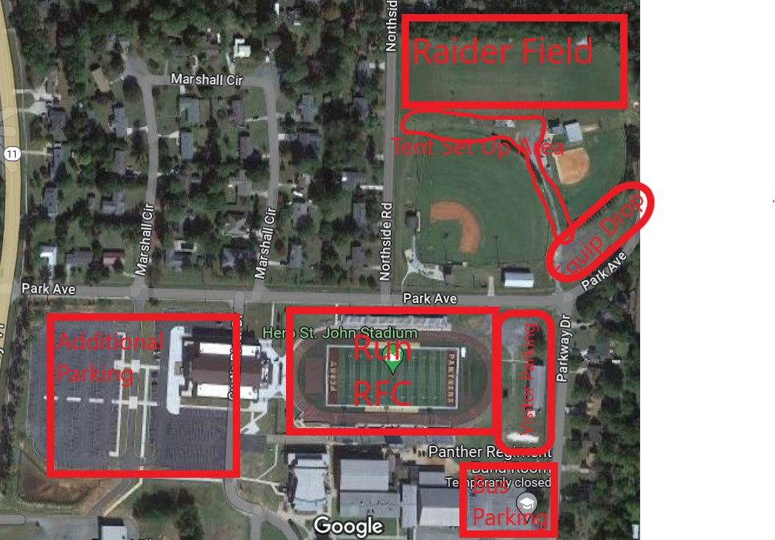
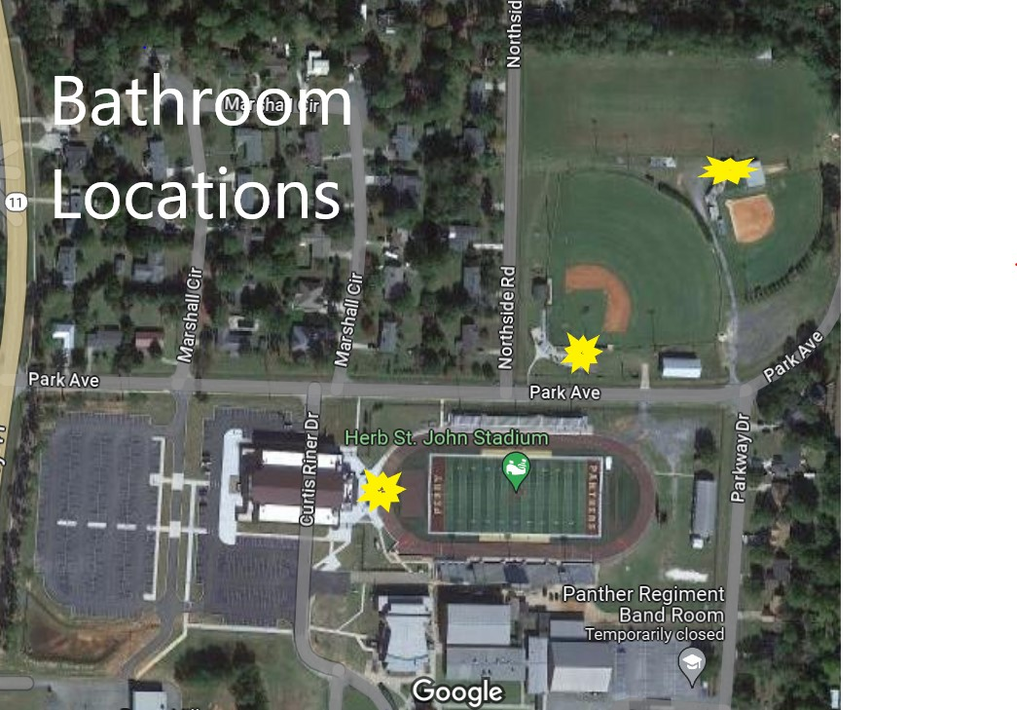

End of SOP.

