05/26/2026

SUBJECT: LETTER OF INSTRUCTION (LOI) FOR THE COASTAL GEORGIA RAIDER INVITATIONAL 25 SEPTEMBER 2026
1. Purpose: This LOI announces the 2026 Coastal Georgia Raider Invitational to be held at Jekyll Island, Georgia, on 25 September 2026. This competition is meant to give teams a challenging meet at one of the most premier locations the state has to offer in order to further expand Raider in the southern/coastal region of Georgia.
2. Scope: The Coastal Georgia Raider Invitational is designed to:
a. Offer cadets a physically demanding competition
b. Promote a competitive spirit among the participants
c. Provide a physical fitness challenge
d. Develop respect and self-esteem among cadets
e. Provide a challenging coastal terrain not found in any other Georgia competition

3. Specifics: The meet will start with a coaches brief at 0730 on 25 SEPT 2026. There will be a total of five events with a ten-person team competing and a two-person Ultimate Raider event.

a. TEAM RUN: 4-Kilometer team run. This will be the first event for all teams. Conducted on the southeastern beach of the island, known as Glory Beach, it will be conducted over a mix of soft and compact sand. Teams will run in PT gear and running shoes.

b. ONE ROPE BRIDGE: Ten Member Team must construct a one-rope
bridge across a span of approx. fifty feet. Teams will provide and transport their own swiss seats, rope and snap links. A kern mantle or standard nylon laid (minimum 120ft) rope may be used. While timed separately, this event is conducted at the start of the team 3K ruck.

c. TEAM 5K RUCK: Ten Member Team will negotiate approximately 3-kilometer course carrying (4) rucksacks and all necessary equipment to conduct the one-rope bridge at the start.

d. SANDBAG RELAY: Ten Member Teams will conduct a relay of 10 sandbags.

e. RAIDER FITNESS CHALLENGE (RFC). Ten Member Teams will navigate a series of obstacles on the practice field to include Serpentine, Tire Dance, Low crawl, and Equipment Carry. The entire team will start and finish together.

GENERAL INFORMATION
- The competition will be held on and around the Jekyll Island 4-H Center, including the beach to the east and trails/roads on the west side up to Summer Waves water park.
- The event headquarters, awards ceremony, medical, billeting, and concessions will be located at the Jekyll 4-H Center.
- Public School Buses (w/govt license plate) are allowed free entry onto Jekyll Island. General entry is $10 and discounts are available for veterans with service-connected disabilities. More information can be found at https://www.jekyllisland.com/visiting/parking/
- Trophies will be awarded for First, Second, and Third Place in each event for Male, Mixed, and Female categories. Trophies will be awarded for First, Second, and Third Place overall in each team category.
- If a team DQs on any event, their final placement will be below teams that completed all events, regardless of score.
- Graders will be provided by recruiters from the Brunswick area. Team coaches may be asked to be graders if a need arises.
- Team Composition.
  - Male, Mixed, and Female teams will consist of up to 14 members, but only 10 will be allowed to compete in any one event. Mix Teams must have a minimum of (4) four females. Schools may enter “A” and “B” teams if they choose.
  - Competing cadets will only be allowed to compete on one team only; meaning a cadet on the male team cannot be a substitute for a cadet on the mixed team.
- ACU/OCP/MARPAT trousers, boots and tan or team T-shirt will be worn for all events except the team run. Team runs will be conducted PT Gear and either boots or running shoes.
- Upon completion of the beach run, teams will be assigned to one of three groups to negotiate the 3K Ruck / Rope Bridge, Sandbag Relay, and RFC.
- The entrance fee will be $15 per competitor. For teams wishing to billet, the cost is $50 per competitor.
- Each team should have a release from liability forms included in this LOI for each cadet participating in the competition. These forms will be collected upon check-in by event staff.
- Team tent area will be in the grass area surrounding the soccer field on the north side of the 4-H center.
- Score sheets for the events will be provided in the school packets upon check-in.
- All Hands Meeting will begin at 0730 with the Competition starting at 0800.
- EMS and a nurse will be on-site throughout the competition. Teams will treat minor injuries internally and, in the event, a higher level of care is needed, EMT will be contacted by event HQ.
- If you have any questions. Contact MSgt Will Strohsahl at william.strohsahl@glynn.k12.ga.us or (910) 548-0042.

EVENT LAYOUT
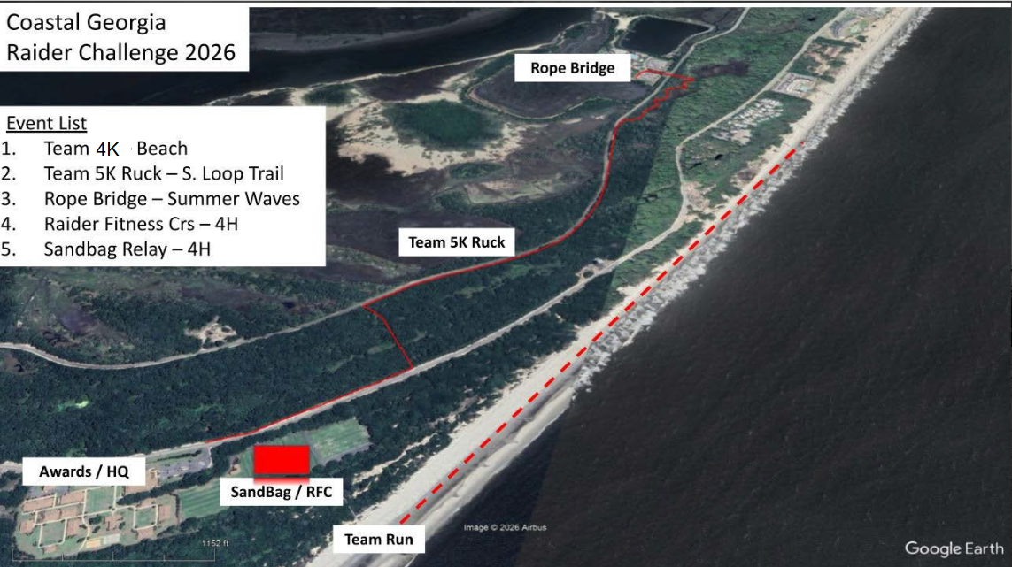
N

Parking. Buses will unload personnel and equipment at the main bus ramp for the 4-H center. Once unloaded, buses will park in the lot adjacent; no cars are authorized in the bus lot. Team trailers will enter at the soccer complex and park in the bus lot once off-loaded. All other vehicles will park in the soccer complex or where is allowed along the road.

Concessions. The concession stand is centrally adjacent to the awards field and will offer a variety of drinks, snacks, and candy.

Restrooms. Restrooms are located in the concession stand area and on the north side of the soccer field.

ANNEX A
TEAM RUN:
- The Team Run will be conducted on the beach to the east of the 4-H center. The route distance is approximately 2.5 miles (4 Kilometers).

- Uniform for this event will be unit PT gear and running shoes or boots (coaches’ choice).

- THIS WILL BE THE FIRST EVENT FOR ALL TEAMS.

- One member of the team will wear a numbered penny jersey to identify the school to the time keepers.
- Teams will line up at the start point accessible via the walkway from the 4H center. The order will be published with the final rotation schedule.

- Teams will be released on 1-minute intervals.

- All team members will start and end together. All members must be in the 10-meter box prior to crossing the finish line.

- A member dropping out of the run will result in a five-minute penalty assessed to the team. If more than one member drops out of the run the team will be disqualified.

- Medals are awarded to the top three teams in each category.

ANNEX C
TEAM RUCK
a. Each team will run a predetermined course. The course will begin at Summer Waves and end at the 4-H center.
b. Teams will stage at the front entrance of the 4-H center (Bus Ramp) 10 minutes prior to the start of their block. Transportation will be provided to the start point.
c. This event is combined with the one-rope bridge. While the team will have a separate one-rope bridge time, the team ruck is the total time to complete the crossing followed on by the movement to the 4-H center.
d. Each team will carry 4 rucks (male/mixed) / 2 rucks (female) weighing 35-40lbs and all equipment necessary to construct/cross a one-rope-bridge. The rucks will be staged at the far-side of the rope bridge crossing.
e. Teams that use an additional ruck to carry the rope are authorized to pre-stage them on the far-side or retrieve from near-side at completion of the rope-bridge.
e. All equipment must be carried throughout the event and cannot be dropped or thrown.

f. The team will start in the corral adjacent to the rope bridge with swiss seats tied and the rope setup.

g. Upon completion of the rope bridge, the team will retrieve all rucks and equipment conduct movement along designated path to the 4-H Center.

h. The timer will start at when the first cadet touches the rope and will stop when the last team member crosses the finish line at the 4H center.

i. Uniform will be ACU/MARPAT trousers and boots.

j. The team is not required to stay together, however, once a cadet crosses the finish line
they are not allowed to assist. If teams place gear short of the finish line, a gear guard
must be posted.
k. Medals will be awarded to the top three teams in each category.

ANNEX B
ONE ROPE BRIDGE

1. One Rope Bridge
a. Each ten-member team must construct a one-rope bridge spanning a fifty-foot distance.
b. Teams may use either a Nylon laid 120-foot rope or Kern mantle rope to construct the bridge.
c. Teams will tie Swiss seats and set up the rope site upon arrival.
d. The first and last man may wear sling ropes properly tied around the waist,
Minimum two wraps around the waist secured with square knot and tied off with an overhand knot or half hitches on each side of the square knot.

e. The judge will inspect each seat as they are tied. Failure to tie a correct seat will result in a penalty and a delayed start until fixed.
2. The rope bridge will be graded in the following manner:
a. Each team will start at a designated rope bridge point and build the rope bridge, cross the dead zone and disassemble the bridge.
b. Time starts when the rope is touched to initiate the crossing. Time will stop when the team has crossed the bridge, the near side has crossed the dead zone, all knots are out of the rope, and the team captain states “Time."
c. The rope does not have to be coiled in any special manner after being torn down but will be free of any knots at the finish line.
d. The judge will give the team the “all clear” command to retrieve the rope bridge equipment for the start of the team ruck portion.
3. Penalties will be assessed according to the rope bridge score sheet. (Annex).
4. Uniform will be ACUs/MARPAT with boots and T-shirts. Any equipment left will result in a 10-second penalty.

5. A rope that fails or falls will result in that team being disqualified.

6. Medals will be awarded to the top three teams in each category.

ANNEX D

SANDBAG RELAY

- The Sandbag relay will be conducted on the soccer field with cones 25 yards laterally and approximately 10 yards horizontally. The sandbag will be a standard, ¾ full bag.
- All Divisions (Male, Mixed, and Female) will be required to carry 10 sandbags through the entirety of the course. There is no reduced amount along the course for mixed / female teams.
- This 10-Raider activity has the Raider team breaking up into two groups of five. Raiders 1 through 5 will move ten, 30-pound sandbags. Time stops when all sandbags are returned to Circle A.
- To start, Raider 1 will grab up to two sandbags from Circle A, carry them around a cone 25-yards away, and then run the bags to Circle B where they will be set (not dropped or thrown!) down.
- Raider 1 will then return to Circle A in the most direct manner possible to repeat this process until all ten sandbags have been moved to Circle B. Raider 2 will carry any available bags from Circle B to Circle C by carrying them around a cone 25-yards away.
- As soon as Raider 3 has any bags to carry in Circle C, Raider 3 will carry those bags around a cone 25-yards away and place them in Circle D.
- This process will continue until all ten sandbags have been moved by Raider 5 from Circle E to Circle F.
- At this point, Raiders 6 through 10 repeat the process in reverse Circle order until all sandbags have been returned to Circle A.
- No Raider can do the course twice.
- Video demonstrations can be seen at Etowah Sandbag Relay (August 2021) - YouTube
- Uniform will be ABU/ACU/OPCs with boots.

ANNEX F

RAIDER FITNESS CHALLENGE (RFC)

- The RFC will be conducted on the Soccer field.
- Uniform for the event will be ACU/MARPAT, team T-shirt, and boots.
- General Scenario: The RFC is the team event designed to test the strength, strategy and endurance of a team of cadets over 400 yards through a variety of physical obstacles.
- The team score is the time it takes to complete the tasks, put all items used back in their approximate starting positions, and finish the course with all team members.
- Time to complete the course will be kept and recorded for each team.
- Judges and/or monitors will be stationed along the route to ensure compliance with all rules. A team may be removed from the course at the 8-minute mark for failure to progress. c. The team will be assembled behind a starting line. The grader will command, “Get Set, GO!” or similar. The GO command will start the clock. At that point, the team begins the course.
- The course will consist of the following items in order
  - A 20- yard Water Can carry (6 cans) & 30lb. Ammo Can carry (14 cans).
  - Agility Maze / Serpentine
  - Tire flip (1-2 person)
  - Stretcher Carry. Team will transport (2) stretchers, each weighing 100lbs
  - Tire Dance
  - Low Crawl
  - Kettlebell carry (8 total)
  - Turn Around Flag/Pole

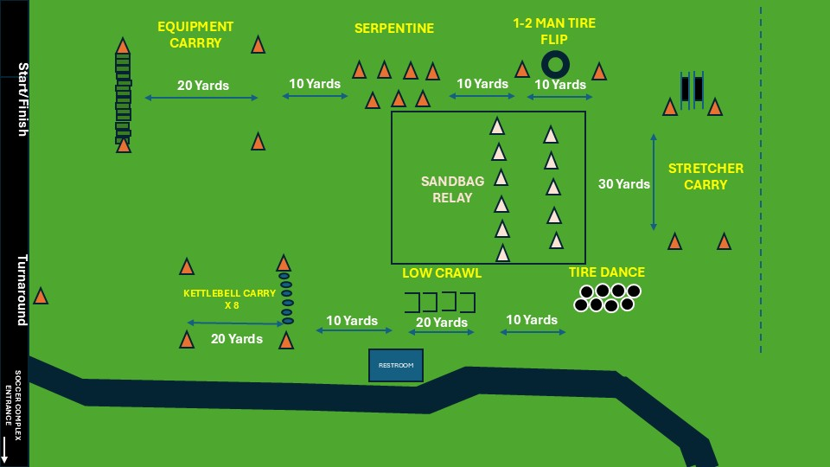

HOLD HARMLESS AGREEMENT

I/We, the undersigned, hereby grant permission for a legal dependent to participate in the below listed activity of the GA JROTC department.
I/We do hereby agree to release, and otherwise hold harmless all instructors, all school administrative officials, Glynn Academy High School, and the Glynn County School District from any liability for personal injury, property or other type of loss which occurs because of the aforementioned activity, to me or any of the undersigned. I/We understand and agree that my signature hereunder constitutes a waiver of rights by myself or my estate to sue, for any personal injuries, death or property damage caused by, or a result of the activity of, the hereinabove named parties, and I/We freely assume all risks, hazards, or losses which may result from said activity.
JROTC instructors, school, and GA officials will make every reasonable effort to properly supervise, control, and render safe all training and activities related to this competition. This _____ day of ______________, 2026.
Emergency Phone: _______________
(Student signature)_____________________(Parents signature)_____________________
INSURANCE INFORMATION
This is to certify that ___________________is covered by insurance providing coverage for hospital and medical treatment.

Printed Name of Parent/Guardian_______________________________
Signature of Parent/Guardian Date __________

REGISTRATION

School Name:_______________________________________________

POC:______________________________________________________

Billeting - $50 per (includes registration)

Number of Male Cadets: _____
Number of Female Cadets: _____
Number of Male Adults: ______
Number of Female Adults: _____

Non-Billeting - $15 per
Number of participating Cadets: ______

Category of Teams: Male_____ Mix _____ Female ____

Price is $15 per cadet. If staying overnight, the total cost is $50 per cadet which includes the registration..

Amount Enclosed: ___________(Make checks payable to Red Terrors MCJROTC Booster Club)

Signature of POC:__________________________________

**** .

Mail checks and forms to:
Red Terrors MCJROTC Booster Club
1001 Mansfield St
Brunswick, Ga 31520

GA MCJROTC Coastal Georgia Raider Invitational
Team Run Score Sheet

School: _________________________________ Male Mix Female

Team Commander: _____________________________________________________

Penalties Assessed:
Penalty | Incidents | Incident Total
Team member crosses the finish line more than 10 meters apart from each other (30 seconds per incident)
Team finishes with 9 members (10-minute penalty)
Team finishes with 8 or less members(DQ)
Profanity (1-Minute first incident / DQ on second violation)
 | Cumulative Penalty Time

Event Time: ___________________
+
Penalty Time: __________________

Total Time: _____________________

Head Judges Signature: ______________________________________

Commanders Signature: _______________________________________

GA MCJROTC Coastal Georgia Raider Invitational
Ruck Score Sheet

School: _________________________________ Male Mix Female

Team Commander: _____________________________________________________

Penalties Assessed:
Penalty | Incidents | Incident Total
Dropping any equipment along the course (1-minute per incident)
Cutting corners on the course (DQ)
Crossing the finish line without all 10 members at the Rally Point (2 minute penalty).
Dropping equipment after crossing the finish line (1 minute per incident)

Profanity (1-Minute first incident / DQ on second violation)
 | Cumulative Penalty Time

Event Time: ___________________
+
Penalty Time: __________________

Total Time: _____________________

Head Judges Signature: ______________________________________

Commanders Signature: _______________________________________

GA MCJROTC Coastal Georgia Raider Invitational
Raider Fitness Course (RFC) Score Sheet

School: _________________________________ Male Mix Female

Team Commander: _____________________________________________________

Penalties Assessed:
Penalty | Incidents | Incident Total
Failure of any team member to go around designated turn around point (DQ)
Failure to pick up required equipment at each pick up point (30 seconds per piece)
Dropping equipment at any point on the course (30 seconds per incident)
Failure by any Cadet to complete Tire Stepper or execute a proper low crawl (1-min penalty each occurence)
Failure to complete the course (DQ)
Profanity (1-Minute first incident / DQ on second violation)

 | Cumulative Penalty Time

Event Time: ___________________
+
Penalty Time: __________________

Total Time: _____________________

Head Judges Signature: ______________________________________
Commanders Signature: _______________________________________

ROPE BRIDGE Coastal Georgia Raider Challenge

COMMANDER: ________________________________ ____ Male Mix Female

SCHOOL: |  |  |  | MIX
ROPE BRIDGE SCORE SHEET |  |  |  | Time Per Penalty | # of  Penalties |  |  | Total
EQUIPMENT/PREPARATION/INSPECTION: 5 MINUTES.
 |  |  |  | 30 SEC
Rope improperly laid out. (Not in duffle bag and not touching the ground at start) |  |  |  | 30 SEC
CONSTRUCTION OF ROPE BRIDGE
Far Side Raider –Improper Bowline or Figure 8 when crossing |  |  |  | 30 SEC
Far Side Raider not clipped in with snap link prior to entering dead zone |  |  |  | 30 SEC
Far Side Raider not belayed properly across the dead zone |  |  |  | 30 SEC
Far Side Raider improperly secures to far side via 180° and snap link (note 1) |  |  |  | 30 SEC
Far Side anchor knot not two round turns w/2 half hitches or tensionless anchor |  |  |  | DQ
Improper Transport Knot: wireman’s knot or figure 8 knot with a bite |  |  |  | DQ
One steel locking snap link not locked |  |  |  | DQ
Two snap links in transport knot do not have opposite gate openings |  |  |  | DQ
Near-side not secured w/round turn, 2 half hitches with or without quick release |  |  |  | 30 SEC
CROSSING
Any Raider hooked up before near side or far side is complete |  |  |  | 30 SEC
Failure to face rope, mount onto rope w/snap link then rotate body under rope |  |  |  | 30 SEC
Dead zone violation (touching obstacle during loading/unloading, equipment loss) |  |  |  | 30 SEC
Crossing Raiders FEET or HANDS touch the dead zone and use feet or hands for momentum across the Dead Zone. |  |  |  | 30 SEC
More than three (3) Raiders clipped into the bridge rope at any one time |  |  |  | 30 SEC
BREAKDOWN OF ROPE BRIDGE
Breaking Down rope bridge before last cadet is off rope |  |  |  | 30 SEC
Near Side Raider not clipped in with snap link prior to entering dead zone |  |  |  | 30 SEC
Near Side Raider not belayed properly across the obstacle |  |  |  | 30 SEC
Near Side Raider bowline w/overhand safety or figure 8 incorrect while crossing |  |  |  | 30 SEC
Rope or any item left in the dead zone after time is called |  |  |  | 30 SEC
Knots left in the Rope after bridge break down and “TIME” is called |  |  |  | 30 SEC
ADDITIONAL PENALTIES AND NOTES
Improper markings on rope that are obviously an advantage |  |  |  | DQ
Coaching from a non-team member |  |  |  | DQ
Rope Bridge Failure |  |  |  | DQ
Use of Speed Tighteners (do not twist stick or snap-links) |  |  |  | DQ
LESS THAN 8 Raiders CROSS ON BRIDGE |  |  |  | DQ
Sportsmanship violation/coaches and Cadets (profanity, disrespecting judge, etc) per incident |  |  |  | 1 minute
Note 1: snap link does not have to be used if far-side knot is tied immediately
Judge Signature: _____________________________________________

Commanders Signature: ________________________
COMMENT(S) on Reverse side
 |  |  |  | TIME
GA MCJROTC Coastal Georgia Raider Invitational
Sandbag Relay Scoresheet

School: _________________________________ Male Mix Female

Team Commander: _____________________________________________________

Penalties Assessed:
Penalty | Incidents | Incident Total
Team failing place sandbag inside circle (30 sec per sandbag)
Throwing sandbags (30 sec per sandbag)
Cutting corners on the course (DQ)
Profanity (1-Minute first incident / DQ on second violation)
 | Cumulative Penalty Time

Event Time: ___________________
+
Penalty Time: __________________

Total Time: _____________________

Head Judges Signature: ______________________________________

Commanders Signature: _______________________________________

