**Scrubbers Information**

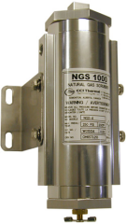           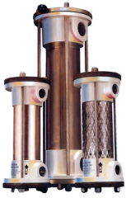          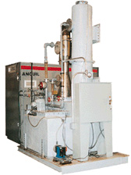

***Image Credit: CCI Thermal Technologies Inc. | Anguil Environmental Systems, Inc.***

Scrubbers are air pollution control devices that use liquid to remove particulate matter or gases from an industrial exhaust or flue gas stream. This atomized liquid (typically water) entrains particles and pollutant gases in order to effectively wash them out of the gas flow. In comparison to other air pollution control devices, scrubbers are very multidisciplinary, with the ability to remove solids, mists, and gases simultaneously while also providing cooling. They are also capable of handling explosive and flammable gases safely. However, scrubbers suffer from high levels of corrosion and produce slurry waste streams which are less convenient for recycling and disposal.

|  |  |
| --- | --- |
| **Advantages** | **Disadvantages** |
| * Can handle flammable and explosive dusts with little risk. | * High potential for corrosion problems. |
| * Provides gas absorption and dust collection in a single unit. | * Collected particulate may be contaminated and unrecyclable. |
| * Provides cooling of hot gases. | * Protection against freezing required. Certain streams may require reheating to avoid visible plume. |
| * Compact; can often be retrofitted into existing collection systems. | * Disposal of waste sludge can be very expensive. |
| * Corrosive gases and dusts can be neutralized. | * Requires makeup water to replace purged liquid and disposed sludge |

**Scrubber Design and Operation**

Scrubbers are devices that use a liquid (often water) to capture and remove pollutants. Through a nozzle or orifice a scrubbing liquid is atomized and dispersed into the gas stream. The droplets entrain and capture dust particles through agglomeration, adherence, or encapsulation. This effectively increases the size and mass of the particles, making them easier to collect in a subsequent filter or separation process. The scrubbing liquid simultaneously absorbs and neutralizes gaseous pollutants. Suspended liquid is typically recovered in mist collectors and recycled through the system.

 Many air scrubbers, wet scrubbers, and gas scrubbers are available with pre-filters or final filters to further reduced emissions.  Pre-filters are installed upstream of the scrubber intended to catch larger particles.  While the scrubber itself would be able to remove these larger particulates as well, their removal allows the scrubber to be designed to focus more keenly and effectively on smaller particulates. A final filter is often installed downstream of the scrubber, and is intended to catch fine particles that were not removed during the scrubbing process.

A key parameter in the design of scrubbers is the liquid-to-gas ratio (L/G). It is commonly expressed in gallons per minute (gpm) of liquid divided by actual cubic feet per minute (acfm) of gas. This ratio is determined by the solubility of the gas pollutants, the abundance of pollutants and particulate matter in the gas stream, and the mass transfer characteristics of the tower. Increasing (L/G) increases the collection efficiency of the system, so finding the optimum ratio is important for balancing performance with operating costs.

**Types of Scrubbers**

There are a number of different types of scrubbers which vary in terms of both function and performance.

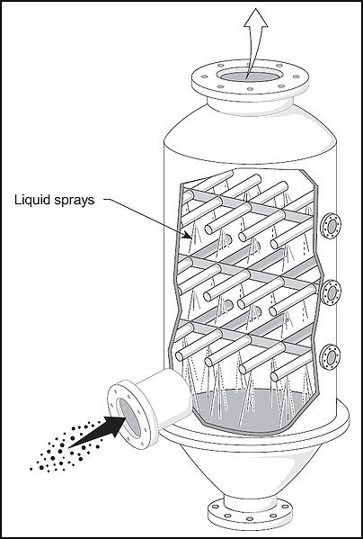

**Spray Towers**

In spray towers or spray chambers, gas streams are fed into a chamber and contacted with scrubbing liquid produced by spray nozzles. The droplet size is controlled to optimize particle contact and droplet separation from the gas stream. Chambers can be oriented for cross-flow, countercurrent flow, or concurrent (co-current) flow. Chambers may also include baffles to improve gas-liquid contact.

Spray towers have low power consumption but have relatively low particulate collection efficiencies. The recirculated water in the system must be thoroughly cleaned to prevent excessive nozzle fouling or clogging. Nozzle cleaning and replacement are a major part of the maintenance required for these units.

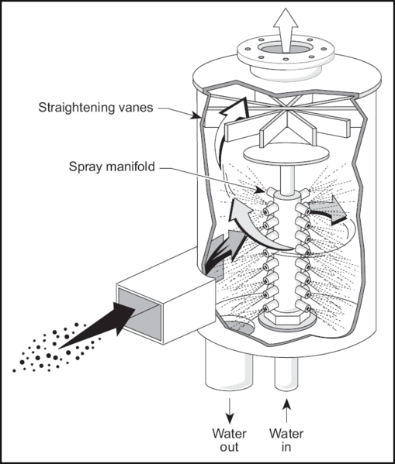

**Cyclone Spray Chambers**

Cyclone spray chambers are scrubbers which combine the capture techniques of cyclones and spray towers. Gas streams typically enter into the chamber tangentially at high speeds. The high speeds induce cyclonic action, and the centrifugal force from this promotes droplet separation, allowing the use of a smaller droplet size which increases collection efficiency.

Cyclone spray chambers are more efficient than spray towers and have lower liquid requirements, but require more power due to higher pressure drops. They are preferred over spray towers for gas streams with heavier particulate loads.

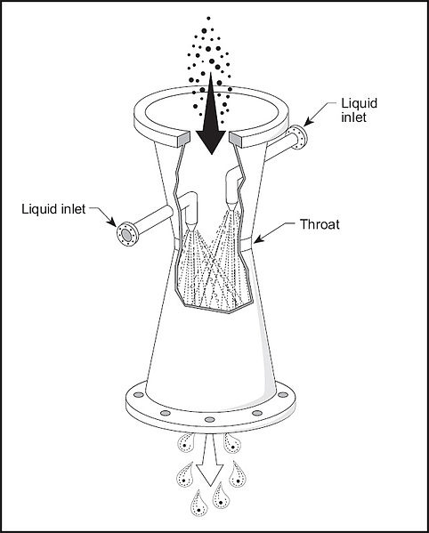

**Venturi Scrubbers**

Venturi scrubbers are scrubbers with a venturi shaped chamber with converging and diverging sections. Water is injected at low pressure into the throat of the venturi through which the gas stream passes at high velocities. The energy from the gas atomizes the liquid, allowing particles and pollutants to be entrained in droplets. Venturi jet scrubbers use a modified design in which liquid is injected into the throat at high velocity rather than the gas stream.

Venturi scrubbers have high collection efficiencies for particulate pollution and are simple to install and maintain. However, they require large pressure drops leading to higher power requirements than other scrubber designs. Venturi jet scrubbers have lower pressure drops than typical venturi scrubbers, but have significantly lower efficiencies as a result.

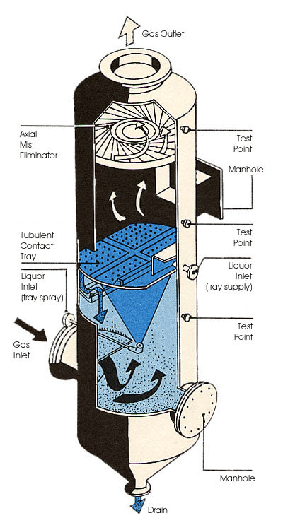

**Orifice Scrubbers**

Orifice scrubbers are similar to venturi scrubbers in that the gas stream flows at high velocity through a narrow section (orifice) to atomize the liquid into droplets. The gas moves through pools of scrubbing liquid at high speeds before it enters the orifice. As it exits, droplets and pollutants are removed through impingement (collision) on a series of baffles.

Orifice scrubbers have the advantage of low water recirculation rates. Some manufacturers provide units with adjustable orifices for changing the impingement velocity.

**Impingement Scrubbers**

Impingement or perforated plate scrubbers are a variation of orifice scrubbers. In these units, the gas stream enters at the bottom of the unit and passes through a perforated tray which contains or is sprayed with a layer of liquid. Gas-liquid contact is achieved within the forth generated by the gas passing through the liquid layer. After passing through the perforations the gas-droplet mixture impinges on plates or baffles mounted above the perforations.

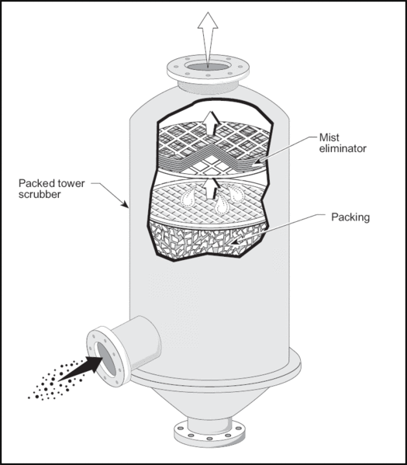

**Packed Bed Scrubbers**

Packed bed or packed tower scrubbers are chambers which contain one or more layers of packing material to increase gas-liquid contact, such as Raschig rings, spiral rings, or Berl saddles. Gas streams enter in the bottom of the chamber and flow upward (countercurrent) or horizontally (cross-flow) through the packing as scrubbing liquid is distributed uniformly to the packing material. Once through the packing, cleaned gas passes through a mist eliminator while the waste liquid/slurry falls to the bottom by gravity. Some packed towers designed for

Packed bed scrubbers are primarily gas absorbers and are the most effective scrubbers for treating gas streams with gaseous pollutants. They can collect solids, but are not often used for this purpose because wet dust collecting in the beds would require unreasonable maintenance.

**Selection tip**: One of the key design considerations for packed tower scrubbers is the selection of packing material. The packing's surface area, material, shape, weight, and cost are all important factors for finding a chemically compatible packing that gives maximum gas-liquid contact and low gas-phase pressure drop.

|  |  |  |  |
| --- | --- | --- | --- |
| **Scrubber Type** | **Efficiency** | **Power Inputs** | **Liquid Requirements** |
|  |  | *hp/1000 cfm* | *gal/1000 ft3* |
| Spray-chamber | 90% (+8µm particles) | 0.5 - 2 | 1 - 20 |
| Cyclone-spray | 95% (+5µm particles) | 1 - 3.5 | 2 - 10 |
| Impingement | 97% (+5µm particles) | 2 - 3 | 2 - 5 |
| Orifice | 97% (+5µm particles) | 0.5 | 2 - 4 |
| Venturi | 98% (+0.5µm particles) | 3 - 12 | 3 - 15 |

**Comparison of different scrubber types.**

**Dry Scrubbers**

Wet scrubbers are the most common and well-known types of scrubbers. However, recently the term 'scrubber' has also been used to describe air pollution devices which inject a dry sorbent or spray into a gas stream. This effectively eliminates the problematic liquid waste stream, capturing instead a dry solid. Applications for dry scrubbers include the removal of acid and odorous gases from boilers, incinerators, and wastewater treatment plant operations.

* **Dry sorbent injectors** inject an alkaline material into a gas stream to react with acid gases. The reaction produces solid salts which are removed in the system's particulate control device. Efficiencies for these devices are limited, but can be improved by increasing the humidity or using wet scrubbing in addition to dry injection.
* **Dry spray absorbers** are packed towers where the gases are contacted with an atomized alkaline slurry. Acid gases form solid salts which can then be removed in the system's particulate control device. Spray dryers can achieve acid gas removal efficiencies above 80%.

**Orientation**

Orientation describes the way in which the scrubber liquid flows in reference to the gas flow. Flow orientation can affect the scrubber collection efficiency, size, pressure drop, and gas velocity.

* In **cross-current**or **horizontal flow**, the scrubber liquid flows perpendicular to the gas flow. This arrangement allows for a slightly higher flow rate which can reduce the size of the unit, but is typically less efficient than counter-current flow.

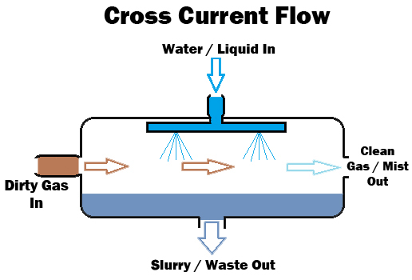

* In **co-current flow**, the scrubber liquid and gas flow in the same direction. This arrangement allows for a higher flow rate which reduces the size of the unit, but is less efficient than counter-current flow.

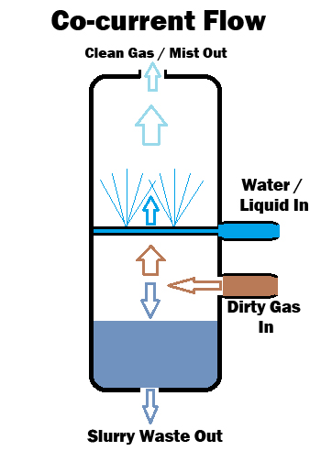

* In **counter-current**or **vertical flow**, the scrubber liquid flows opposite the gas flow. This arrangement is the most efficient. However, because the liquid flows against the gas flow, flow rates are lower than in a co-current or cross-current flow units.

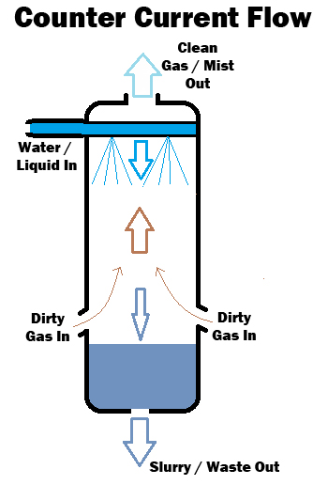

**Scrubber Model**

Scrubber models differ based on how they are installed and where they are operate.

* **Stationary or enclosed** scrubbers are housed in their own building or enclosure. These are typically used to treat process exhaust gases from industrial waste streams before they are released into the atmosphere.
* **Portable**scrubbers are small units used for local cleansing and cleaning applications. In addition to small size, they may have wheels or handles to make them easier to transport.
* **Skid or base plate** mounted scrubbers are designed to be placed on a skid or plate positioned on the floor. These scrubbers frequently contain transport features such as forklift slots for movement around a facility.
* **Trailer or truck** scrubbers are mounted on a trailer or truck for mobile spot dust or fume abatement.

**Performance Specifications**

Performance specifications are the ratings assigned by a manufacturer that describe the scrubber's performance. These are the specifications most important for industrial buyer to consider when selecting a suitable scrubber for their application.

* **Airflow** or **gas flow rate** defines the acceptable flow rate or range of flow rates of the gas stream through the scrubber, measured in cubic feet per minute (cfm).
* **Liquid** or **water flow rate** defines the intended flow rate or range of flow rates of the scrubber liquid in the system, often described in gallons per minute (gpm). It may be given as a liquid-to-gas ratio (L/G). It determines the amount of water used by the scrubber, which will have a large impact on the operating costs of the system.
* **Minimum particle size filtered** indicates the minimum diameter of particulate matter that a dust collector is capable of capturing, measured in micrometers (µm). This rating effectively defines the range of capability of the collection device.
* **Efficiency**, **collection efficiency**, or **capture rate** defines the percentage of particulate matter and/or gaseous pollutants in the filtered gas stream that is effectively removed by the scrubber. Efficiencies can vary widely for different types of scrubbers and different gas streams.

**Other Considerations**

In addition to performance criteria, there are other parameters to consider when selecting scrubbers for a particular application. These include material compatibility and operating temperature.

* **Material compatibility** - It is important to ensure the materials used in the construction of the scrubber are compatible with the chemical (acidity, reactivity) and physical (abrasivity) properties of the gas stream. Applications where the scrubbing liquid contains additional chemicals or substances may make it necessary to use specialty materials with high corrosion or chemical resistance.
* **Operating temperature** - Although scrubbers are often designed to provide cooling or quenching of hot gas streams, these devices still are limited to a certain range of temperatures, above or below which they may not operate effectively.

**References**

Cooper, C. D., & Alley, F. C. (2011). Air pollution control: A design approach. (4 ed.). Long Grove, IL: Waveland Press, Inc.