Environmental Policy

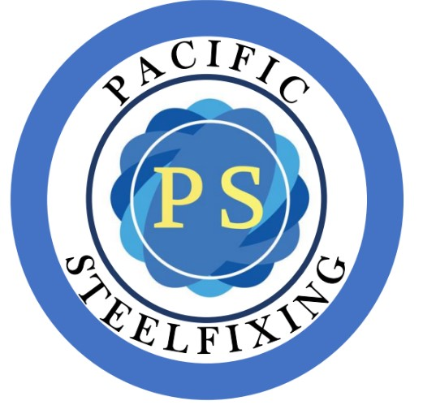By implementing a variety of management systems and industry best practice initiatives, Pacific Steelfixing seeks to significantly reduce the environmental impact of its operations through lowering our own personal environmental footprint.

Our values and principles:

We are dedicated to following and applying all applicable environmental legislation.

We are dedicated to consistently enhancing our environmental performance through the implementation, monitoring, and evaluation of our policies, programs, and services.

In doing our tasks and responsibilities, we are dedicated to maintaining and improving our environment. Our constant goal is to reduce the impact of our actions on the environment.

We can ensure that we implement sustainable practices that are e ective by adhering to our sustainability philosophy.

To achieve these objectives, we will:

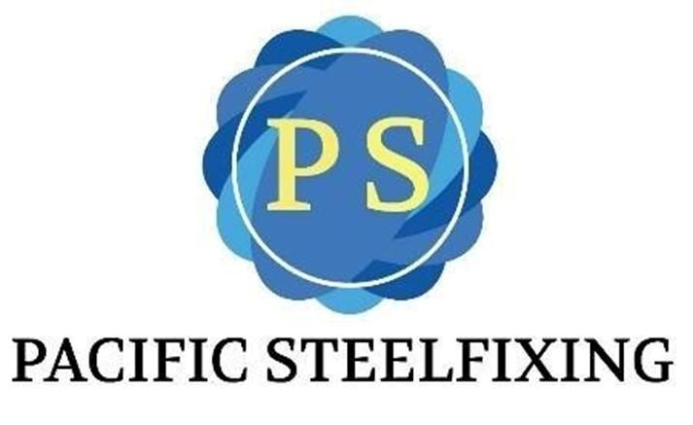

Implement programs to reduce environmental damage that consider progress in science, technology, and regulation in addition to community goals and customer needs.

Ful ll all legal obligations regarding the environment and aim to go above and beyond the minimum Make sure that each employee has the chance to share in shaping the organization's sustainability goals and philosophy.

Reduce hazardous and consumer waste while minimizing energy use by choosing sustainable energy-saving suppliers, materials, and equipment.

As needed, o er training to give employees the abilities and information required to manage environmental risk and abide by applicable laws.

Whenever feasible, make use of leftover materials and o cuts to cut down on waste production.

Workplace Health & Safety Advisor: Date: Signature:

Jaymee Rickard