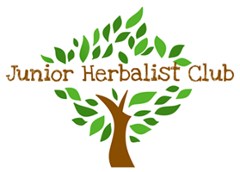

**Junior Herbalist**© **Leader Training – application form**

|  |  |
| --- | --- |
| Name |  |
| Address |  |
| Email |  |
| Telephone number (mobile) |  |
| Date of Birth |  |
| Qualification held |  |
| Professional body | NHAA / Other (please state) |
| Membership number |  |
| Professional Liability Insurer details |  |
| Do you have any prior teaching experience? |  |
| Do you have any allergies/disabilities/special dietary requirements? |  |

I understand that because of the high professional standard of the training and the course content, it is a requirement that all herbalists and naturopaths enrolling in the JHC leader training program must:

* Have graduated from an NHAA-accredited course
* Have and maintain a current membership with NHAA or an equivalent professional association
* Have and maintain current appropriate professional insurance

Signed: Date: