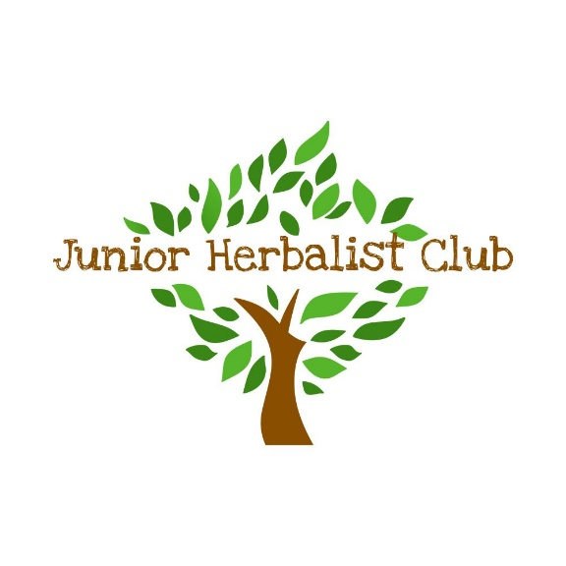

Junior Herbalist© Leader Training – application form

Name

Address

Email

Telephone number (mobile)

Date of Birth

Qualification held

Professional body | NIMH / URHP / Other (please state)
Membership number

Professional Liability Insurer details | Eg. Balens Block Insurance
Do you have any prior teaching experience?

Do you have any allergies/disabilities/special dietary requirements?

I understand that only herbalists who have graduated from NIMH / EHTPA accredited courses (or have completed individual accreditation) may undertake the course leader training.

I have paid the £100 deposit to secure my place on the leader training course and understand that this deposit is non-refundable*. I understand that payment in full needs to be made before 30th April 2025.

Signed: Date:

*Should the course have to be cancelled by the organisers, all monies paid including deposits will be refunded in full

