*Crankin’ A’s*

**Where to Stay in Delightful DeLand**

**In conjunction with Model A Days at the Pioneer Settlement in Barberville**

**October 31-November 2, 2025**

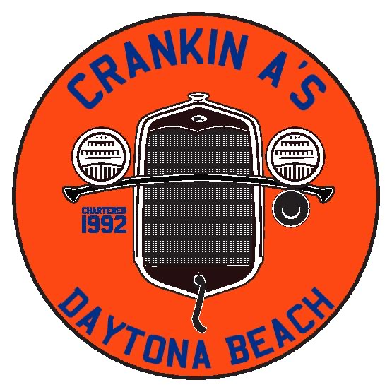**Model A Days with the Crankin’s A’s of Daytona Beach has set up a “Host Hotel” with special Model A Rates for our Model A Day Weekend.** After checking in at the *Crankin’s A’s Garage* at the Pioneer Settlement in Barberville Friday afternoon, many of our out-of-town guests want to stay in DeLand overnight. So we have set up the local *Comfort Inn and Suites* to make it easier and more convenient to get the most out of your weekend in DeLand.

We have set up accommodations in DeLand at the *Comfort Inn and Suites* at 400 East International Speedway Boulevard (ISB) in DeLand, near the intersection of US 92 (ISB) and US 17. This location is 13 miles south of the Pioneer Settlement and a stone’s throw from beautiful Downtown DeLand.

We have a room block under the name “Crankin’s A’s Model A Club” at a discounted rate of $122 plus tax. This rate is good for reservations made prior to October 18 and can be extended through the weekend if desired. You can call the hote directly at 386.736.3100 or use this booking link to book directly online. <https://www.choicehotels.com/reservations/groups/RJ17C0>

On Friday evening – Halloween - we will have an impromptu Mini-Tour and Dinner. We will tour downtown DeLand in our Model A’s as their downtown Halloween celebrations are winding down. Should be fun!

So make your reservations and join us for a great weekend.

ALSO – when you arrive on Friday afternoon, we will be there to take photos of you and your car, suitable for framing!

Questions? Call Kevin Duffy at 386.547.9625 or email at [KRDuffy@me.com](mailto:KRDuffy@me.com)