# Hector’s World Cyberbullying

Students will learn how to become safe and responsible digital citizens by only sharing personal information with people they trust and keeping their computers safe. They will also learn about the importance of seeking guidance from a trusted adult when they feel unsafe or uneasy online or if they experience cyberbullying.

Hector and his friends celebrate being good digital citizens and help their good friend Ming to deal with a cyberbully.

[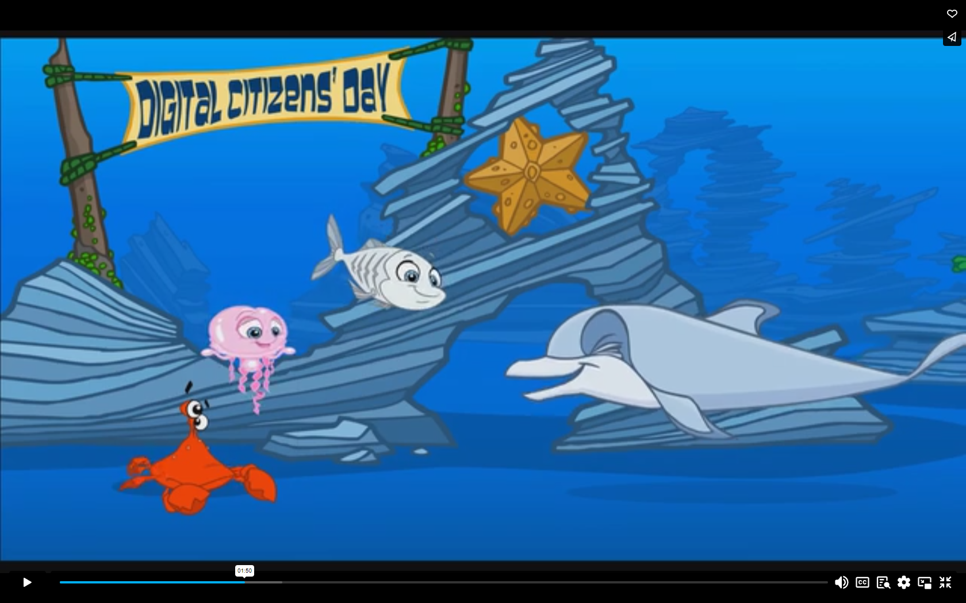](https://www.esafety.gov.au/educators/classroom-resources/hectors-world/cyberbullying)

<https://www.esafety.gov.au/educators/classroom-resources/hectors-world/cyberbullying>

What are some things you can do if you get cyberbullied?

**Cyberbullying is serious!**

**Don’t keep it to yourself.**

 **Talk about it.**

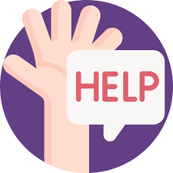 **Get help** from a trusted adult like your mum, dad or a good friend.

**Apologise** if you make a mistake

**Forgive** people when they apologise.