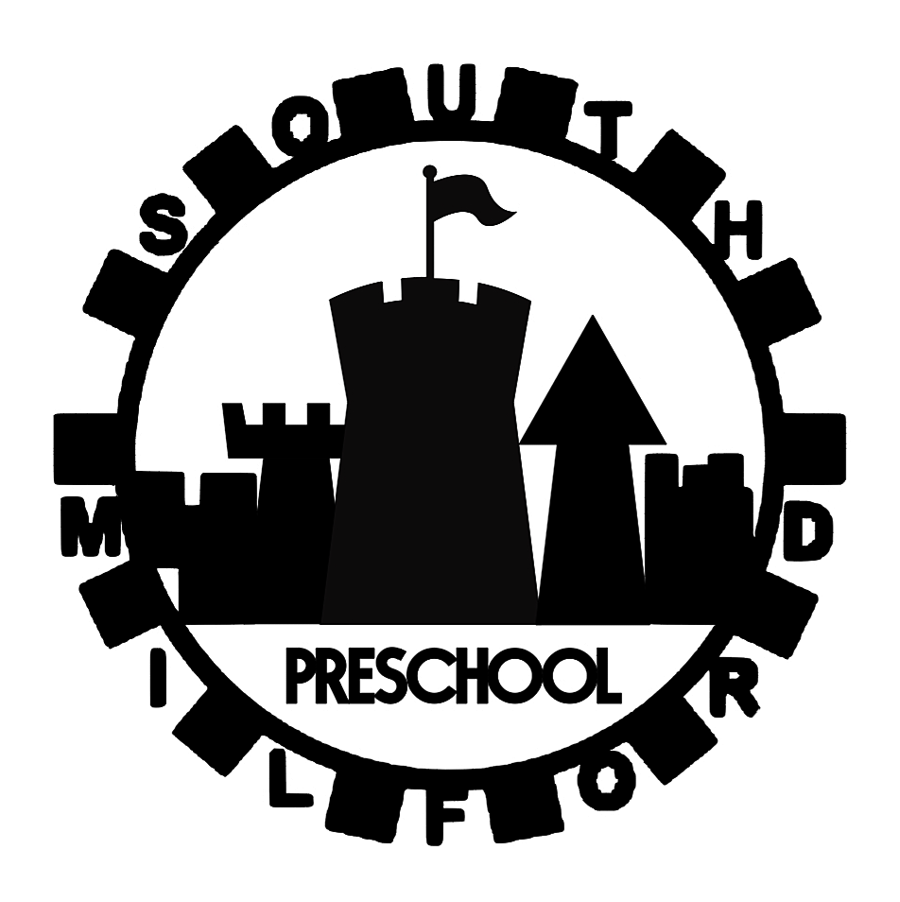

| South Milford Preschool | The WI Hall 71 High Street South Milford LS25 5AF southmilfordpreschool@gmail.com |
| --- | --- |
| THE SEND LOCAL OFFER  (North Yorkshire Council)What is the local offer? The local offer provides information to help families and their children with SEND information regarding what help and support is available in their local area. This is a comprehensive and accessible list or directory of services available. This applies to children aged 0-25 with SEN. Where can I find this information? The Local Offer can be found on your local authorities website. For North Yorkshire Council, all information can be found here: [SEND Local Offer - North Yorkshire](https://www.northyorks.gov.uk/children-and-families/send-local-offer)  **What type of services are available?** In many cases, the Local Offer provides links to:   * Childcare and Early Years * Education * Health and Social Care * Leisure and Transport * Funding and financial matters * Youth and preparing for adulthood.   North Yorkshire Council also provides specific information regarding:   * Educational Health Care Plans (EHCP’s) * SEND groups and networks   **How do I access the services advertised?**  The Local Offer can be accessed by parents or practitioners and the North Yorkshire website has designated guidance for each. The webpage can be easily navigated and will direct you to the relevant place. If your child attends school or early years childcare, you can ask them for help and support with this. The SENCO at South Milford Preschool is Mel Riches.  **EARLY HELP  What is it?** North Yorkshire Council promotes a collaborative approach known as Early Help. This is a step up from universal services and allows children to access more targeted services that they may require because of specific circumstances, (e.g. a bereavement). Early Help helps to resolve problems before they become overwhelming and costly. Who Should Offer Early Help? The first person or professional to offer support is usually the one identifying the issue and therefore implementing Early Help Support - this person is known as the Early Help Champion. Early Help can be provided by a broad range of services and gives responsibility to identify and deliver this service to families to all professionals in North Yorkshire. Early Help Strategy The following document outlines the ambitions for the Early Help service and describes how professionals and families will work together to plan and deliver the services. It outlines the Early Help processes and its delivery with the child and family at the center of the service.  [Early Help Strategy - North Yorkshire](https://www.northyorks.gov.uk/sites/default/files/2022-12/Early%20Help%20Strategy.pdf) | Useful Links  * [Video - North Yorkshire SEND Local Offer](https://www.youtube.com/watch?v=4_ixTc5uWow) * [Video - SEND Information advice and Support Service (SENDIASS)](https://www.youtube.com/watch?v=Yx8SnMlh1H0) * [Apply for 2 year old funding](https://www.northyorks.gov.uk/children-and-families/early-education-and-childcare/early-years-funding-2-year-olds)   [Early Years Funding for 3 & 4 Year olds (Including Pupil Premium)](https://www.northyorks.gov.uk/children-and-families/early-education-and-childcare/early-years-funding-3-and-4-year-olds)  [Help with Childcare Costs](https://www.northyorks.gov.uk/children-and-families/early-education-and-childcare/information-about-childcare-support-costs)  [Children and Families Hubs](https://www.northyorks.gov.uk/children-and-families/children-and-family-hubs) Useful Contacts **North Yorkshire Council 0300 131 2131** Local Offer Children and Young People's Service North Yorkshire County Council County Hall Northallerton DL7 8AD  **Further Information**  [Early Help Offer - North Yorkshire](https://www.northyorks.gov.uk/children-and-families/early-help/children-and-families-early-help-offer)  [Resources and Support for parents](https://www.safeguardingchildren.co.uk/parents-carers/)  [Video - Early Help in North Yorkshire](https://www.youtube.com/watch?v=DaDz5eocKPs)  Early Help Selby 01609 534829 earlyhelpcentral@northyorks.gov.uk |

Written by: Mel Riches   
Date: May 2023