

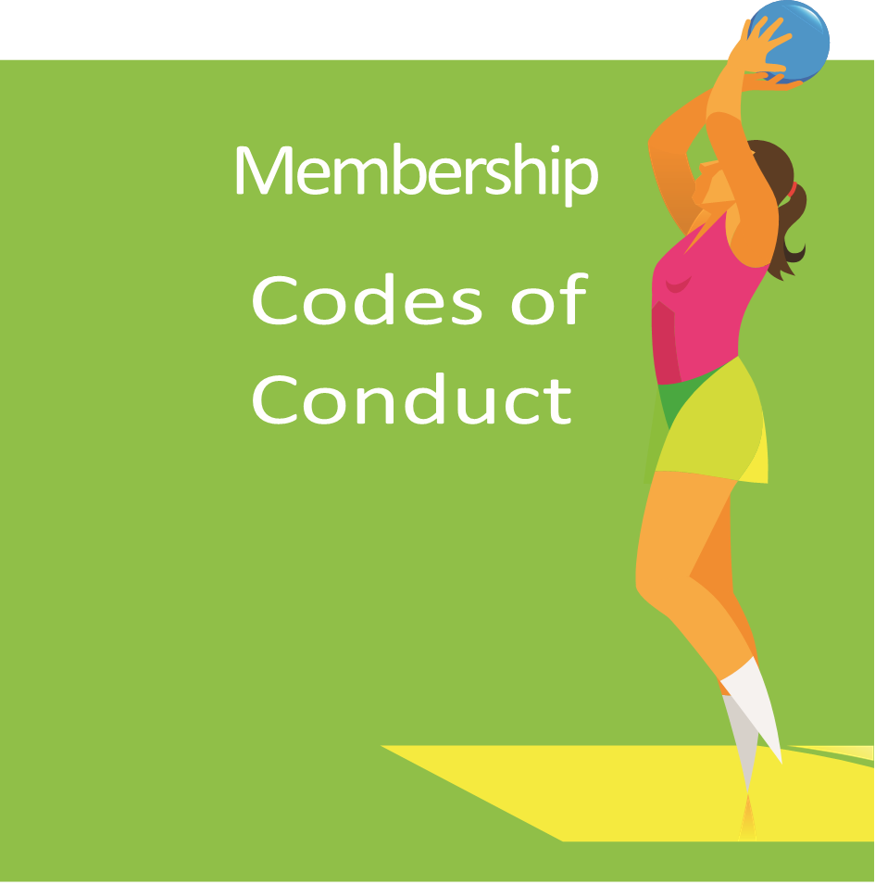

CLUB ETHICS

Gosport Gators aims to provide the opportunity for players of all backgrounds and levels of ability to play netball. We provide a safe and friendly environment in which our members can develop and flourish both on and off the courts. We feel netball gives our members the opportunity to develop communication and team building skills. We encourage them to take on a leadership role by assisting in the development and mentoring of younger or less experienced players. We believe that the lessons that can be learned from sport can be drawn upon throughout all aspects of life.

Whilst we all like to win and a healthy competitive spirit is encouraged, Gators is more focused on encouraging each child to play to the best of their abilities and strive to achieve their own aims. We believe that recognition of reaching these goals is very important and we hold an annual presentation evening to give our members the opportunity to get together and celebrate each other’s achievements.

**Strategic Initiative = BE KIND**

**FUN!**

**CODES OF CONDUCT**

**Gosport Gators expects their members to treat the committee, team managers, coaching volunteers and each other with respect**.

Members are expected to take part in all activities as requested by the coaching team. Bullying, bad language and disruptive behaviour will not be tolerated.

In return, the committee, team managers and coaching staff are expected to treat the children with the same respect.

We expect all members, coaches, volunteers and parents to sign up to the club code of conduct and adhere to all club policies and procedures.

Details of all club policies and procedures can be obtained from a committee team member or by emailing **GosportGatorsNetball@outlook.com**

If a parent or child has any concerns or queries these can be discussed with our Safeguarding Officer.

**FOR PLAYERS**

**BEHAVIOUR:**

* Maintain good behaviour in training and matches.
* Have respect for one another and opponents.
* Play within the rules, respect umpires and accept their decisions.
* Applaud good play and accept success and failure with the same good grace.
* Be good sports, shake hands with the opposition after matches & thank umpires.
* Ensure appropriate language at all times.
* Junior members must not consume alcohol, tobacco or drugs when representing the club.

**ATTITUDE:**

* Follow coaches’ instructions during training, matches and events.
* Try to improve as a player by giving 100% attention and effort at all times.
* Co-operate and do your best to make netball enjoyable for everyone.
* Respect the decision of the coaches in team selection. Netball is a team sport and there may be times when you are not on court or playing in a preferred playing position.
* Inform your coach of any injury or worries that you may have.
* Have fun!

**APPEARANCE:**

* Wear appropriate kit and remove jewellery for training, matches & events.
* Nails should be kept short and long hair should be tied back
* Arrive in kit for matches.

**COMMITMENT/PUNCTUALITY:**

* Attend the weekly training sessions whenever possible
* Inform your coach if you are unable to attend training, matches & events.
* Be punctual for training and matches and inform your coach if you are delayed.
* Members must pay any fees for training/ matches promptly.

**REMEMBER TO:**

* Bring a non-fizzy drink
* Switch off mobile phones.
* Child Safety: Tell your coach if someone other than your parent/carer will be collecting you.

**FOR PARENTS, CARERS AND SUPPORTERS**

**As a parent, carer, and supporter of Gosport Gators Netball Club, I will work within the following guidelines:**

* Do not force an unwilling child to participate in netball.

Remember children are involved in netball for their enjoyment not yours.

Encourage your children to play to the rules and not to argue with umpires or other officials.

Teach your child that honest effort is more important than victory so that the result of each game is accepted without undue disappointment.

Turn losing into winning by helping your child work towards skill improvement and good sportsmanship.

Never ridicule or yell at a child for making a mistake or losing a game.

Remember that children learn best by example. Applaud good play by your team and by members of the opposition.

Do not question the umpire’s decisions or honesty. Remember he/she is only human with the same feelings as you, and like you, can sometimes make an honest error.

Recognise the importance and value of coaches who are all volunteers. They give children their time and resources to provide netball for your child.

Read the rules of netball to understand better what you are watching and commenting on.

Promote this code of conduct to other parents, carers and supporters.