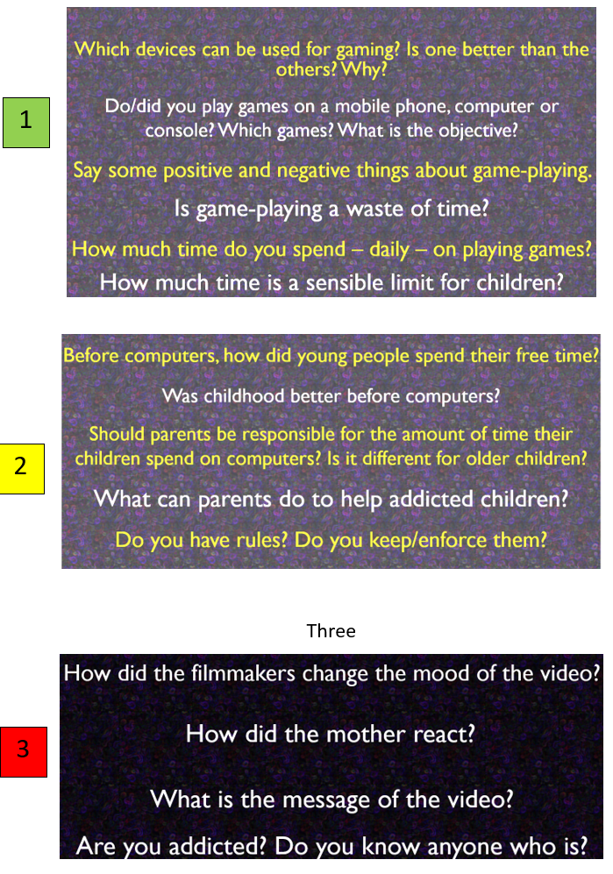

b

a

