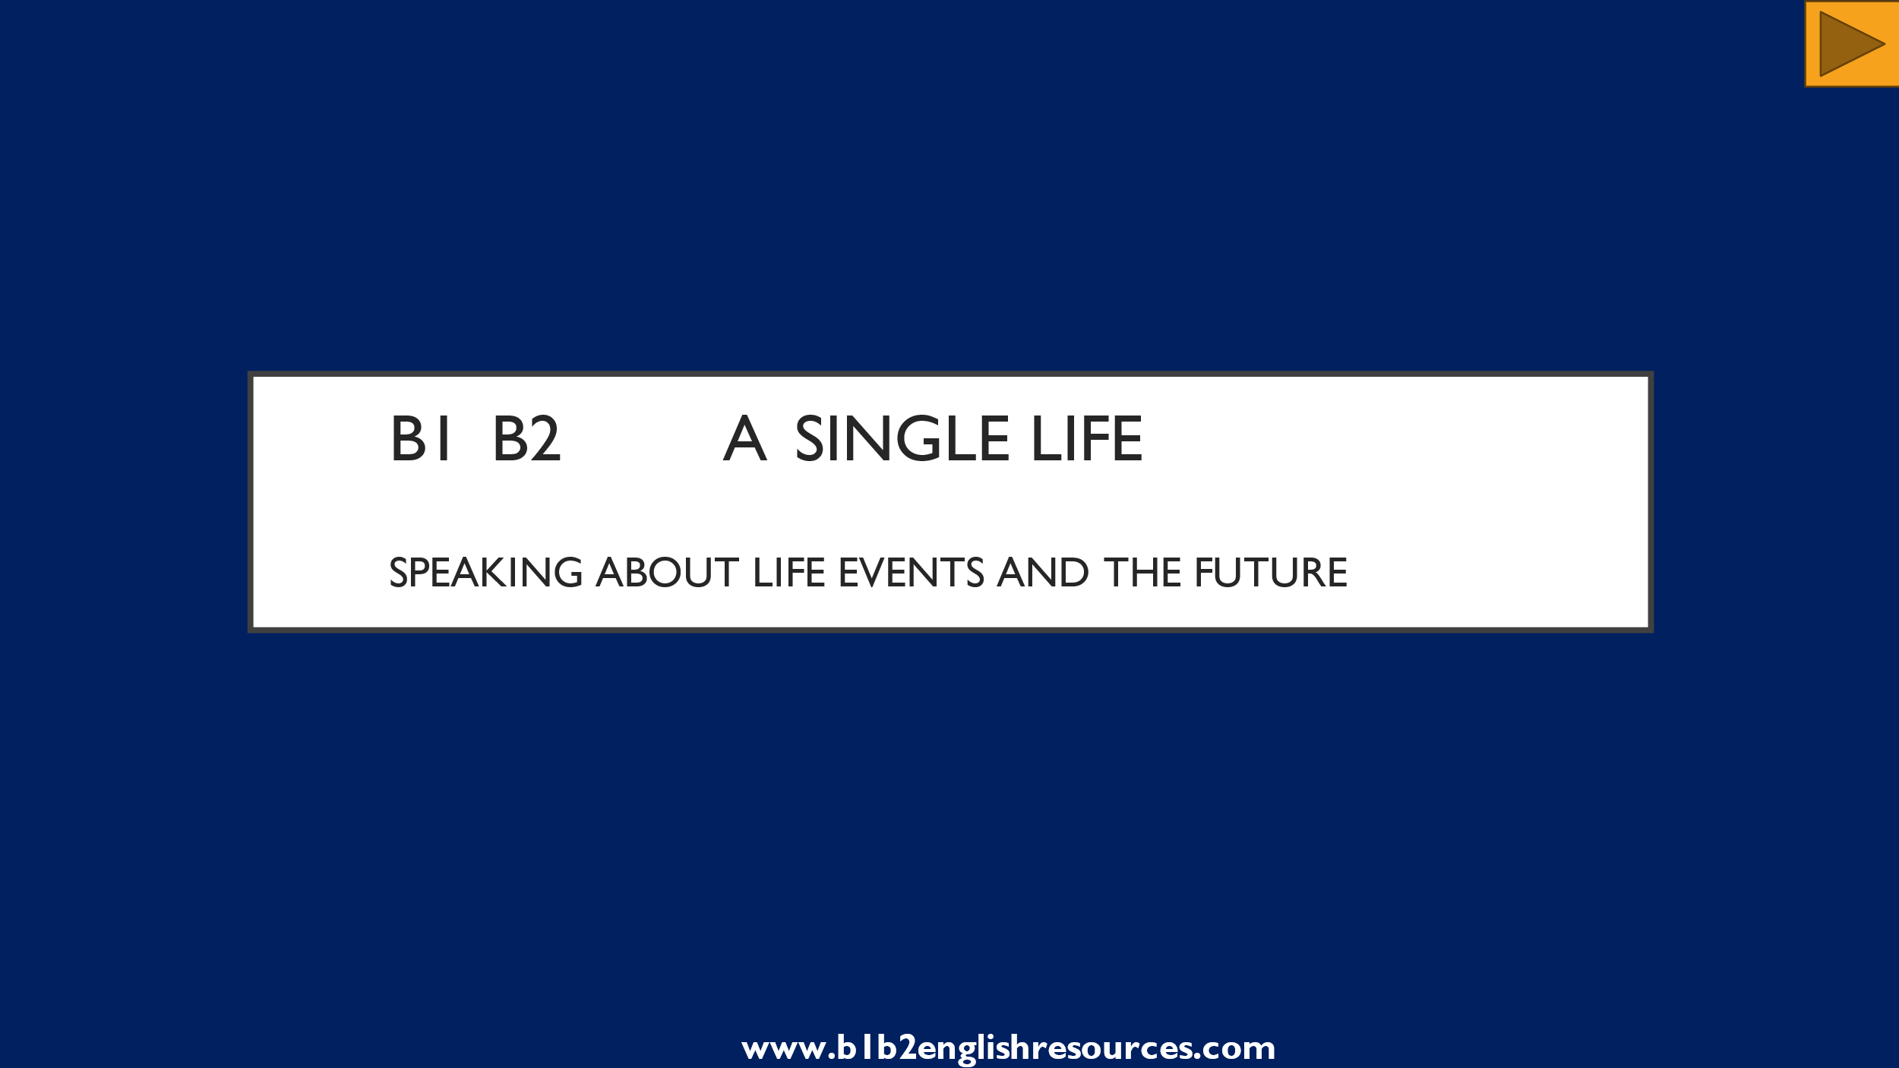

**Learning Objectives:**

**Students will practise:**

* **Describing events that happened in the past and present, and could happen in the future.**
* **Talking about milestones in life.**
* **Describing a room.**
* **Noticing and describing changes.**
* **Talking about their own hopes and plans for the future.**

**Materials:**

* **PowerPoint presentation.**
* **One video, 2’30” (YouTube link embedded in the presentation).**

**Suitable for:**

* **Intermediate students and above.**
* **All ages.**

**Sensitive vocabulary / pictures / ideas:**

* **None.**

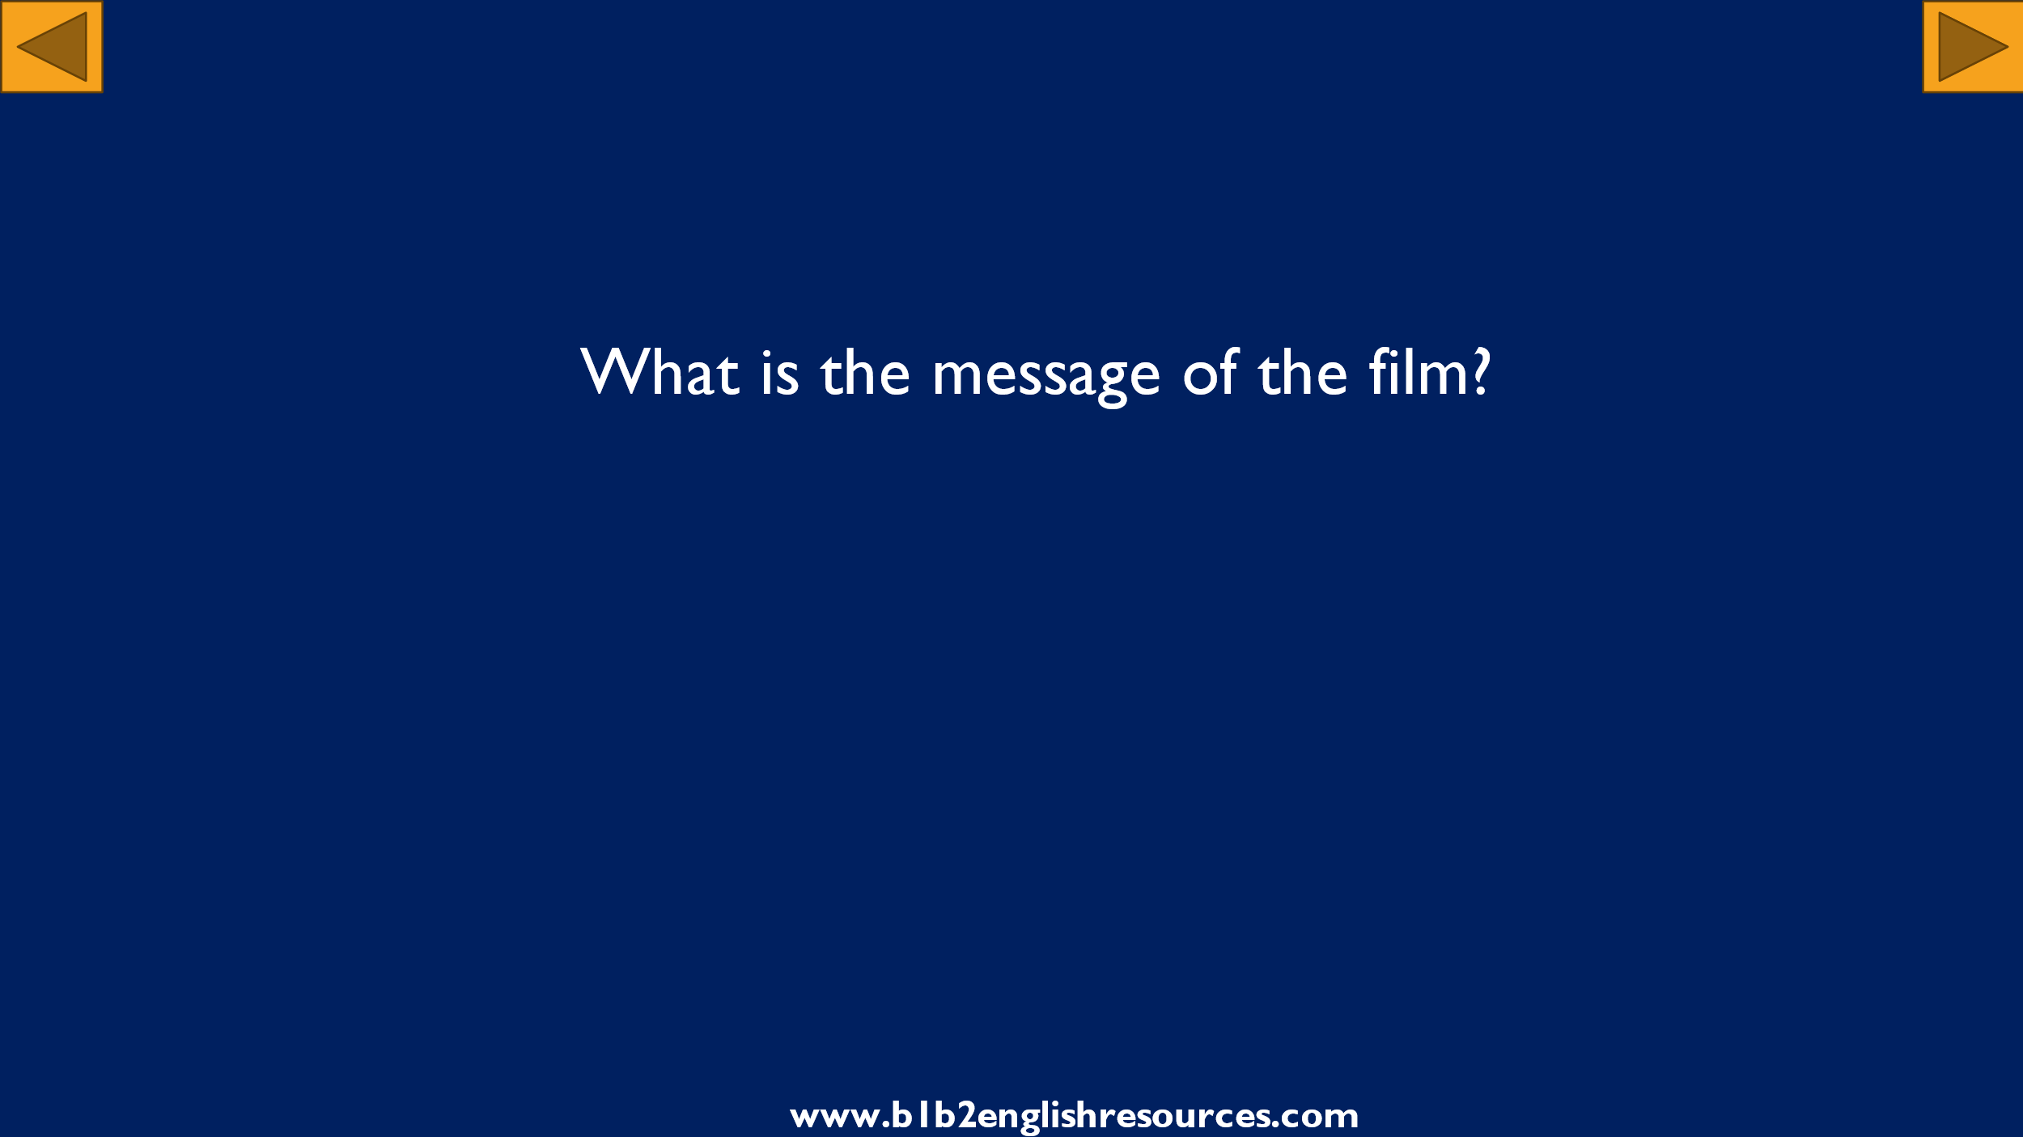

**Perhaps the message is that we should live our lives to the full because time is short.**

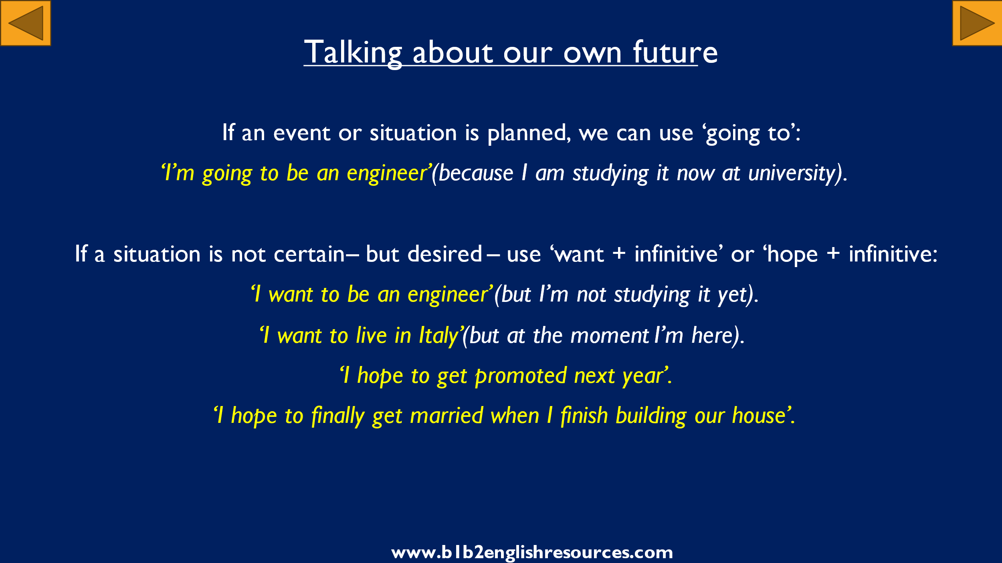

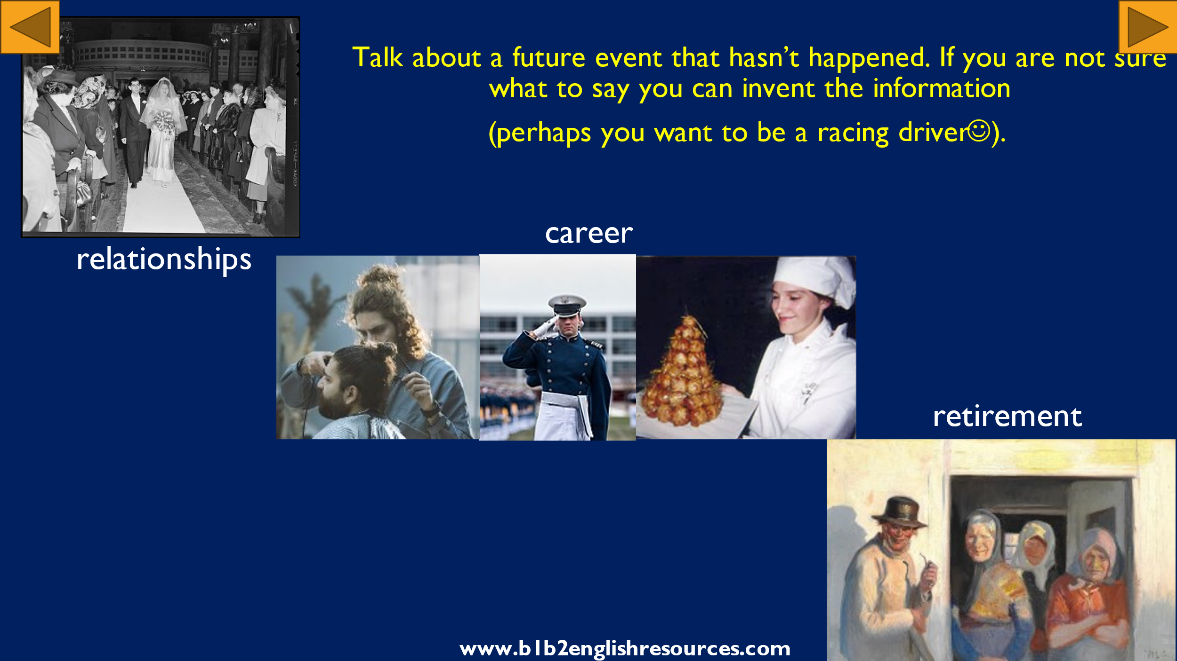

**Explain the grammar. Students speak in pairs (or with the teacher).**

