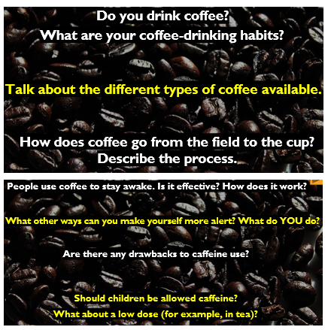
3
2
1

Kopi Luwak
Kopi Luwak coffee is one of the most exclusive and expensive non-alcoholic drinks in the world. The name refers to the method of its production and is not the name of the beans.
So, what’s so special about this coffee? You might not quite believe this, but the coffee beans are eaten in their raw state (they look like bright red berries, similar to rosehips) by an animal – usually the civet cat – and the partially digested beans are collected in the form of faeces (poop) after the animal has passed them. These beans (see picture below) are separated, have the outer shell removed, are cleaned and then roasted.
The high cost of the coffee is due to both the production process, which is labour-intensive and time-consuming, and the fact that demand is more than the supply, which pushes up the price. Even the cheaper brands of Kopi Luwak retail for more than 30 times the cost of regular coffee beans.
Lovers of coffee claim that this coffee has a special taste which can’t be experienced by drinking regular coffees. It is said to have a complex flavour which has no bitterness yet is smooth and earthy, with a hint of chocolate.

6
5
4

