 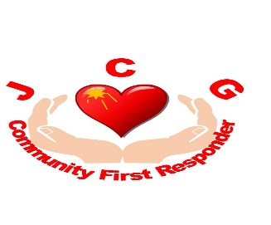

JOHNSTOWN, CROSSPATRICK ,GALMOY and GATHABAWN

CFR

CODE OF CONDUCT

As a volunteer member of the Johnstown, Crosspatrick , Galmoy and Gathabawn Community First Responders I will:

* represent the group with professionalism, dignity and pride
* be courteous and behave appropriately for any given situation
* be tactful, reassuring, understanding and sympathetic at all times with both the patient and their family, friends or bystanders as well as with fellow Responders
* maintain a high level of personal hygiene given the close contact expected with others
* maintain the training provided by attending regular refresher sessions, self-study, participating in meetings and/or additional opportunities organized by the group
* display respect for other volunteers, programme participants, visitors, clients, members of the public and property
* respect the privacy of people served by the group and fellow team members and hold in strict confidence sensitive, private and personal information, ensuring that details of any calls are not shared with anyone outside of the team and any associated paperwork is not available to any member of the public. The one exception to this is in cases of suspected child/vulnerable adults abuse/neglect, which will be handled according to the law and program policy. All information within the group is confidential and must remain so.
* ensure that any statements made to the media (print, broadcast or social) go through the coordinator. No member is authorized to communicate or issue statements to any form of media via verbal, written or printed matter.
* keep the coordinator of the group informed of progress, concerns and problems encountered while on call or stand by
* keep personal opinions and actions separate from those made as a representative of the group and the CFR program in general
* avoid conduct, both on and off duty, that would jeopardize the program effectiveness
* ensure equipment and stock is well maintained and inform the necessary parties if additional resources are needed

In addition, as a member of the Johnstown, Crosspatrick Galmoy and Gattabaun Community First Responders I will not:

* consume or be under the influence of alcohol or illegal drugs while on call or when scheduled to back up a fellow team member. If I have consumed alcohol, I will err on the side of caution and not attend calls. Equally, if I am taking any prescription medication that would impair my ability to drive or function properly, I will inform my Co-Ordinator and exercise appropriate caution when attending a patient to ensure I do not contravene road regulations.
* smoke, vape or consume alcohol without ensuring that any team logo will not be visible while doing so. I will do this in order to support the heart healthy message we, the National Ambulance Service and the Irish Heart Foundation are trying to promote.
* use vulgar or inappropriate language while representing the group
* solicit gratuities, gifts or bequests while on call or standby
* discriminate on the basis of race, colour, religion, sex, age, national origin, marital status, disability and/or sexual orientation.

Policy subject to change.

Signed CFR_______________________

Coordinator ____________________

Johnstown/Crosspatrick/Galmoy and Gathabawn Community First Responders