HOW TO: New Web Page Admin instructions
- GO to www.site.123.com
  - Log in with Kofc2269@gmail.com
    - Password Council2269!

How to Create an EMAIL BLAST
- After logging into site above click on the KoC website
- Click on Mail Listing Button
  - Then click on +Send New Message button
- Chose a template design that you would like
  - For Newletter distribution , please select a template with the button on it
  - Go to your newsletter that was uploaded to the site and link the button back to the newsletter location on the website.
    - Rename the button text to Newsletter link
  - Click next
- On Content Tab put your email subject
  - Email title
  - Type in the text box your message
  - Click Next
- On settings Tab
  - Turn Test Message OFF
  - In Filter select the Team or group tags you want the message to go to, OR leave blank for 261 emails to go out.
  - You can change the Sender name if you want it to come from YOU> and you can also Change where you want the reply emails to go by putting your own email in or leaving it to go to the Admin google email address. KofC2269@gmail.com I can provide the log to see the emails by helping you get logged into it and provide pass code. Reach out to Mike Bigler 314-915-5968
  - Click Next
- On Confirmation Verify your email is correct and hit send.
1 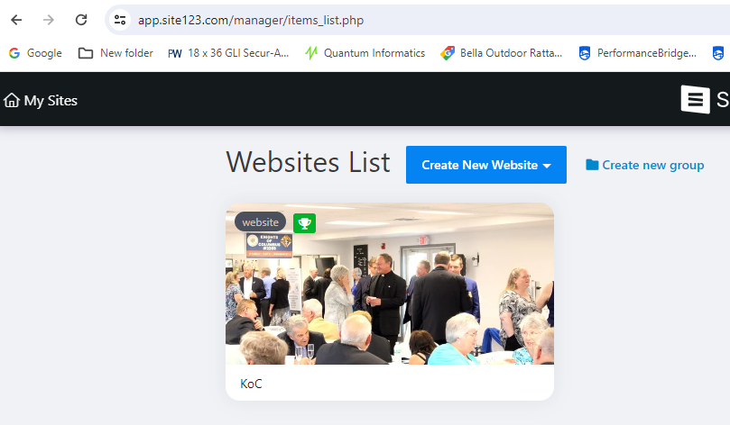
2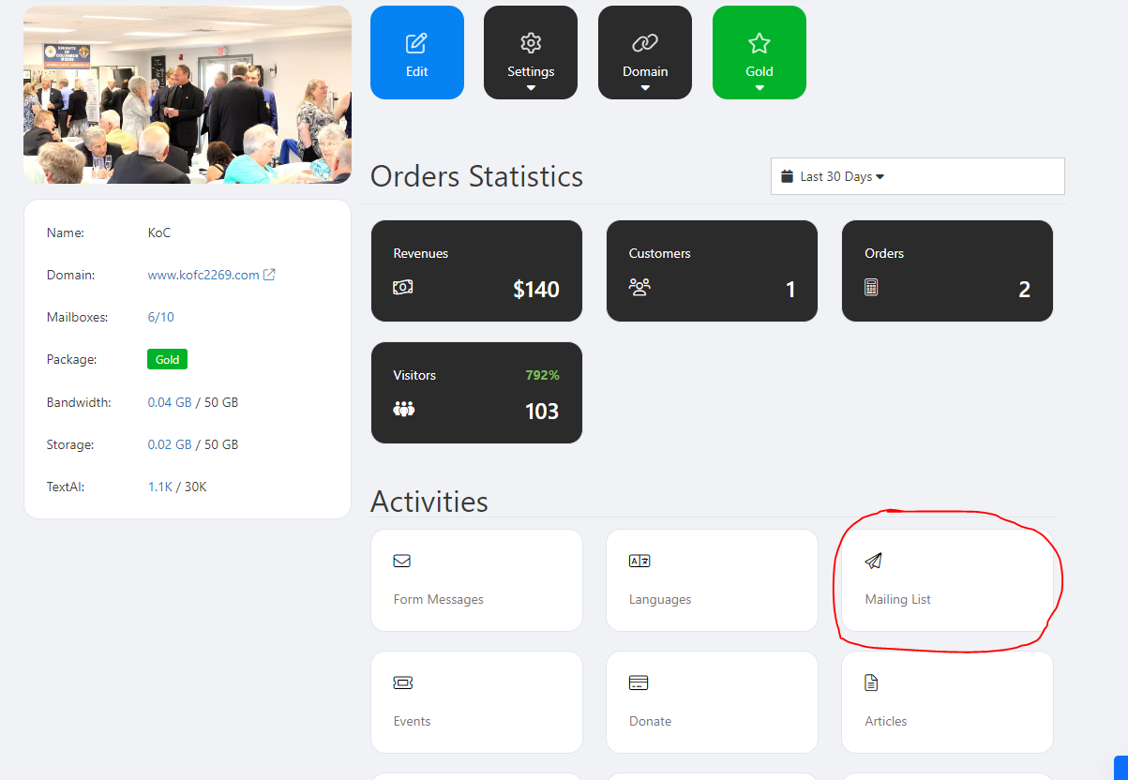
3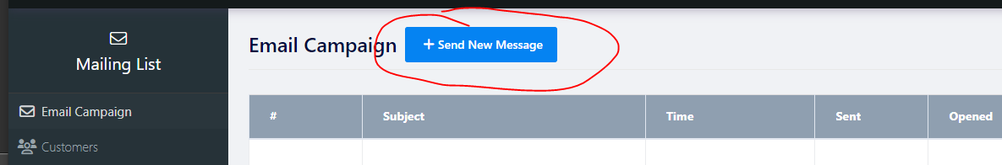
4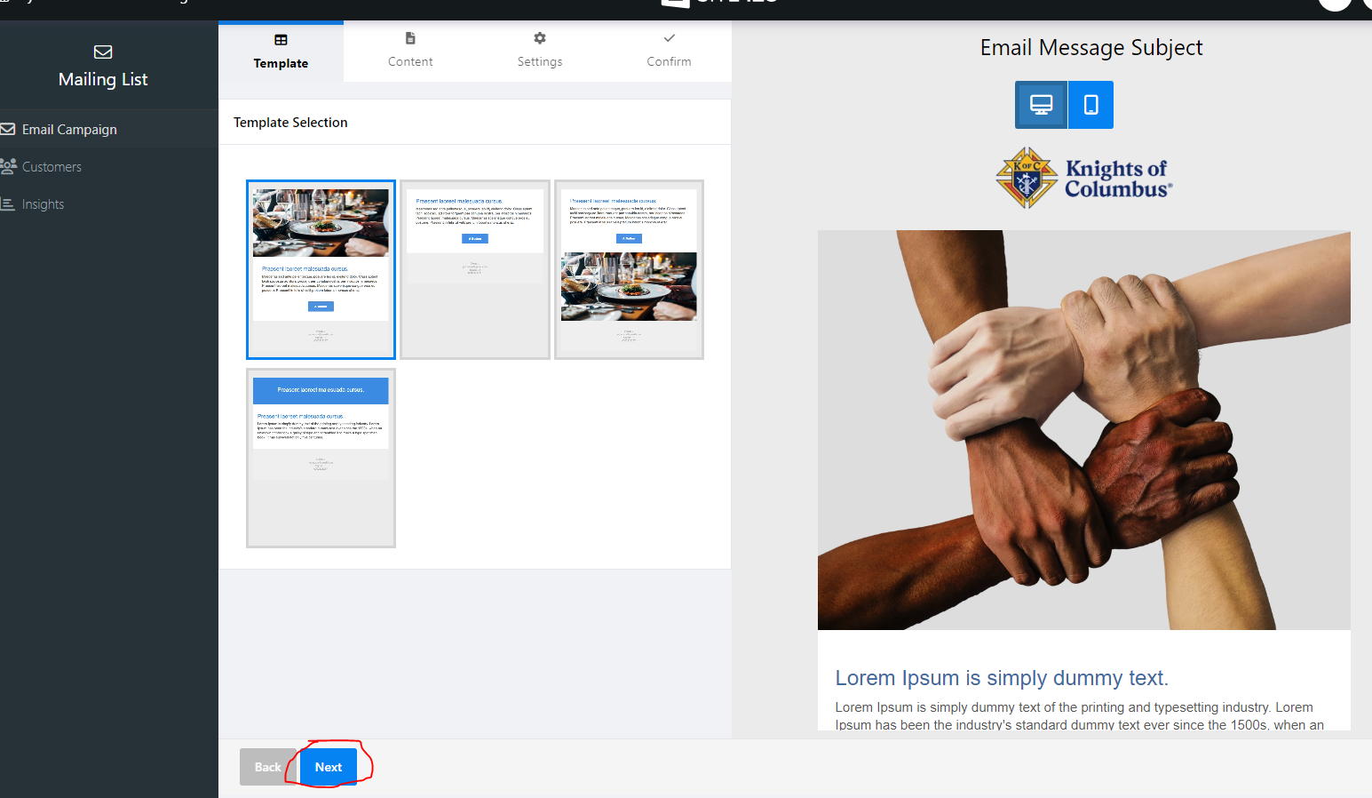
5 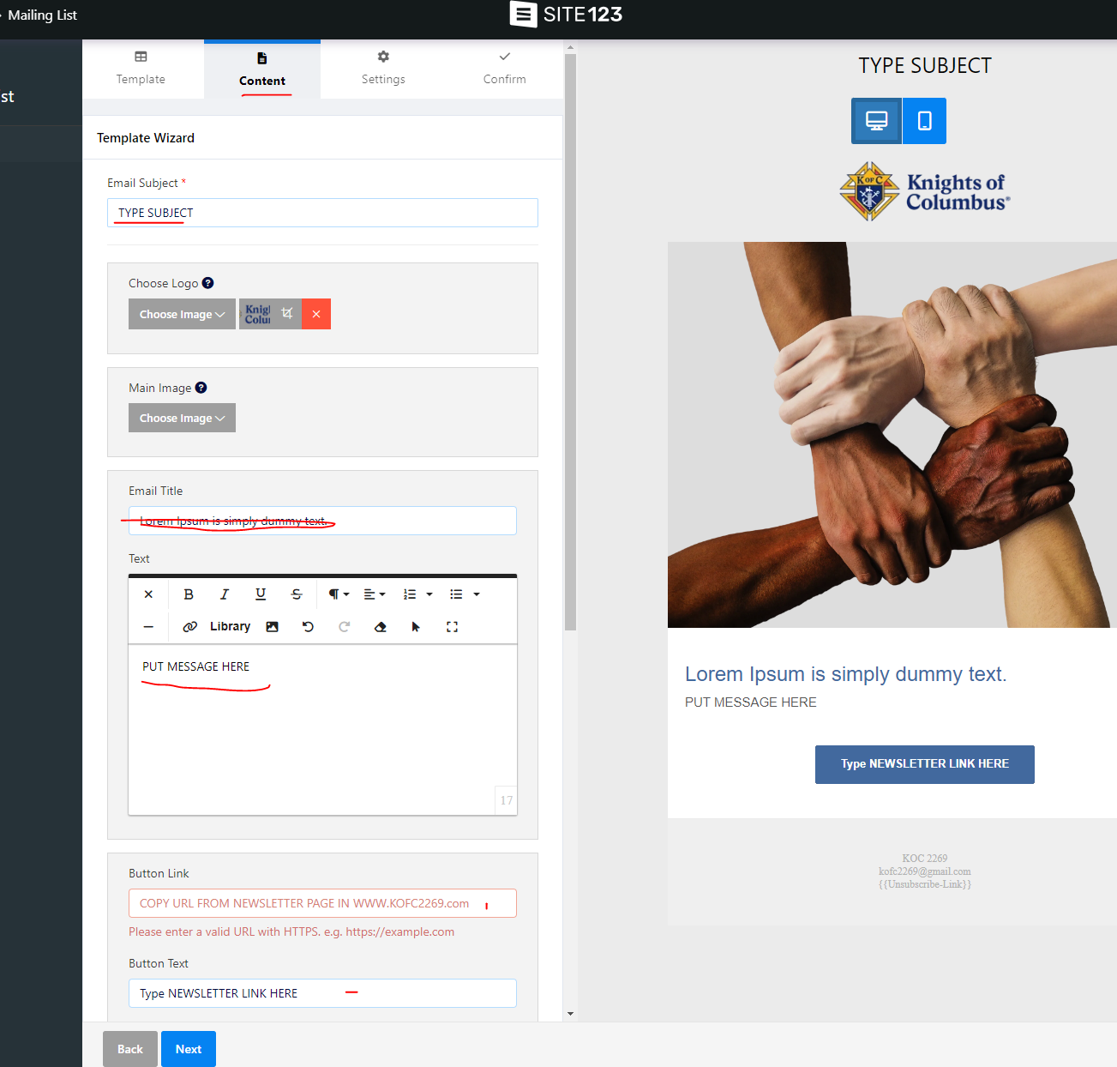
6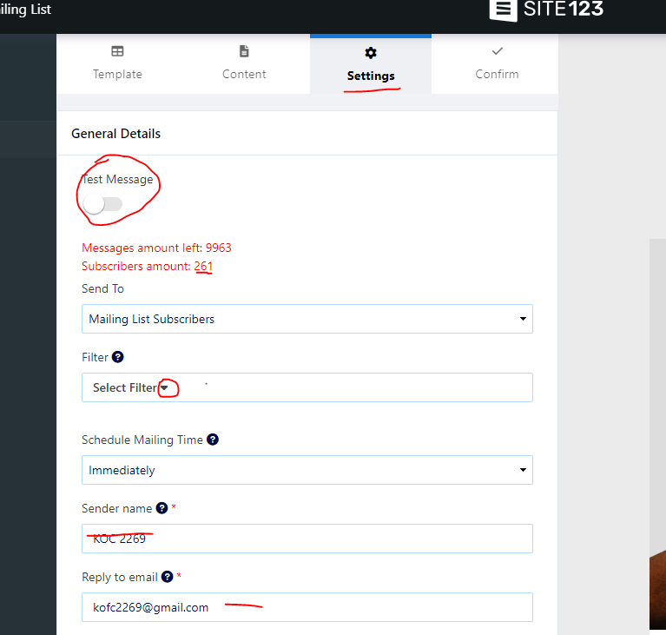
7