HOW TO SAVE A NEWSLETTER TO THE KOFC2269.COM SITE
- GO to www.site.123.com
  - Log in with Kofc2269@gmail.com
    - Password Council2269!
- Click on blog button
- Click on POSTS
  - Click on Newsletters
- Click on the upload button 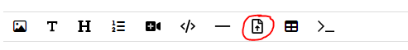
- On the new download file that it created put mouse over it and click the change button.
  - Click choose file in new window that opens
    - Click upload and tell it which pdf you are wanting to upload.
    - Name the file in the title box
    - Click update
  - Once you see your new newsletter for the month you can move it with the arrow button on the left to put it at the top of the list.

