Self-Testing

There are several ways to test your own energies and your response to substances. Whenever you are contemplating a new supplement, drug, or even which food to choose, you can test it to make sure it’s going to be healthy for you. It is important, whichever test you use, that you maintain an objective mind- do not assume, guess, or pre-determine what the outcome might be. Your unconscious mind can overcome your body’s natural response to the test.

I will describe 2 types of self-tests: The Pendulum test and the Jug or Weight test. With both tests, it is important to check before you test a substance or point whether the test is working for you.

1. **The Pendulum Test**
   1. This is a test you can do anywhere.
   2. It is best used to determine whether a substance (food, medication, vitamin, etc.) resonates with your energy system or repels it.
   3. You stand with your feet flat on the ground and feel whether your body sways forward or back in response to the substance.
   4. First, you will say your real name: “My name is….”. Your body should sway forward because this is a true statement.
   5. Next, state: “My name is Minnie (or Micky) Mouse.” Since this is not true (at least not for anyone who will be reading this) your body should sway backward.
   6. Do not try to influence the movement. Just relax, close your eyes, and feel it.
   7. If your body swayed forward for your name and backwards for the false name, you are ready to use the pendulum test.
   8. Just hold whatever substance you are testing in your hand in front of your solar plexus and see whether you sway forward or backward.
2. **The Jug Test**
   1. This is not a portable test since you need a heavy jug, bottle, or weight.
   2. It is more accurate.
   3. At home, I keep a weight on my kitchen counter and when I shop, I pick up a water jug to test.
   4. You can use any bottle filled with water, sand, stones – as long as you are able to lift it with your arm straight in front of you.
   5. You can use either arm.
3. **First you must “qualify the anterior deltoid muscle” which is what is being tested.**
   1. To make sure your testing is accurate, that it will unlock if energy is flowing and lock if not.
   2. First lift the jug to make sure you can easily.
   3. Next, pinch the muscle in front of your shoulder. 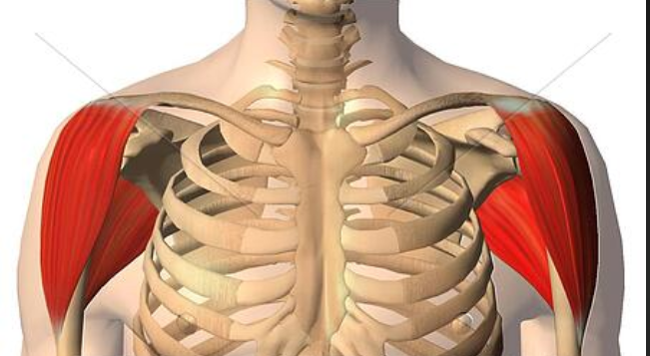
   4. The jug should be harder or impossible to lift. If it’s still easy to lift, it’s too light; add some weight.
   5. Next, trace figure 8’s over the shoulder area to unlock the muscle and enable you to lift the jug again.
   6. Once this is established, you are ready to test a substance.
4. **Testing a substance with the Jug Test**
   1. First, make sure your muscle is unlocked by lifting the jug easily with your arm straight in front of you.
   2. Then hold the substance in front of your solar plexus and lift again.
   3. If you CANNOT lift the jug with the substance, the test is over- that substance weakens you energetically.
   4. If you CAN lift it, that means the substance does not weaken you, but you can test further.
   5. Pinch the area in the front of your shoulder and try to lift the jug. It should be too heavy to lift.
   6. Then, again, hold the substance in front of your solar plexus and test.
   7. There are 2 possibilities here:
      1. If the Jug is still too hard to lift, it means the substance is **neutral** for you: it neither strengthened nor weakened you energetically.
      2. If the jug is easy to lift, the substance energetically strengthens you.