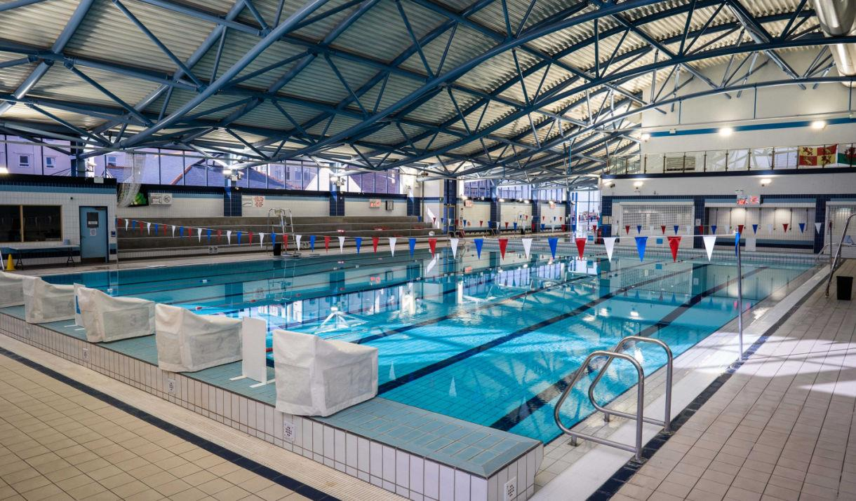

Swim Conwy Spring Meet

(Swum under FINA and Swim Wales Rules and Disciplinary Code)

Llandudno Swimming Centre

8 lane 25 metre pool, with Daktronics electronic timing

22-23rd March 2025

Warm up TBC

LEVEL 3

Licence No TBC

**CLOSING DATE 2nd March 2025**

**EVENT INFORMATION AND ENTRY FORM**

Swim Conwy Spring Meet

22 -23rd March 2025

(Swum under FINA and Swim Wales Laws and Disciplinary Code)

MEET INFORMATION

**Entries will be on a first come basis.**

Entries should be made via clubs ONLY and should be sent electronically using Hy-Tek Team Manager.

Electronic entries should be emailed to:- nofio.swimming.gala@gmail.com

Original entry forms can also be submitted to the meet organiser and a Stamped Addressed Envelope should also be supplied to allow confirmation of entries to be returned.

Completed form should be sent to: *Olwen Catherall c/o Llandudno Swimming Centre. Mostyn Broadway. Llandudno LL30 1YR*

Entries from clubs should be accompanied by a Payment Summary Sheet and a

SINGLE cheque to cover all entries and coach/chaperone poolside passes. Cheques should be payable to *Swim Conwy* or BACS

**Account Name: Swim Conwy**

**Sort Code 40-18-08**

**A/c Number 41482815**

**Reference Spring Meet/club name**

Please note that entries will be refused if: -

* They are received without the relevant fee
* They are completed incorrectly (Membership number must be included)
* They are received after the closing date of 2nd March 2025
* Ages are on 23rd March 2025

**Age Groups**

Age groups for boys - 9, 10, 11, 12, 13, 14, 15 & over

Age groups for girls - 9, 10, 11, 12, 13, 14, 15 & over

**Entry Fee**

Entry fee is £7.50 per event

**Medals and Awards**

Medals will be awarded for 1st 2nd & 3rd place Also awards to be made to Best Boy and Best Girl in each age group and a Top Team Trophy

**Spectators**

Admission charges: -

£4.00 per session

£12.00 per day

£20.00 weekend pass

**Car Parking**

The Swimming Centre is situated next to a Council Car Park. The current charges applicable are, there is limited free parking close to the centre on Mostyn Broadway.

**Catering**

Catering facilities are available at our neighbouring Theatre/Conference Centre, Venue Cymru. Alternative facilities are available in close proximity within Llandudno Retail Park.

**Camera Use**

Use of cameras and video equipment is allowed following the guidelines set by Swim Wales..

By entering this competition, the swimmer, parent or guardian accepts photographs taken by an accredited professional photographer may be used for promotional purposes by the County or the Governing Body.

**Meet Office**

A Meet Office will be open for the duration of the Meet and can be contacted via Reception. Please note that this number will be active during the meet.

**Session Times**

To be confirmed following receipt of closing date.

**General Conditions**

The Meet will be swum under: -

* FINA Technical Rules & Swim Wales Rules and Disciplinary Code.
* No alcohol or tobacco advertising is permitted on any clothing.
* Entries may only be accepted from competitors registered as members of Affiliated Clubs, holding either primary or multi registration membership.
* Swimmers must only swim for one club during this Meet.
* Competitors must have been registered members of the Club in whose name they are

entered at least 30 days prior to closing date.

* All decisions made by the Meet Director will be final and binding.
* Refunds will be done after closing date with Dr’s/Medical note.

**Events**

Events will be held as shown on the attached programme of events.

Time trials will not be permitted.

**Entry Times**

This year the event will be a ‘NO TIME’ gala. In any event where entries exceed capacity, the meet organisers reserve the right to scratch the fastest swimmers/close the event early. Any swimmers not accepted will have their fees returned.

**Presentation**

Competitors must report to medal desk after the announcements of result have been made. Medals will be ready collection during the session.

A swimmer unable to pick up their medal personally should send a deputy to pick up the medal on their behalf.

**Officials**

**Your club is asked to provide a qualified official (J1/J2) on a ratio of 10 swimmers = 1 official, and/or other volunteers to help with the running of the event. Officials will be required to follow the protocol which can be downloaded from the Swim Wales web site and will receive refreshments, lunch and refund for car parking.**

**Meet Procedure Heats**

Competitors will be seeded according to submitted times, **slowest to fastest**. Coaches should ensure that swimmers make themselves available for marshalling at least 2 events prior to the event they are competing in.

**Other conditions Starts**

Over the top starts will, where necessary or appropriate, be used during the Meet.

**Passes**

All Coaches and Chaperones, who will be on the poolside at any time during the competition, must have individual accreditation obtained by completing the official form enclosed in this Information Pack.

Accredited coaches and chaperones ***from the same club*** may use purchased poolside passes , although the number of coaches and/or chaperones on poolside at any one time must not exceed the number of passes that have been paid for.

Passes will need to be worn at all times. Anyone without a pass will be asked to leave poolside/changing area. Lunch is included for pass holders.

The closing date for passes will be the same as the closing date for entries.

***Applications will not be accepted on the day.***

**HEALTH & SAFETY**

The health, safety and wellbeing of all swimmers, officials, volunteers, spectators and visitors is paramount – all Health and Safety rules / regulations/ requirements must be complied with at all times.

A full risk assessment must be carried out in accordance with the Swim Wales Meet License Report Pack.

A copy of the Pool Operating Procedures and / or the Normal Operating Procedures & Emergency Action Plan for the facility being hired for a meet must be obtained in advance, and must be available throughout the duration of the meet

All swimmers, officials, volunteers, spectators, and visitors are required, at all times, to abide by the rules set out in the Pool Operating Procedures and / or the Normal Operating Procedures & Emergency Action Plan for the facility hired for the meet.

**Unacceptable Behavior**

Behavior becomes “unacceptable” when it is considered “Offensive” to others; this includes, but is not limited to, the following:

Theft, willful damage to property and / or equipment, acts of vandalism, abuse of alcohol and / or drugs, bullying, offensive language, aggressive / violent acts, threatening behavior, all breaches of safety practices, failure to comply with instructions / directions, actions that bring the sport of swimming into disrepute.

**Competitive Start Award**

Swimmers must have attained the standard of the Competitive Start Award in order to start from the blocks; (this is the responsibility of the club coach).

Swimmers who have not attained the standard of the Competitive Start Award must lower themselves into over the side into the water, on the long whistle of the Referee before starting at an appropriate place.

**Jewellery**

“For safety and security reasons, the wearing of jewellery is not permitted while in the water during warm-ups / swim-downs and / or competition. This includes watches, necklaces, chains, bangles, wrist bands, ear-rings (except studs), and rings (except wedding bands).

Swim Conwy will not be responsible for any jewellery brought to events and will not be liable if such jewellery is lost or damaged.”

The Region, along with the Governing Body, may use computers to record entry times and results. By submitting entries you are accepting the conditions and consent is hereby given for holding personal information relating to the sport of Swimming as required by the current Data

**Protection Act**

The organisers retain the right to amend these conditions if necessary, without notice

**Information for Spectators with Disability**

Are you a Registered Disabled person or have a disability that makes it difficult or uncomfortable for you to queue prior to paying entry as a spectator? If so: -

* On arrival at the pool please go to the reception where you will be advised on access.
* You will then be able to access the balcony via the lift or stairs directly.
* NO queuing will be necessary.

If you have any questions or queries during the event a member of the Meet Team will endeavour to assist you.

Within the spectators gallery we have 7 designated Wheel Chair access.

We are only allowed by Health & Safety regulations to admit on to the balcony 427 it would be appreciated therefore, that spectators who need assistance would arrive at the start of the warm up session thus ensuring a suitable seat is available.

(It is difficult to allocate a specific area on the balcony seating area for spectators with a disability as it might not be where they would choose to sit.

Also, if there are no disabled spectators present then we would have seating which cannot be used).

Swim Conwy

Spring Meet

(Swum under FINA and Swim Wales Rules and Disciplinary Code)

Llandudno Swimming Centre

8 lane 25 metre pool, with Daktronics electronic timing

|  |  |  |
| --- | --- | --- |
| **Schedule of Events** | | |
|  | **Saturday 22nd March** | **Sunday 23rd March** |
| Morning | ***Session 1*** | ***Session 4*** |
| Mixed 1500 Freestyle | Mixed 800 Freestyle |
| Female 50 Fly | Male 50 Fly |
| Male 100m Backstroke | Female 100m Backstroke |
| Female 100m Breaststroke | Male 100m Breaststroke |
| Male 50m Freestyle | Female 50m Freestyle |
| Afternoon | ***Session 2*** | ***Session 5*** |
| Female 200m IM | Male 200m IM |
| Male 100m Butterfly | Female 100m Butterfly |
| Female 200m Back | Male 200m Backstroke |
| Male 200m Freestyle | Female 200m Freestyle |
| Female 400m Freestyle   |  | | --- | | Male 50m Breaststroke | | Male 400m Freestyle   |  | | --- | | Female 50m Breaststroke | |
| Evening | ***Session 3*** | ***Session 6*** |
| Female 200 Fly | Male 200 Fly |
| Male 400m IM | Female 400m IM |
| Female 50m Backstroke | Male 50m Backstroke |
| Male 200m Breaststroke | Female 200m Breaststroke |
| Female 100m Free | Male 100m Free |

ISwim Conwy

Spring Meet 2025

Llandudno Swimming Centre

22-23rd March 2025

PAYMENT SUMMARY SHEET

Please return this form together with:

1. Entry Forms
2. Cheque/s made payable to *SWIM CONWY*

|  |  |
| --- | --- |
| **Club** |  |
| Name |  |
| Address |  |
|  |  |
| Post Code |  |
| Tel Home |  |
| Tel Mobile |  |
| Email |  |
| Position in Club |  |

|  |  |  |  |
| --- | --- | --- | --- |
| **Summary** | Number |  |  |
| Total Individual Entries |  | @ £7.50 | £ |
| Total Poolside Passes (includes lunch) |  | @ £25.00 (weekend)* | £ |
| Total Cheque Enclosed made payable to SWIM CONWY |  |  | £ |

**\*cost waived if an official is provided for each day**

PLEASE NOTE ONLY MEMBERS REGISTERED WITH SWIM

WALES/ASA AND HAVING A DBS CHECK

(If required by governing body) ARE ELIGIBLE FOR COACH/CHAPERONE PASS

I confirm all swimmers are current members and have paid the appropriate membership fee.

I declare that only our team members who have reached the standard of the ASA Competitive Start Award will be permitted to start from the poolside. Those who have not will start in the water.

I confirm all the Meet Conditions have been brought to the attention of swimmers, parents/guardians and coaches including the rules regarding photography.

I agree to abide by the conditions laid down by the Swim Conwy Meet Organisers for this event.

Signature Date:

**Return to:** *Olwen Catherall, c/o Llandudno Swimming Centre, Mostyn Broadway, Llandudno. LL30 1YR*

**Email:**

**Nofio.swimming.gala@gmail.com**

**Closing Date: Sunday 2nd March 2025**