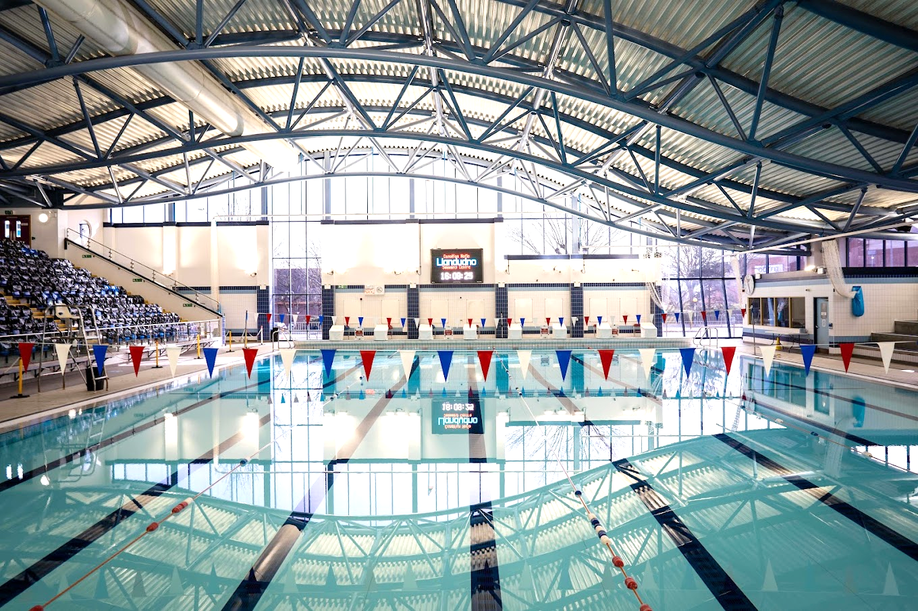

Llandudno Swimming Centre

18th & 19th October 2025

8 Lane 25-meter main pool with Daktronics electronic timing and cooldown pool

 Conwy Autumn Gala 2025

Level 2 Meet

License No: 2WL251529

Closing date 25th September 2025

CLOSING DATE 17.00 25th September 2025 EVENT INFORMATION AND ENTRY FORM

CONWY AUTUMN GALA 2025 - L2

18TH & 19TH October 2025

(Swum under FINA and Swim Wales Laws and Disciplinary Code)

MEET INFORMATION

Entries

Entries should be made via clubs ONLY and should be sent electronically using Hy-Tek Team Manager. The events file for use with TM is available from the Swim Wales website & nofio.swimming.gala@gmail.com

Electronic entries should be emailed to:- nofio.swimming.gala@gmail.com

Completed form should be sent to: Olwen Catherall c/o Llandudno Swimming Centre. Mostyn Broadway. Llandudno LL30 1YR

Entries from clubs should be accompanied by a Payment Summary Sheet and a

SINGLE cheque to cover all entries and coach/chaperone poolside passes. Cheques should be payable to SWIM CONWY

Please note that entries will be refused if: -
- They are received without the relevant fee
- They are completed incorrectly (Membership number must be included)
- They are received after the closing date
- Ages are as at 19TH Oct 2025. (Final date of the event)

Age Groups

Age groups for boys - 9, 10,11,12,13,14, 15&Over

Age groups for girls - 9,10,11,12,13,14,15&Over

Entry Fee

Entry fee is £7.50 per event

1500m and 800m £10.00

Medals and Awards

Medals will be awarded for 9,10,11,12,13,14,15 & Over 1st 2nd & 3rd places in all age group categories. Awards to be made to Best Club, Best Boy and Best Girl overall.

Skins
Individual ‘Skins’ events will be held in conjunction with the meet. Entries for the Skins events are selected from the 8 highest placed competitors in the 200m IM events. These events are for boys 14yrs&under and 15yrs&over, and girls 14yrs&under and 15yrs&over.

Spectators Admission charges:-

£4.00 per session

£10.00 per day

£20 weekend pass

Results will be on Meet Mobile and shared with Clubs.

Car Parking

The Swimming Centre is situated next to a Council Car Park. The current charges applicable are, there is limited free parking close to the centre on Mostyn Broadway.

Catering

Catering facilities are available at our neighbouring Theatre/Conference Centre, Venue Cymru. Alternative facilities are available in close proximity within Llandudno Retail Park.

Camera Use

We will follow Swim Wales and Ffit Conwy Guidance.

Meet Office

A Meet Office will be open for the duration of the Meet and can be contacted via Reception. Please note that this number will be active during the meet.

Session Times

To be confirmed following receipt of entries.

General Conditions

The Meet will be swum under: -
- FINA Technical Rules & Swim Wales Rules and Disciplinary Code.
- No alcohol or tobacco advertising is permitted on any clothing.
- Entries may only be accepted from competitors registered as members of
- affiliated Clubs, holding either primary or multi registration membership.
- Swimmers must only swim for one club during this Meet.
- Competitors must have been registered members of the Club in whose name they
- are entered at least 30 days prior to closing date.
- All decisions made by the Meet Director will be final and binding.
- Refunds will only be given with a Dr’s note.

Events

Events will be held as shown on the attached programme of events.

Time trials will not be permitted.

There will be 800m and 1500m events for both male and female athletes. This will be limited to the number of entries and will be confirmed after the closing date.

Entry Times

The Organisers may request validation of any stated Entry Time.

In any event where entries exceed capacity, the meet organisers reserve the right to limit entries with the faster swimmers in each event being given priority. Any swimmers not accepted will have their fees returned. Entries will be confirmed after closing date, if the Meet is oversubscribed, slowest swimmers might be scratched.

Officials

Each club must supply qualified officials (judges) to help with the running of the event. This will be based on number of swimmers attending from each club, 1-10,2-20 3-30+. Failure to do so might affect your accepted entries.

Officials will need to register their availability on Swim Meet. Officials get free parking, lunch and refreshments.

Meet Procedure Heats

Competitors will be seeded according to submitted times, slowest to fastest. Coaches should ensure that swimmers make themselves available for marshalling at least 2 events prior to the event they are competing in. 1500m and 800m will be restricted to 2 heats.

Other conditions Starts

Over the top starts will, where necessary or appropriate, be used during the Meet. Backstroke ledges will be used.

Passes

All Coaches and Chaperones, who will be on the poolside at any time during the competition, must have individual accreditation obtained by completing the official form enclosed in this Information Pack.

Accredited coaches and chaperones from the same club may use purchased poolside passes 'on rota', although the number of coaches and/or chaperones on poolside at any one time must not exceed the number of passes that have been paid for.

Passes will need to be worn at all times. Anyone without a pass will be asked to leave poolside/changing area.

The closing date for passes will be the same as the closing date for entries.

Applications will not be accepted on the day.

HEALTH & SAFETY

The health, safety and wellbeing of all swimmers, officials, volunteers, spectators and visitors is paramount – all Health and Safety rules / regulations/ requirements must be complied with at all times.

Protection Act

The organisers retain the right to amend these conditions if necessary, without notice.

Information for Spectators with Disability

Are you a Registered Disabled person or have a disability that makes it difficult or uncomfortable for you to queue prior to paying entry as a spectator? If so: -
- On arrival at the pool please go to the reception where you will be advised on access.
- You will then be able to access the balcony via the lift or stairs directly.
- NO queuing will be necessary.

If you have any questions or queries during the event a member of the Meet Team will endeavour to assist you.

Within the spectators gallery we have 7 designated Wheelchair places.

We are only allowed by Health & Safety regulations to admit on to the balcony 427 it would be appreciated therefore, that spectators who need assistance would arrive at the start of the warm up session thus ensuring a suitable seat is available.

(It is difficult to allocate a specific area on the balcony seating area for spectators with a disability as it might not be where they would choose to sit.

Also, if there are no disabled spectators present then we would have seating which cannot be used).

CONWY AUTUMN GALA – L2

(Swum under FINA and Swim Wales Rules and Disciplinary Code)

 | Saturday 18TH Oct | Sunday 19th Oct
Morning | Session 1 | Session 4
 | Female 50m Freestyle | Male 50m Freestyle
 | Male 400m IM | Female 400m IM
 | Female 200m Backstroke | Male 200m Backstroke
 | Male 100m Butterfly | Female 100m Butterfly
 | Mixed 800m Freestyle | Mixed 1500m Freestyle
Afternoon | Session 2 | Session 5
 | Male 200 IM | Female 200 IM
 | Female 400m Freestyle | Male 400m Freestyle
 | Male 100m Backstroke | Female 100m Backstroke
 | Female 200m Breaststroke | Male 200m Breaststroke
 | Male 200m Freestyle | Female 200m Freestyle
 | Female 50m Breaststroke | Male 50m Breaststroke
 | Skins boys 14&under | Skins girls 14&under
Evening | Session 3(short warmup) | Session 6(short warm up)
 | Male 50m Butterfly | Female 50m Butterfly
 | Female 50m Backstroke | Male 50m Backstroke
 | Male 100 Breaststroke | Female 100 Breaststroke
 | Female 200m Butterfly | Male 200m Butterfly
 | Male 100m Freestyle | Female 100m Freestyle
 | Skins boys 15&over | Skins girls15&over

SWIM CONWY L2

AUTUMN GALA 2025

Llandudno Swimming Centre

ENTRY FORM

Name |  |  |  | Club
Address |  |  |  | DOB
Phone |  |  | Age (on 19/10/25) |  | M/F

please enter entry times below

50m Freestyle
100m Freestyle |  | 200m IM
200m Freestyle |  | 400m IM
400m Freestyle |  | 50m Breaststroke
Mixed 800m Freestyle |  | 100m Breaststroke
Mixed 1500m Freestyle |  | 200m Breaststroke
50m Backstroke |  | 50m Butterfly
100m Backstroke |  | 100m Butterfly
200m Backstroke |  | 200m Butterfly
 |  | Total number of entries.

I declare that the above particulars are correct and agree to abide by the Meet conditions. I accept that there will be no refund of entry fees unless the Meet is oversubscribed.

Signature of Competitor: ....................................................…………………………….Date:......................................

SWIMMERS ARE WARNED THAT RANDOM DOPING CONTROL MAY TAKE PLACE DURING THIS MEET. All competitors, and if competitors are under the age of 18 years on the first day of competition, parents guardians or persons with parental responsibility as defined by the Children Act 1989 are reminded that a condition of membership of Swim Wales is that a swimmer must consent to being drug tested if required.

TO BE COMPLETED BY PARENT/GUARDIAN IF SWIMMER IS UNDER THE AGE OF 18 ON FIRST DAY OF COMPETITION. I confirm that I am a person having parental responsibility in accordance with the Children Act 1989 and that I have read and accept the Championship Information and Conditions.

I also confirm that the above competitor has achieved the ASA Competitive Start Award.

Signature of Parent/Guardian: ...........................................……................................ Date:........................................

Print Name………………………………………………………………………………………………………..

Closing Date: 17.00 23rd September 2025

PLEASE NOTE ONLY MEMBERS REGISTERED WITH SWIM

WALES/ASA AND HAVING A DBS CHECK

(If required by governing body)

ARE ELIGIBLE FOR COACH/CHAPERONE PASS

SWIM CONWY AUTUMN MEET 2025

Llandudno Swimming Centre

PAYMENT SUMMARY SHEET

Please return this form together with:
- Entry Forms
- Cheque/s made payable to SWIM CONWY
- BACS Payment-Account Name SWIM CONWY, sort code 40-18-08 Account No 41482815

Club

Name

Address

Post Code

Tel Home

Tel Mobile

Email

Summary | Number
Total Individual Entries  800m Freestyle&1500m Freestyle |  | @ £7.50  @£10.00 | £
Total Poolside Passes |  | @ £15.00 per day  @£25.00 per weekend (inc lunch &  rerefreshments) | £
Total Cheque Enclosed made payable to SWIM CONWY. |  |  | £

It is requested that a single cheque for the complete club entry is submitted or BACS

I confirm all swimmers are current members and have paid the appropriate membership fee.

I declare that only our team members who have reached the standard of the ASA Competitive Start Award will be permitted to start from the poolside. Those who have not will start in the water.

I confirm all the Meet Conditions have been brought to the attention of swimmers, parents/guardians and coaches including the rules regarding photography.

I agree to abide by the conditions laid down by the Swim Conwy Meet Organisers for this event.

Signature Date:

Return to: Olwen Catherall, c/o Llandudno Swimming Centre, Mostyn Broadway, Llandudno. LL30 1YR

Email: nofio.swimming.gala@gmail.com

Level 2 Meets Qualifying Times

BOYS |  |  |  |  |  |  |  |  |  | GIRLS
 | 9 | 10 | 11 | 12 | 13 | 14 | 15&O |  | Event | 9 | 10 | 11 | 12 | 13 | 14 | 15&O
QT | 46.00 | 44.00 | 42.00 | 41.00 | 38.00 | 37.00 | 36.00 |  | 50m Free | 49.00 | 46.00 | 45.00 | 44.00 | 41.00 | 40.00 | 38.00
QT | 1:40.00 | 1.38.00 | 1:35:00 | 1.33.00 | 1:29:00 | 1.27.00 | 1:25:00 |  | 100m Free | 1:47:00 | 1.44.00 | 1:32:00 | 1.28.00 | 1:25:00 | 1.24.00 | 1:22:00
QT | 3:23:00 | 3.25.00 | 2:58:00 | 2.55.00 | 2:40:00 | 2.30.00 | 2:28:00 |  | 200m Free | 3:25:00 | 3.18.00 | 3:13:00 | 3.00.00 | 2:58:00 | 2.55.00 | 2:51:00
QT | 6:40:00 | 6.20.00 | 5:58:00 | 5.40.00 | 5:21:00 | 5.15.00 | 5.00.0 |  | 400m Free | 6:52:20 | 6.30.00 | 6:00:00 | 5.50.00 | 5.40.00 | 5.00.00 | 5.26.20
QT | 15.00.0 | 13.30.0 | 12.30.0 | 11.30.0 | 11.00.0 | 10.30.0 | 10.15.0 |  | 800m Free | 15.00.0 | 13.30.0 | 12.30.0 | 11.30.0 | 11.00.0 | 10.30.0 | 10.30.0
QT | 26.30.0 | 25.00.0 | 23.00.0 | 22.30.0 | 22.00.0 | 20.00.0 | 20.00.0 |  | 1500m Free | 27.00.0 | 25.00.0 | 23.00.0 | 22.00.0 | 21.00.0 | 21.00.0 | 21.00.0
QT | 1.10.00 | 1.00.00 | 1.03.00 | 55.00 | 48.00 | 46.00 | 45.00 |  | 50m Breast | 1.12.00 | 1.10.00 | 1.01.00 | 1.00.00 | 56.00 | 55.00 | 53.00
QT | 2:15:00 | 2.00.00 | 1:51:00 | 1.45.00 | 1:40:00 | 1.20.00 | 1:34:00 |  | 100m Breast | 2:21:00 | 2.10.00 | 2:01:00 | 2.00.00 | 1:50:00 | 1.48.00 | 1:46:00
QT | 4:40:00 | 4.20.00 | 3:48:00 | 3.30.00 | 3:28:00 | 3.20.00 | 3:15:00 |  | 200m Breast | 4:38:00 | 4.30.00 | 4:05:00 | 4.00.00 | 3:43:00 | 3.40.00 | 3:35:00
QT | 1.08.00 | 1.05.00 | 1.02.00 | 1.00.00 | 56.00 | 55.00 | 52.00 |  | 50m Fly | 1.09.00 | 1.06.00 | 1.03.00 | 1.00.00 | 59.00 | 58.00 | 57.00
QT | 2:22:00 | 2.00.00 | 1:48:00 | 1.45.00 | 1:36:00 | 1.28.00 | 1:31:00 |  | 100m Fly | 2:13:00 | 2.00.00 | 1:52:00 | 1.55.00 | 1:43:00 | 1.40.00 | 1:39:00
QT | 4:35:00 | 4.00.00 | 3:30:00 | 3.20.00 | 3:06:00 | 3.00.00 | 2:50:00 |  | 200m Fly | 4:33:00 | 4.00.00 | 3:46:00 | 3.30.00 | 3:26:00 | 3.20.00 | 3:15:00
QT | 1.10.00 | 1.05.00 | 1.00.00 | 58.00 | 55.00 | 54.00 | 50.00 |  | 50m Back | 1.09.00 | 1.06.00 | 1.03.00 | 1.00.00 | 58.00 | 57.00 | 56.00
QT | 2:10:00 | 2.00.00 | 1:48:00 | 1.45.00 | 1:38.0 | 1.35.00 | 1:33:00 |  | 100m Back | 2:08:00 | 2.00.00 | 1:51:00 | 1.48.00 | 1:43:00 | 1.40.00 | 1:39:00
QT | 3:59:00 | 3.40.00 | 3:30:0 | 3.20.00 | 3:15:00 | 3.10.00 | 2:50:00 |  | 200m Back | 4:02:00 | 4.00.00 | 3:40:00 | 3.30.00 | 3:23:00 | 3.20.00 | 3:15:00
QT | 3:59:00 | 3.40.00 | 3:30:00 | 3.20.00 | 3:15:00 | 3.00.00 | 2:50:00 |  | 200m IM | 4:23:00 | 4.00.00 | 3:44:00 | 3.40.00 | 3:27:00 | 3.25.00 | 3:20:00
QT | 8:00:00 | 7.30.00 | 7:20:00 | 7.00.00 | 6:40:00 | 6.30.00 | 6:20:00 |  | 400m IM | 8.00.00 | 7.30.00 | 7.20.00 | 7.00.00 | 6:53:00 | 6.50.00 | 6:42:00

