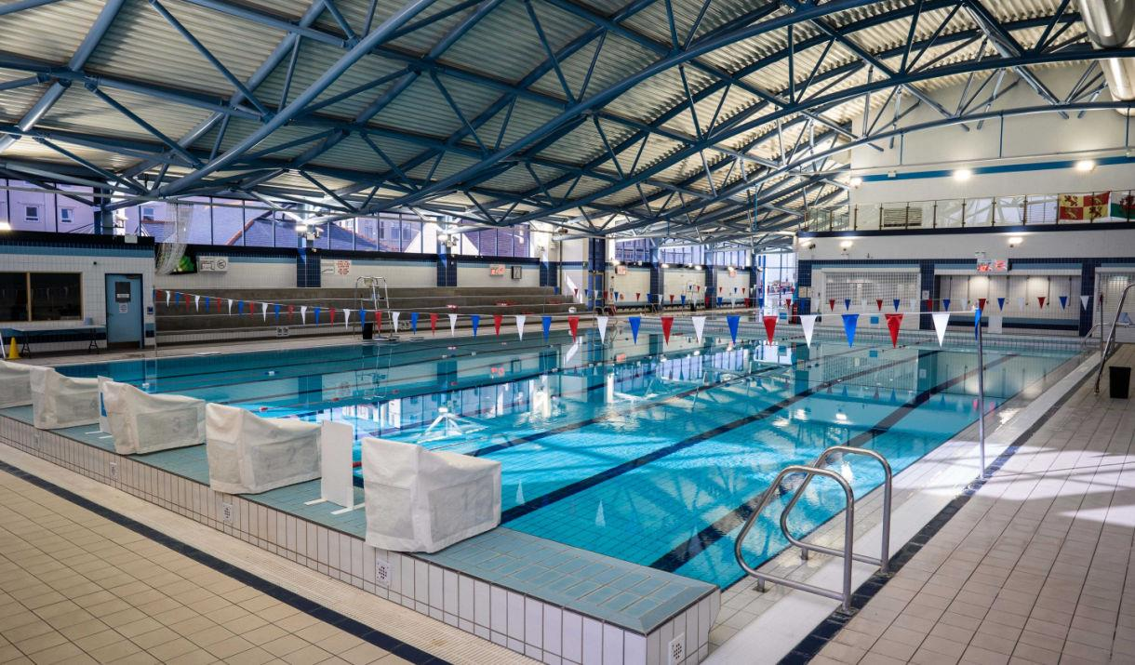
Conwy Spring Meet

Llandudno Swimming Centre

8 lane 25 metre pool, with Daktronics electronic timing

21st – 22nd March 2026

Level 3

Licence No:

CLOSING DATE 28th February 2026

EVENT INFORMATION AND ENTRY FORM

Swim Conwy Spring Meet
21st – 22nd March 2026

MEET INFORMATION

Entries will be on a first come basis.
Entries should be made via clubs ONLY and should be sent electronically using Hy-Tek Team Manager.

Electronic entries should be emailed to:- nofio.swimming.gala@gmail.com

Original entry forms can also be submitted to the meet organiser and a Stamped Addressed Envelope should also be supplied to allow confirmation of entries to be returned.

Completed form should be sent to: Olwen Catherall c/o Llandudno Swimming Centre. Mostyn Broadway. Llandudno LL30 1YR

Entries from clubs should be accompanied by a Payment Summary Sheet and a
SINGLE cheque to cover all entries and coach/chaperone poolside passes. Cheques should be payable to Swim Conwy or BACS

Account Name: Swim Conwy
Sort Code 40-18-08
A/c Number 41482815
Reference Spring Meet/club name

Please note that entries will be refused if: -
- They are received without the relevant fee
- They are completed incorrectly (Membership number must be included)
- They are received after the closing date of 28th February 2026
- Ages are on 22nd March 2026.

Age Groups
Age groups for boys - 9, 10, 11, 12, 13, 14, 15 & over
Age groups for girls - 9, 10, 11, 12, 13, 14, 15 & over

Entry Fee
Entry fee is £8.00 per event

Medals and Awards
Medals will be awarded for 1st 2nd & 3rd place. Also awards to be made to Best Boy and Best Girl and a Top Team Trophy

Spectators
Admission charges: -
£4.00 per session
£12.00 per day
£20.00 weekend pass

Car Parking
The Swimming Centre is situated next to a Council Car Park. The current charges applicable are, there is limited free parking close to the centre on Mostyn Broadway.

Camera Use
Use of cameras and video equipment is allowed following the swimming centre policies.

Meet Office
A Meet Office will be open for the duration of the Meet and can be contacted via Reception. Please note that this number will be active during the meet.

Session Times
To be confirmed following receipt of closing date.

General Conditions
The Meet will be swum under: -
- FINA Technical Rules & Swim Wales Rules and Disciplinary Code.
- No alcohol or tobacco advertising is permitted on any clothing.
- Entries may only be accepted from competitors registered as members of Affiliated Clubs, holding either primary or multi registration membership.
- Swimmers must only swim for one club during this Meet.
- Competitors must have been registered members of the Club in whose name they are
entered at least 30 days prior to closing date.
- All decisions made by the Meet Director will be final and binding.
- Refunds will be done after closing date with Dr’s/Medical note.

Events
Events will be held as shown on the attached programme of events.
Time trials will not be permitted.

Entry Times
This year the event will be a ‘NO TIME’ gala. In any event where entries exceed capacity, the meet organisers reserve the right to scratch the fastest swimmers/close the event early. Any swimmers not accepted will have their fees returned.

Presentation
Medals can be collected from the medal desk after the announcements of result have been made. Medals will be ready collection during the session.
A swimmer unable to pick up their medal personally should send a deputy to pick up the medal on their behalf.

Officials
Your club is asked to provide a qualified official (J1/J2) on a ratio of 10 swimmers = 1 official, and/or other volunteers to help with the running of the event. Officials will be required to follow the protocol which can be downloaded from the Swim Wales web site and will receive refreshments, lunch and refund for car parking.

Meet Procedure Heats
Competitors will be seeded according to submitted times, slowest to fastest. Coaches should ensure that swimmers make themselves available for marshalling at least 2 events prior to the event they are competing in.

Other conditions Starts
Over the top starts will, where necessary or appropriate, be used during the Meet.

Passes
All Coaches and Chaperones, who will be on the poolside at any time during the competition, must have individual accreditation obtained by completing the official form enclosed in this Information Pack.

Accredited coaches and chaperones from the same club may use purchased poolside passes although the number of coaches and/or chaperones on poolside at any one time must not exceed the number of passes that have been paid for.
Passes will need to be worn at all times. Anyone without a pass will be asked to leave poolside/changing area. Lunch is included for pass holders.

The closing date for passes will be the same as the closing date for entries.
Applications will not be accepted on the day.

HEALTH & SAFETY

All swimmers, officials, volunteers, spectators, and visitors are required, at all times, to abide by the rules set out in the Pool Operating Procedures and / or the Normal Operating Procedures & Emergency Action Plan for the facility hired for the meet.

Competitive Start Award

Swimmers must have attained the standard of the Competitive Start Award in order to start from the blocks; (this is the responsibility of the club coach).

Swimmers who have not attained the standard of the Competitive Start Award must lower themselves into over the side into the water, on the long whistle of the Referee before starting at an appropriate place.

Jewellery

For safety and security reasons, the wearing of jewellery is not permitted while in the water during warm-ups / swim-downs and / or competition. This includes watches, necklaces, chains, bangles, wrist bands, ear-rings (except studs), and rings (except wedding bands).

Swim Conwy will not be responsible for any jewellery brought to events and will not be liable if such jewellery is lost or damaged.”

Computer use

Computers may be used to record entry times and results. By submitting entries you are accepting the conditions and consent is hereby given for holding personal information relating to the sport of Swimming as required by the current GPDR.

Information for Spectators with Disability

If you are a Registered Disabled person or have a disability that makes it difficult or uncomfortable for you to queue prior to paying entry as a spectator.
- On arrival at the pool please go to the reception where you will be advised on access.
- You will then be able to access the balcony via the lift or stairs directly.
- NO queuing will be necessary.

If you have any questions or queries during the event a member of the swimming centre will endeavour to assist you.

Within the spectator’s gallery we have 7 designated wheelchair places.

It would be appreciated therefore, that spectators who need assistance would arrive at the start of the warmup session thus ensuring a suitable seat is available.

Swim Conwy
Spring Meet

Llandudno Swimming Centre
8 lane 25 metre pool, with Daktronics electronic timing

Schedule of Events
 | Saturday 22nd March | Sunday 23rd March
Morning | Session 1 | Session 4
Morning | Mixed 1500 Freestyle | Mixed 800 Freestyle
Morning | Female 50 Fly | Male 50 Fly
Morning | Male 100m Backstroke | Female 100m Backstroke
Morning | Female 100m Breaststroke | Male 100m Breaststroke
Morning | Male 50m Freestyle | Female 50m Freestyle
Afternoon | Session 2 | Session 5
Afternoon | Female 200m IM | Male 200m IM
Afternoon | Male 100m Butterfly | Female 100m Butterfly
Afternoon | Female 200m Back | Male 200m Backstroke
Afternoon | Male 200m Freestyle | Female 200m Freestyle
Afternoon | Female 400m Freestyle | Male 400m Freestyle
  Male 50m Breaststroke
  Female 14&U 50m IM Relay
  Female 50m Breaststroke
  Male 14&U 50m IM Relay
Evening | Session 3 | Session 6
Evening | Female 200 Fly | Male 200 Fly
Evening | Male 400m IM | Female 400m IM
Evening | Female 50m Backstroke | Male 50m Backstroke
Evening | Male 200m Breaststroke | Female 200m Breaststroke
Evening | Female 100m Free  Male 15+ 50m IM Relay | Male 100m Free  Female 15+ 50m IM Relay

Conwy
Spring Meet 2026

Llandudno Swimming Centre
21st – 22nd March 2026

PAYMENT SUMMARY SHEET

Please return this form together with:
- Entry Forms
- Cheque/s made payable to SWIM CONWY

Club
Name
Address
Post Code
Tel Home
Tel Mobile
Email
Position in Club

Summary | Number
Total Individual Entries |  | @ £8.00 | £
Total Poolside Passes (includes lunch) |  | @ £25.00 (weekend)* | £
Total Cheque Enclosed made payable to SWIM CONWY |  |  | £

I confirm all swimmers are current members and have paid the appropriate membership fee.
I declare that only our team members who have reached the standard of the ASA Competitive Start Award will be permitted to start from the poolside. Those who have not will start in the water.
I confirm all the Meet Conditions have been brought to the attention of swimmers, parents/guardians and coaches including the rules regarding photography.
I agree to abide by the conditions laid down by the Swim Conwy Meet Organisers for this event.
Signature Date:

Return to: Olwen Catherall, c/o Llandudno Swimming Centre, Mostyn Broadway, Llandudno. LL30 1YR
Email:

nofio.swimming.gala@gmail.com

Closing Date: Saturday 28th February 2026

