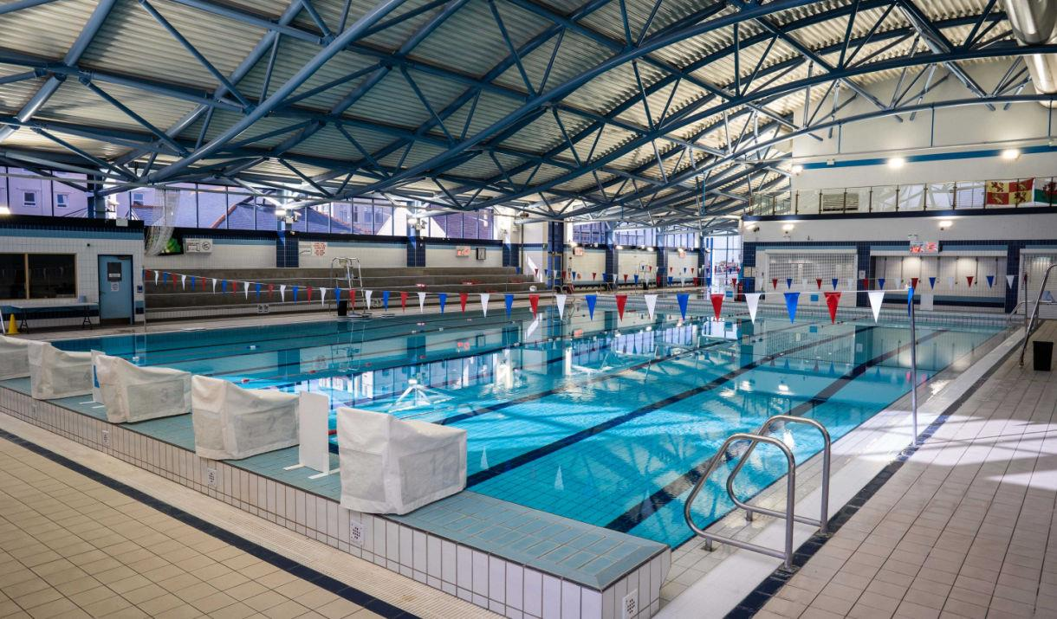

Swim Conwy Spring Meet

Llandudno Swimming Centre
8 lane 25 metre pool, with Daktronics electronic timing & cooldown pool

21st & 22nd March 2026

LEVEL 3
Licence No: 3WL260093

CLOSING DATE 28TH February 2026

EVENT INFORMATION

Swim Conwy Spring Meet
21st & 22nd March 2026

Entries should be made via clubs and should be sent electronically using Hy-Tek Team Manager.

Electronic entries should be emailed to:- secretaryswimconwy@gmail.com

Original entry forms can also be submitted to the meet organiser and a Stamped Addressed Envelope should also be supplied to allow confirmation of entries to be returned.

Completed manual form should be sent to: Teresa Scott, 17 Marine View, Rhos-on-Sea, Conwy LL28 4PQ

Account Name: Swim Conwy
Sort Code 40-18-08
A/c Number 41482815
Reference Spring Meet26/club name

Please note that entries will be refused if: -
- They are received without the relevant fee
- They are completed incorrectly (Membership number must be included)
- They are received after the closing date of 28th February 2026
- Ages are as at 22nd March 2026

Age Groups
Age groups for boys – 9/10, 11, 12, 13, 14, 15 & over
Age groups for girls - 9/10, 11, 12, 13, 14, 15 & over

Entry Fee
Entry fee is £8.000 per event

Spectators
Admission charges: -
£5.00 per session
£10.00 per day
£17.00 weekend pass

Medals and Awards
Medals will be awarded for 1st 2nd & 3rd place. Also awards to be made to Best Boy and Best Girl and a Top Team Trophy.

Car Parking
The Swimming Centre is situated next to a Council Car Park.

Camera Use
Use of cameras and video equipment is allowed following the guidelines set by the swimming centre policy.

Meet Office
A Meet Office will be open for the duration of the Meet.

Session Times
To be confirmed following receipt of closing date.

General Conditions
The Meet will be swum under: -
- FINA Technical Rules & Swim Wales Rules and Disciplinary Code.
- Entries may only be accepted from competitors registered as members of Affiliated Clubs, holding either primary or multi registration membership.
- Swimmers must only swim for one club during this Meet.
- Competitors must have been registered members of the Club in whose name they are
entered at least 30 days prior to closing date.
- Refunds will be done after closing date with Dr’s/Medical note.

Events
Events will be held as shown on the attached programme of events.
Time trials will not be permitted.

Entry Times
There are no QT’s or UCT’s for this meeting.
In the event where entries exceed capacity, the meet organisers reserve the right to bring the closing date forward. Any swimmers not accepted will have their fees returned.

Presentations
Medals can be collected from the medal desk after the announcements of result have been made. Medals will be ready collection during the session.
A swimmer unable to pick up their medal personally should send a deputy to pick up the medal on their behalf.

Officials
Each club is asked to provide a qualified official (J1/J2) on a ratio of 10 swimmers = 1 official, and/or other volunteers to help with the running of the event.
Officials will receive refreshments, lunch and full refund for car parking.

Heats
Competitors will be seeded according to submitted times, slowest to fastest. Coaches should ensure that swimmers make themselves available for marshalling at least 2 events prior to the event they are competing in.

Over the Top Starts
Over the top starts will, where necessary or appropriate, be used during the Meet.

Passes
All Coaches and Chaperones, who will be on the poolside at any time during the competition, must have individual accreditation obtained by completing the official form enclosed in this Information Pack.

Accredited coaches and chaperones from the same club may use purchased poolside passes although the number of coaches and/or chaperones on poolside at any one time must not exceed the number of passes that have been paid for.

The closing date for passes will be the same as the closing date for entries.

HEALTH & SAFETY

The health, safety and wellbeing of all swimmers, officials, volunteers, spectators and visitors is paramount – all Health and Safety rules / regulations/ requirements must be complied with at all times.

A copy of the Pool Operating Procedures and / or the Normal Operating Procedures & Emergency Action Plan for the facility being hired for a meet must be obtained in advance, and must be available throughout the duration of the meet

All swimmers, officials, volunteers, spectators, and visitors are required, at all times, to abide by the rules set out in the Pool Operating Procedures and / or the Normal Operating Procedures & Emergency Action Plan for the facility hired for the meet.

Competitive Start Award

Swimmers must have attained the standard of the Competitive Start Award in order to start from the blocks; (this is the responsibility of the club coach).

Swimmers who have not attained the standard of the Competitive Start Award must lower themselves into over the side into the water, on the long whistle of the Referee before starting at an appropriate place.

Protection Act
The organisers retain the right to amend these conditions, if necessary, without notice

Information for Spectators with Disability

Registered Disabled persons or anyone with a disability that makes it difficult or uncomfortable for you to queue prior to paying entry as a spectator:
- On arrival at the pool please go to the reception where you will be advised on access.
- You will then be able to access the balcony via the lift or stairs directly.
- NO queuing will be necessary.

If you have any questions or queries during the event a member of the swimming centre will endeavour to assist you.

Within the spectators gallery we have 7 designated Wheelchair spaces.

We are only allowed by Health & Safety regulations to admit on to the balcony 427 it would be appreciated therefore, that spectators who need assistance would arrive at the start of the warm up session thus ensuring a suitable seat is available.

Swim Conwy Spring Meet 2026
Programme of Events

Conwy
Spring Meet 2026

Llandudno Swimming Centre
21st & 22nd March 2026

PAYMENT SUMMARY SHEET

Please return this form together with:
- Entry Forms
- Cheque/s made payable to SWIM CONWY

Club
Name
Address
Post Code
Tel Home
Tel Mobile
Email
Position in Club

Summary | Number
Total Individual Entries |  | @ £8.00 | £
Total Poolside Passes (includes lunch) |  | @£12.50 per day  £25.00 weekend | £
Total Cheque Enclosed made payable to SWIM CONWY |  |  | £
*Cost for poolside passes halved if an official is provided for each day
PLEASE NOTE ONLY MEMBERS REGISTERED WITH SWIM
WALES/ASA AND HAVING A DBS CHECK ARE ELIGIBLE
FOR COACH/CHAPERONE PASS

I confirm all swimmers are current members and have paid the appropriate membership fee.
I declare that only our team members who have reached the standard of the ASA Competitive Start Award will be permitted to start from the poolside. Those who have not will start in the water.
I confirm all the Meet Conditions have been brought to the attention of swimmers, parents/guardians and coaches including the rules regarding photography.
I agree to abide by the conditions laid down by the Swim Conwy Meet Organisers for this event.
Signature Date:

Return to: Teresa Scott, 17 Marine View, Rhos-on-Sea, Conwy LL28 4PQ

Email:

secretaryswimconwy@gmail.com

Closing Date: Saturday 28th February 2026

