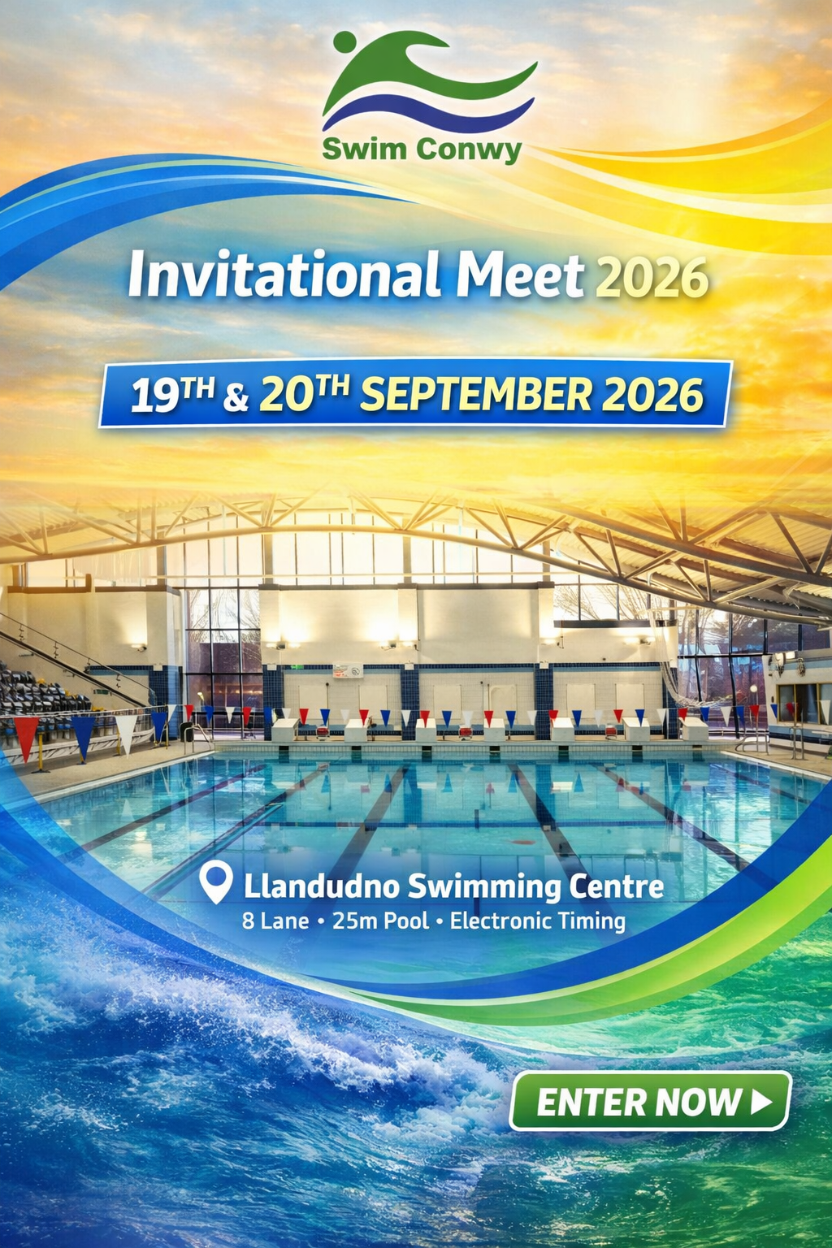



Swim Conwy September Invitational Meet 2026
(Under World Aquatics and Swim Wales Laws)
Llandudno Swimming Centre
19th - 20th September 2026

Meet Information & Conditions

Meet License No: 2WL261708

Entries

- Entries should be made via clubs only and should be sent electronically using Hy-
Tek Team Manager. The events file for use with TM is available from secretaryswimconwy@gmail.com
- Electronic entries should be emailed to secretaryswimconwy@gmail.com
- Entries from clubs should be accompanied by a payment summary sheet to cover all entries and coach/chaperone poolside passes. We can only accept bank transfer with ref to SCINV26 & your club name - HSBC 40-18-08 a/c 41482815
- Following confirmation of accepted entries, full payment must be received no later than one week prior to commencement of the meet. The Meet Organiser reserves the right to withdraw entries where payment has not been received by this deadline.
- All entry submissions must be received by 4th September 2026

Entry Fees & Passes

- Standard events: £9 online & £10 manual / individual.
- 800m & 1500m: £11 online & £12 manual / individual.
- This is a Level 3 licensed invitational meet; there are no Qualifying Times or Cut Off times.
- In the event that the duration of the meet exceeds the session time limits permitted under the meet licence, the Meet Organiser reserves the right to restrict entries. Restrictions may be applied to individual events where necessary to ensure the smooth running of the competition. Any rejected entries will be refunded.
- Competitors must have been registered members of the Club in whose name they are entered at least 30 days prior to the first day of the Meet.

Age Groups

- Age as at 20th September 2026 (final date of the event).
- Age groups for girls and boys: 9yrs,10yrs,11yrs,12yrs,13yrs,14yrs,15yrs &16yrs & over.

Meet Office

- A Meet Office will be open for the duration of the Meet and can be contacted at secretaryswimconwy@gmail.com

Session Times

- To be confirmed following receipt of entries. Clubs will be notified by email.

Medals

- Top 3 in each age group will receive medals. Plus, awards for top boy, top girl and top club.

Officials

- Each club is requested to provide one qualified official for every 10 swimmers (or part thereof). Failure to do so may affect the acceptance of entries.
Lunch and refreshments will be provided and free parking – present receipt to Gala reception.

Poolside Passes

- All coaches and chaperones that will be on poolside at any time during the competition must have a poolside pass.

Withdrawals

- All withdrawals must be notified to the day of meet recorder no later than 30 minutes before the start of the appropriate session.
- After closing date, refunds will be given on receipt of a medical certificate on the first day of the meet.
- Withdrawals must be made using the relevant withdrawal form.
- The 800m and 1500m Freestyle events will each be limited to a maximum of two heats. Should the number of entries exceed the available places, accepted swimmers will be determined by submitted entry times. A reserve list will be maintained, and reserve swimmers will be offered places should withdrawals occur prior to the start of the event.

Marshalling

- Coaches should ensure that the swimmers make themselves available for marshalling at least 2 events prior to the event they are competing in.

Heats

- Competitors shall be seeded according to submitted entry times, verified against Swimming Results database where appropriate.
- Over the top starts will, where necessary or appropriate, be used during meets (except in backstroke events).

Medical Conditions

- It is the responsibility of the swimmer and/or parent to declare to the referee any disability or medical condition that could present a safety risk. If such a disability or medical condition exists swimmers must produce a medical note confirming that their participation presents no health or safety problems.

Spectator Admission Fees

- Admission fee shall be:

£4.00 per person, per session
£10.00 per person, per day
£18.00 per person, per weekend

- Concessions @ half the admission rate.
- Children 16 and under accompanied by an adult – free admission

The organisers retain the right to alter these conditions, if necessary, without notice.

Information for Spectators with Disability
- On arrival at the pool please go to the reception where you will be advised on access.
- You will then be able to access the balcony via the lift or stairs directly.
- NO queuing will be necessary.
If you have any questions or queries during the event a member of the facility team will endeavour to assist you.
Within the spectator’s gallery we have 7 designated wheelchair spaces.



Swim Conwy September Invitational Meet 2026
Llandudno Swimming Centre • 19th / 20th September 2026

Programme of Events

Session 1 |  | Saturday 19th September 2026 |  |  | Warm up TBC |  | Start TBC
Event No: | 101 | 100 Breaststroke |  |  | Female
 | 102 | 200 Freestyle |  |  | Open/Male
 | 103 | 400 IM |  |  | Female
 | 104 | 50 Breaststroke |  |  | Open/Male
 | 105 | 100 Freestyle |  |  | Female
 | 106 | 100 Backstroke |  |  | Open/Male
Session 2 |  | Saturday 19th September 2026 PM |  |  | Warm up TBC |  | Start TBC
Event No: | 201 | 50 Backstroke |  |  | Female
 | 202 | 400 Freestyle |  |  | Open/male
 | 203 | 200 I.M |  |  | Female
 | 204 | 50 Butterfly |  |  | Open/male
 | 205 | 200 Backstroke |  |  | Female
Session 3 |  | Saturday 19th September 2026 PM |  |  | Warm up TBC |  | Start TBC
Event No: | 301 | 800 Freestyle |  |  | Open/Male
 | 302 | 1500 Freestyle |  |  | Female
 | 303 | 100 Butterfly |  |  | Open/Male
 | 304 | 200 Butterfly |  |  | Female
 | 305 | 200m Breaststroke |  |  | Open/Male
 | 306 | 50 Freestyle |  |  | Female
Session 4 |  | Sunday 20th September 2026 AM |  |  | Warm up TBC |  | Start TBC
Event No | 401 | 100 Breaststroke |  |  | Open/male
 | 402 | 200 Freestyle |  |  | Female
 | 403 | 400 I.M |  |  | Open/male
 | 404 | 50 Breaststroke |  |  | Female
 | 405 | 100 Freestyle |  |  | Open/male
 | 406 | 100 Backstroke |  |  | Female
Session 5 |  | Sunday 20th September 2026 PM |  |  | Warm up TBC |  | Start TBC
Event No | 501 | 50 Backstroke |  |  | Open/male
 | 502 | 400 Freestyle |  |  | Female
 | 503 | 200 I.M |  |  | Open/male
 | 504 | 50 Butterfly |  |  | Female
 | 505 | 200 Backstroke |  |  | Open/male
Session 6 |  | Sunday 20th September 2026 PM |  |  | Warm up TBC |  | Start TBC
Event No | 601 | 800 Freestyle |  |  | Female
 | 602 | 1500 Freestyle |  |  | Open/Male
 | 603 | 100 Butterfly |  |  | Female
 | 604 | 200 Butterfly |  |  | Open/Male
 | 605 | 200 Breaststroke |  |  | Female
 | 606 | 50 Freestyle |  |  | Open/Male

SWIMMER ENTRY FORM

Name |  |  |  | Club
Address |  |  |  | WASA No
 |  |  |  | M/F
 |  |  |  | DOB
phone |  |  | Age
please enter entry times below
50m Freestyle |  | 200m Breaststroke
100m Freestyle |  | 100m Breaststroke
200m Freestyle |  | 200m Butterfly
400m Freestyle |  | 100m Butterfly
200m Backstroke |  | 200m Individual Medley
100m Backstroke |  | 400m Individual Medley
50m Backstroke |  | 800m Freestyle
50m Butterfly |  | 1500m Freestyle
50m Breaststroke

Please note: 800m and 1500m Freestyle entries are charged at £12 per race for individual / manual entries (£11 per race for online entries).

Total number of entries = _______ @ £10 per race

Total 800m & 1500m entries only = _______ @ £12 per race

I declare that the above information is correct and agree to abide by the Meet conditions. I accept that there will be no refund of entry fees unless the Meet is oversubscribed.

I also confirm that the above competitor has achieved the ASA competitive start award

Signature of Competitor/Parent: ............................................…………………………….Date:...................................



Swim Conwy September Invitational Meet 2026
Llandudno Swimming Centre • 19th / 20th September

PAYMENT SUMMARY SHEET

Payment calculation: Standard events @ £10 manual / individual (£9 online). 800m & 1500m freestyle @ £12 manual / individual (£11 online).

Club
Name
Address
Phone (home / mobile)
email
Position in club
SUMMARY
Total individual entries |  | @ £10 per race | £
800m & 1500m entries |  | @ £12 per race | £
Total poolside passes |  | @ £25 for * weekend(includes lunch) | £
Total |  |  | £

I confirm all swimmers are current members and have paid the appropriate membership fee.

I declare that our team members who have reached the standard of the ASA competitive start award will be permitted to start from the poolside. Those who have not will start in the water.

I confirm that the Meet conditions have been brought to the attention of swimmers, parents / guardians and coaches including the rules regarding photography.

I agree to abide by the conditions laid down by the Meet Organisers for this event.

Signature: .......................................................................................................................Date:..................................

Return to: secretaryswimconwy@gmail.com

