**IKF Malmö and Agenda 2030**

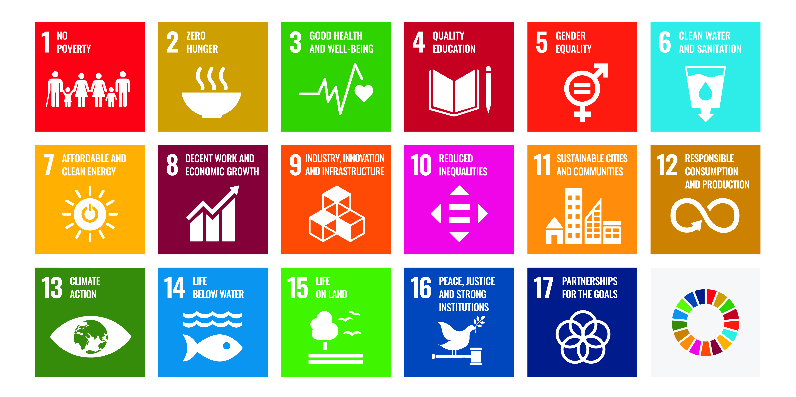

This document describes how the International Women's Association in Malmö (IKF Malmö) works with Agenda 2030 and the Global Goals and will be updated annually. We have attached a summary matrix that provides further information about and shows the links between our ongoing and completed projects relating to the Global Goals.

**Background to Agenda 2030**

Agenda 2030 was adopted by the UN in 2015 and consists of 17 global goals for sustainable development. The goals address our greatest societal challenges in areas such as the environment, economy, health, gender equality and peace. The ambition is to achieve these goals by 2030.

**IKF Malmö – A civil society on the move**

Since 1970, IKF Malmö has served as a dynamic meeting place that promotes women's rights, democracy and mutual integration through extensive core activities in the form of study groups in adult education and projects at local, national and international levels. In addition to its long experience of working to include foreign-born women in Swedish society, IKF's strengths lie in the operational breadth of its work with individuals from different backgrounds. This means that we place a strong emphasise on adapting our tools and methods to each target group.

At IKF Malmö, work on Agenda 2030 is central to our activities. Our work is based on principles of social sustainability and human rights, with a particular focus on women's empowerment, participation and establishment in society. Our target group is foreign-born women of all ages – most of our members are between 35 and 79 years old.

We are a well-established non-profit organisation working to:

* Gender Equality
* Diversity
* Cultural Understanding
* Integration
* Women's access to work and entrepreneurship
* Economic gender equality
* Women´s health and wellbeing

We believe that civil society plays a crucial role in the implementation of the global goals. Our goal is for IKF Malmö to serve as a democratic and dynamic meeting place and hub for knowledge dissemination, skills development and social development – locally, nationally and within EU collaborations. Read about our goals and activities in our Operational Plan, latest 2025, at www.ikf.se.

**Agenda 2030 – The sustainable Development Goals**

The 17 global goals are

* Goal 1: No Poverty
* Goal 2: Zero Hunger
* Goal 3: Good Health and Wellbeing
* Goal 4: Quality Education
* Goal 5: Gender Equality
* Goal 6:Clean Water and Sanitation
* Goal 7:Affordable and Clean Energy
* Goal 8: Decent Work and Economic Growth
* Goal 9: Industry, Innovation and Infrastructure
* Goal 10:Reduced Inequalities
* Goal 11: Sustainable Cities and Communities
* Goal 12: Responsible Consumption and Production
* Goal 13: Climate Action
* Goal 14: Life Below Water
* Goal 15:Life On Land
* Goal 16: Peace, Justice and Strong Institutions
* Goal l 17: Partnership for the Goals

**Global goals where IKF Malmö makes a particular difference**

IKF Malmö contributes in particular to the following goals:

* Goal 1: No Poverty
* Goal 3:Good Health and Well-being
* Goal 4: Quality Education
* Goal 5: Gender Equality
* Goal 8:Decent Work and Economic Growth
* Goal 10: Reduced Inequalities
* Goal 12: Responsible Consumption and Production
* Goal 16: Peace, Justice and Strong Institutions

**Goal 1- No Povert**y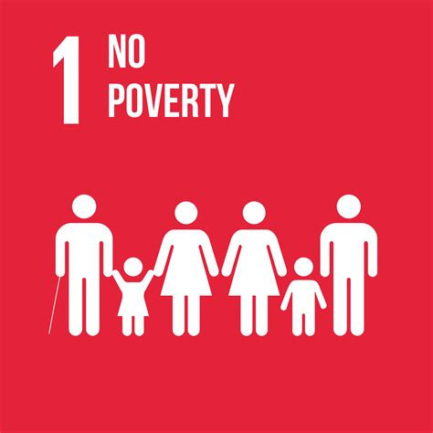

IKF's work in study groups and various projects actively contributes to reducing poverty, both directly and indirectly. By empowering women, creating increased livelihood opportunities and offering access to meaningful activities, we create the preconditions for better living conditions. Our work also contributes to reducing child poverty, as the increased livelihood opportunities for mothers affect the entire family's economy.

One example is the Mammakraft programme, which is run in collaboration with the City of Malmö every semester. The programme is aimed at mothers with teenage children and provides knowledge about society's resources - schools, health care and social services. By empowering mothers, safer families are created.

IKF also offers preparatory vocational study groups in Care & Health and Children & Youth. In 2024, we also offered the pre-vocational study group Jobbredo for women, which focuses on networking and exchanging experiences about the labour market. This group develops methods to improve participants' job opportunities in a structured way.

The Future Belongs to Everyone project focuses on women aged 65+ with a foreign background. Many of these women live on low pensions and risk social isolation. The project aims to reduce loneliness and strengthen community. In the summer of 2024, thanks to project funding, we were able to offer participants Skånetrafiken's summer pass, which enabled day trips in Skåne and increased freedom of movement - something that is otherwise a financial burden. In total, over 120 women participate in the project.

Knowing and controlling your finances is a key to independence. That is why personal finance is a recurring theme in our study groups. We use adapted financial literacy materials, translated into Swedish to suit the needs of our participants. The aim is to give women the tools to plan for the future, make informed decisions and feel confident about their everyday finances.

Our pre-vocational study groups make a concrete contribution to reducing poverty. Many women who participate find work after completing the programme, earning a salary that is higher than the financial assistance they were previously living on. The results for 2024 speak for themselves:

* 17 participants completed the Care & Health course - 12 got internships, 9 got jobs.
* 16 participants completed the Children & Youth course - 2 went on to internships, 1 got a job.
* 6 participants completed the Jobbredo course - 1 went on to an internship, 3 got jobs.

In total, 13 foreign-born women entered the labour market.

Out of 39 participants in our pre-vocational courses, 33% went directly to work - a significantly higher proportion than the national employment rate for foreign-born women (18.6% according to Statistics Sweden).

At EU level, around 64% of adults at risk of poverty are unemployed - employment is therefore a key measure against economic vulnerability.

**Goal 3- Good Health and Wellbein**g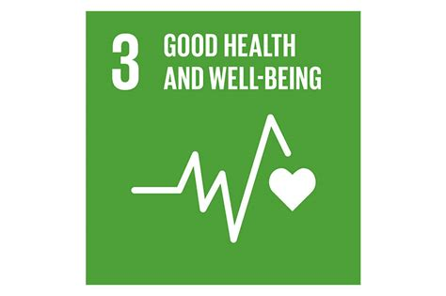

IKF actively promotes both physical and mental health through projects and study groups. Through a holistic approach, we focus on well-being in everyday life - especially for women with a foreign background who often face additional challenges.

In the international Inclusive Minds project, IKF is collaborating with partner organisations in Austria to combat mental health problems among women aged 40-60 with a foreign background. Research shows that this group often faces increased stress, stigma and resistance to talking about mental health. In this project, we have worked with an organisation in Greece to develop an interactive board game that facilitates conversations about mental health, stress and recovery.

In the Future Belongs to Everyone project, we work to improve the quality of life and reduce loneliness among women over 65 with a foreign background. Loneliness is common among older people, especially in groups with limited social networks. Through joint activities, we promote community and mental well-being. The initiative has also resulted in the book ‘Malmö became my home’, in which ten senior women talk about their lives and how they ended up in Malmö.

Our study groups are an important platform for promoting good health and well-being. Through themes such as yoga, exercise, nutrition and well-being, participants are given practical tools to improve their health. We also offer cookery classes with a focus on nutrition - as good nutrition affects both physical and mental wellbeing. The yoga is specially adapted for beginners and people with different physical conditions.

We believe that celebration and joy are also part of health. That's why we organise end-of-term parties and festivities for our participants. On 8 March each year, we celebrate International Women's Day with a major event that brings together both participants and members.

We also see clear links between health and employability. Many participants have health problems that make paid work difficult or impossible, but the study groups offer a social context and a meaningful occupation that is in itself health-promoting.

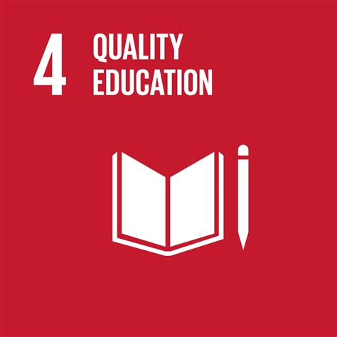

**Goal 4- Quality Educatio**n

Education is the basis for empowerment, participation in society and access to the labour market. At IKF, study groups are at the heart of our activities and are a key tool for promoting lifelong learning.

Participants come either on their own initiative or through cooperation with the social administration and labour market unit in Malmö city. We offer study groups in areas such as Swedish language, civic orientation, English, crafts, health, nutrition and yoga. In addition, we have pre-vocational study groups in Care & Health and Children & Youth.

The pre-vocational courses do not lead to a formal qualification, but they provide basic vocational skills and strengthen the participants' opportunities for work, training or further studies. Upon successful completion of the course, participants receive a diploma certifying their knowledge. The Care & Health course includes internships in, for example, elderly care, while in the Children & Youth course we support participants in finding relevant internships after the end of the course.

Participants' educational backgrounds vary greatly - some have never been to school, others have university degrees, sometimes at advanced level. Language skills also vary, which often makes our groups inclusive - participants from the same background support each other in learning.

By promoting knowledge, language development and personal growth, we help to empower individuals. Our education also includes values-based learning, where themes such as human rights, sustainable development, democracy and global citizenship are discussed.

We actively work against discrimination and in favour of a respectful and tolerant learning environment where differences are seen as an asset. Even when participants have different opinions, we promote dialogue and understanding.

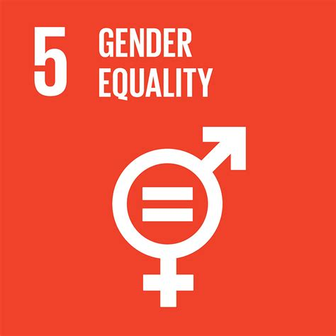

**Goal 5-Gender Equality**

Since its establishment in 1970, IKF has had gender equality as a central part of its mission. We work for women's rights, democracy and human rights - with a particular focus on foreign-born women who often face structural barriers in both society and the labour market.

The goal of gender equality is embedded in all our activities - from our local actions to our European co-operation projects. Our activities are based on reciprocal integration processes that empower women to claim their rights and participate fully in society.

**Actions with a gender equality focus**

In the Equal project and its follow-up Equal 2.0, we have conducted a norm-critical study together with Jämställd Utveckling Skåne and Studieförbundet Vuxenskolan. The focus has been on women who are often left out of the gender equality discussion - our target group. The work has resulted in norm-critical methodological material for workplaces, as well as material on domination techniques and inclusion used in our study groups. It has been developed in co-operation with Malmö against Discrimination and Malmö University.

In the SpeakItUp project, we focused on young women's public speaking and leadership skills. Through the development of a board game, an app and training materials, participants have learnt to express themselves in public and democratic contexts. This strengthens both self-esteem and civic engagement.

We have also worked with local initiatives in Malmö to strengthen girls' participation in civil society and give young women access to leisure activities and safe meeting places.

**Fighting violence and gender-based discrimination**

We work actively to counter violence against women and girls, both physical, psychological and digital.

In the course Mammakraft, which is run in collaboration with the City of Malmö, mothers with teenage children at risk of gang crime or extremism learn from the police, lawyers, social services and civil society actors, among others. During ten sessions, they gain a better understanding of society's resources and each other - and often build new social networks that live on after the course ends.

Scroll Off works to address gender-based hate speech and disinformation online, a growing problem that affects women's safety, freedom of expression and participation in public life. The initiative develops training materials for youth workers and strengthens their skills in talking about gender equality and digital violence with young people.

**Gender equality in the study groups**

The study groups are a natural arena for working on gender equality. We offer a special study circle on human rights and gender equality, but also raise these issues in all groups - both through content and working methods. The meetings are based on participatory learning and empowerment, which strengthens women to express themselves, take up space and make independent decisions.

The pre-vocational groups in Care & Health and Children & Youth are further examples of how we are strengthening women's livelihoods - a crucial part of gender equality.

**Digital equality and security**

We also work on digital literacy and digital security. We discuss digital footprints - what we leave behind online - and how to protect our privacy online. For women who may not have actively used digital tools before, this is both a gender equality and safety endeavour.

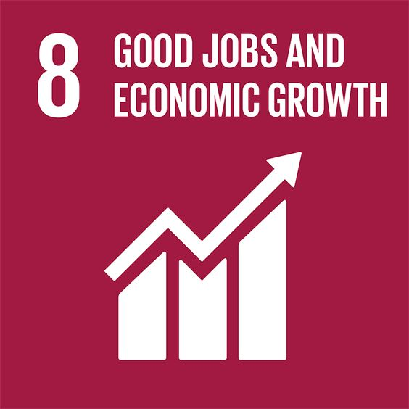

**Goal 8- Decent Work and Economic Growt**h

IKF works actively to strengthen women's path to employment, earning capacity and economic empowerment. This is done through our pre-vocational study groups, projects focusing on entrepreneurship and our collaborations with authorities, business and other actors.

Participants gain basic knowledge of working in health, social care and children's services. The study groups do not lead to a formal qualification, but provide practical and theoretical knowledge equivalent to that of a care assistant.

The Care & Health course includes a work placement, usually in elderly care. At the end of the course, participants receive a diploma certifying the skills required to apply for a job or work placement. After the courses, many have gone on to employment, extended internships or further studies.

The study groups strengthen women's self-confidence and knowledge of their rights and obligations in the labour market, which in itself is an important part of achieving decent work.

**Language and Work**

We also offer study groups focusing on the Swedish language - a crucial factor in getting a job, understanding labour market requirements and participating in society. In a previous project, ATLAAS, we developed methods for effective second language learning, which continues to characterise our educational activities.

**Measures to increase labour preparedness**

We have implemented the pre-vocational study group Jobbredo, where participants were trained for work or further studies through practical exercises, study visits and workshops.

In FEM-MIAS, we have supported women micro-entrepreneurs in their most vulnerable development phases through a transnational training programme. Through this, women entrepreneurs were given tools to strengthen their businesses and develop sustainable business models.

**Creating job opportunities in practice**

Every year, IKF receives both trainees from Lund and Malmö universities and people in job training or other initiatives through the Swedish Public Employment Service. After their time with us, several of them have gone on to employment - with us or with other employers - with IKF as an important reference and route into the labour market.

**Entrepreneurship and business**

We have run a business network for foreign-born women that promoted entrepreneurship, networking and growth. By providing a supportive platform where women could exchange experiences, make contacts and receive guidance in their business development, their opportunities to start or further develop their own businesses were strengthened.

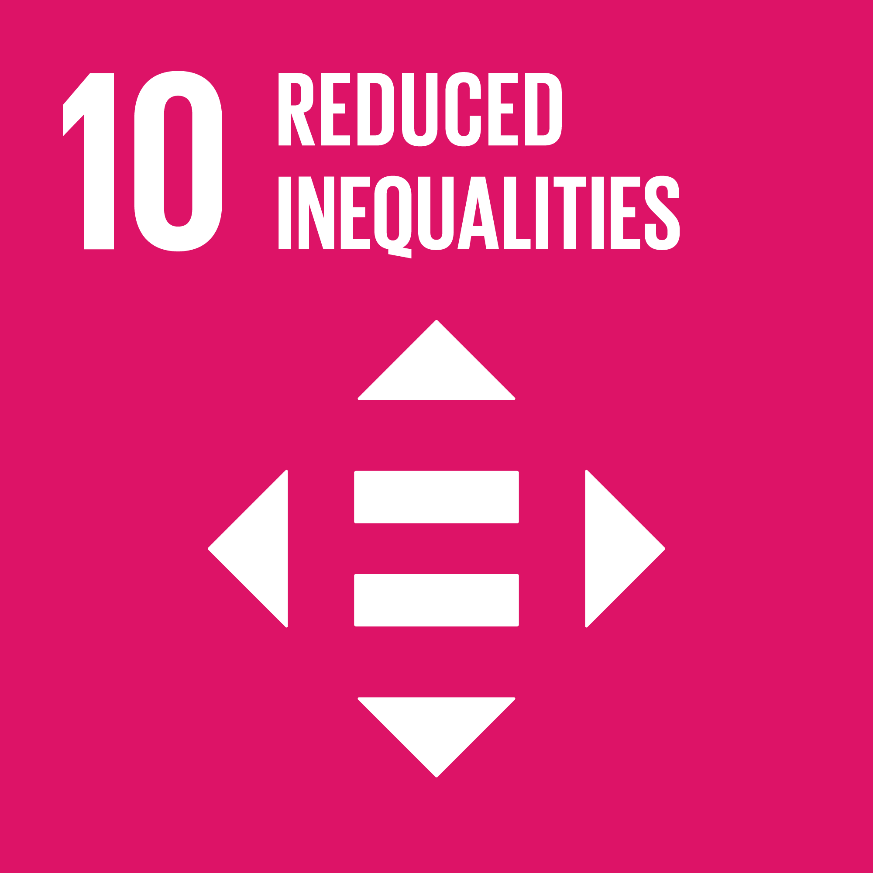

**Goal 10- Reduced Inequalitie**s

IKF's activities focus on reducing inequality - both within Sweden and globally - by empowering foreign-born women, making discriminatory structures visible and creating inclusive contexts where everyone can participate on equal terms.

We take an intersectional perspective, which means that we see how different power structures - such as gender, ethnicity, age, language, disability or socio-economic background - interact and affect people's life chances.

**Inclusion in the study groups**

Our study groups are a central platform for inclusion. Prior to each semester, we map participants' needs and backgrounds - such as previous education, housing situation, health and any disabilities. This knowledge enables us to customise our activities and meet each participant where she is - linguistically, socially and educationally.

The study groups also create networks and social contexts that are particularly important for women who have recently arrived in Sweden or who live in vulnerable situations. Participants from the same language group or country often support each other - while learning about society, rights and opportunities.

**Actions for inclusion in civil society and the labour market**

We have run several initiatives to facilitate inclusion in the labour market and in civil society:

Through Equal and Equal 2.0, we raised issues of norm-critique and exclusion. The focus has been on women who are often outside the established gender equality debate. The work has resulted in training materials that are used in our study groups and can be used in workplaces that want to work with gender equality and equality.

As many women fled Ukraine as a result of the war, we launched two programmes to support and include Ukrainian women:

* CARE - Women and Competence: Focusing on labour market entry through workshops, study visits and coaching.
* INCLUSION: Focusing on civil society participation and networking, career coaching and connecting with employers.

The Future Belongs to Everyone project focuses on senior women (65+) with a foreign background. Through joint activities, discussions and excursions, we counteract loneliness and isolation, which can otherwise reinforce social and economic gaps.

**Economic empowerment - key to equality**

Starting in 2024, we have developed a training material on personal finance to be used in all study groups. The material, in easy-to-understand Swedish, aims to strengthen women's financial independence, a key factor in tackling inequality.

We know that women generally have lower incomes, lower pensions, more part-time work and greater responsibility for unpaid care work. It is therefore important that participants are given the tools to understand their finances, plan for the future and make informed choices.

Personal finance is an area we will work on continuously, both in the study groups and in future projects.

**Focus on equality in new projects and partnerships**

When we develop new initiatives or collaborations, we always think about inclusion and equality - in terms of target group, content and location. That's why we organise activities in different parts of Malmö, including areas with lower socio-economic status. We aim to reach those who have the least access to resources, networks and influence - and create safe and equal meeting places.

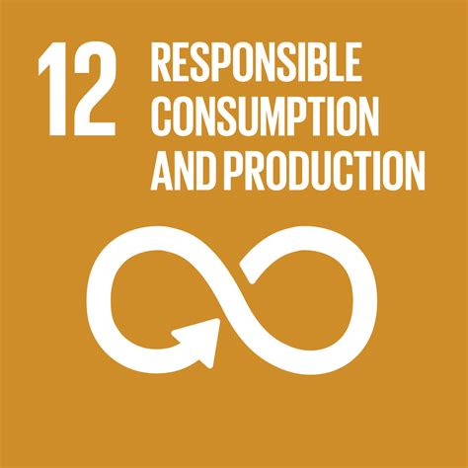

**Goal 12- Responsible Consumption and Productio**n

IKF's work on sustainability takes place through practical initiatives, training programmes and conscious choices in our daily activities.

We want to raise awareness of how we can work together to contribute to a more resource-efficient and environmentally sustainable future, with a particular focus on women and youth.

**Sustainable consumption in practice**

Many of our initiatives focus on creating sustainable lifestyles that are economically, socially and environmentally sustainable. Here are some examples:

Susent (Sustainable Entrepreneurship for Young Women) teaches young women how to make eco-friendly, handmade cosmetics. The initiative discusses sustainability and environmental impact, and participants work on sustainable packaging to reduce plastic use. The project is aimed at women aged 18-30, particularly those who are not in employment or education.

Ethikas (Empowering Migrant Women Using Design Thinking Approaches for Sustainable Entrepreneurship) aims to promote sustainable entrepreneurship among migrant women. Through the method of design thinking - a creative, solution-focused approach - participants will explore how sustainable design and business ideas can contribute to both community development and personal livelihoods.

**Making sustainable choices in everyday life**

In addition to these initiatives, we also encourage sustainable habits in our internal operations. This includes, for example:

* Limit unnecessary printing and paper consumption
* Minimising food waste at events and communal meals
* Reuse and recycle materials, e.g. in our craft and sewing groups

We try to integrate sustainability issues also in our study groups, where discussions on the environment, resource management, climate justice and consumption patterns are woven into the content. This promotes awareness and behavioural change over time.

Sustainability is an important part of future civil society work, and we recognise the importance of combining social inclusion with environmental responsibility.

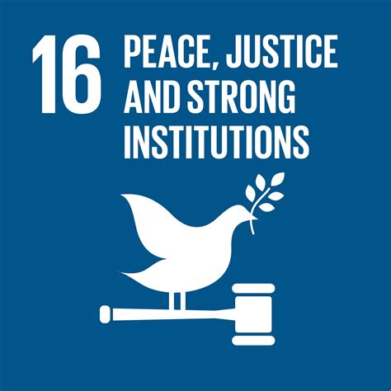

**Goal 16- Peace, Justice and Strong Institutions**

IKF's work for peaceful and inclusive societies is based on democracy, human rights and non-discrimination. We want to contribute to a society where everyone - regardless of background - feels safe, has knowledge of their rights and the opportunity to make their voice heard.

**Prevention of violence and vulnerability**

We work preventively by empowering women, spreading knowledge and creating networks. One example is the course Mammakraft, a collaboration with the city of Malmö. It brings together mums with teenage children to:

* Gaining knowledge about youth development
* Meet with representatives from the police, social services, lawyers and other social actors
* Discussing honour-based oppression and violent extremism

The aim is to empower the mothers in their parenting role and give them the tools to prevent their children from becoming involved in gang crime, drug use or destructive environments. At the same time, the women build support in each other and are encouraged to keep in touch after the course ends.

**Combating gender-based hate and disinformation**

Within the framework of Scroll Off, we focus on countering gender-based hate speech and disinformation online, which ultimately threatens both girls' and women's freedom of expression and safety - both digitally and in physical contexts.

**The initiative has developed:**

* A training material for youth workers on gender-based hate online
* A digital learning platform (to be launched during the project)

We want to equip youth workers with the knowledge to better talk to young people about the risks and expressions of hate online - and how to deal with it in a non-violent and conscious way.

**Democratic dialogue and citizenship**

In our study groups we promote participation in community life by

* Discussing human rights, democratic principles and gender equality
* Creating forums for dialogue where different perspectives can meet in a safe environment
* Encouraging civil courage, civic engagement and knowledge of rights

We particularly emphasise how women, including those who are not citizens, have rights in Sweden - both in the public space and in their everyday lives. We recognise that increased knowledge leads to increased security, empowerment and participation in society.

**Safe community as a method**

An important tool in IKF's work is to create safe meeting places. The community that is built in our groups often becomes a support far beyond the teaching sessions. Gathering regularly, listening to each other and building trust is in itself a peace-promoting endeavour - and a foundation for a society where everyone can participate.

**Summary and conclusion**

Through the work we do, IKF contributes to creating peaceful and inclusive societies, where every individual has a place, feels safe and has the opportunity to express their opinion. We recognise that working against violence and vulnerability, as well as the active fight against gender-based hatred and disinformation, is crucial to building a society where justice and human rights are respected for all.

Through our initiatives such as Mammakraft, Scroll Off and our study groups, we offer concrete tools to prevent social vulnerability, strengthen democracy and promote dialogue between individuals and social actors. Our actions aim to strengthen people's capacity to act in public life and to build a community where everyone feels involved.

Through our initiatives such as Mammakraft, Scroll Off and our study groups, we offer concrete tools to prevent social vulnerability, strengthen democracy and promote dialogue between individuals and social actors. Our actions aim to strengthen people's capacity to act in public life and to build a community where everyone feels involved..

För att fortsätta bygga och bevara fredliga och inkluderande samhällen är det avgörande att fortsätta stödja dessa processer och arbeta för ökad förståelse och samarbete på alla nivåer i samhället.