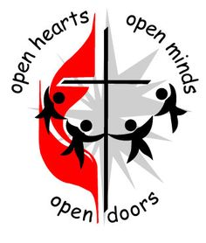
July Newsletter 2024 First United Methodist Church

November 01, 2023
500 South College St.
Trenton, TN 38382
Trenton1stUMC@gmail.com
(731) 855-0561
Church Secretary/ Admin. Assistant: Brenda Ridings
Pastor: REV KEN SMITH

Sunday Worship Schedule
Eaton Worship Service 9:00 AM
Eaton Sunday School 10:00 AM
Trenton Sunday School 9:45 AM
Trenton Worship Service 10:50 AM

CHANGES
Hebrews 12:1-2
Therefore, since we are surrounded by such a great cloud of witnesses, let us throw off everything that hinders and the sin that so easily entangles. And let us run with perseverance the race marked out for us, fixing our eyes on Jesus, the pioneer and perfecter of faith.

Change. Sometimes we just don’t know what to do when things change. The world becomes unknown and we tend to get a little trepidatious. We become apprehensive about what is coming next. Will we be OK? Will things work as they always worked? Or will things just fall apart? We look around and we just don’t know what to do or how to think.

Or do we?

My name is Kenneth Smith (please call me Ken or Pastor Ken – my mother never even called me Kenneth!), and I am your new pastor. I know changing pastors is one change that most churches don’t want to go through. I can think of several reasons offhand why this change shouldn’t be unsettling to you. First and foremost, we know each other already! I can recall the first time that I set foot into the sanctuary at Trenton First United Methodist Church. My wife Layne and I were there to set up for the first Music & a Message service that we did at Trenton. I was enthralled! Then I met several of you at the service and I was immediately taken with Trenton First. At that first Music & a

Message service, I moved my membership. That is the second reason – this is actually a homecoming to me. I am now the pastor of my home church! Another reason is that several of you have actually heard me speak or preach. I have attended several United Women of Faith services with Layne and provided a devotional at one. Some of you might have heard me preach at another Music & a Message service. I have enjoyed every moment spent in this church. Another reason is that Layne and I are overjoyed with the opportunity before us at Trenton First and Eaton UMCs. We are simply thrilled to be at both churches.

But, as I think about it, the main reason not to fear change is found in those two verses from Chapter 12 of Hebrews, and it is so simple. Many have come before us in these two churches. That “great cloud of witnesses” that came before us went through change too, and they survived. Both churches survived. And the church catholic has survived for over two millennia now, through changes that would dwarf what we see as change today.

Why? The writer of Hebrews gives us the answer: Jesus. He came before us and is the “pioneer and perfecter” of our faith. Churches survive change because they keep their eyes upon Jesus. They run the race before them keeping their eyes on Jesus. Jesus is the key to our success as a church.

This is why you will hear me say over and over that I preach the Gospel of Jesus Christ. I know that if we focus on Jesus and His words, lessons, stories, and works, we cannot go wrong. Jesus has been and always will be our focus.
Change? Jesus never changes. Why should we fear change when we have Jesus!
Blessings!

Pastor Ken

. 

Angie Alexander (niece of Bobby Jones), Larry Ridings, Andrea Pope, Teresa Wade, Lyn Putnam, Bill Woods, Bobby Jones, Mary Parker (niece of Becky George), Kenny Flowers, Charles and Pam Cox (family of Barbara Griggs), Dianne Dorsett, John Rogers, Family of Kay Sawyer (Sandy Hodges’ Aunt), Patricia Powell, Sally Reasons Carlton.

Our Members at Eaton:

Shirley Bailey, Family of Peggy Richardson, Edith Walters (Trenton Health Care), R.L. and Dona Mackin and Linda Grennay.
PLEASE KEEP IN YOUR PRAYERS THOSE WHO ARE IN REHABILITATION, NURSING HOMES AND ASSISTED LIVING, AND RETIREMENT HOMES:
Dorothy Davis, Dot Kilzer, Luther Coble,
Charlie Lancaster, Joyce Rollins, Becky George.

ACOLYTES FOR JULY

July 7 John and Elizabeth
July 14 Andrew and Reid
July 21 Evelyn and Maddy
July 28 Gus and Anna Lynn
Please make sure your child is in the
narthex at 10:35 AM.
Please call Pat Haltom or the church office if your child will not be at church on their day.

JULY BIRTHDAYS
July 3 Judie Reasons
July 5 Cydney Beth Lane
July 9 Kyle Smith
July 19 Stacey Hodges
July 22 Courtney Ballentine
July 24 Olivia Frazier
July 24 Beverly Wallin
July 30 Sandra Cochran

IMPORTANT NOTE!!!
If you have borrowed chairs or tables from the church, we ask that you return them. We need these as we will be meeting in the Fellowship Hall for the next 2 to 6 weeks. We had 120 chairs, now we only have 105. We are also missing one of the large round tables.
There is a sign out and sign back in sheet on the bulletin boards right outside the church office. Nothing should be taken out of the church without filling out this sheet.

Trustees, Jim Lee, Chairman

TRUSTEES MEMORIAL FUND

In Memory of: Frank Parker
By: Marion Crisp

In Memory of: Rev. Gene Rollins
By: Mr/Mrs Bill Woods

In Honor of: Bobby & Priscilla Jones
BY: Marion Crisp

In Honor of: Barbara Griggs
By: Marion Crisp

__________________________

As requested:

A reminder of flexible hours
for the summer for the church office.
Monday and Wednesday
11 AM to 4 PM
Tuesday and Thursday
8 AM to 1 PM

Our security system stays the
same:
Monday through Thursday
The system is on 8 AM to 3 PM

Office will be closed July 4th Holiday
_________________________________

There will be a brief Trustees meeting
right after worship service on
Sunday, July 7

Box 256
Trenton, TN 38382
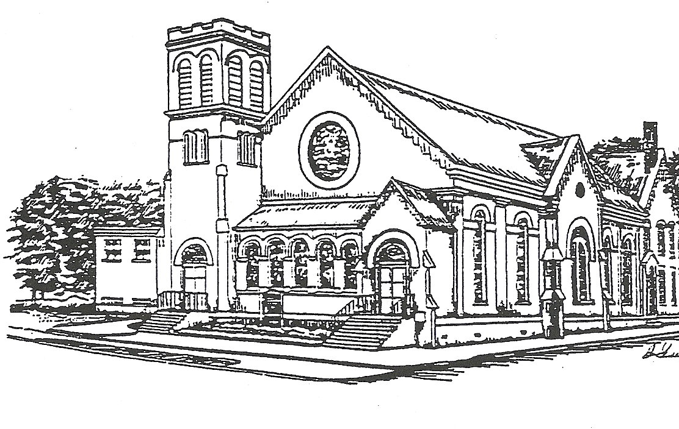

Presorted Standard
Permit No. 57

Office hours for Secretary:
11 AM – 4 PM
Monday and Wednesday
8:00 AM – 1:00 PM
Tuesday - Thursday

