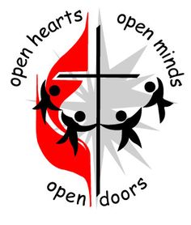
August Newsletter 2024 First United Methodist Church

November 01, 2023
500 South College St.
Trenton, TN 38382
Trenton1stUMC@gmail.com
(731) 855-0561
Church Secretary/ Admin. Assistant: Brenda Ridings
Pastor: REV KEN SMITH

Sunday Worship Schedule
Eaton Worship Service 9:00 AM
Eaton Sunday School 10:00 AM
Trenton Sunday School 9:45 AM
Trenton Worship Service 10:50 AM

Love God.
Love God’s People
Luke 10:27
He answered,
“Love the Lord your God with all your heart and with all your soul and with
all your mind’; and, ‘Love your neighbor as yourself”,
Jesus told us.

You heard me preach about it in the Love is All Around sermon, and again, in the Reach Out sermon. Now it is time to start thinking as a church about those five simple words and how we can make a difference in the lives of those around us.

First, we start with the basics:

Love God: We rarely ever fall in love with someone without getting to know them first. How do we get to know God? We read about Him in the Bible! Very soon you will be finding a great little tool in your bulletin that will help with this – a “Bible in a year” reading plan. I would ask that everyone take a year and read a few chapters of the Bible each day. You will get lo know God and love Him more in that year. You will love Him with your heart, soul, strength, and mind because you will have read the entirety of His word. Scripture tells us the same:

Deuteronomy 11:18

Fix these words of mine in your hearts and minds; tie them as symbols on your hands and bind them on your foreheads.

Love God’s People: Where do we start? Why, in our own church! Talk to each other! Support each other! Love each other!
Then, go out into the highways and the hedges, the football games and the hangouts, the coffee shops and restaurants, and tell the people you meet about what we have in this wonderful church of ours! What we have is a wonderful, Christ-filled and loving congregation of God’s people that want to share that love with others. The fields are white with the harvest. The Word of God is the sickle. Ezekiel was told the same:

Ezekiel 3:1

And he said to me, “Son of man, eat what is before you, eat this scroll; then go and speak to the people of Israel.” ² So I opened my mouth, and he gave me the scroll to eat.³ Then he said to me, “Son of man, eat this scroll I am giving you and fill your stomach with it.” So, I ate it, and it tasted as sweet as honey in my mouth.

We have our orders: “Love God. Love God’s People”. Remember this every day. Practice this every day.

But don’t actually eat your Bible, in spite of what God told Ezekiel!

Blessings! Pastor Ken

. 

Angie Alexander (niece of Bobby Jones), Larry Ridings, Andrea Pope, Teresa Wade, Lyn Putnam, Bill Woods, Bobby Jones, Kenny Flowers, Charles and Pam Cox (family of Barbara Griggs), Dianne Dorsett, Patricia Powell, Sally Reasons Carlton, Luther Coble, Becky George, Sherry Buchanan, Pat Putnam, Jodie Agee.

Our Members at Eaton:

Shirley Bailey, Family of Peggy Richardson, Edith Walters (Trenton Health Care), R.L. and Dona Mackin and Linda Grennay.
PLEASE KEEP IN YOUR PRAYERS THOSE WHO ARE IN REHABILITATION, NURSING HOMES AND ASSISTED LIVING, AND RETIREMENT HOMES:
Dorothy Davis, Dot Kilzer, Luther Coble,
Charlie Lancaster, Joyce Rollins, Becky George.

ACOLYTES FOR AUGUST

August 4 Ava and Lily
August 11 Reid and Maddy
August 18 Gus and John
August 25 Evelyn and Carly
Please make sure your child is in the
narthex at 10:35 AM.
Please call Pat Haltom or the church office if your child will not be at church on their day.

TRUSTEES MEMORIAL FUND

In Honor of: Becky George
Luther Coble
BY: Fisherman’s Class
__________________________



Welcome to our Church Family!!!!!
Emma Lang
Layne Smith

***********************************************
Note!!!
Since school is starting back, Brenda’s office hours will go back to:
8 to 1 PM, Monday through Thursday
Also:
Brenda will be on vacation
the last week in August.
***********************************************
AUGUST BIRTHDAYS

August 3 Dr. Phillip Cook
August 4 Brittany Peterson
August 9 Ralph Cochran
August 11 Brad Ballentine
August 11 Perry Lane
August 13 Glenna Helms
August 21 Mattie Dupree
August 21 Ed Joyner
August 29 Andrea Joyner
August 29 Ann T. Elliott


You are invited to an
“Open House”
Sunday, August 11th
1 to 2 PM
in our fellowship hall, to welcome our new pastor and his wife:
Rev. Ken and Layne Smith

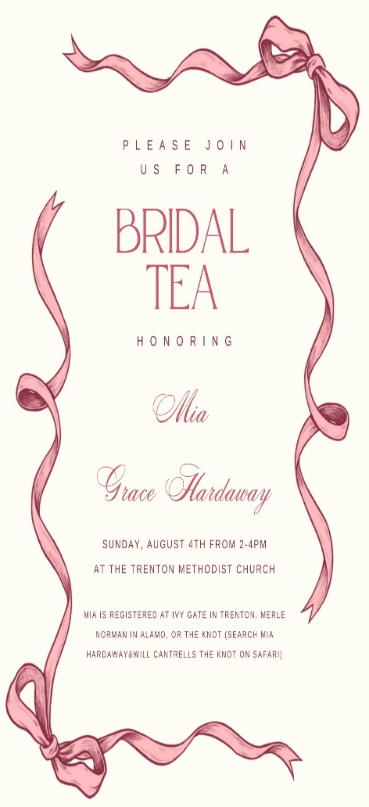

Mia is the granddaughter of
Mrs. Jewell Hardaway……
+++++++++++++++++

If you are in need of Pastoral care, please call Pastor Ken: 770-843-5975 or call the church office. Brenda will have his office hours if you want to stop by to talk with him.

Please Join the Members of
Ross United Methodist Church

101 Calcutt Street
Dyersburg, TN 38024

Saturday, August 3, 2024 at 2:00 p.m.

“Homecoming Celebration Commemorating 138 Years of Progressive Kingdom Building”

We are prayerfully requesting the presences of ALL~ Past Members of Ross UMC, Family Members, Clergy/Parishioners from Neighboring Churches, Citizens of our Beloved Community, and Civic & Community Based Organizations

A Reception Will Take Place Directly After the Program
Donations are Welcome and Will Benefit the Ministries of the Church
++++++++++++++++++++++++++++++++++++++++++++

HELP!!! We are in need for someone dependable to help run the audio/video ministry. Please see Sandy or contact the church office. We will have training sessions. There will be some Sundays that Sandy can not be here and there are special events that we will need someone also.



It’s back to school time for Mom’s Day Out!! We are so very excited to get our year started.! We have 22 friends enrolled this year with many returning and bringing along a sibling as well. Our “Open House” for students and their parents will be Sunday, August 4.

Our goals for August are as follows:
All about me, my family and
emotions.

We are looking for volunteers for August to help with getting back into the swing of things.
Email: MDO.fumctrenton@gmail.com for more information. Thank you for all you do for MDO!

We appreciate you!!!!!!

Lauren Moeller
Director, Mom’s Day Out
Trenton FUMC MDO
731-694-2966

500 South College Street
P.O. Box 256
Trenton, TN 38382
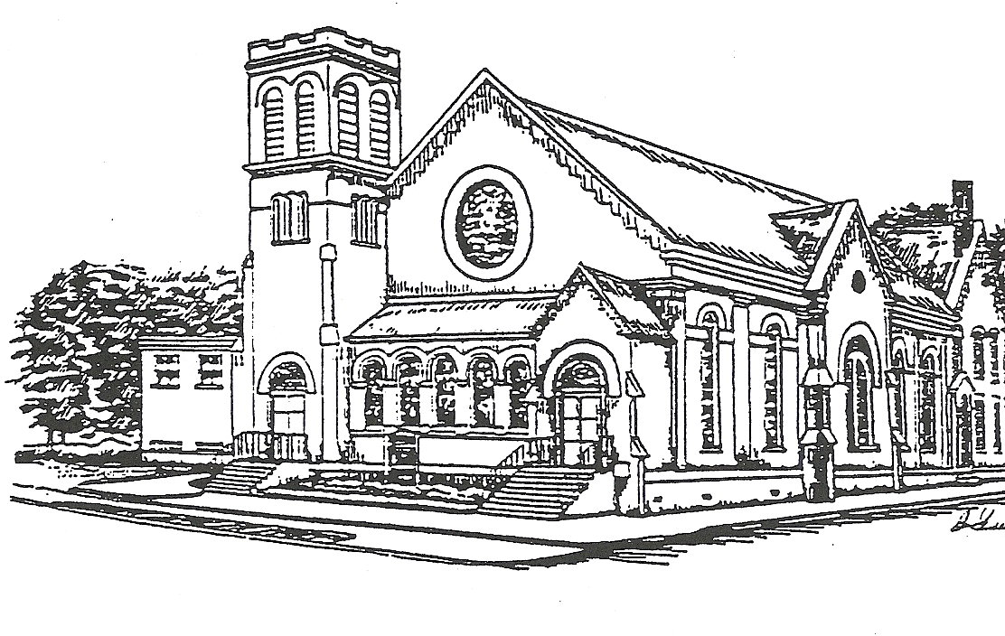

Presorted Standard
Permit No. 57

Office hours
8 AM – 1 PM
Monday through Thursday

Pastor: Rev. Ken Smith
Tuesday and Thursday
770-843-5975

