
September Newsletter 2024 First United Methodist Church

November 01, 2023
500 South College St.
Trenton, TN 38382
Trenton1stUMC@gmail.com
(731) 855-0561
Church Secretary/ Admin. Assistant: Brenda Ridings
Pastor: REV KEN SMITH

Sunday Worship Schedule
Eaton Worship Service 9:00 AM
Eaton Sunday School 10:00 AM
Trenton Sunday School 9:45 AM
Trenton Worship Service 10:50 AM

A DIFFERENT WALK
2 John 1:1-6

¹ The elder,
To the lady chosen by God and to her children, whom I love in the truth—and not I only, but also all who know the truth— ² because of the truth, which lives in us and will be with us forever:
³ Grace, mercy and peace from God the Father and from Jesus Christ, the Father’s Son, will be with us in truth and love.
⁴ It has given me great joy to find some of your children walking in the truth, just as the Father commanded us. ⁵ And now, dear lady, I am not writing you a new command but one we have had from the beginning. I ask that we love one another. ⁶ And this is love: that we walk in obedience to his commands. As you have heard from the beginning, his command is that you walk in love.

The writer of 2 John got it right. This unknown writer was writing to a church – the “lady”- and its members – the “children”. He loved them in the “truth” – the grace, mercy, and peace of God the Father and Jesus the Son, who will be with us always in truth and love.

The writer greets his friends and those he loves as we would today. Everything seems perfectly normal. But something troubling is happening that is easy to miss. It seems that only some of the children are walking in the truth. The writer offers no new commandments to the children, only that they continue to follow the Great Commandment of Christ:

Love God. Love God’s People.

Then he starts talking about walking. This walk is a “Different Walk” than what would be normal for people: The children are to walk in obedience to His commands. They are to walk in love.

2 John is a very short book. I suggest that you read it all. In all its brevity, it addresses a primary concern for us today.
Heresy has crept into the church. Deceivers are afoot. False teachings are being taught. Many are being deceived.
The heresy of the world is creeping into the church.

Are we not in the same position today? Church attendance is down to historically low levels. We are told anywhere we would like to look how to look, act, and think. More and more people are getting their instructions for life from the secular world.

The world is broken. Things are a mess.
We need a Different Walk. Not a new one, for the Walk we need is as old as Jesus, and God. We are to walk in love, as the Savior taught us. It won’t be easy. We will be beset with adversity on all sides. We might find ourselves on strange roads with odd surroundings. There will be unaccustomed situations. Things will be hard at times, but they will always be worth the effort, IF we are on the Walk with Jesus!

Let’s start that Different Walk. We know the first step: Love God. Love God’s People.

Take that first step.
Blessings!

Pastor Ken
. 

Larry Ridings, Andrea Pope, Teresa Wade, Lyn Putnam, Bill Woods, Kenny Flowers, Charles and Pam Cox (family of Barbara Griggs), Dianne Dorsett, Patricia Powell, Luther Coble, Becky George, Pat Putnam, Faye Campbell-Bunn, Delores Smith, Family of Nancy Warren.

Our Members at Eaton:

Shirley Bailey, Family of Peggy Richardson, Edith Walters (Trenton Health Care), R.L. and Dona Mackin and Linda Grennay.
PLEASE KEEP IN YOUR PRAYERS THOSE WHO ARE IN REHABILITATION, NURSING HOMES AND ASSISTED LIVING, AND RETIREMENT HOMES:
Dorothy Davis, Dot Kilzer, Luther Coble,
Charlie Lancaster, Joyce Rollins, Becky George.

BIRTHDAYS FOR SEPTEMBER

September 2 Barbara Griggs
September 2 Carol A Halliburton
September 6 Betty Poteet
September 8 Layne Smith
September 9 Bill Hodges
September 10 Sandy Hodges
September 11 Clint Buchanan
September 12 Allie Privitt
September 12 Ken Smith
September 13 Tucker Hopkins
September 20 Terrie Joyner
September 20 LaNita VanDyke
September 21 Dot Kilzer
September 22 Gary Wygant
September 22 Shannon Ragusa
September 24 Jeanne Crossnoe
September 26 Sallie King

ACOLYTES FOR SEPTEMBER

September 1 Maddy & Lily
September 8 Elizabeth & Carly
September 15 Anna Lynn & Evelyn
September 22 Reid & John
September 29 Gus & Andrew
Please make sure your child is in the
narthex at 10:35 AM.
Please call Pat Haltom or the church office if your child will not be at church on their day.

TRUSTEES MEMORIAL FUND

In Honor of: Judie Reasons
Kenny Flowers
Delores Smith
Marion Crisp
BY: Fisherman’s Class

In Honor of: Gary & Sherry Buchanan’s
50th Anniversary
Rev. Ken & Layne Smith

By: Ed and Sallie King

In Memory of: Harold Thompson
Mattie Vera Cannon

By: Ed and Sallie King

Note!!!
Since school is starting back, Brenda’s office hours will go back to:
8 to 1 PM, Monday through Thursday
Also:
Brenda will be on vacation
the last week in August.
***********************************************
If you are in need of Pastoral care, please call Pastor Ken: 770-843-5975 or call the church office. Brenda will have his office hours if you want to stop by to talk with him.
HELP!!! We are in need for someone dependable to help run the audio/video ministry. Please see Sandy or contact the church office. We will have training sessions. There will be some Sundays that Sandy can not be here and there are special events that we will need someone also.
++++++++++++++++++++++++
Pat Haltom is retiring from her position as acolyte coordinator. If you would consider taking over, please let me know or let Pat know.
This is such an important part of our worship service. Thank you

+++++++++++++++++++++++++++ 

Thank all of you so much for the food, the calls, the texts and especially the prayers during my recent illness. I love my church family.
Judie Reasons

####
Sherry Buchanan would like to thank everyone for the kindness shown to her during her recent illness. The calls, prayers and texts were very much appreciated.
**********************************
We would like to have greeters on Sundays the way we used to. Please let me know if you would be willing to volunteer from time to time.
*********************************
We are finding our doors in the very front and the parking lot side being left unlocked. If you are in the church, please be mindful of locking up before you leave!!!!! If you do not have a key, go out the kitchen door and it will lock behind you if the button is turned.

500 South College Street
P.O. Box 256
Trenton, TN 38382
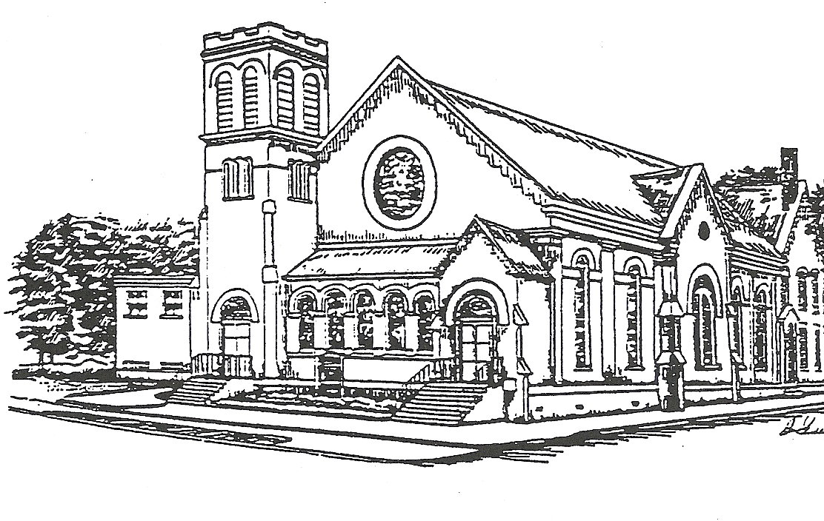

Presorted Standard
Permit No. 57

Office hours
8 AM – 1 PM
Monday through Thursday

Pastor: Rev. Ken Smith
Tuesday and Thursday
770-843-5975

