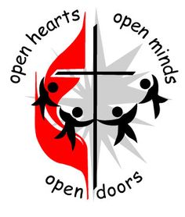
October 2024 First United Methodist Church

November 01, 2023
500 South College St.
Trenton, TN 38382
Trenton1stUMC@gmail.com
(731) 855-0561
Church Secretary/ Admin. Assistant: Brenda Ridings
Pastor: REV KEN SMITH

Sunday Worship Schedule
Eaton Worship Service 9:00 AM
Eaton Sunday School 10:00 AM
Trenton Sunday School 9:45 AM
Trenton Worship Service 10:50 AM

PICKING UP THE PIECES

Jeremiah 17:14-18
The Message Translation
God, pick up the pieces.
Put me back together again.
You are my praise!
Listen to how they talk about me:
“So where’s this ‘Word of God’?
We’d like to see something happen!”
But it wasn’t my idea to call for Doomsday.
I never wanted trouble.
You know what I’ve said.
It’s all out in the open before you.
Don’t add to my troubles.
Give me some relief!
Let those who harass me be harassed, not me.
Let them be disgraced, not me.
Bring down upon them the day of doom.
Lower the boom. Boom!

“Into every life a little rain must fall.” Did you ever wonder where that little bit of advice or proverb came from? Did you ever feel even worse after hearing it? I think we all have from time to time and knowing that the old proverb is true doesn’t make things much better, or life easier.

Or decisions easier. Or a loss easier to take. Or suffering easier.

You will hear me say many times that the world is a broken place. Think about a room full of broken glass. I mean really big sharp points sticking out everywhere. Then imagine being in the room with untold numbers of people, in all sorts of moods. And all the people in it are broken people. And so are you. You are bound to get cut on one of those sharp points eventually.

Then you can get an idea of what I mean when I say that the world is a broken place, full of broken people. Bad things are bound to happen to everyone from time to time. Some people choose to make it hard on themselves by leading lives that are outside the Will of God. And we often must interact with those people. Many can’t help the situation they find themselves in.

The simple fact is that, without Jesus Christ, all of us are in the same broken boat in the same broken world. As Followers of Christ, it is our responsibility to reach out to those broken people in this world. They might not look like us or act like us, but God loves them the same as He loves us. The Savior expects us to find the lost sheep and bring them back into the fold. He was quite clear.

God asked Jeremiah to preach to the broken people in Judah. And he took a beating from them because he was delivering God’s message. The fact that God had sent Jeremiah to preach to Judah didn’t change how their misunderstanding, taunts, and barbed comments hurt him. So, Jeremiah asks God to come against those that were coming against Jeremiah.

God listened to Jeremiah and He sent Jesus as the Savior. God didn’t take the hurt from the world or the brokenness, but He did send the Solution. Jesus came so that everyone could have a chance to heal from the cuts of this broken world. All we must do is go to Him.

Oh, and the poem about the rain. It is entitled “The Rainy Day” and was written by Henry Wadsworth Longfellow. Look it up.

And remember those broken people in this world and tell them about Jesus. Pick up the pieces.
.
Blessings!

Pastor Ken
. 

Larry Ridings, Andrea Pope, Teresa Wade, Lyn Putnam, Bill Woods, Patricia Powell, Luther Coble, Pat Putnam, Greg Moore (brother of Julie Riley), Tom Murphree (friend of Pastor Ken Smith.

Our Members at Eaton:

Shirley Bailey, Edith Walters, Dona Mackin and Mona Scarborough.

PLEASE KEEP IN YOUR PRAYERS THOSE WHO ARE IN REHABILITATION, NURSING HOMES AND ASSISTED LIVING, AND RETIREMENT HOMES:
Dorothy Davis, Dot Kilzer, Luther Coble,
Charlie Lancaster, Joyce Rollins, Becky George.

ACOLYTES FOR OCTOBER

October 6 John and Carly
October 13 Elizabeth and Anna Lynn
October 20 Maddy and Reid
October 27 Gus and Andrew
Please make sure your child is in the
narthex at 10:35 AM.
Please call Pat Haltom or the church office if your child will not be at church on their day.

TRUSTEES MEMORIAL FUND

In Honor of: Barbara Grigg’s Birthday
BY: Delores Smith

In Memory of: Sylvia Fisher
Martha Roberts

By: Fisherman’s Class
Barbara Griggs
***********************************************
If you are in need of Pastoral care, please call Pastor Ken: 770-843-5975 or call the church office. Brenda will have his office hours if you want to stop by to talk with him.

Pat Haltom is retiring from her position as acolyte coordinator. If you would consider taking over, please let me know or let Pat know.
This is such an important part of our worship service.
Thank you

+++++++++++++++++++++++++++ 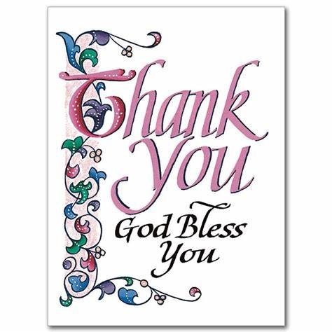

Thank all of you so much for the food, the calls, the texts and especially the prayers during my recent illness. I love and appreciate my church family.
God bless you, Beverly Wallin
####

**********************************
We would like to have greeters on Sundays the way we used to. Please let me know if you would be willing to volunteer from time to time.
*********************************
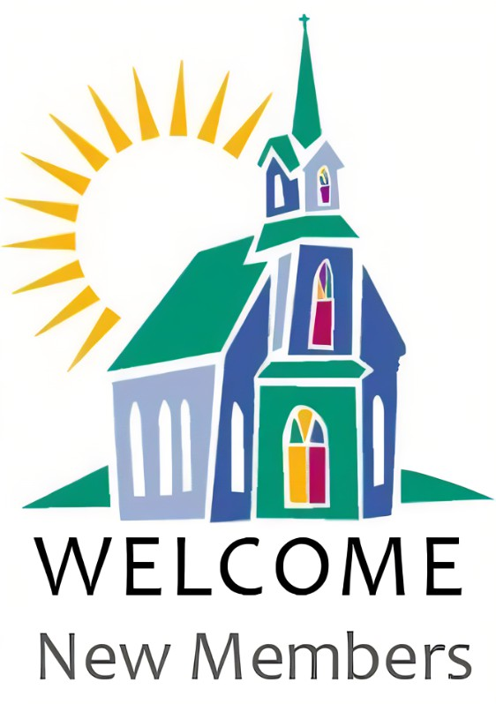
We are so happy to welcome Clay Rachels as a new member to our church family.

BIRTHDAYS FOR OCTOBER

October 4 Daniel Hodges
October 6 Gil Hodges
October 9 Andrew Beard
October 9 Allie Hager
October 11 Cicily Buchanan
October 15 Maddy Tucker
October 24 John Morgan
October 28 Amanda Haltom
October 26 Peggy Davis
October 30 Fred Davis
October 31 Janie Collins

++++++++++++++

There will be a brief meeting on October 6 right after church
about the “Bridal Tea” for Hodges/Lang
on Oct. 27th. If you will be willing
to help Leah Jean, please attend or if you can not
attend the meeting, you may contact Leah Jean
731-697-5652

500 South College Street
P.O. Box 256
Trenton, TN 38382
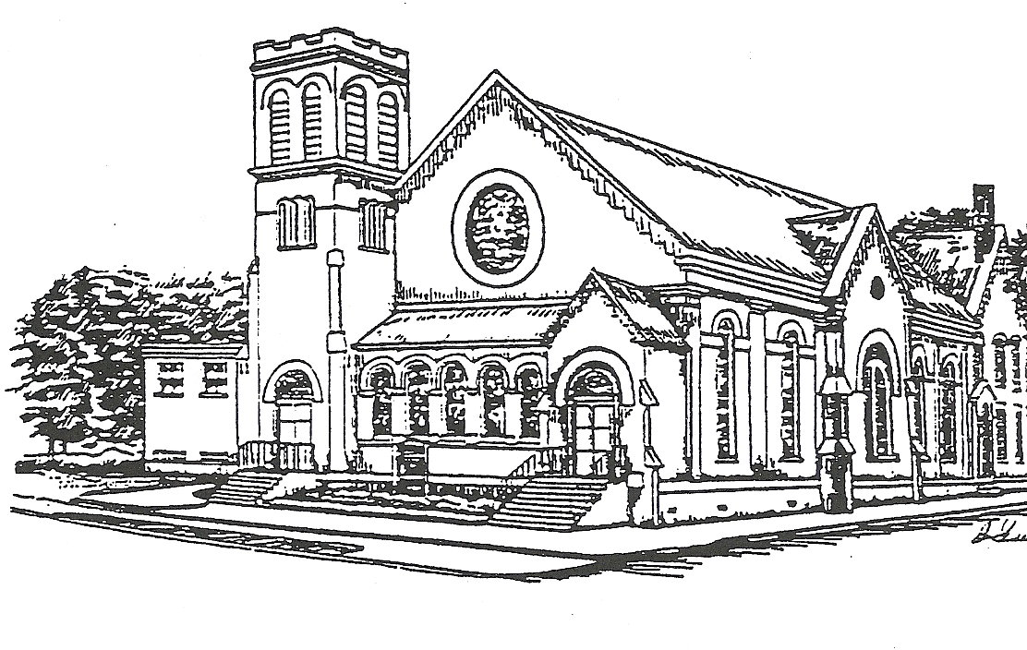

Presorted Standard
Permit No. 57

Office hours
8 AM – 1 PM
Monday through Thursday

Pastor: Rev. Ken Smith
Tuesday and Thursday
770-843-5975

