WELCOME TO GRACE CHURCH

“A people gladly serving both God and neighbor”

We worship on April 13, 2025 (9 a.m.)

PALM SUNDAY

(Come as you are, then “go home different”)

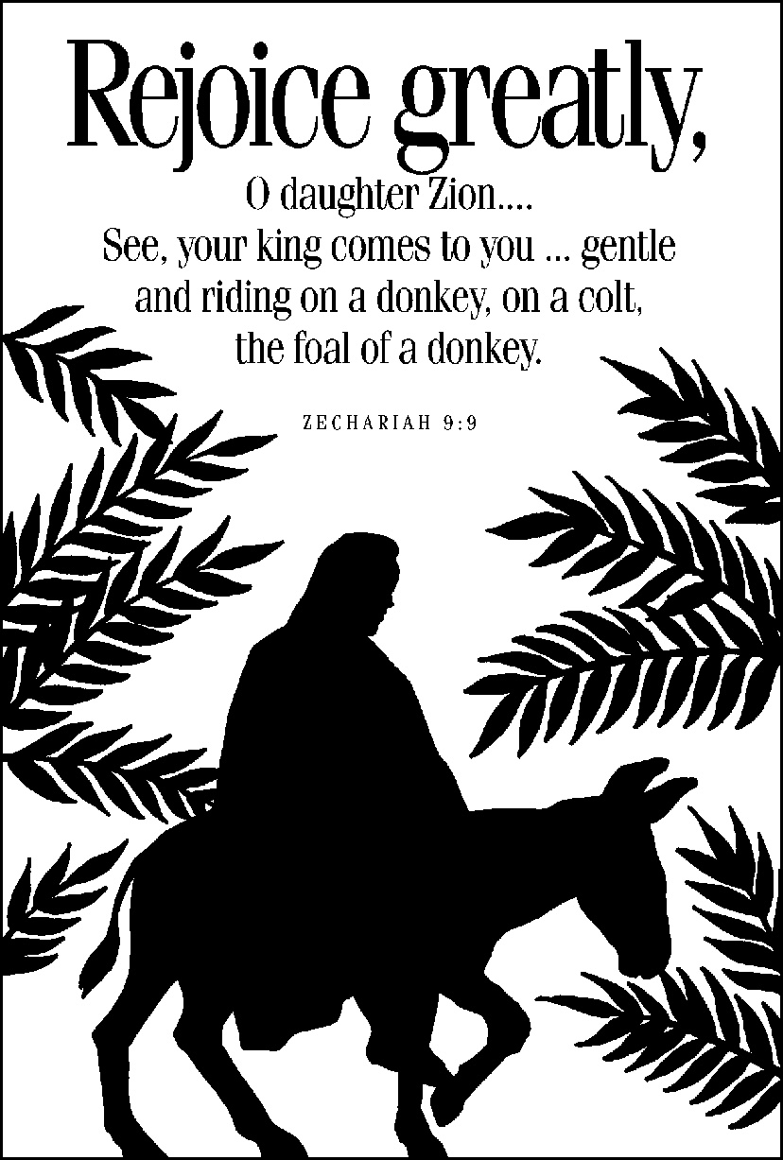

SERVING IN WORSHIP TODAY ... Nancy Lieberman (pianist) and Jerry Graham (liturgist)

GATHERING HYMN: (U.M. # 278) ...................................... “Hosanna, Loud Hosanna”

(1) Hosanna, loud hosanna, the little children sang; through pillared court and temple
...the lovely anthem rang. To Jesus, who had blessed them close folded to his breast,
...the children sang their praises, the simplest and the best.

(2) From Olivet they followed mid an exultant crowd, the victor palm branch waving,
...and chanting clear and loud. The Lord of earth and heaven rode on in lowly state,
...nor scorned that little children should on his bidding wait.
\
(3) “Hosanna in the highest!” that ancient song we sing, for Christ is our Redeemer,
the Lord of heaven our King. O may we ever praise him with heart and life and voice,
...and in his blissful presence eternally rejoice!
A CALL TO WORSHIP .............................................................. Inspired by Matthew 21

The disciples went and did as Jesus had instructed them...bringing the donkey and colt...
They placed their cloaks on them, and Jesus sat on them.

A very large crowd spread their cloaks on the road,
...others cut branches from the trees and spread them on the road.

Crowds ahead...and those that followed shouted out: “Hosanna to the Son of David! Hosanna!”
Blessed is He who comes in the name of the Lord! Hosanna in the highest!

Disciples meet on this Palm Sunday to prepare for all the good things that this King brings!
We celebrate Jesus, and His entrance into the hearts and homes of the people we know.

May our worship always extend into joyful service in His Name. HOSANNA!
Hosanna to the Son of David! HOSANNA!

OPENING HYMN (U.M. # 280) ........................ “All Glory, Laud And Honor” (vss. 1-5)

(REFRAIN) All glory, laud, and honor, to thee, Redeemer, King,
to whom the lips of children made sweet hosannas ring.

(1) Thou art the King of Israel, thou David’s royal Son,
who in the Lord’s name comest, the King and Blessed One.

(2) The company of angels are praising thee on high,
and we with all creation in chorus make reply.

(3) The people of the Hebrews with palms before thee went;
our prayer and praise and anthems before thee we present.

(4) To thee, before thy passion, they sang their hymns of praise;
to thee, now high exalted, our melody we raise.

(5) Thou didst accept their praises; accept the prayers we bring,
who in all good delightest, thou good and gracious King.

INVITATION OF GOD’S PRESENCE
(We also offer our own “GOD IS GOOD” greeting to others)

PRAISE SONG ......................................................................................... “Hosanna”

(1) Hosanna, hosanna, hosanna, in the highest. Hosanna, hosanna, hosanna, in the highest.

(CHORUS) Lord, we lift up Your name with hearts full of praise,
Be exalted, O Lord my God, Hosanna in the highest.

(2) Glory, glory, glory to the King of kings. Glory, glory, glory to the King of kings. (CHORUS)

PRAISE HYMN (# 279) ..................................................... “Filled With Excitement”

(1) Filled with excitement, all the happy throng spread cloaks & branches on the city streets,
There in the distance they begin to see, riding on a donkey, comes the Son of God.

(Refrain) From every corner a thousand voices sing praises to him who comes in the
name of God. With one great shout of acclamation loud triumphant song breaks forth:
“Hosanna, hosanna to the King! Hosanna, hosanna to the King!”

(2) As in that entrance to Jerusalem, we sing hosannas to the Christ, our King,
to the living Savior who still calls today, asking us to follow him with love and faith. (Refrain)

BODY BUILDING.........You may share a joy, announcement or testimony of God’s grace

PRAYER CONCERNS..........We lift up those needing strength and healing from the Lord

PRAYER SONG ................................................................. “Thank You For The Cross”

(VERSE) Thank You for the cross, the mighty cross: that God himself should die for such as us
And every day we’re changed into Your image more and more.
Yes, by the cross we’ve truly been transformed

(CHORUS) And we’re so amazed and we give You praise that You would save us at such a cost!
We’re so amazed and we give You praise...For the power of the cross...for the power of the cross

PRAYER

GOD’S HOLY WORD .......................................................... Selected Scriptures

Job 24:12...John 1:18...Hebrews 12:10...1 Corinthians 12:24-25...Genesis 45:6-7

“But God sent me ahead of you to preserve for you a remnant on earth
and to save your lives by a great deliverance.”

TODAY’S MESSAGE .......................................................... Pastor Mike Langford

“A Great Deliverance”

“BUT GOD”...A Lenten sermon series on the Lord who turns things around in a big way.

HYMN (U.M. # 421) ............................................ “Make Me A Captive, Lord” (vss. 1-4)

(1) Make me a captive, Lord, and then I shall be free. Force me to render up my sword,
and I shall conqueror be. I sink in life’s alarms when by myself I stand;
Imprison me within thine arms, and strong shall be my hand.

(2) My heart is weak and poor until it master find; it has no spring of action sure,
It varies with the wind. It cannot freely move till thou hast wrought its chain;
Enslave it with thy matchless love, and deathless it shall reign.

(3) My power is faint and low till I have learned to serve; it lacks the needed fire to glow,
It lacks the breeze to nerve. It cannot drive the world until itself be driven;
Its flag can only be unfurled when thou shalt breathe from heaven.

(4) My will is not my own till thou hast made it thine; if it would reach a monarch’s throne,
It must its crown resign. It only stands unbent amid the clashing strife,
When on thy bosom it has leant, and found in thee its life.

A SENDING

Thank you for presenting your tithes and offerings in the plates at the exit

BECAUSE OF THE LORD’S GREAT LOVE, WE ARE NOT CONSUMED, FOR HIS COMPASSIONS NEVER FAIL. THEY ARE NEW EVERY MORNING; GREAT IS YOUR FAITHFULNESS.

This worship service is over. NOW BEGINS our Christian service in Jesus’ Name!

167

We are not on a 167-hour “vacation from God” when our worship ends. We show the grace daily!

Grace United Methodist Church ... 216 S. Market Street, Mechanicsburg, Pa. 17055

(717) 766-3282...gracechurch216@gmail.com...website: https://www.gracechurchmech.com/

PASTOR: W. Michael Langford (Mike’s cell: 717-659-9613, his email: wallymike@gmail.com)

MINISTERS: All of us! (We are ministers of God’s grace...and we’re on-duty ‘24/7’)

BECAUSE OF THE LORD’S GREAT LOVE, WE ARE NOT CONSUMED, FOR HIS COMPASSIONS NEVER FAIL. THEY ARE NEW EVERY MORNING; GREAT IS YOUR FAITHFULNESS.

“GRACE NOTES” (Call or email your announcement). Regular events underlined

BECAUSE OF THE LORD’S GREAT LOVE, WE ARE NOT CONSUMED, FOR HIS COMPASSIONS NEVER FAIL. THEY ARE NEW EVERY MORNING; GREAT IS YOUR FAITHFULNESS.

SUNDAY, April 13 (Worship ... every Sunday at 9 a.m.)
10:15 a.m. … Adult Sunday School in the fireplace area of the sanctuary

BECAUSE OF THE LORD’S GREAT LOVE, WE ARE NOT CONSUMED, FOR HIS COMPASSIONS NEVER FAIL. THEY ARE NEW EVERY MORNING; GREAT IS YOUR FAITHFULNESS.

MONDAY, April 14 (Easter Egg Making in the fellowship hall...8 a.m.)
07:30 p.m. ... Narcotics Anonymous meeting

BECAUSE OF THE LORD’S GREAT LOVE, WE ARE NOT CONSUMED, FOR HIS COMPASSIONS NEVER FAIL. THEY ARE NEW EVERY MORNING; GREAT IS YOUR FAITHFULNESS.

TUESDAY, April 15 (Easter Egg Making in the fellowship hall...8 a.m.)

BECAUSE OF THE LORD’S GREAT LOVE, WE ARE NOT CONSUMED, FOR HIS COMPASSIONS NEVER FAIL. THEY ARE NEW EVERY MORNING; GREAT IS YOUR FAITHFULNESS.

MAUNDY THURSDAY, April 17
07:00 p.m. ... Holy Week Worshp with Holy Communion (“Tenebrae”: service of shadows)

BECAUSE OF THE LORD’S GREAT LOVE, WE ARE NOT CONSUMED, FOR HIS COMPASSIONS NEVER FAIL. THEY ARE NEW EVERY MORNING; GREAT IS YOUR FAITHFULNESS.

GOOD FRIDAY, April 18
12:00 p.m. ... Good Friday remembrance. The sanctuary is open for reflection until 3 p.m,

BECAUSE OF THE LORD’S GREAT LOVE, WE ARE NOT CONSUMED, FOR HIS COMPASSIONS NEVER FAIL. THEY ARE NEW EVERY MORNING; GREAT IS YOUR FAITHFULNESS.

EASTER SUNDAY, April 20 (Worship ... every Sunday at 9 a.m.)
06:21 a.m. ... SON-RISE outdoor reflection at flag pole area. 20 minute time of reflection.
10:15 a.m. … Adult Sunday School in the fireplace area of the sanctuary

BECAUSE OF THE LORD’S GREAT LOVE, WE ARE NOT CONSUMED, FOR HIS COMPASSIONS NEVER FAIL. THEY ARE NEW EVERY MORNING; GREAT IS YOUR FAITHFULNESS.

TUESDAY, April 22
Leadership Council (time to be announced)

BECAUSE OF THE LORD’S GREAT LOVE, WE ARE NOT CONSUMED, FOR HIS COMPASSIONS NEVER FAIL. THEY ARE NEW EVERY MORNING; GREAT IS YOUR FAITHFULNESS.

THURSDAY, April 24
12:00 p.m. ... Bible Study in the sanctuary. Our focus is 1 John chapter 3. Bring a Bible.

BECAUSE OF THE LORD’S GREAT LOVE, WE ARE NOT CONSUMED, FOR HIS COMPASSIONS NEVER FAIL. THEY ARE NEW EVERY MORNING; GREAT IS YOUR FAITHFULNESS.

PLEASE PRAY FOR:
Shane DiPietro, Joan Staub, Jeff Strauch, the Tavernia family, Rey, Bob, Linda, Maxine and Jim.
AT-HOME MEMBERS: Arlene Bowman, Doris Martin, Barb Shope, Freda Turner, Elena Yarlett

Always pray for those God puts in your path, and for all who need to know the Lord Jesus!

BECAUSE OF THE LORD’S GREAT LOVE, WE ARE NOT CONSUMED, FOR HIS COMPASSIONS NEVER FAIL. THEY ARE NEW EVERY MORNING; GREAT IS YOUR FAITHFULNESS.

MINISTRY CHALLENGE... During Holy Week, be in awe of God’s grace. Jesus is moving us “toward His cross” empowering us to live purposefully and sacrificially. He is at work in YOU!

BECAUSE OF THE LORD’S GREAT LOVE, WE ARE NOT CONSUMED, FOR HIS COMPASSIONS NEVER FAIL. THEY ARE NEW EVERY MORNING; GREAT IS YOUR FAITHFULNESS.

FROM LAST WEEK...Paul experienced relief through Titus, who reported the Corinthians were turning to God. This blessed the Apostle. God comforts the downcast! (2 Cor. 7:5). Jonah didn’t like Assyrians repenting. God showed him what was really valuable. (Jonah 4). The Lord selects us... the weak & foolish things to shame the wise & strong. (1 Cor 1:27). Jesus tells of a self-satisfied man who “learned late” to value life & purpose. (Luke 12:20). God teaches Peter that we should welcome even outsiders into God’s Kingdom. (Acts 10). These are all surprising Bible “BUT GOD” moments. Find your own One Shining Moment, as God turns things around in your life. Delight to know that God can use even us in His service

BECAUSE OF THE LORD’S GREAT LOVE, WE ARE NOT CONSUMED, FOR HIS COMPASSIONS NEVER FAIL. THEY ARE NEW EVERY MORNING; GREAT IS YOUR FAITHFULNESS.

