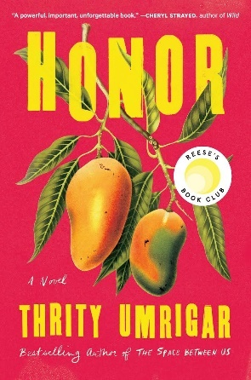 | 8th November 2024: HONOR by Thrity Umrigar (Host: Hermine)  A poignant novel about two Indian women from different worlds. One is a journalist from Mumbai, the other a village woman seeking justice after a horrific incident. Their lives intersect as they confront deep-seated traditions, violence, and the complexities of love and honor.
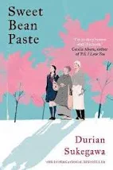 | 4th October 2024: Sweet Bean Paste by Durian Sukegawa (Host: Joyce)  This heartwarming story follows a lonely street vendor, Sentaro, who meets Tokue, an elderly woman with a talent for making sweet bean paste. Their friendship blossoms as they share their personal struggles, revealing themes of redemption and human connection.
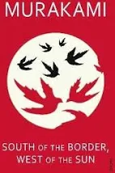 | 6th September 2024: South of the Border, West of the Sun by Haruki Murakami (Host: Nada)  A reflective novel about Hajime, a man who reconnects with his childhood love Shimamoto after years of an ordinary life. As they rekindle their relationship, he is drawn into memories and desires that threaten to unravel the life he has built.
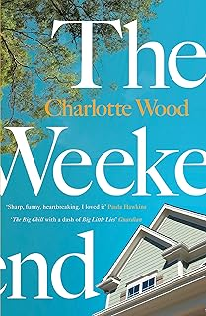 | 5th July 2024: The Weekend by Charlotte Wood (Host: Stefania)  Three women in their 70s come together to clean out the house of their recently deceased friend, Sylvie. Over a holiday weekend, they confront their pasts, their friendship, and the limitations of aging, in a candid exploration of female relationships.
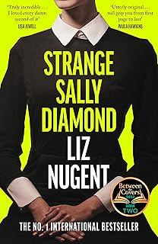 | 7th June 2024: Strange Sally Diamond by Liz Nugent (Host: Fiona)  Sally Diamond, a socially awkward woman, triggers a media storm when she follows her deceased father's bizarre instructions for dealing with his body. As dark secrets about her past are revealed, Sally must navigate her strange, unsettling life.
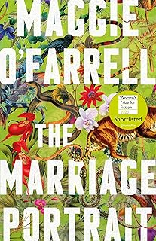 | 3rd May 2024: The Marriage Portrait by Maggie O'Farrell (Host: Sue)  Set in Renaissance Italy, this historical novel focuses on the life of Lucrezia de' Medici, who is married off to a powerful duke. As she faces the dangers of court politics and her husband’s darker side, she must fight to survive.
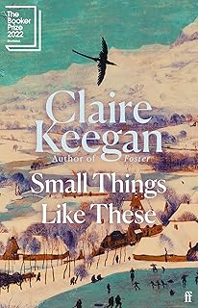 | 5th April 2024: Small Things Like These by Claire Keegan (Host: Cristina)  In this quietly powerful novella set in 1980s Ireland, a coal merchant named Bill Furlong uncovers a dark secret involving a local convent. His moral dilemma forces him to make a life-altering decision amidst a climate of silence and repression.
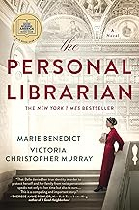 | 1st March 2024: The Personal Librarian by Marie Benedict and Victoria Christopher Murray (Host: Patrizia)  This novel centers around Belle da Costa Greene, a Black woman passing as white in early 20th-century America, who becomes the librarian for J.P. Morgan. She must balance her professional success with the dangers of keeping her identity hidden.
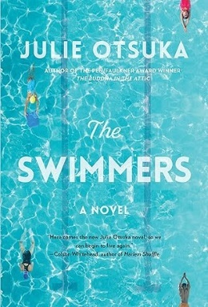 | 2nd February 2024: The Swimmers by Julie Otsuka (Host: Tracey)  A novel about a group of people who regularly swim in a subterranean pool. When a crack in the pool disrupts their routine, their lives unravel, particularly Alice, who struggles with dementia, and her daughter as they navigate a shifting world.
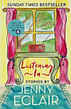 | 12th January 2024: Listening Inn by Jenny Eclair (Host: Astra)  A collection of bittersweet stories about women of different ages and stages of life, reflecting on their relationships, regrets, and hopes. With humor and insight, Eclair examines the nuances of marriage, motherhood, and aging.
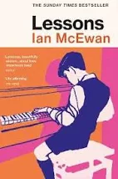 | 1st December Lessons by Ian McEwan (Host: Cinzia)  This story, though not as widely known as McEwan's other works, is a reflection on themes of memory, guilt, and the passage of time. McEwan often delves into human emotions and relationships with sharp psychological insight, so December Lessons likely explores similar introspective themes, involving personal conflicts or moral dilemmas.
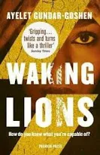 | 17th November 2023: Waking Lions by Ayelet Gundar-Goshen (Host: Hermine)  This gripping novel explores moral dilemmas and privilege through the story of Dr. Eitan Green, an Israeli neurosurgeon who hits and kills an African migrant with his car. Instead of reporting the accident, he flees the scene, but the victim's widow finds him and forces him into a life of secret servitude. The novel examines issues of guilt, power, and immigration in modern-day Israel.
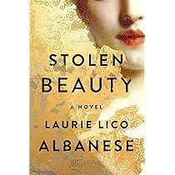 | 6th October 2023: Stolen Beauty by Laurie Lico Albanese (Host: Stefania)  This historical novel alternates between two women connected by the famous Viennese artist Gustav Klimt. One is Adele Bloch-Bauer, Klimt's muse and the subject of his famous painting The Woman in Gold, and the other is her niece Maria, who must escape Nazi-occupied Austria. Stolen Beauty is a tale of art, history, and the strength of women facing immense personal and political challenges.
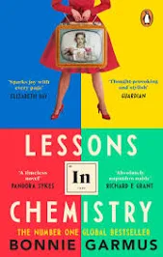 | 15th September 2023 Lesson in Chemistry by Bonnie Garmus (, Host: Joyce)  Set in the 1960s, this novel follows Elizabeth Zott, a chemist whose career is thwarted by a male-dominated society. Her unconventional path leads her to become the star of a TV cooking show, where she teaches housewives chemistry along with recipes, challenging social norms.
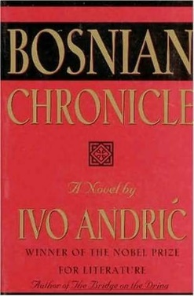 | 29th June 2023 Bosnian Chronicle by Ivo Andric (, Host: Nada)  Set during the Napoleonic Wars in the early 19th century, the novel explores the complex interactions between various ethnic and religious groups in Bosnia under Ottoman rule. Through the eyes of consuls and local leaders, it reflects on politics, culture, and human nature in a time of transition.
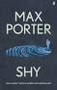 | 5th May 2023 Shy by Max Porter (Host: Sue)  A poetic and experimental novel that delves into the mind of Shy, a troubled teenage boy at a boarding school for difficult children. Through fragmented thoughts and stream-of-consciousness writing, Porter explores themes of trauma, mental health, and the longing for connection.
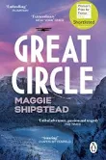 | 14th April 2023 Great Circle by Maggie Shipstead (Host: Susi)  This epic novel spans generations, telling the parallel stories of Marian Graves, an aviator in the early 20th century who attempts to fly around the world, and a modern-day actress cast to play her in a biopic. The narrative explores ambition, freedom, and the sacrifices required for greatness.
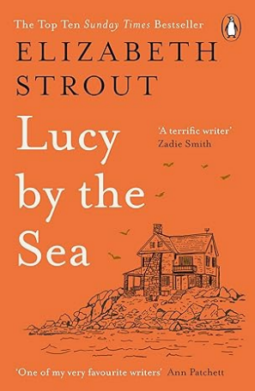 | 3rd March 2023 Lucy by the Sea by Elizabeth Strout (Host: Astra)  Set during the COVID-19 pandemic, this novel follows Lucy Barton as she leaves New York City to live in rural Maine with her ex-husband. The novel deals with themes of isolation, familial ties, and the personal impact of global crises, all told in Strout's signature introspective style.
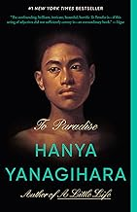 | 3rd February 2023 To Paradise by Hanya Yanagihara (Host: Tracey)  This ambitious novel spans three centuries and presents an alternate version of American history. It explores themes of love, loss, and societal expectations, focusing on different characters across various timelines and examining utopian visions, pandemics, and political unrest.
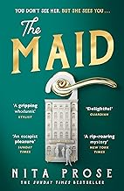 | 13th January 2023 The Maid by Nita Prose (Host: Cristina)  This mystery novel centers on Molly Gray, a socially awkward hotel maid who becomes embroiled in a murder investigation after discovering a wealthy guest dead in his room. As Molly navigates clues and suspects, she learns to trust her instincts and solve the mystery while also finding her own place in the world.

