ARTIFACT: Solicit, accept, and provide constructive feedback.
Supra Badge: Professional Foundations in LDT
Sub-Badge: ID Professional Communicator
Challenge: Solicit, accept, and provide constructive feedback.
Artifact: Screenshots of Final Project from EDCI 531 (Fall 2024) showing all three required elements of the challenge have been practiced.

Requesting Feedback
Summary:
- Identifying who to request feedback from
- Requesting the feedback
Step 1: Using “Instant Messages” in Brightspace, I requested my peer for feedback.
- Scheduling a call to discuss
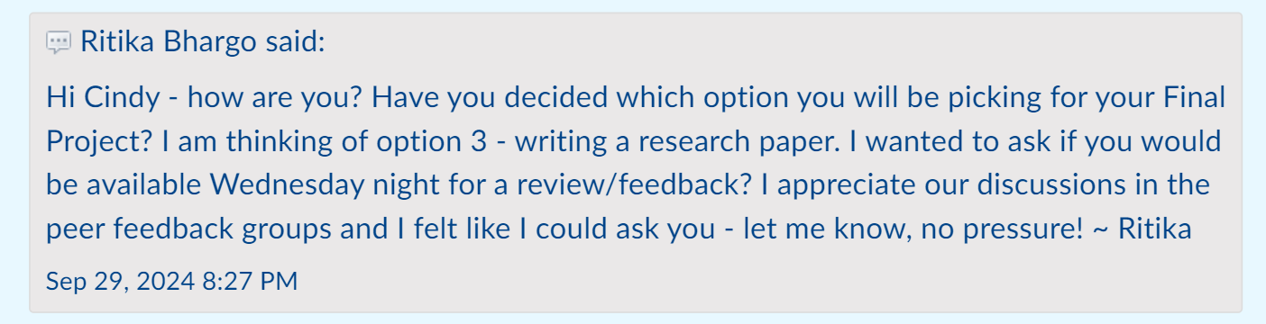

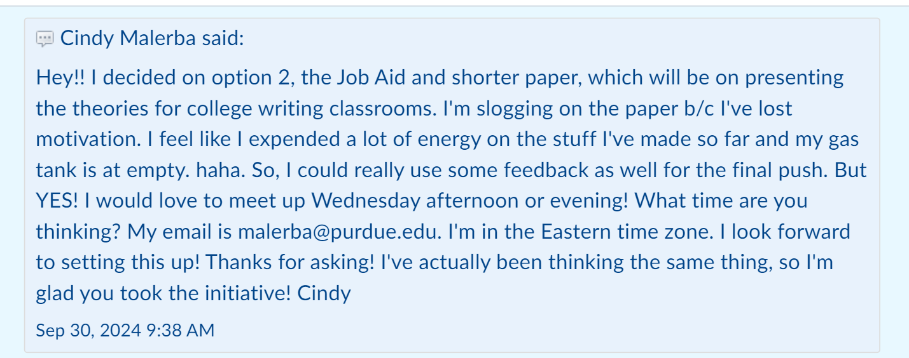
Step 2: Gauged my peer’s interest and availability.

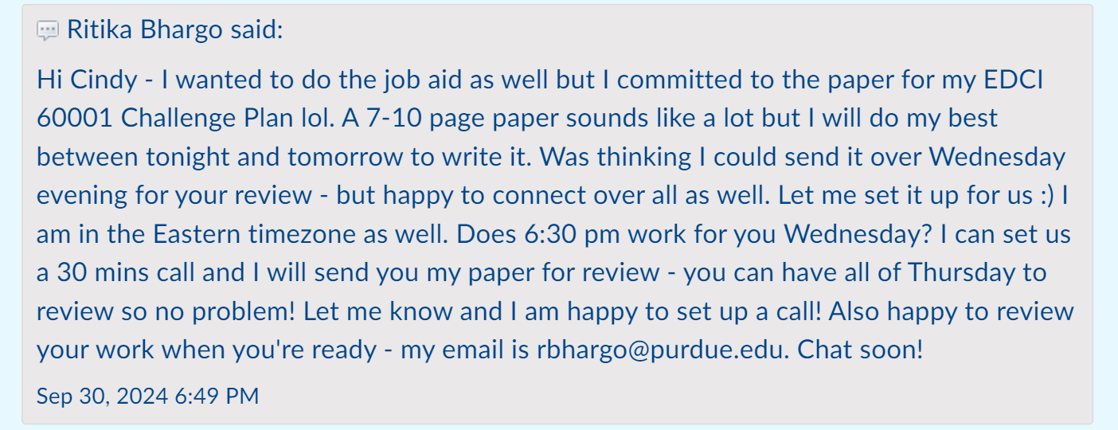

Just engaging in a conversation, I received so many helpful tips and information!
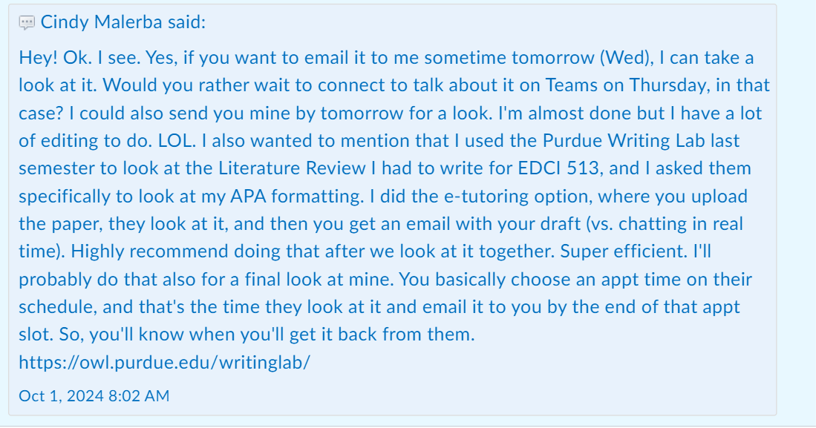

Step 3: Schedule a call.

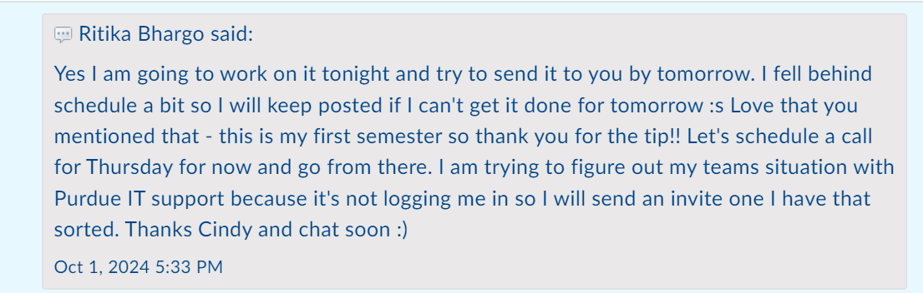

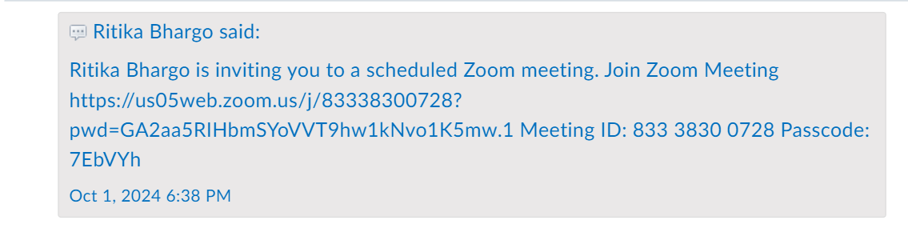
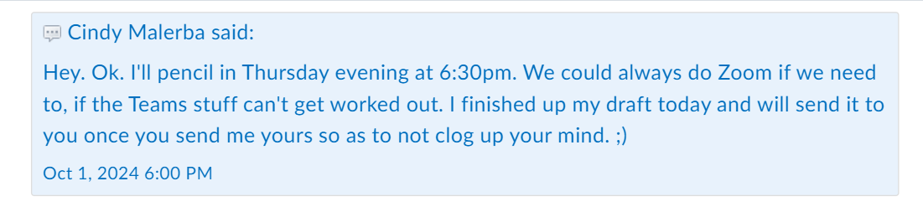

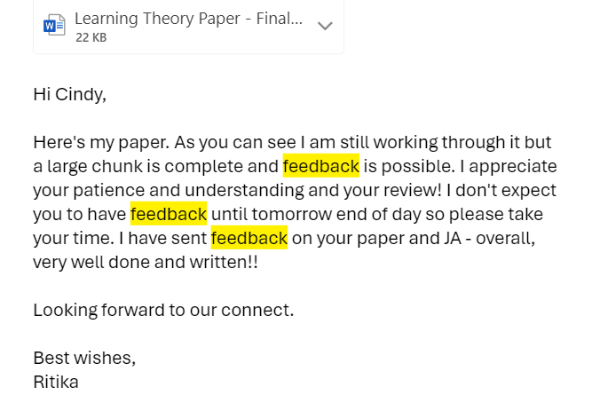
It is important to include timelines, so the reviewer knows what the expected turnaround time is.

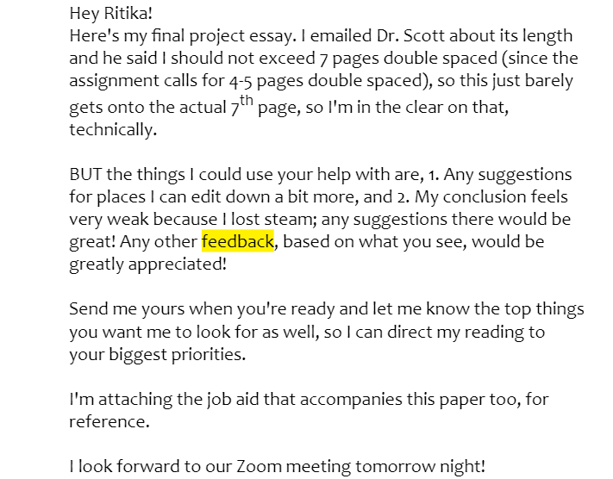
Step 4: Providing feedback. My peer sent me an email with her paper. She also clearly identified the areas where she could use feedback, which helped.

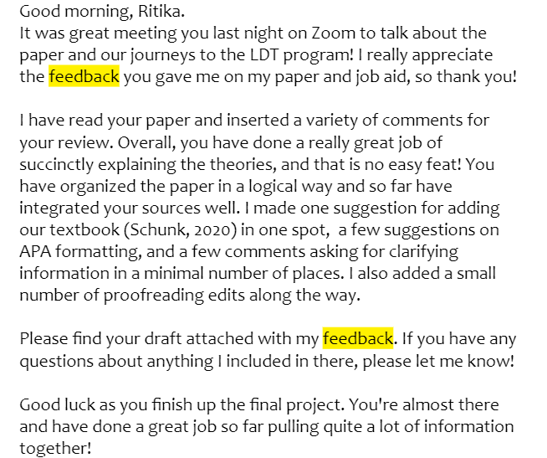

My suggestions: Overall, my peer drafted a well-written paper so there wasn’t much feedback to provide. Below are some screenshots that covered my feedback.
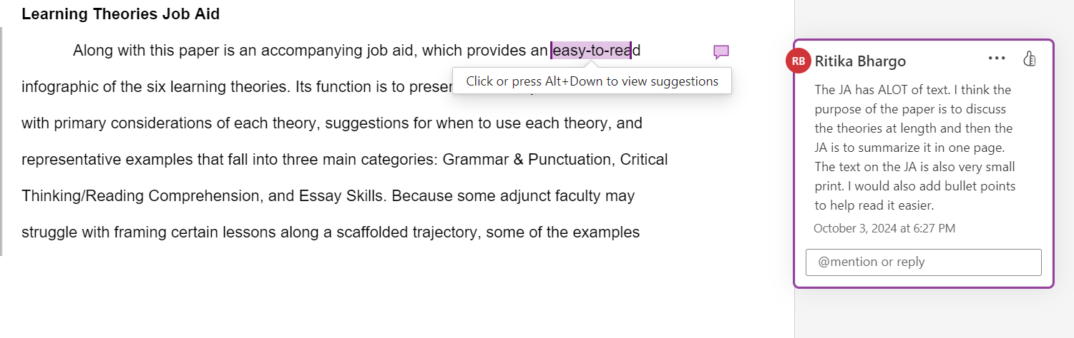
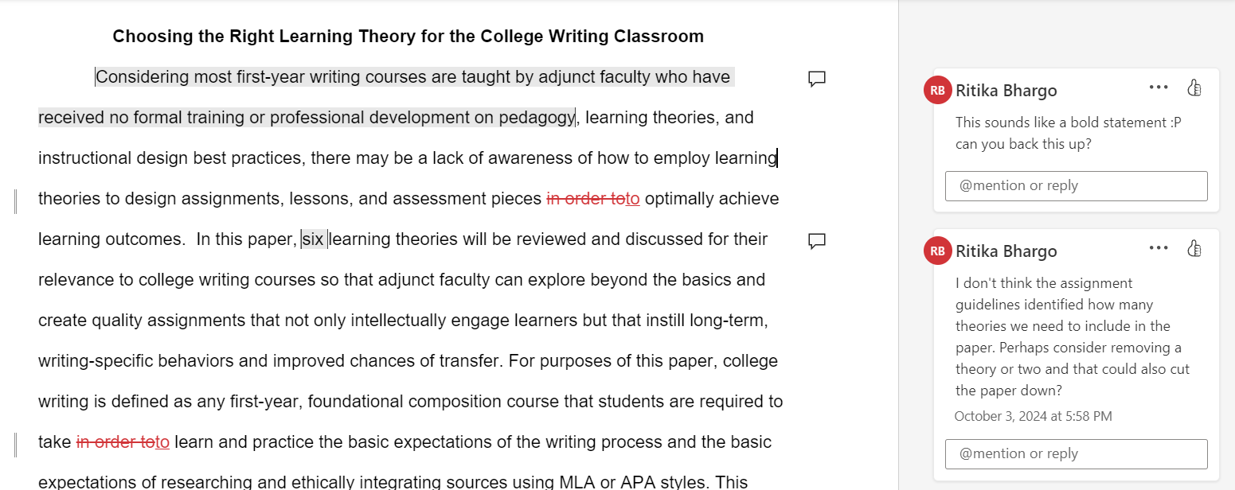

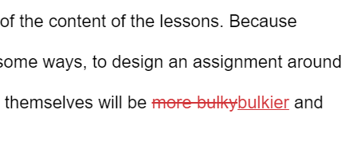
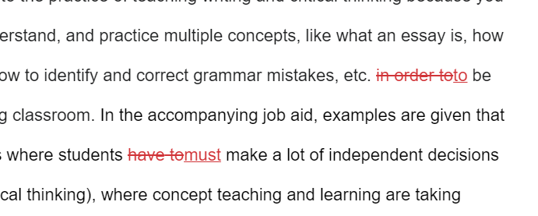
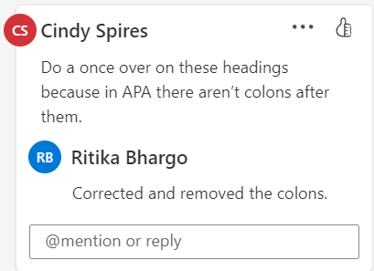
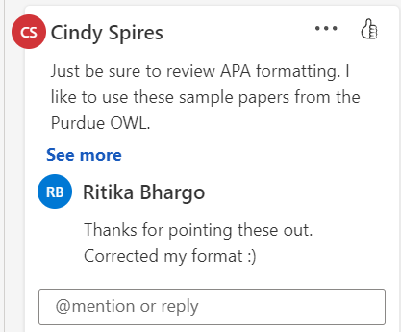
Step 5: Go through feedback and apply to enhance my paper/writing. My comments back to my peer reflect how and if I utilized that feedback.

