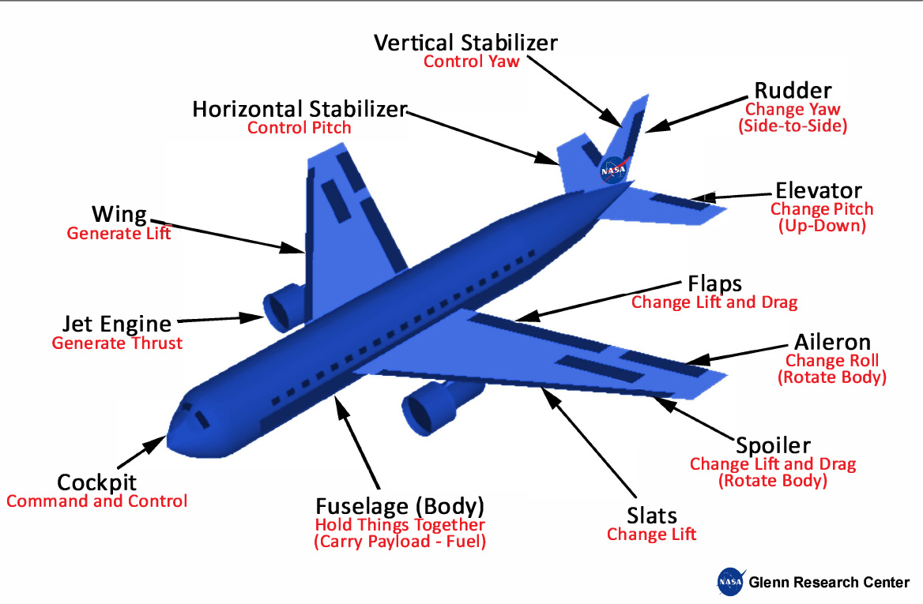
PITCH: -
Pulling back on the sidestick or yoke will cause the aircraft to pitch up
Pushing down on the sidestick or yoke will cause the aircraft to pitch down
ROLL:
Moving the sidestick or yoke to the left or right will cause the aircraft to roll to the left or right
YAW:
Pushing the left or right ruder pedal will cause the aircraft to yaw
Note: Primary function in a single engine aircraft is to counter the torque when taking off and climbing but main function is to counter crosswind when landing

Four Forces on an Airplane
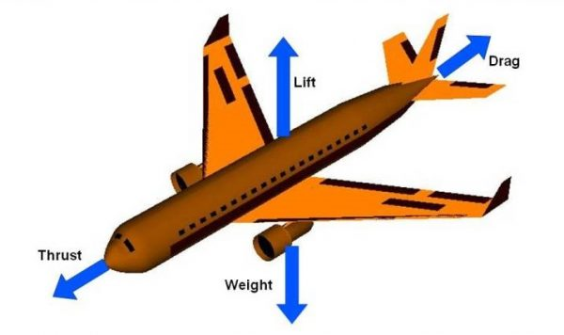

Weight
Weight is a force that is always directed toward the center of the earth.

Lift
To overcome the weight force, airplanes generate an opposing force called lift

Drag
As the airplane moves through the air, there is another aerodynamic force present. The air resists the motion of the aircraft and the resistance force is called drag. Drag is directed along and opposed to the flight direction

Thrust
To overcome drag, airplanes use a propulsion system to generate a force called thrust.

