What is the name of the part of the airport where planes park and are serviced at the airport?

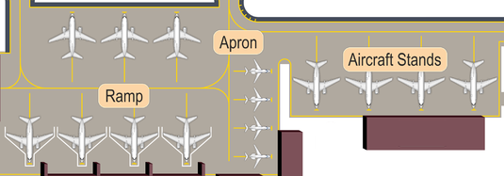

Tarmac
Though commonly used to describe the area where planes park, tarmac isn’t officially a place. That word is the name of a product produced by a British company that produces a surface coating that is applied to roads and airfields. It is not a place where planes park.
Ramp
This is a term used quite frequently. It’s a common unofficial term for an apron that is very much in use at airports.
The use of ramp has its roots in airports that served seaplanes and as a literal ramp from the water to the airfield.
Apron
If the ramp is not an official term, then it’s got to be the apron.
This is in fact the official term used by both the International Civil Aviation Organization (ICAO) and the Federal Aviation Administration (FAA)
The apron is a busy and dangerous place.
It’s the part of the airport where vehicles and airplanes share the same space.
The many movements on the apron are not generally controlled by the air traffic control tower.
At large airports, aprons are governed by their own towers while at small ones it could be left to each pilot.
Stand

There are 2 types of stands for aircraft to park
Contact or Air Bridge
Air bridges provide all-weather dry access to the plane and enhance airport operations' security.
Permanently attached to the terminal

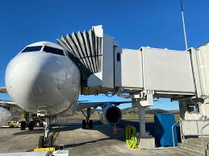

Remote
These stands are not attached to the terminal
In most cases a bus takes the passengers from the plane to the terminal and vice versa
At Toulouse often passengers use steps to descend and walk directly into the terminal as the plane is parked very close





