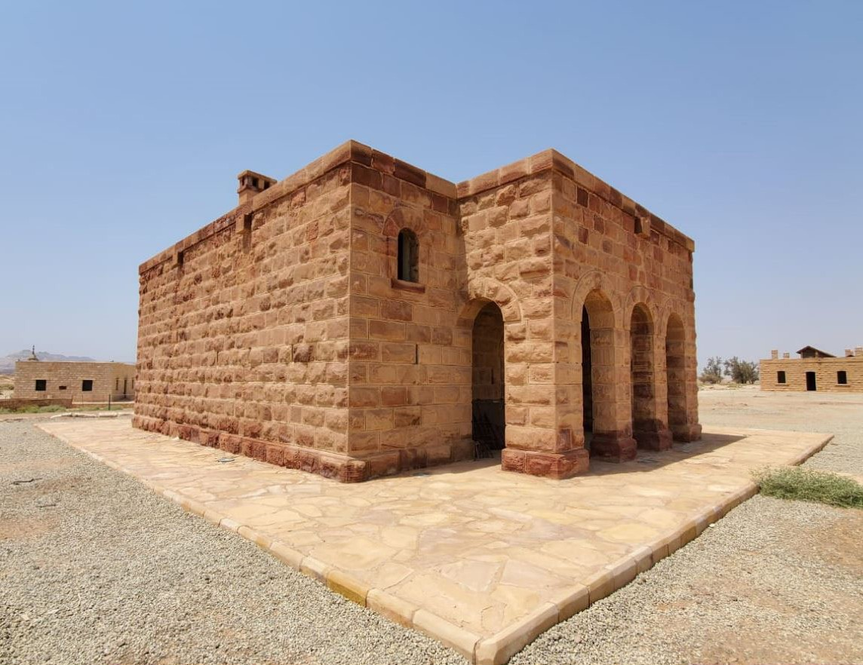


Hegra Heritage Boutique Hotel Evaluation of The Existing Condition Assessment Report for Building B05
Date 2022/09/12
Contents
1 Introduction 3
2 Methodology of Assessment 3
3 Report Evaluation 4
ACTS Report: Page #4 4
Comments by COM 4
ACTS Report: Page #5 5
Comments by COM 5
ACTS Report: Page #6 6
Comments by COM 6
ACTS Report: Page #7 7
Comments by COM 7
ACTS Report: Page #8 8
Comments by COM 8
ACTS Report: Page #9 9
Comments by COM 9
ACTS Report: Page #10 10
Comments by COM 10
ACTS Report: Page #11 11
Comments by COM 11
ACTS Report: Page #12 12
Comments by COM 12
ACTS Report: Page #13 13
Comments by COM 13
ACTS Report: Page #14 14
Comments by COM 14
ACTS Report: Page #15 15
Comments by COM 15
ACTS Report: Page #161 16
Comments by COM 16
ACTS Report: Page #17 17
Comments by COM 17
ACTS Report: Page #18 18
Comments by COM 18
ACTS Report: Appendix 1 (Satellite view of subjected buildings) 19
Comments by COM 19
ACTS Report: Appendix 2 (Defect Mapping) 20
Comments by COM 20
ACTS Report: Proposed NDT Test Locations 21
Comments by COM 21
ACTS Report: Proposed Trial Pit Locations 22
Comments by COM 22
4 Conclusion 23

Introduction
The United Nations Educational, Scientific and Cultural Organization (UNESCO) approved in 1972 the Convention on the Protection of the World Cultural and Natural Heritage. To pass it on to future generations and present it as human civilization of exceptional value. Mada'in Saleh and its annexes in the Saudi city of Al-Ula have gained this distinctive value, and our topic here is Hejaz railway station and its re-use.
The Hejaz Railway Station is located near the city of Al-Hajar, (the first site in the inclusion of Saudi Arabia on the UNESCO World Heritage List). The station was built in the middle of the eighteenth century to accommodate travelers on the pilgrimage route linking Medina and Damascus. A railway station was built and a castle next to it to provide safety for pilgrims, and a cistern was dug for water supply. The castle and cistern were renovated as part of a project to restore the adjacent railway station buildings. Mada'in Saleh station is located between Al-Dar Al-Hamra station and Al-Ula station in Saudi Arabia.
The construction of Mada'in Saleh station was completed in 1325 AH corresponding to 1907 AD. Mada'in Saleh station is located at the north of the monuments of Mada'in Saleh, and it is also one of the stations of the Hejaz Railway. The site consists of 16 heritage buildings that the concerned authorities are working on to restore life to it and use it as a touristic area to inform the world about this important part of the history of this region.
According to ICCROM's 2013 recommendations on the best practices for the preservation of urban heritage elements, the clear and most important goal is to highlight the rarity of these elements and the extent of their contribution to the formation of the local culture, and the importance of preserving it, as well as preserving the stories and social situations that were behind the formation of these elements, in addition to introducing the country's culture and its cultural and social history through its heritage.
- Appleton Charter for the Protection and Enhancement of the Built Environment (ICOMOS Canada 1983) concentrates on essential principles such as:
- Classifying the levels of intervention in the historical environment.
- Respecting the originality is an essential basis for protective and reinforcing activities.
- The best methods in the field of documentation is avoiding guessing.
- Using traditional materials and techniques.
- Preserving the appearance of the building in a reversibility manner and respecting the integrity and the safety of the structure.
The plan of dealing with the heritage buildings in Al-Hejaz Al-Ula station will be within this framework and according to the studies and field tests carried out .

Methodology of Assessment
This report has analyzed the previous assessment of existing buildings for building B05, which was done by ACTS, reviewed it, adding comments & recommendations

Figure 1 An example for the review done by the consultant

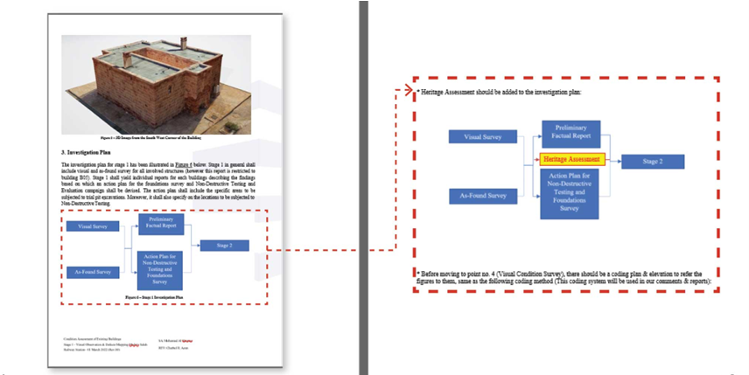
Report Evaluation

ACTS Report: Page #4
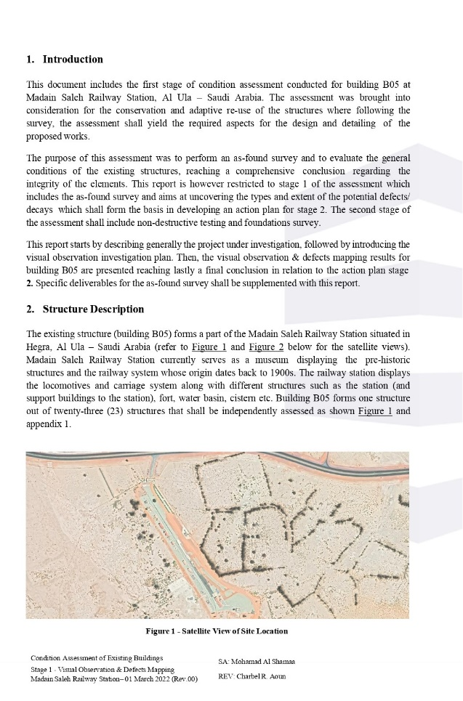

Comments

ACTS Report: Page #5
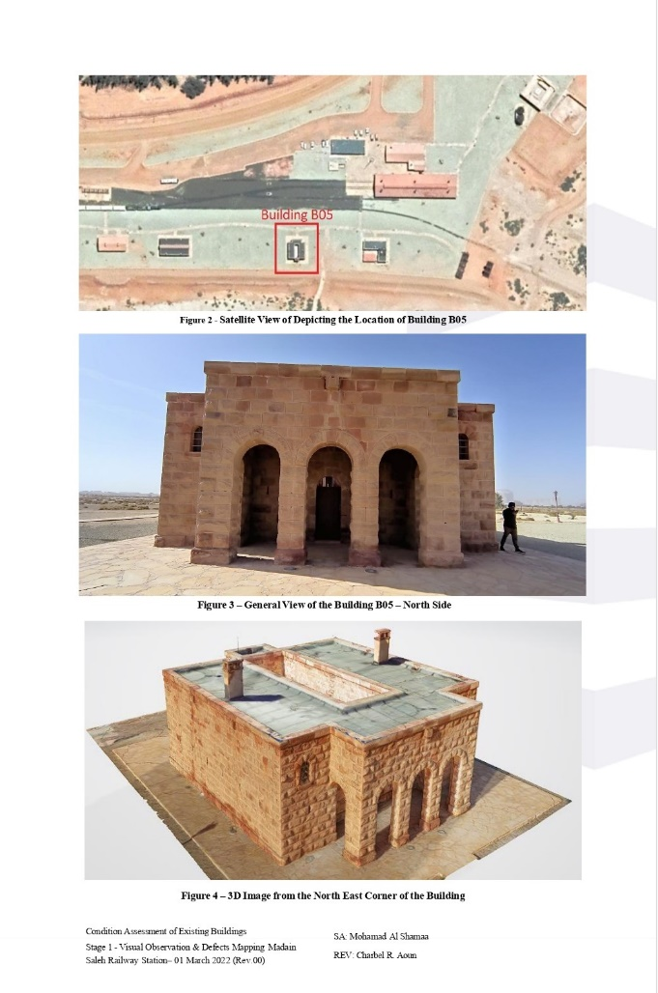

Comments

ACTS Report: Page #6
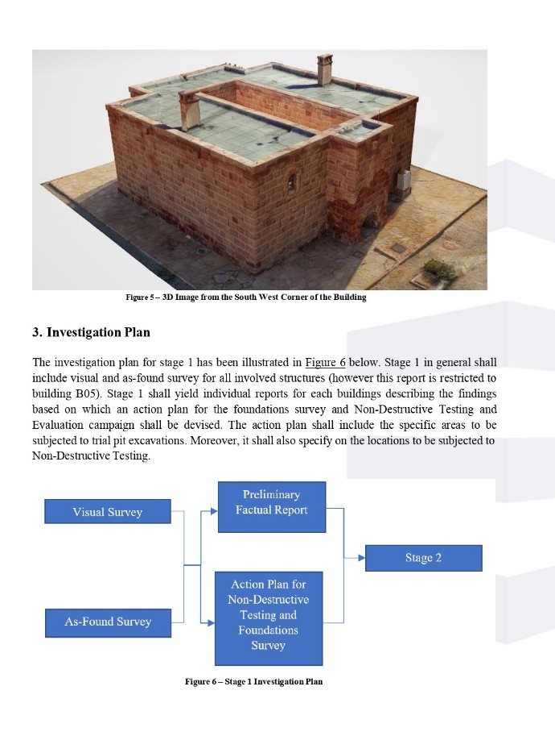

Comments
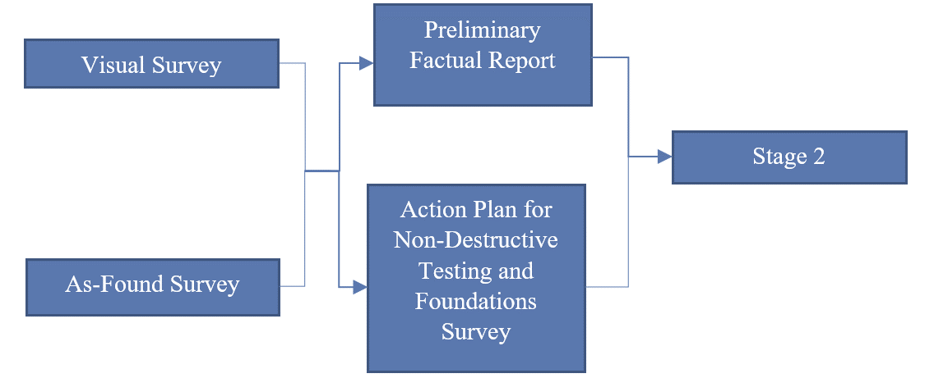
* Heritage Assessment should be added to the investigation plan:
Heritage Assessment
Before moving to point no. 4 (Visual Condition Survey), there should be a coding plan & elevation to refer the figures to them, same as the following coding method (This coding system will be used in our comments & reports):

ACTS Report: Page #7
 | Subject | Observation | Output | Photo
 | Qualitative Visual Observation | Defects’ causes must be determined in order to be treated | Classification of defects according to their causes
 | Quantitative Inspection | Each type of defects may have more than sub-type which needs more than one treatment method | Classifying the types & sub-types of defects
 | Foundation Settlement or upheaving as a reason of cracks | According to the visual inspection, it was found that it is not foundation settlement, but stresses at the edges of the windows | Stress will be determined via the structural model & analysis
 | Stair-Step Mortar Cracks | This crack occurred due to the difference between the material (The windowsill is stone & this additional part is mortar and was added to align with the upper part of the window) | We recommend removing these additional mortar parts as they are not original elements. | 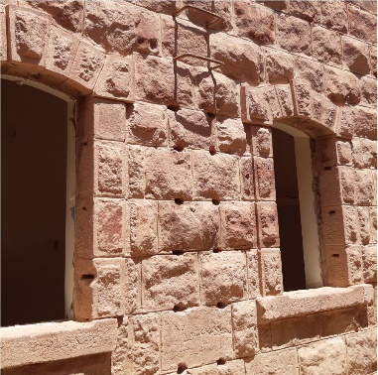
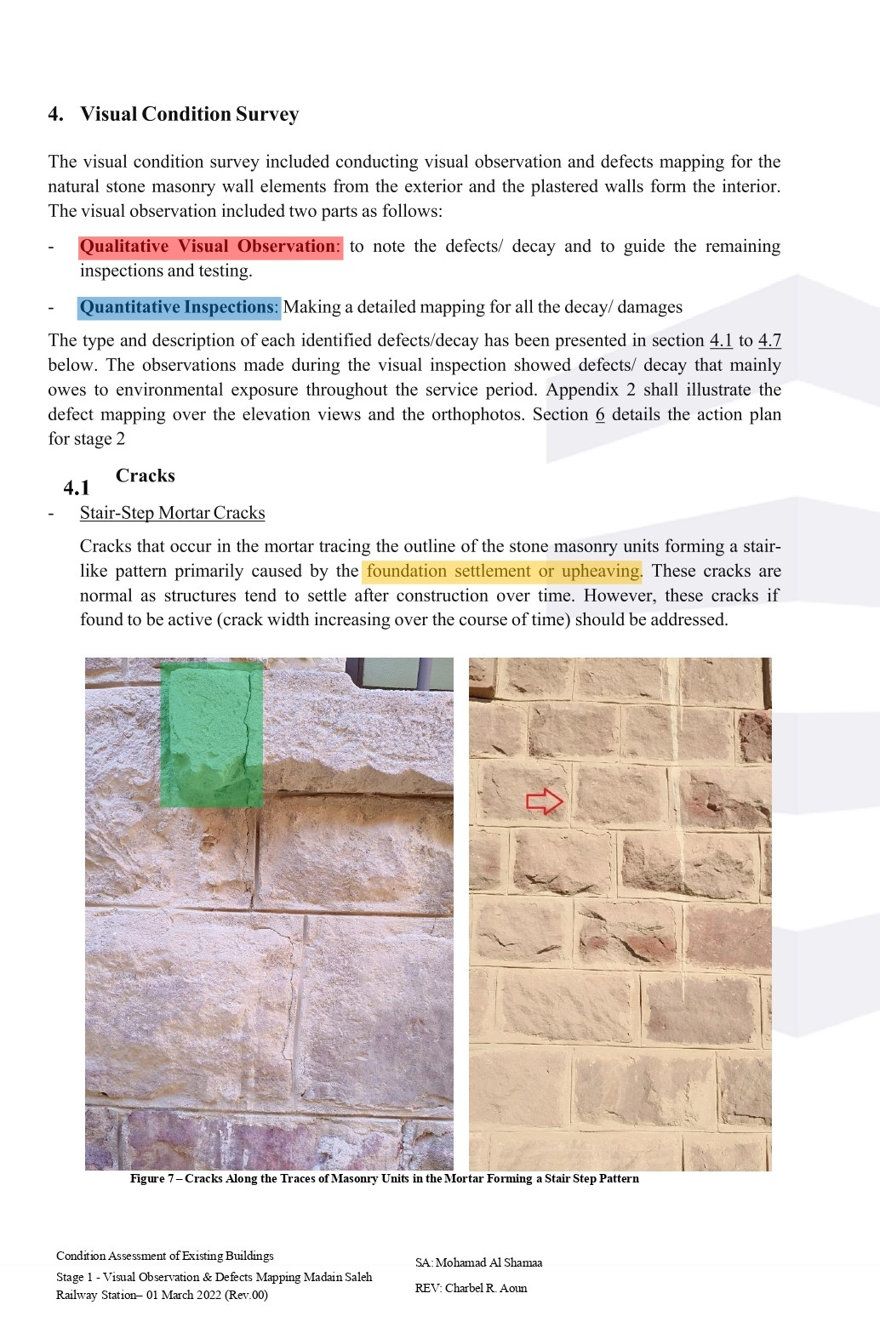

Comments

ACTS Report: Page #8
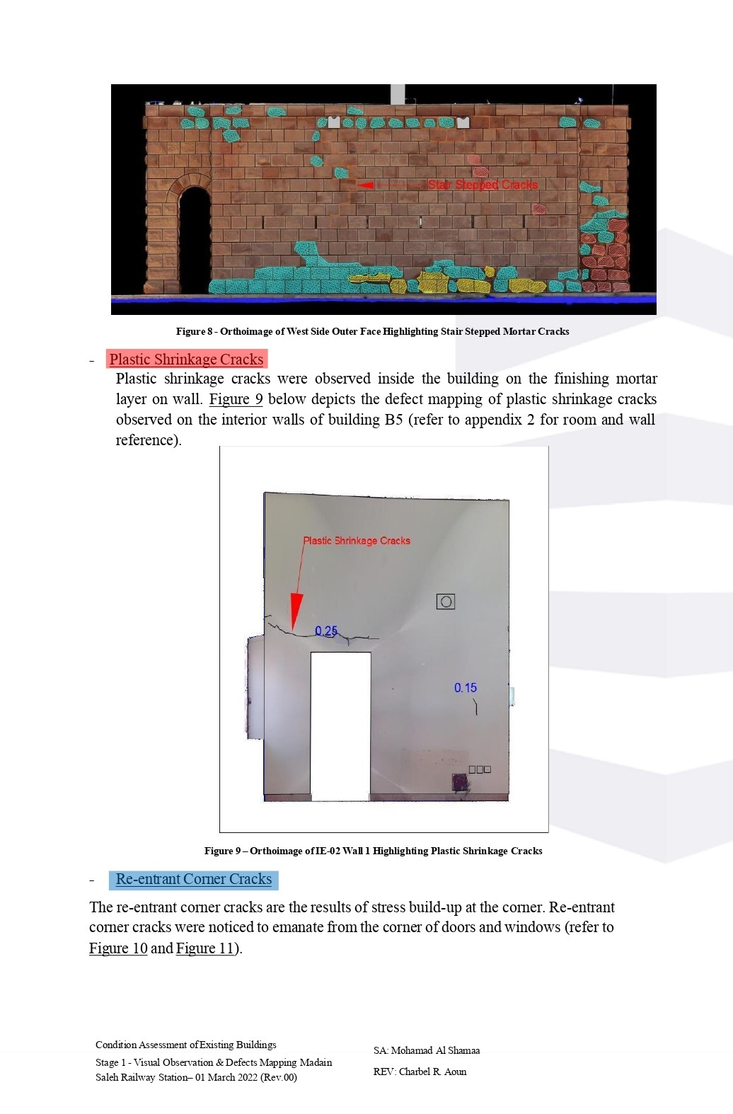

Comments by
 | Subject | Observation | Output | Photo
 | Plastic Shrinkage Cracks | 1- This is not a defect in the shrinkage of the plastic paint, but rather a separation of the door lintel from the stones above, due to the difference in the heat coefficient of the different materials | 1- Detecting the crack above the door and reconnecting the door lintel and the stones above of it | 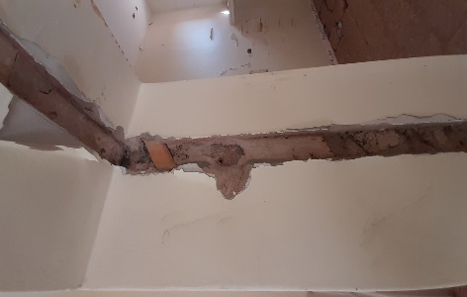  EL3.3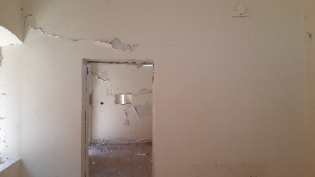
 | Plastic Shrinkage Cracks | 2- According to the exposed part of the door frame, there are metal beams under the door lintel | 2- Injection between the lintel & the metal beams with non-shrinking material
 | Plastic Shrinkage Cracks | 3- The door will be shifted as per the new design | 3- As per the new design, the door will be shifted, Corners should be treated with stiffeners such as fiber mesh, and ensure the quality of the used materials
 | Re-entrant Corner Cracks | The exact description is that these corners are weak points | Corners should be treated with stiffeners such as fiber mesh, and ensure the quality of the used materials | 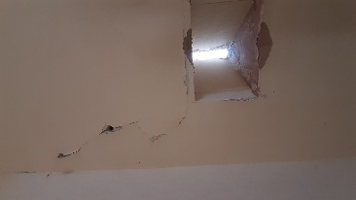

ACTS Report: Page #9
 | Subject | Observation | Output | Photo
 | Re-entrant Corner Cracks | Two types of cracks should be distinguished in the image:  1- Cracks at the corners of the openings due to stresses  2- Minor cracking in the plaster due to irregular loads | 1- Qualitative treatment, if it does not affect other elements such as the window frame  Quantitative treatment, by determining the cracks’ lengths to stop stretching  2- Cutting around the crack until reaching the stone wall at an acute angle along the crack and then performing the treatment. If the crack depth reaches the stone, plaster should be removed & fiber mesh to be used for strengthening. If it is a superficial crack, injection of lime mortar is enough. | 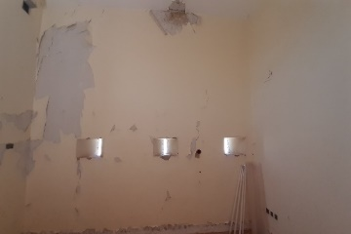  E3.4
 | Re-entrant Corner Cracks | The difference between the following types of cracks should be noted:  1- Cracks in the upper corner of the door  2- Cracks in the corners of the windows | 1- Needs detection and treatment by injection, replacement or strengthening with fiber mesh  2- It requires the use of fiber mesh for strengthening | 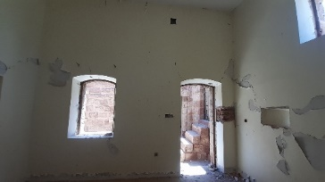  E5.4
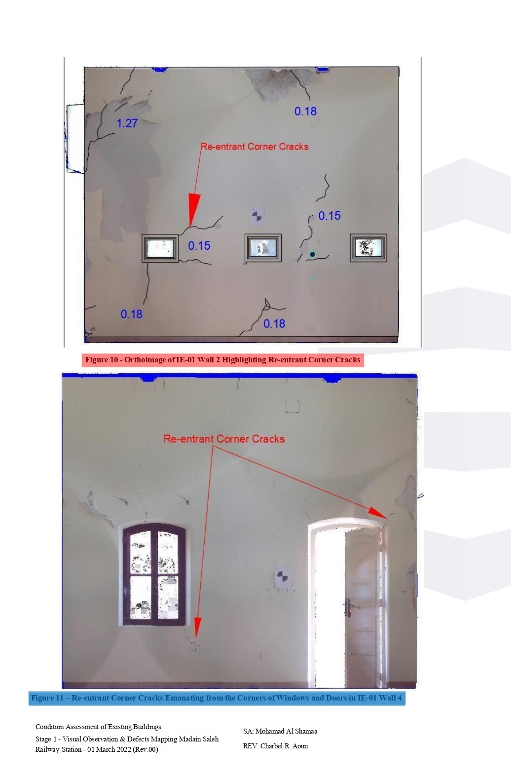

Comments by

ACTS Report: Page #10
 | Subject | Observation | Output | Photo
 | Dampness:  Walls | According to the picture, and the actual site condition, the following appears:  1- Dampness in the elevation EL03-M/N occurred due to damage to the roof insulation  2- Dampness in EL03-A to I is due to the presence of a space that was used as a bathroom  3- Dampness in EL03-F/G/L, which is due to the nature of the most porous stone components  4- Dampness in the corners due to the capillary property, as shown in EL03A/B | 1- After isolating the roof, dampness here will be treated  2- This part will be demolished as per the new design  3- It’s okay not to be treated if it doesn’t affect the surrounding stones  4- Foundations of the building must be insulated | 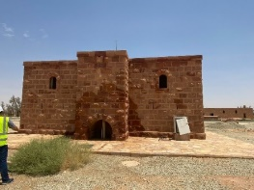  EL03
 | Dampness:  Ceilings | Dampness has caused damage to the plaster. | After isolating the roof with the proper material, dampness here will be treated | 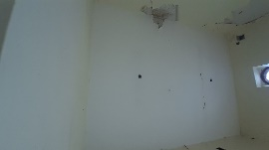  C5.6
 | Efflorescence | Most probably it is white calcium carbonate formed on the surface of the stone, and it can be removed with a brush, and if the chemical formula changes, it may become harmful. | It is recommended that a test to be done in a chemical lab to know the exact components, so we can easily treat it accordingly | 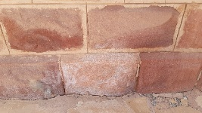
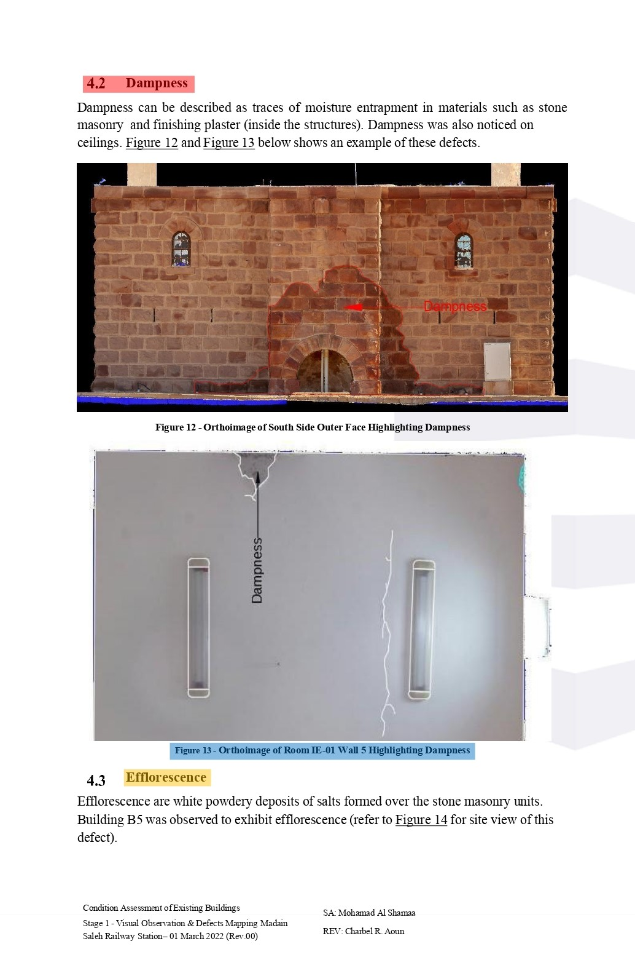

Comments by

ACTS Report: Page #11
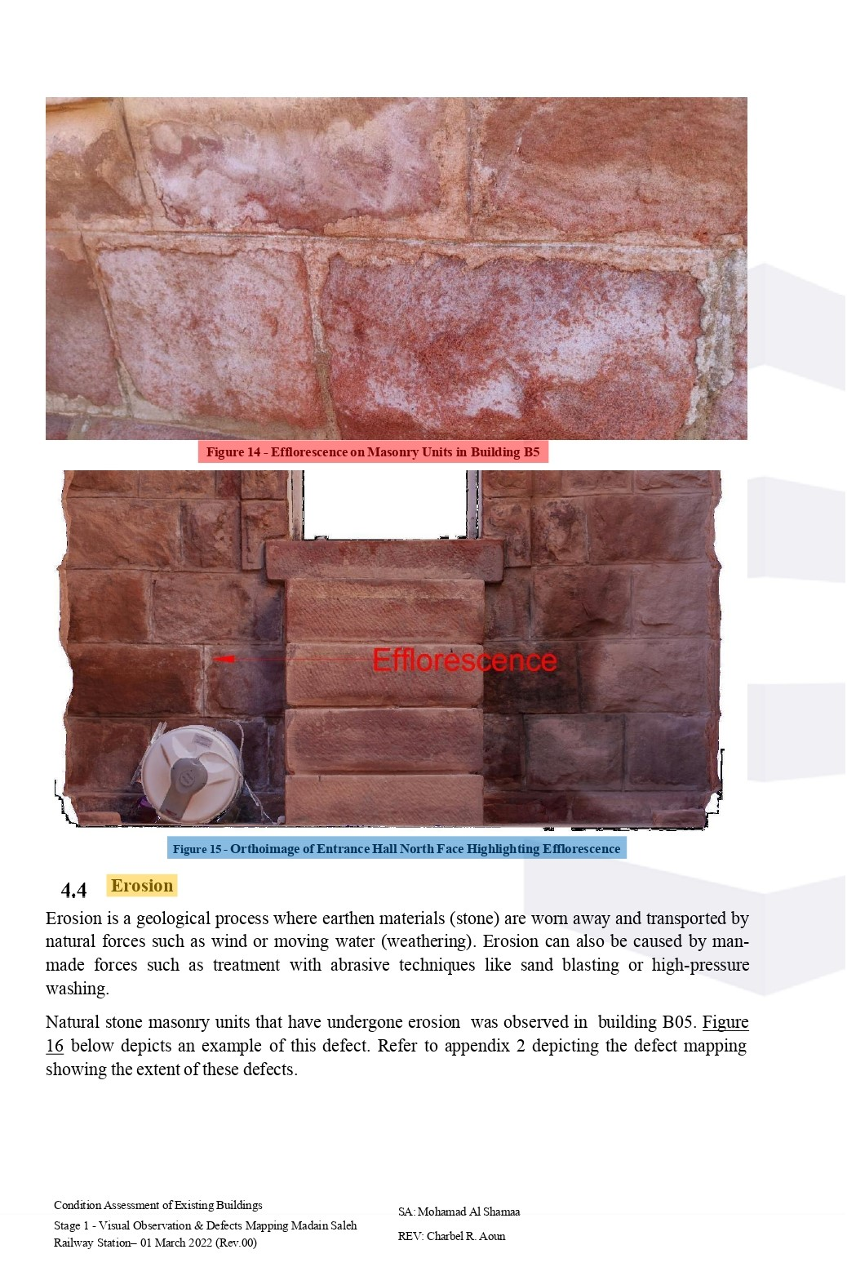

Comments by
 | Subject | Observation | Output | Photo
 | Efflorescence | Differentiating between 2 types of efflorescence:  1- Stone superficial efflorescence which leads to stone crumbling  2- Mortar efflorescence which leads to the deterioration of the mortar | Treatment should be comprehensive in all the affected areas with brush & chisel | 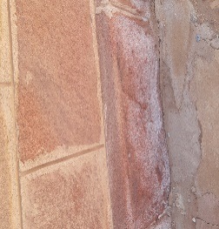  EL04-A
 | Efflorescence | There is no need for this case as this part will be removed as per the new design
 | Erosion | Erosion occurs as a result of natural factors. | Barriers around the building (Natural such as trees or artificial such as fences) must be considered in the new design in order to prevent the building from being directly exposed to storms

ACTS Report: Page #12
 | Subject | Observation | Output | Photo
 | Erosion | - We do not see that what appears in the figure is a process of erosion, but what has been eroded is the lime mortar  - Yes, there is damage to mortar, but the defect in the stone is a congenital defect due to granular heterogeneity | - Chisel should be used to determine the edges of the stone, then removing the defected parts. If the damage is deep, stone must be replaced, and the surrounding mortar must be repaired.
 | Mortar Deterioration | The most important causes of mortar erosion are:  1- The ingredients of the mixture are incorrect  2- The difference of the granular composition between the mortar and stone  3- The small available thickness of filling | All causes that lead to mortar deterioration must be known in order to produce a proper mixture of mortar that has resistance and sustainability
 | Stone Spalling | This type of spalling tends to be found in the lower part of the building as a result of the nature of the climate and the components of the stone | Resin stabilizers are the best at giving more rigidity and insulation | 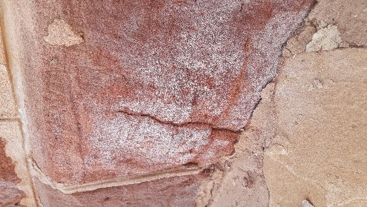  EL02-A
 | Stone Spalling in the hall entrance | After inspecting the site, it was found that they are erosion | Determining these locations to be injected with resin materials | 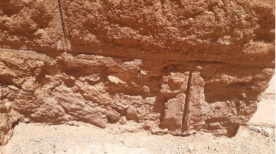  EL06-A
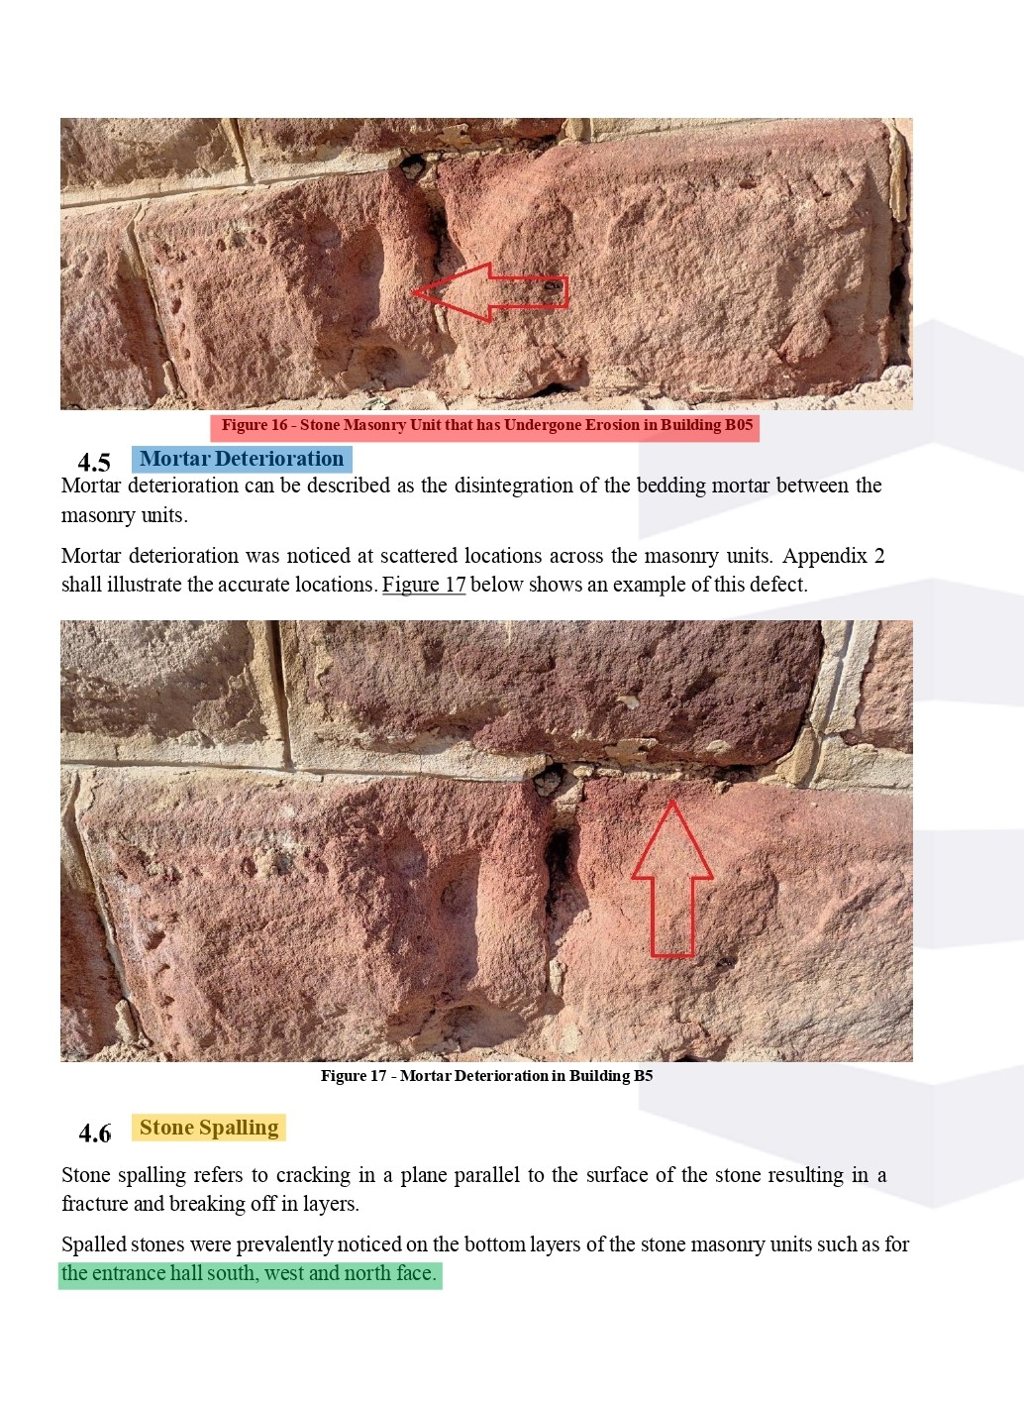

Comments by

ACTS Report: Page #13
 | Subject | Observation | Output | Photo
 | Stone Spalling | After visual inspection, this figure is not an example on spalling, but it should be for erosion | The defected stones must be replaced with new ones
 | Termite Holes | - Termite holes on the stone are characterized by finding sand covering them, and this is what distinguishes them from the holes that are man-made  - Termites cannot reach great depths in the stone, only few centimeters  - Other colonies of various insects were observed in various locations of the building | All holes in the building should be marked & injected with insecticide treatment materials | 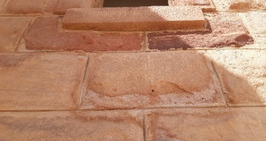  EL.01  EL04  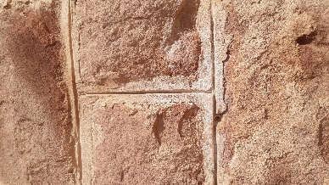  W24  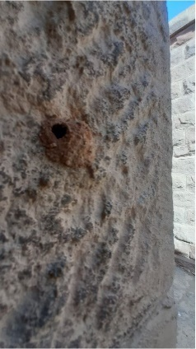
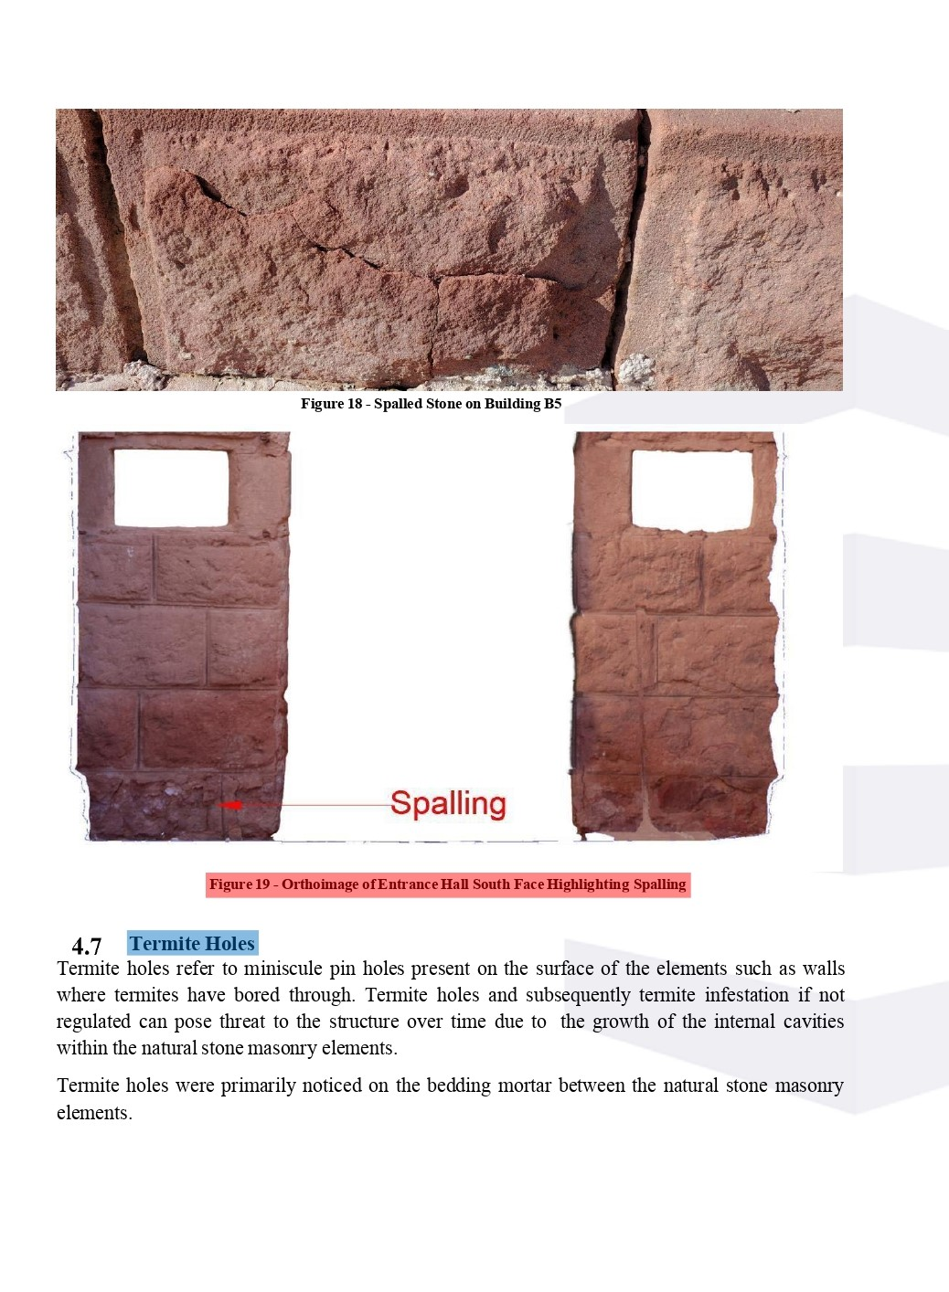

Comments by

ACTS Report: Page #14
 | Subject | Observation | Output | Photo
 | Termite Holes:  Fig. 20 & 21 | - We should distinguish between the termite holes and the holes that occurred due to human intervention  - We should distinguish between the termite holes in the stone & the ones in the mortar  - The type of insects that caused holes in the stones directly must be determined | Detecting the holes to find out the direction of them | 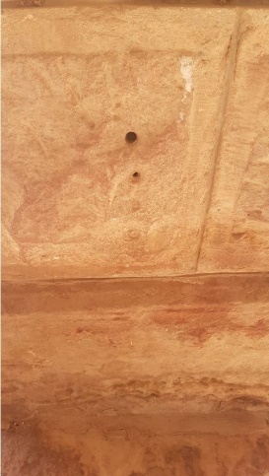
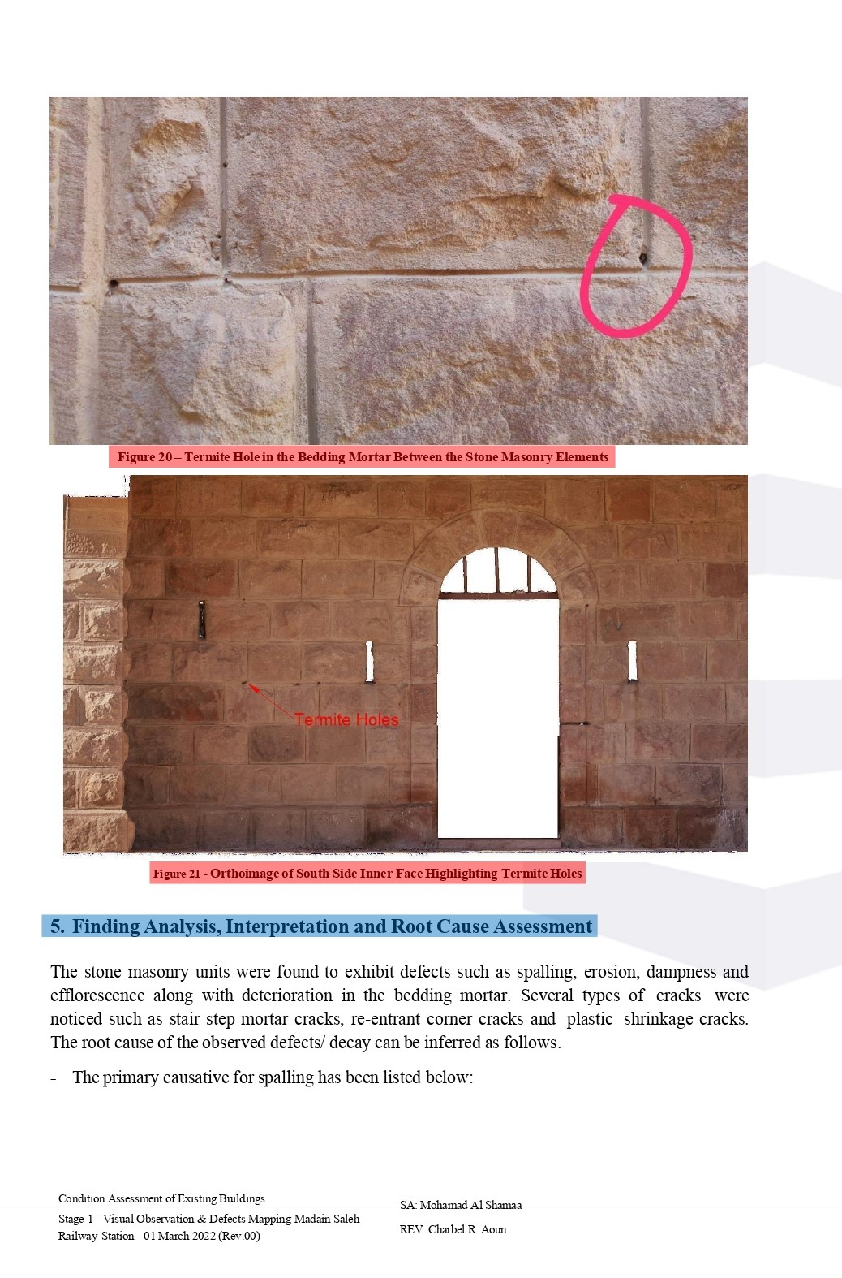

Comments by

 | The reasons for the deterioration according to the report | More reasons
 | 1- Spalling  2- Erosion  3- Dampness  4- Efflorescence  5- Mortar deterioration  6- Cracks  7- Termite holes | 1- Specific density difference between the different materials  2- Bad mortar specifications  3- Defects due to human intervention  4- Impurities in the granular structure of the stone  5- Bad workmanship  6- Sandstone is relatively weak to resist natural factors

ACTS Report: Page #15
Subject | Observation | Output
The reasons for the deterioration of the building | The report explanation is okay, but it should be classified as per the affected items such as:  - Stone  - Mortar  - Plaster  - Ceilings  - Floorings  - Defects’ classification as per the causes such as:  - Defects caused by the environment  - Defects caused by human intervention  - Defects caused by building materials  - Design flaws  - Defects due to the nature of the geographic area  - Defects of soil and site | - The treatment of defects in buildings depends on the evaluation of the condition of the building, the evaluation depends on the causes of deterioration, and a precise study gives impressive results  - The type of defects must match the attached photos  - Any photos and attachments must be referenced to the coding plan & elevations  - Differentiation must be considered between the structural deterioration that affects the safety of the building, and surface deterioration that does has no effect but requires treatment.
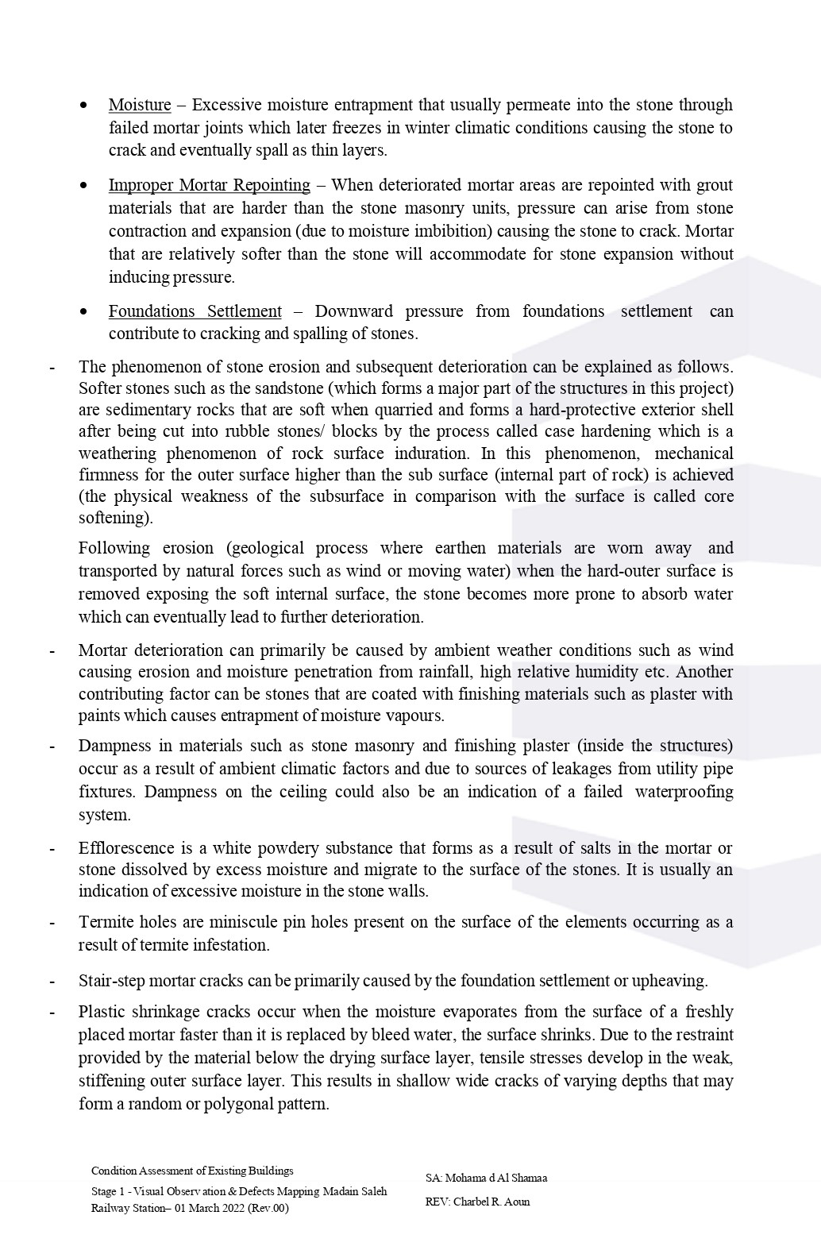

Comments by

ACTS Report: Page #161
 | Subject | Observation | Output
 | Action Plan for Stage 2  - Visual Survey & As-found Survey  - Heritage Assessment  - Preliminary Report  - Testing  - NDT & MASO Tests  - Final Report | - This is followed by documentation, damage sorting, original and non-original item sorting, photographic documentation, and sketches  - The report didn’t mention a study of the heritage elements in the building  - Determining the extent to which the study matches reality  - Determining the quantities and locations of the required tests  - Reviewing test results / Determining convenient samples and taking the proper action  - Recommendations | - Recommendations  - Identifying the original & non-original elements of the buildings  - Recommendations  - Recommendations  - Suggestions for solutions to overcome obstacles  - Specs. & quantities
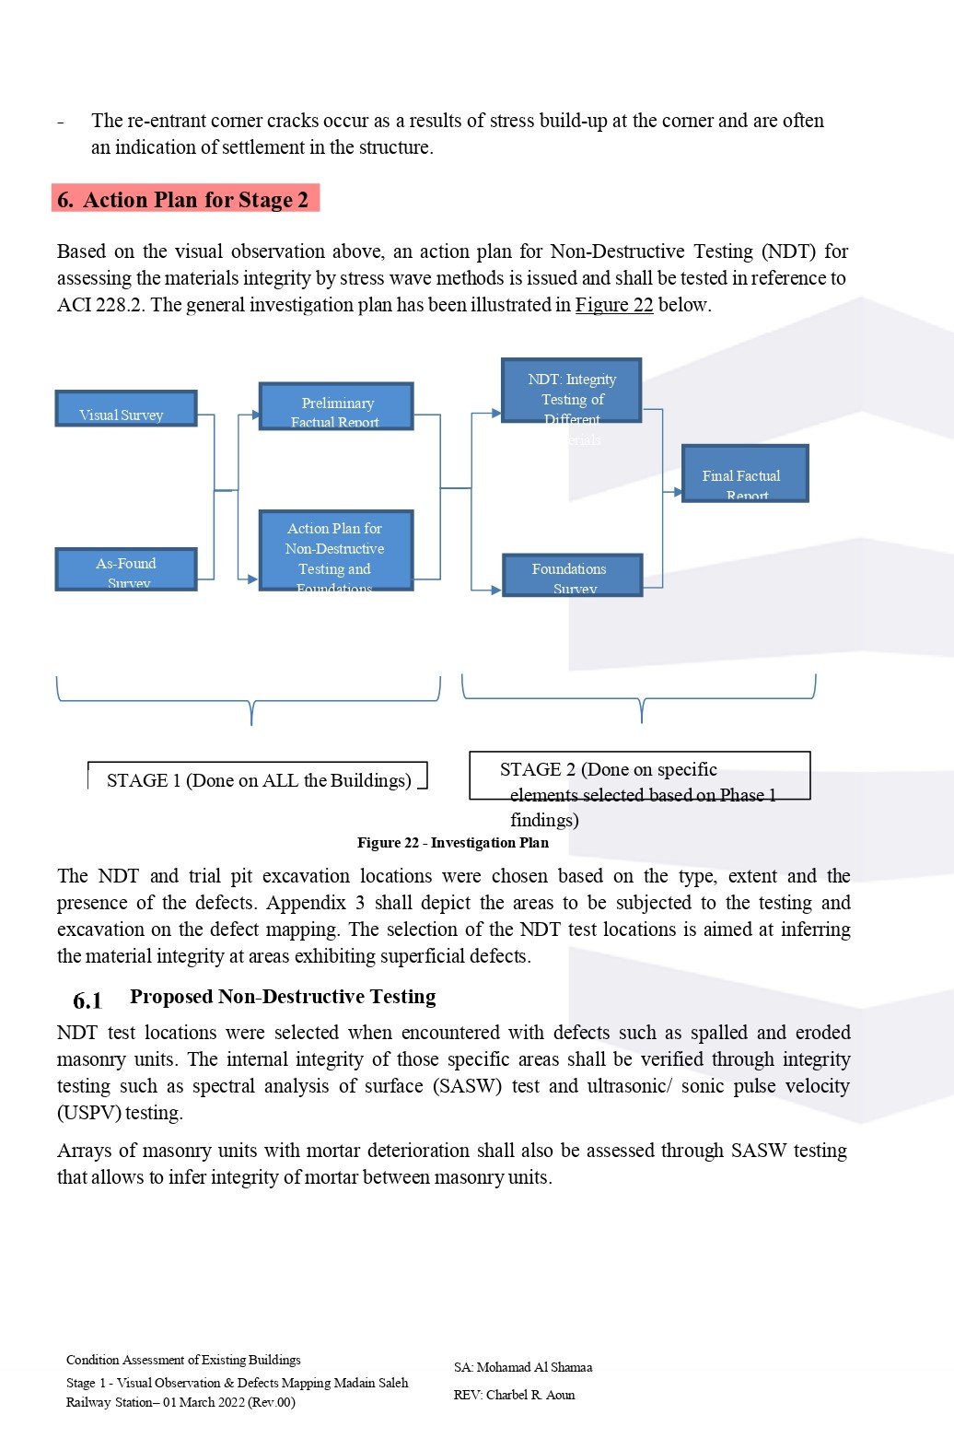

Comments by

 | Subject | Proposed Tests | Missing Required Tests | Desired Results
 | Proposed Non-Destructive Testing | - SASW  - USPV | - Half-Cell Potential Test  - Schmidt Hammer Test  - Rebar Detector | - To check if there is any corrosion in the steel of the slab  - To check the strength of the concrete slab  - To check the distance between the steel I-beams in the roof

ACTS Report: Page #17
 | Subject | Observation | Output
 | Proposed Trial Pits Excavations | - The exact location of the excavation will be agreed upon with the structural engineer at the site  - Outdoor sample to be taken from the marked location in Fig. 23.  - If no strip foundation found, another sample to be taken under an internal wall. | - Recommendation for conservation of the walls which have cracks  - Inspection of foundations to determine damages
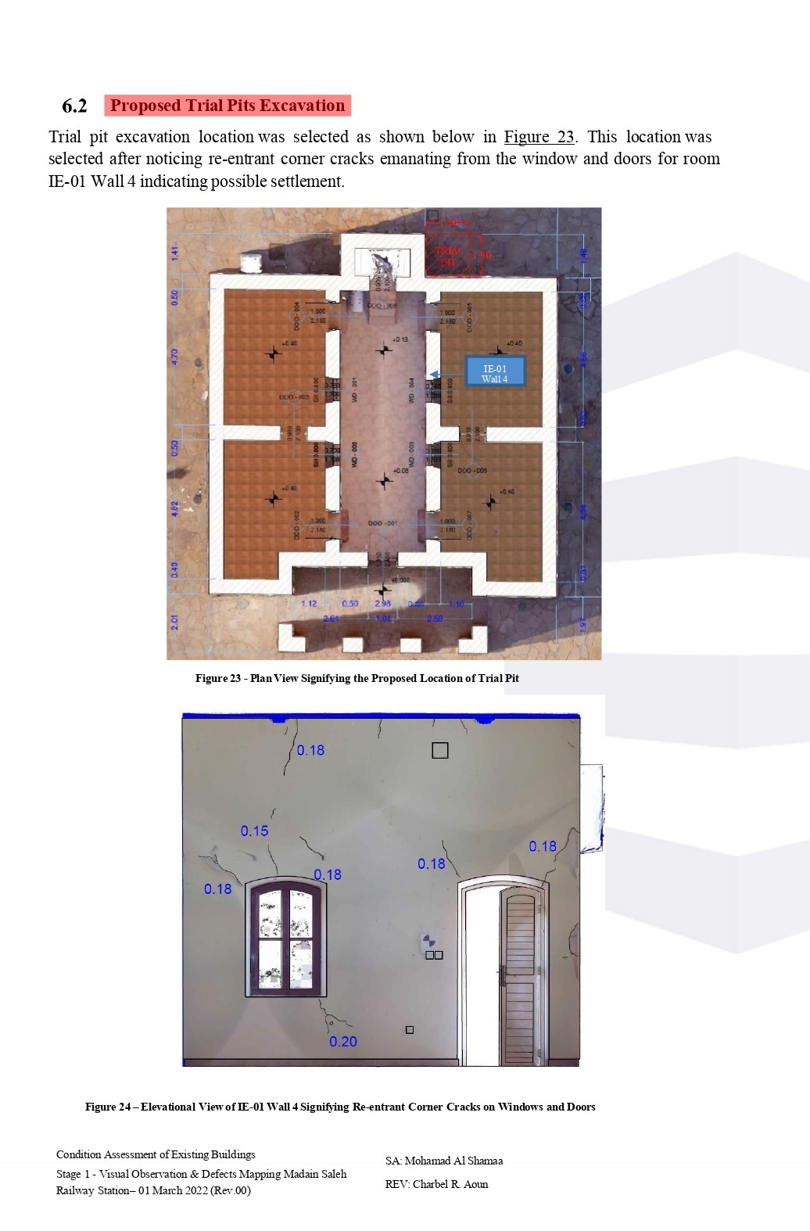

Comments by

Proposed Tests | Missing Required Tests | Desired Results
Trial Pits Excavation | - Wall Core  - XRD for Mortar & Plaster | - To determine the specific gravity, absorption & allowable compressive strength of the stone  - To determine the components of the materials.

ACTS Report: Page #18
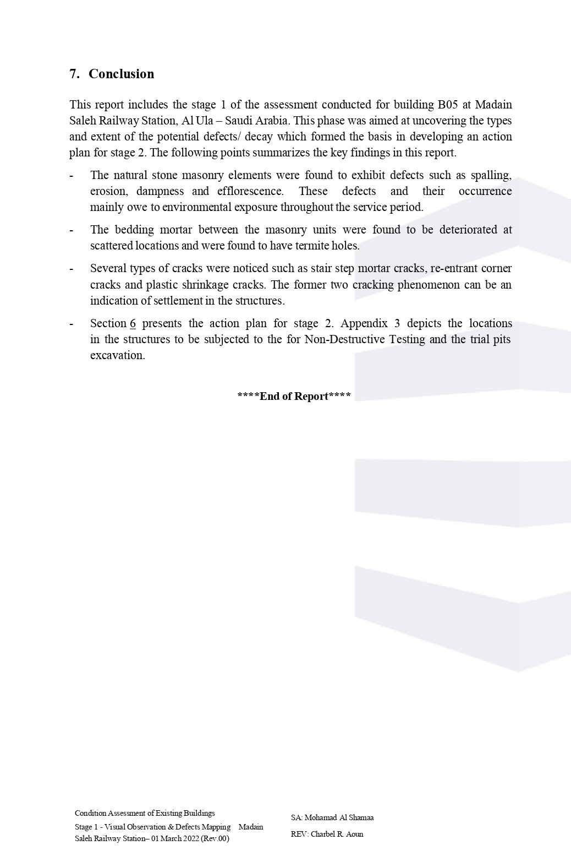

Comments
Subject | Observation
More Reasons for Building Defects | - The presence of fallen mortar and accumulated on the surface of the stone that needs to be removed carefully.  - Transverse cracks in the mortar are evidence of shrinkage.  - The separation of the mortar from the surface of the stone due to the difference of the specific density.  - Mortar deterioration due to the nature of the mixture.  - Holes in the mortar & the stones caused by insects.  - There is a crack in a gypsum spatter dash between external wall & the ground, which means that the ground around the building is unstable.  - Cracked stone with efflorescence (double damage).  - Spalling of stones (Not efficient, but needs treatment).  - Defects due to human intervention, by placing plastic to fix the nails on the wall.  - Making holes in some stones for electrical wiring.  - Breaking the edges of the stone when installing or dismantling doors and windows.  - The use of non-original sandstone to complete the construction of the building.  - Writings deformation on the walls.  - Using mortar to complete windowsills instead of stone, which led to its separation from the original stone.  - The toilet is incorrectly functioned, resulting in severe defects to this part of the building (improper use).  - The damage of the surface of the stone in some locations significantly shows the weakness of the grainular density.  - There is a difference in the mortar used originally and the one used later, especially for electrical installation works.  - There are nests of insects and spiders in the space between mortar and stone around the inner frame of doors and windows.  - The color difference of some stones, which requires detection of the different types of the used stones.  - Dampness reflected on the stone rows M & N of the building, which shows a clear evidence of water leakage from the roof.

ACTS Report: Appendix 1 (Satellite view of subjected buildings)
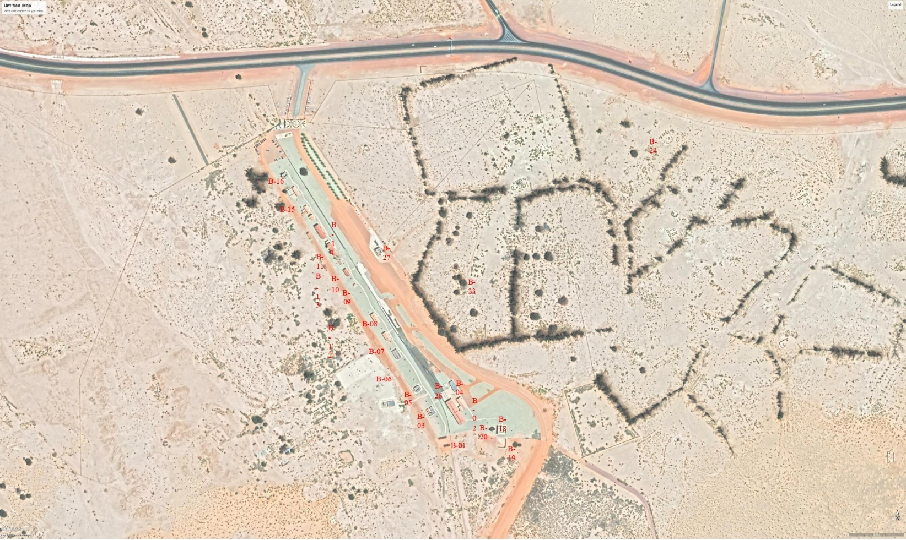

Comments by

ACTS Report: Appendix 2 (Defect Mapping)
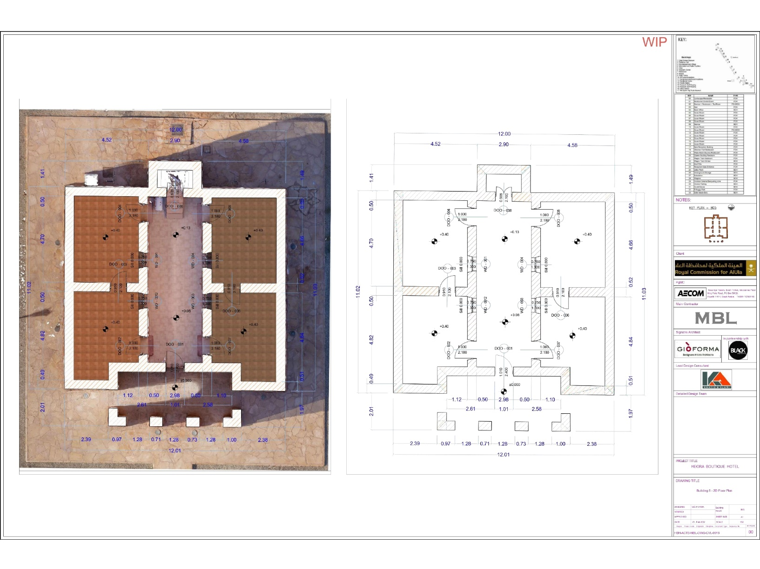

Comments by

ACTS Report: Proposed NDT Test Locations
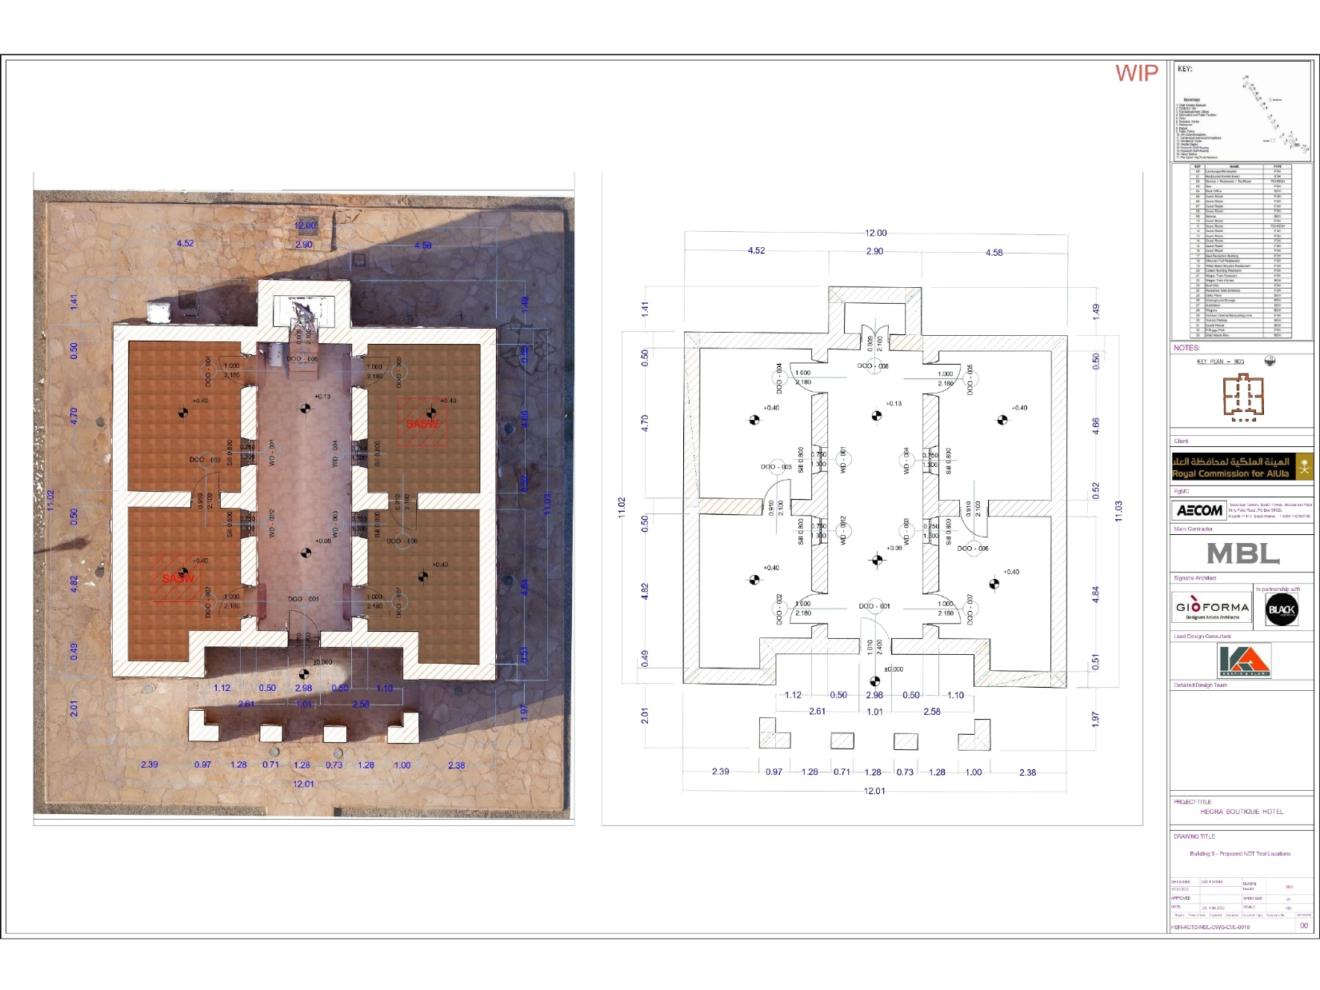

Comments by

ACTS Report: Proposed Trial Pit Locations
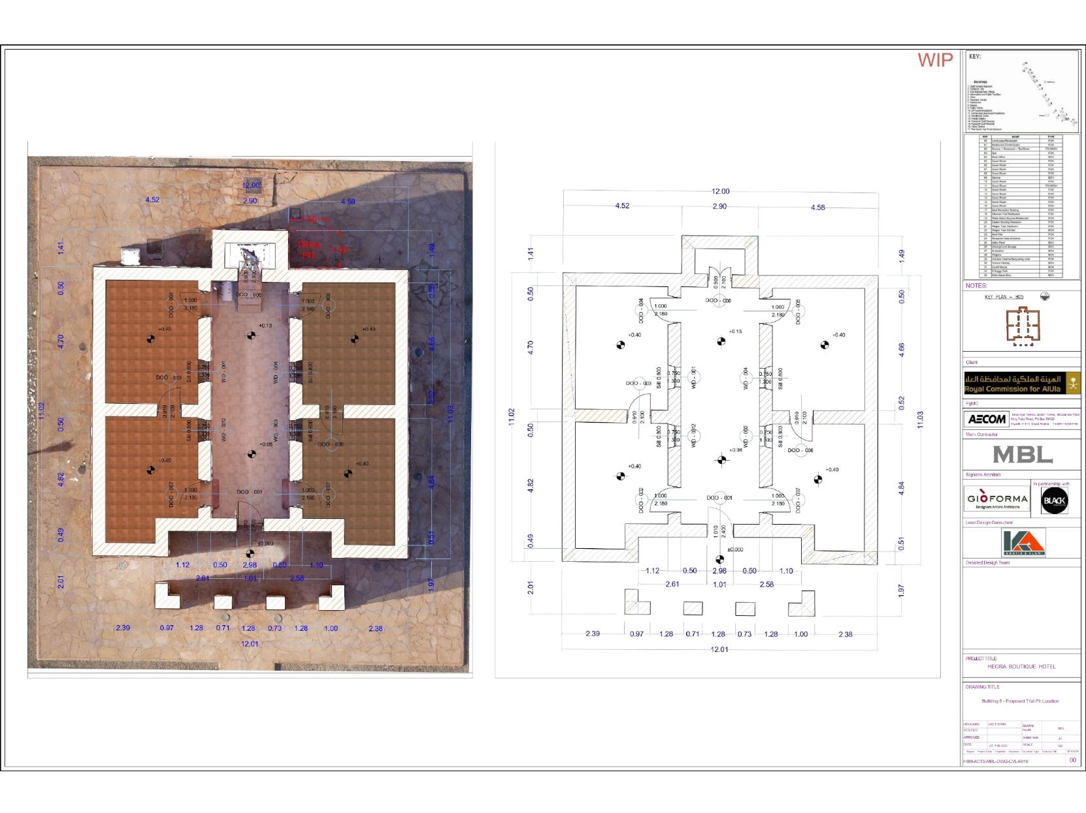

Comments by

Conclusion
- We note that the previous report covers many technical aspects such as damages and defects in the building. Our assessment of the current situation had to cover many of the shortcomings that were covered and completed in the submitted report.
- Available data has been collected to avoid duplication of works, identify the missing data and create an accurate database.
- It was taken into consideration that heritage buildings require careful specialized treatment to deal with them.
- Compatibility in the visual site was clarified and the points of interventions and comparisons with the expected design were identified.
- The necessary recommendations were made to move to the next stage in the process of the architectural and structural plan.

